**Question 1) Programs on Files**

//A program to demonstrate copying of files

#include<iostream>

#include<fstream> using namespace std; int main()

{

cout<<"\nenter the file name to be copied : "; char n1[80];

cin>>n1;

cout<<"\nenter the destination file name : "; char n2[80];

cin>>n2; ifstream filein;

filein.open(n1,ios::in); ofstream fileout; fileout.open(n2,ios::out); char ch; while((ch=filein.get())!=EOF)

{

fileout<<ch;

}

filein.close(); fileout.close();

return 1;

}

//A program to demonstrate write and read functions

#include<iostream>

#include<fstream> using namespace std; class student

{

int rno;

char name[80]; float marks; public:

void getdata()

{

cout<<"\nenter name : "; cin>>name; cout<<"\nenter roll no : "; cin>>rno;

cout<<"\nenter marks : "; cin>>marks;

}

void display()

{

cout<<"\n\n\nNAME : "<<name; cout<<"\nROLL NO : "<<rno; cout<<"\nMARKS : "<<marks;

}

};

int main()

{

student stu; ofstream fileout;

fileout.open("record.dat",ios::app); ifstream filein("record.dat");

cout<<"\npress 1 for a new record , \npress 2 to retrieve the data \n: "; int n;

cin>>n; switch(n)

{

case 1:{stu.getdata(); fileout.write((char*)&stu,sizeof(stu));

break;

}

case 2:{while(filein.read((char*)&stu,sizeof(stu)))

{

stu.display();

}

break;

}

default:cout<<"\nwrong option ...";

}

return 1;

}

//A program to demonstrate seek and tell functions

#include<iostream>

#include<fstream> using namespace std; int main()

{

ifstream filein; filein.open("test.txt",ios::in); int n; filein.seekg(0,ios::end); n=filein.tellg();

cout<<"\nthe total number of charcters is : "<<n;

cout<<"\nenter the cursor position from where the file is to be read : ";

int m;char ch; cin>>m;

filein.seekg(m,ios::beg); while(filein)

{

ch=filein.get(); cout<<ch;

}

filein.close(); return 1;

}

**Question 2)Student information Display**

//A program to write the records in input.txt

#include<iostream>

#include<cstring>

#include<fstream> using namespace std; int main()

{

char name[80];int rno;int m[6]; ofstream fileout; fileout.open("input.txt",ios::app);

cout<<"\nEnter name , roll no , marks of 6 subjects : after entering press

#:\n";

while(1)

{

cin>>name; if(strcmp(name,"#")==0) break;

cin>>rno;

for(int i=0;i<6;i++) cin>>m[i]; rno=733000+rno;

fileout<<endl<<rno<<" "<<name; for(int i=0;i<6;i++)

fileout<<" "<<m[i];

}

return 1; fileout.close();

}

//The program to display the output

#include<iostream>

#include<fstream> using namespace std; int main()

{

ifstream infile; infile.open("input.txt",ios::in); int rno,m[6],i;i=0;

char name[80];

cout<<"------------------------------------------\n";

cout.width(3); cout<<"SNO"; cout.width(10); cout<<"Rollno"; cout.width(15); cout<<"Name"; cout.width(12); cout<<"Precentage";

cout<<"\n------------------------------------------\n";

while(!infile.eof())

{

float p=0; infile>>rno>>name; for(int i=0;i<6;i++)

{

infile>>m[i];p=p+m[i];

}

p=p/6;

cout<<endl; cout.width(3); cout<<++i; cout.width(10); cout<<rno; cout.width(15); cout<<name; cout.width(12); cout<<p;

}

return 1;

}

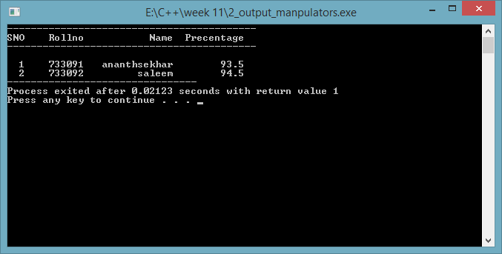

**Question 3)Class template**

#include<iostream>

using namespace std; template<class T> class matrix1

{

T **p; int m,n; public:

matrix1()

{}

matrix1(int l,int k)

{

int i; m=l;n=k;

p=new T*[m]; for(i=0;i<m;i++) p[i]=new T[n];

}

void getdata()

{

int i,j;

cout<<"\nenter the data : "; for(i=0;i<m;i++)

{

for(j=0;j<n;j++)

{

cin>>p[i][j];

}

}

}

void display()

{

cout<<"\nthe matrix is : \n"; int i,j;

for(i=0;i<m;i++)

{

cout<<endl; for(j=0;j<n;j++)

{

cout<<" "<<p[i][j];

}

}

}

void search(T &k)

{

int i,j,flag;flag=0; for(i=0;i<n;i++)

{

for(j=0;j<m;j++)

{

if(p[i][j]==k)

{

"<<i<<" "<<j<<" position...";

cout<<"\nsearch element found at

flag=1;

}

}

}

if(flag==0)

cout<<"\nsearch element not found ....";

}

friend matrix1 add(matrix1 r,matrix1 s)

{

matrix1 temp(r.m,r.n); temp.m=r.m; temp.n=r.n;

int i,j; for(i=0;i<(temp.m);i++)

{

for(j=0;j<(temp.n);j++)

{

temp.p[i][j]=r.p[i][j]+s.p[i][j];

}

}

return temp;

}

};

int main()

{

int ch;

cout<<"\npress 1 for integer and press 2 for float : "; cin>>ch;

switch(ch)

{

case 1:

{

int x;int m,n;

cout<<"\nenter the order of matrix : "; cin>>m>>n;

matrix1 <int>a(m,n); matrix1 <int>b(m,n); matrix1 <int>c(m,n); cout<<"\nfirst matrix"; a.getdata();

cout<<"\nsecond matrix"; b.getdata();

c=add(a,b);

cout<<"\nthe summation is : "; c.display();

cout<<"\nenter the search element : "; cin>>x;

c.search(x);

}break; case 2:

{

float x;int m,n;

cout<<"\nenter the order of matrix : "; cin>>m>>n;

matrix1 <float>a(m,n); matrix1 <float>b(m,n); matrix1 <float>c(m,n); cout<<"\nfirst matrix"; a.getdata(); cout<<"\nsecond matrix"; b.getdata();

c=add(a,b);

cout<<"\nthe summation is : ";

c.display();

cout<<"\nenter the search element : "; cin>>x;

c.search(x);

}break; default:cout<<"\ninvalid choice .....";

}

return 1;

}

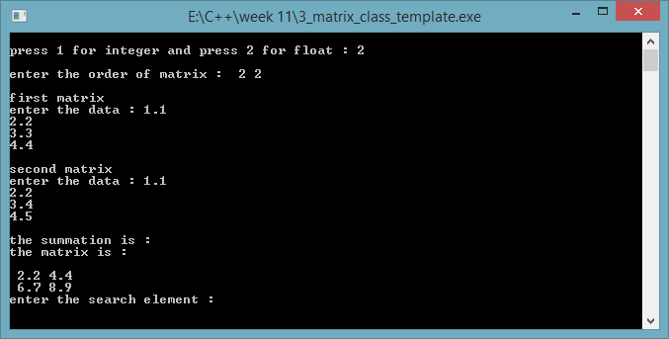

**Question 3)Function Template**

#include<iostream> using namespace std; template<class T>

void lsearch(T *p,T x,int n)

{

int i,flag;flag=0; for(i=0;i<n;i++)

{

if(p[i]==x)

{

cout<<"\nsearch element found at "<<i+1<<" position...."; flag=1;

}

}

if(flag==0)

{

cout<<"\nsearch element not found ....";

}

}

int main()

{

int a[10]={11,22,33,44,55,66,77,88,99,0};

char b[10]="aqwrtypol"; int a1;char b1;

cout<<"\nenter the search element in integer : "; cin>>a1;

cout<<"\nenter the search element in character : ";

cin>>b1; lsearch(a,a1,10); lsearch(b,b1,10); return 1;

}

