**PART A**



**1)**Variable names can range from 1 to 255 characters . Must begin with _ or a alphabet capital orsmall.Spaces or special characters not allowed.We cannot use c++ keyword as an identifier.

**2)**Thelargest use void data type is create generic pointers. If we don’t know to what type ofdatatype the pointer points , we can use these generic pointers. But type casting is required while usage.

Int i=10;

Void *gp;gp=&I;

Cout<<(int)*gp;

**3)** An enumeration is a user-defined data type consists of integral constants and each integralconstant is give a name. Basically used for creation of symbolic constants.

enum boolean{ false;

true; };

enum boolean check;

**4)**Array is collection of similar homogenous data types;

Ex:-

Char name[100];

Name is array of 100 characters.

Since an array is derived from the primitive data types , it is known as derived data type .

**5)**In C++ a variable can be declared anywhere in the scope of the program. This feature is highlybeneficial as at the time of writing the program , we don’t know how many variables can gonna be necessary , hence during the middle of the program , the declaration of new variables is helpful.

:: scope resolution operator can be used to access the global definition of a variable .

**6)**A reference variable provides an alias ( alternative name ) for a previously defined variable .

Its major use is in call by reference mechanism and return by reference mechanism , with these mechanisms the original data might be differed by other functions.

Ex:

Int &x=a;

Both x,a are hold the same address . or both are one and the same.

**7)**class

Public

Private

Inline

Namespace

New

Delete

**8)**

:: scope resolution operator

It is used to define a member function of a class outside the class.

It is used to access the global version of a variable.

**9)**

new is an operator whereas malloc()is function hence saves time.

There is no type casting required in new , where as in (int *)malloc() type casting is required since it returns a void pointer.

Syntax of new is rather easier. Int *p=new int;

**10)**

char * const p;

this is a constant pointer , which means the address pointed by the pointer cannot be changed . but the value at address can be changed .

that implies char ch;

p=&ch; //illegal

*p=’x’; //legal char const *p;

this is a pointer to a constant ,which means the address pointed by the pointer can changed but not the value at address.

That implies

Char ch;

P=&ch ; //legal

*p=’x’; //illegal

**PART B**



**3.1)**

ALGORITHM:-1)read two numbers

2)call the function swap 3)print the values after swap Function:-

void swap(int &x,int &y)

{

int t=x; x=y; y=t;

}

Return type is void.

Takes two parameters as reference variables.

/*Function program to swap the values of a pair of integers using reference variables. Developed by Sekhar Karedla of BE ¼ CSE-2, CBIT */

#include<iostream> using namespace std;

void swap(int &x,int &y) //function defination

{

int t=x;

x=y;

y=t;

}

int main()

{

cout<<"enter two numbers : "; //reading numbers

int a,b;

cin>>a>>b;

swap(a,b);

cout<<"after swapping : "<<a<<" "<<b; //displaying numbers

return 1;

}

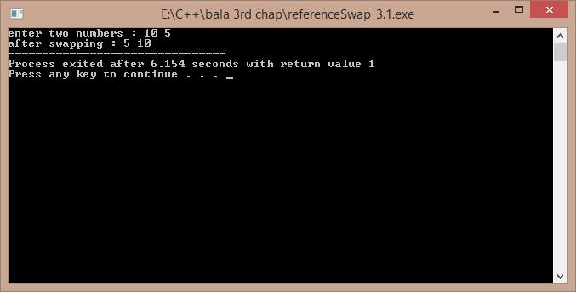

**3.2)**

ALGORITHM:-

1)read the size of vector from the user 2)create the vector using new operator

3)display the default values so as to show the created vector

/*A program to create a vector of size as demanded by the user , Developed by Sekhar Karedla BE ¼ CSE-2,CBIT*/

#include<iostream> using namespace std; int main()

{

int m,i;

cout<<"enter the size of vector : ";

cin>>m; //reading size

int *p=new int[m]; //creating the vector

cout<<"the garbage values are : \n";

for(i=0;i<m;i++) //displaying the garbage values

{

cout<<p[i]<<"\n";

}

return 1;

}

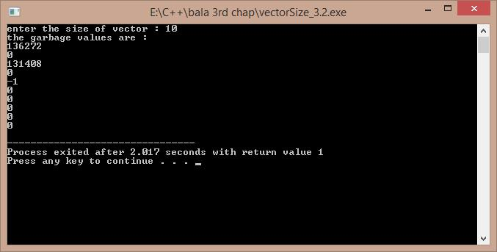

**3.3)**

ALGORITHM:-1)start

2)read the number of lines from user 3)use two for loops to get the pattern 4)end

/*A program to display the following pattern 1 22 333 4444

55555

……

, Developed by Sekhar Karedla BE ¼ CSE-2,CBIT*/ #include<iostream>

using namespace std; int main()

{

int i,j,m;

cout<<"enter the no of lines : "; cin>>m;

for(i=1;i<=m;i++)

{

for(j=1;j<=i;j++)

{

cout<<i;

}

cout<<"\n";

}

return 1;

}

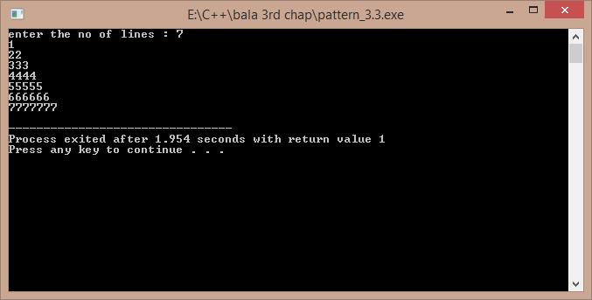

**3.4)**

ALGORITHM:-1)start

2)take all the values in float

3)create three loops , one for the increment of p , one for r , one for n (nested loops) 4) calculate the value of v in each case using pow function under cmath header file

5)store the obtained data in a file so as for the convenience of the user to display the output Mainly using fprintf() function.

6)end

/*A program to develop the results of the investment equation v=(1+p)^n. Developed by Sekhar Karedla BE ¼ CSE-2,CBIT*/

#include<iostream>

#include<cmath> using namespace std;

int main()

{

float p,v,n,r;FILE *fp;char ch;

fp=fopen("result3.4.txt","w"); //opening a file

fputs("3.4 PROBLEM REULTS \n ---------------------------------------------------------

------- \n",fp); //to initiate with the file some basic borders

fputs("P\t\tr\t\tn\t\t\tV\n",fp);

for(p=1000;p<=10000;p=p+1000)

{

for(r=0.10;r<=0.21;r=r+0.01)

{

for(n=1;n<=10;n++)

{

v=p*(pow((1+r),n)); //calculating v and storing in file the next line

fprintf(fp,"\n%f\t%f\t%f\t\t%f",p,r,n,v);

}

}

}

fclose(fp);

cout<<"the results have been stored int the text file result3.4.txt ."; return 1;

}

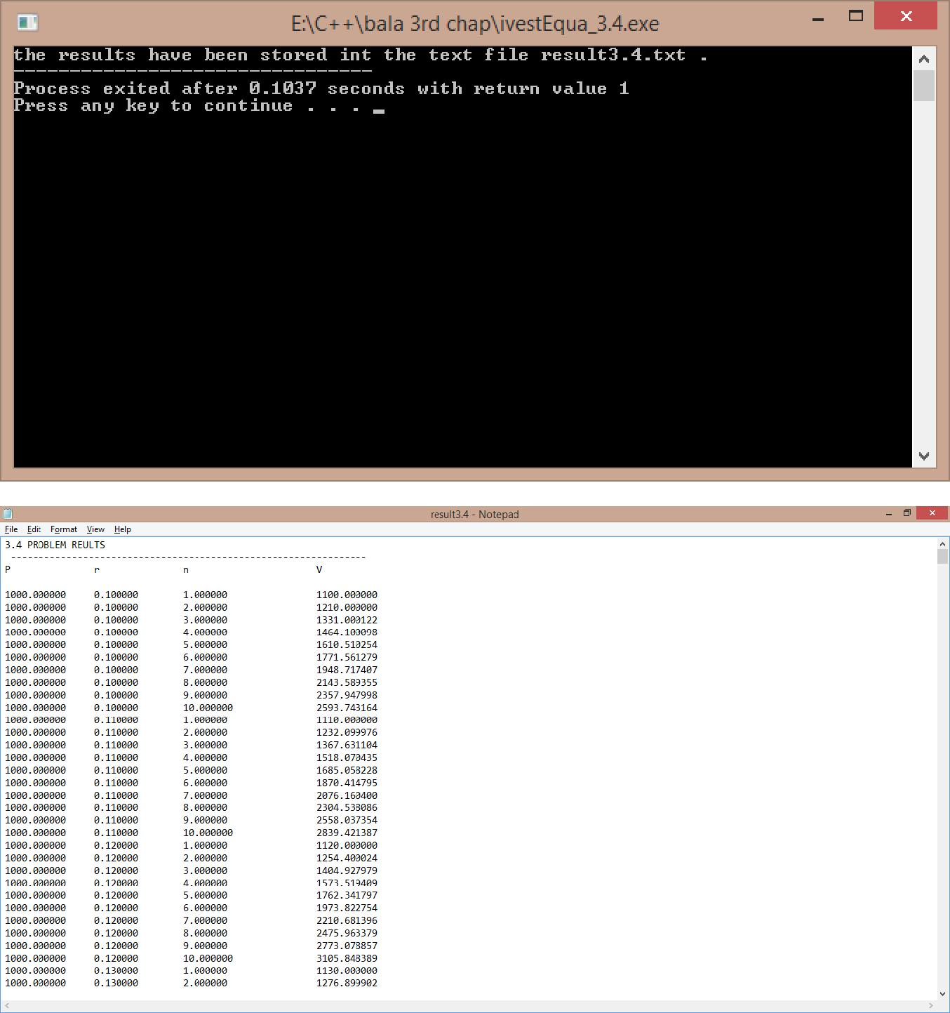

***THE CONTENTS OF THE FILE(RESULT3.4.txt) ARE:-***

|  |  |  |  |
| --- | --- | --- | --- |
| 3.4 PROBLEM REULTS | |  |  |
| ---------------------------------------------------------------- | | |  |
| P | r | n | V |

|  |  |  |  |
| --- | --- | --- | --- |
| 1000.000000 | 0.100000 | 1.000000 | 1100.000000 |
| 1000.000000 | 0.100000 | 2.000000 | 1210.000000 |
| 1000.000000 | 0.100000 | 3.000000 | 1331.000122 |

|  |  |  |  |
| --- | --- | --- | --- |
| 1000.000000 | 0.100000 | 4.000000 | 1464.100098 |
| 1000.000000 | 0.100000 | 5.000000 | 1610.510254 |
| 1000.000000 | 0.100000 | 6.000000 | 1771.561279 |
| 1000.000000 | 0.100000 | 7.000000 | 1948.717407 |
| 1000.000000 | 0.100000 | 8.000000 | 2143.589355 |
| 1000.000000 | 0.100000 | 9.000000 | 2357.947998 |
| 1000.000000 | 0.100000 | 10.000000 | 2593.743164 |
| 1000.000000 | 0.110000 | 1.000000 | 1110.000000 |
| 1000.000000 | 0.110000 | 2.000000 | 1232.099976 |
| 1000.000000 | 0.110000 | 3.000000 | 1367.631104 |
| 1000.000000 | 0.110000 | 4.000000 | 1518.070435 |
| 1000.000000 | 0.110000 | 5.000000 | 1685.058228 |
| 1000.000000 | 0.110000 | 6.000000 | 1870.414795 |
| 1000.000000 | 0.110000 | 7.000000 | 2076.160400 |
| 1000.000000 | 0.110000 | 8.000000 | 2304.538086 |
| 1000.000000 | 0.110000 | 9.000000 | 2558.037354 |
| 1000.000000 | 0.110000 | 10.000000 | 2839.421387 |
| 1000.000000 | 0.120000 | 1.000000 | 1120.000000 |
| 1000.000000 | 0.120000 | 2.000000 | 1254.400024 |
| 1000.000000 | 0.120000 | 3.000000 | 1404.927979 |
| 1000.000000 | 0.120000 | 4.000000 | 1573.519409 |
| 1000.000000 | 0.120000 | 5.000000 | 1762.341797 |
| 1000.000000 | 0.120000 | 6.000000 | 1973.822754 |
| 1000.000000 | 0.120000 | 7.000000 | 2210.681396 |
| 1000.000000 | 0.120000 | 8.000000 | 2475.963379 |
| 1000.000000 | 0.120000 | 9.000000 | 2773.078857 |
| 1000.000000 | 0.120000 | 10.000000 | 3105.848389 |

|  |  |  |  |
| --- | --- | --- | --- |
| 1000.000000 | 0.130000 | 1.000000 | 1130.000000 |
| 1000.000000 | 0.130000 | 2.000000 | 1276.899902 |
| 1000.000000 | 0.130000 | 3.000000 | 1442.896973 |
| 1000.000000 | 0.130000 | 4.000000 | 1630.473633 |
| 1000.000000 | 0.130000 | 5.000000 | 1842.435181 |
| 1000.000000 | 0.130000 | 6.000000 | 2081.951660 |
| 1000.000000 | 0.130000 | 7.000000 | 2352.605225 |
| 1000.000000 | 0.130000 | 8.000000 | 2658.444092 |
| 1000.000000 | 0.130000 | 9.000000 | 3004.041992 |
| 1000.000000 | 0.130000 | 10.000000 | 3394.567139 |
| 1000.000000 | 0.140000 | 1.000000 | 1140.000000 |
| 1000.000000 | 0.140000 | 2.000000 | 1299.599976 |
| 1000.000000 | 0.140000 | 3.000000 | 1481.543945 |
| 1000.000000 | 0.140000 | 4.000000 | 1688.960083 |
| 1000.000000 | 0.140000 | 5.000000 | 1925.414429 |
| 1000.000000 | 0.140000 | 6.000000 | 2194.972412 |
| 1000.000000 | 0.140000 | 7.000000 | 2502.268555 |
| 1000.000000 | 0.140000 | 8.000000 | 2852.585938 |
| 1000.000000 | 0.140000 | 9.000000 | 3251.947998 |
| 1000.000000 | 0.140000 | 10.000000 | 3707.220703 |
| 1000.000000 | 0.150000 | 1.000000 | 1150.000000 |
| 1000.000000 | 0.150000 | 2.000000 | 1322.500000 |
| 1000.000000 | 0.150000 | 3.000000 | 1520.874878 |
| 1000.000000 | 0.150000 | 4.000000 | 1749.006104 |
| 1000.000000 | 0.150000 | 5.000000 | 2011.357056 |
| 1000.000000 | 0.150000 | 6.000000 | 2313.060547 |
| 1000.000000 | 0.150000 | 7.000000 | 2660.019287 |

|  |  |  |  |
| --- | --- | --- | --- |
| 1000.000000 | 0.150000 | 8.000000 | 3059.022461 |
| 1000.000000 | 0.150000 | 9.000000 | 3517.875732 |
| 1000.000000 | 0.150000 | 10.000000 | 4045.557129 |
| 1000.000000 | 0.160000 | 1.000000 | 1160.000000 |
| 1000.000000 | 0.160000 | 2.000000 | 1345.599854 |
| 1000.000000 | 0.160000 | 3.000000 | 1560.895874 |
| 1000.000000 | 0.160000 | 4.000000 | 1810.639160 |
| 1000.000000 | 0.160000 | 5.000000 | 2100.341309 |
| 1000.000000 | 0.160000 | 6.000000 | 2436.395996 |
| 1000.000000 | 0.160000 | 7.000000 | 2826.218994 |
| 1000.000000 | 0.160000 | 8.000000 | 3278.414307 |
| 1000.000000 | 0.160000 | 9.000000 | 3802.960449 |
| 1000.000000 | 0.160000 | 10.000000 | 4411.433594 |
| 1000.000000 | 0.170000 | 1.000000 | 1170.000122 |
| 1000.000000 | 0.170000 | 2.000000 | 1368.900146 |
| 1000.000000 | 0.170000 | 3.000000 | 1601.613281 |
| 1000.000000 | 0.170000 | 4.000000 | 1873.887695 |
| 1000.000000 | 0.170000 | 5.000000 | 2192.448975 |
| 1000.000000 | 0.170000 | 6.000000 | 2565.165283 |
| 1000.000000 | 0.170000 | 7.000000 | 3001.243652 |
| 1000.000000 | 0.170000 | 8.000000 | 3511.455078 |
| 1000.000000 | 0.170000 | 9.000000 | 4108.402832 |
| 1000.000000 | 0.170000 | 10.000000 | 4806.831543 |
| 1000.000000 | 0.180000 | 1.000000 | 1180.000122 |
| 1000.000000 | 0.180000 | 2.000000 | 1392.400146 |
| 1000.000000 | 0.180000 | 3.000000 | 1643.032349 |
| 1000.000000 | 0.180000 | 4.000000 | 1938.778198 |

|  |  |  |  |
| --- | --- | --- | --- |
| 1000.000000 | 0.180000 | 5.000000 | 2287.758301 |
| 1000.000000 | 0.180000 | 6.000000 | 2699.555176 |
| 1000.000000 | 0.180000 | 7.000000 | 3185.475098 |
| 1000.000000 | 0.180000 | 8.000000 | 3758.860840 |
| 1000.000000 | 0.180000 | 9.000000 | 4435.456055 |
| 1000.000000 | 0.180000 | 10.000000 | 5233.838379 |
| 1000.000000 | 0.190000 | 1.000000 | 1190.000000 |
| 1000.000000 | 0.190000 | 2.000000 | 1416.100098 |
| 1000.000000 | 0.190000 | 3.000000 | 1685.159180 |
| 1000.000000 | 0.190000 | 4.000000 | 2005.339600 |
| 1000.000000 | 0.190000 | 5.000000 | 2386.354248 |
| 1000.000000 | 0.190000 | 6.000000 | 2839.761719 |
| 1000.000000 | 0.190000 | 7.000000 | 3379.316650 |
| 1000.000000 | 0.190000 | 8.000000 | 4021.387207 |
| 1000.000000 | 0.190000 | 9.000000 | 4785.450684 |
| 1000.000000 | 0.190000 | 10.000000 | 5694.686523 |
| 1000.000000 | 0.200000 | 1.000000 | 1200.000000 |
| 1000.000000 | 0.200000 | 2.000000 | 1440.000000 |
| 1000.000000 | 0.200000 | 3.000000 | 1728.000122 |
| 1000.000000 | 0.200000 | 4.000000 | 2073.600342 |
| 1000.000000 | 0.200000 | 5.000000 | 2488.320557 |
| 1000.000000 | 0.200000 | 6.000000 | 2985.984863 |
| 1000.000000 | 0.200000 | 7.000000 | 3583.181885 |
| 1000.000000 | 0.200000 | 8.000000 | 4299.818359 |
| 1000.000000 | 0.200000 | 9.000000 | 5159.782227 |
| 1000.000000 | 0.200000 | 10.000000 | 6191.739258 |
| 2000.000000 | 0.100000 | 1.000000 | 2200.000000 |

|  |  |  |  |
| --- | --- | --- | --- |
| 2000.000000 | 0.100000 | 2.000000 | 2420.000000 |
| 2000.000000 | 0.100000 | 3.000000 | 2662.000244 |
| 2000.000000 | 0.100000 | 4.000000 | 2928.200195 |
| 2000.000000 | 0.100000 | 5.000000 | 3221.020508 |
| 2000.000000 | 0.100000 | 6.000000 | 3543.122559 |
| 2000.000000 | 0.100000 | 7.000000 | 3897.434814 |
| 2000.000000 | 0.100000 | 8.000000 | 4287.178711 |
| 2000.000000 | 0.100000 | 9.000000 | 4715.895996 |
| 2000.000000 | 0.100000 | 10.000000 | 5187.486328 |
| 2000.000000 | 0.110000 | 1.000000 | 2220.000000 |
| 2000.000000 | 0.110000 | 2.000000 | 2464.199951 |
| 2000.000000 | 0.110000 | 3.000000 | 2735.262207 |
| 2000.000000 | 0.110000 | 4.000000 | 3036.140869 |
| 2000.000000 | 0.110000 | 5.000000 | 3370.116455 |
| 2000.000000 | 0.110000 | 6.000000 | 3740.829590 |
| 2000.000000 | 0.110000 | 7.000000 | 4152.320801 |
| 2000.000000 | 0.110000 | 8.000000 | 4609.076172 |
| 2000.000000 | 0.110000 | 9.000000 | 5116.074707 |
| 2000.000000 | 0.110000 | 10.000000 | 5678.842773 |
| 2000.000000 | 0.120000 | 1.000000 | 2240.000000 |
| 2000.000000 | 0.120000 | 2.000000 | 2508.800049 |
| 2000.000000 | 0.120000 | 3.000000 | 2809.855957 |
| 2000.000000 | 0.120000 | 4.000000 | 3147.038818 |
| 2000.000000 | 0.120000 | 5.000000 | 3524.683594 |
| 2000.000000 | 0.120000 | 6.000000 | 3947.645508 |
| 2000.000000 | 0.120000 | 7.000000 | 4421.362793 |
| 2000.000000 | 0.120000 | 8.000000 | 4951.926758 |

|  |  |  |  |
| --- | --- | --- | --- |
| 2000.000000 | 0.120000 | 9.000000 | 5546.157715 |
| 2000.000000 | 0.120000 | 10.000000 | 6211.696777 |
| 2000.000000 | 0.130000 | 1.000000 | 2260.000000 |
| 2000.000000 | 0.130000 | 2.000000 | 2553.799805 |
| 2000.000000 | 0.130000 | 3.000000 | 2885.793945 |
| 2000.000000 | 0.130000 | 4.000000 | 3260.947266 |
| 2000.000000 | 0.130000 | 5.000000 | 3684.870361 |
| 2000.000000 | 0.130000 | 6.000000 | 4163.903320 |
| 2000.000000 | 0.130000 | 7.000000 | 4705.210449 |
| 2000.000000 | 0.130000 | 8.000000 | 5316.888184 |
| 2000.000000 | 0.130000 | 9.000000 | 6008.083984 |
| 2000.000000 | 0.130000 | 10.000000 | 6789.134277 |
| 2000.000000 | 0.140000 | 1.000000 | 2280.000000 |
| 2000.000000 | 0.140000 | 2.000000 | 2599.199951 |
| 2000.000000 | 0.140000 | 3.000000 | 2963.087891 |
| 2000.000000 | 0.140000 | 4.000000 | 3377.920166 |
| 2000.000000 | 0.140000 | 5.000000 | 3850.828857 |
| 2000.000000 | 0.140000 | 6.000000 | 4389.944824 |
| 2000.000000 | 0.140000 | 7.000000 | 5004.537109 |
| 2000.000000 | 0.140000 | 8.000000 | 5705.171875 |
| 2000.000000 | 0.140000 | 9.000000 | 6503.895996 |
| 2000.000000 | 0.140000 | 10.000000 | 7414.441406 |
| 2000.000000 | 0.150000 | 1.000000 | 2300.000000 |
| 2000.000000 | 0.150000 | 2.000000 | 2645.000000 |
| 2000.000000 | 0.150000 | 3.000000 | 3041.749756 |
| 2000.000000 | 0.150000 | 4.000000 | 3498.012207 |
| 2000.000000 | 0.150000 | 5.000000 | 4022.714111 |

|  |  |  |  |
| --- | --- | --- | --- |
| 2000.000000 | 0.150000 | 6.000000 | 4626.121094 |
| 2000.000000 | 0.150000 | 7.000000 | 5320.038574 |
| 2000.000000 | 0.150000 | 8.000000 | 6118.044922 |
| 2000.000000 | 0.150000 | 9.000000 | 7035.751465 |
| 2000.000000 | 0.150000 | 10.000000 | 8091.114258 |
| 2000.000000 | 0.160000 | 1.000000 | 2320.000000 |
| 2000.000000 | 0.160000 | 2.000000 | 2691.199707 |
| 2000.000000 | 0.160000 | 3.000000 | 3121.791748 |
| 2000.000000 | 0.160000 | 4.000000 | 3621.278320 |
| 2000.000000 | 0.160000 | 5.000000 | 4200.682617 |
| 2000.000000 | 0.160000 | 6.000000 | 4872.791992 |
| 2000.000000 | 0.160000 | 7.000000 | 5652.437988 |
| 2000.000000 | 0.160000 | 8.000000 | 6556.828613 |
| 2000.000000 | 0.160000 | 9.000000 | 7605.920898 |
| 2000.000000 | 0.160000 | 10.000000 | 8822.867188 |
| 2000.000000 | 0.170000 | 1.000000 | 2340.000244 |
| 2000.000000 | 0.170000 | 2.000000 | 2737.800293 |
| 2000.000000 | 0.170000 | 3.000000 | 3203.226562 |
| 2000.000000 | 0.170000 | 4.000000 | 3747.775391 |
| 2000.000000 | 0.170000 | 5.000000 | 4384.897949 |
| 2000.000000 | 0.170000 | 6.000000 | 5130.330566 |
| 2000.000000 | 0.170000 | 7.000000 | 6002.487305 |
| 2000.000000 | 0.170000 | 8.000000 | 7022.910156 |
| 2000.000000 | 0.170000 | 9.000000 | 8216.805664 |
| 2000.000000 | 0.170000 | 10.000000 | 9613.663086 |
| 2000.000000 | 0.180000 | 1.000000 | 2360.000244 |
| 2000.000000 | 0.180000 | 2.000000 | 2784.800293 |

|  |  |  |  |
| --- | --- | --- | --- |
| 2000.000000 | 0.180000 | 3.000000 | 3286.064697 |
| 2000.000000 | 0.180000 | 4.000000 | 3877.556396 |
| 2000.000000 | 0.180000 | 5.000000 | 4575.516602 |
| 2000.000000 | 0.180000 | 6.000000 | 5399.110352 |
| 2000.000000 | 0.180000 | 7.000000 | 6370.950195 |
| 2000.000000 | 0.180000 | 8.000000 | 7517.721680 |
| 2000.000000 | 0.180000 | 9.000000 | 8870.912109 |
| 2000.000000 | 0.180000 | 10.000000 | 10467.676758 |
| 2000.000000 | 0.190000 | 1.000000 | 2380.000000 |
| 2000.000000 | 0.190000 | 2.000000 | 2832.200195 |
| 2000.000000 | 0.190000 | 3.000000 | 3370.318359 |
| 2000.000000 | 0.190000 | 4.000000 | 4010.679199 |
| 2000.000000 | 0.190000 | 5.000000 | 4772.708496 |
| 2000.000000 | 0.190000 | 6.000000 | 5679.523438 |
| 2000.000000 | 0.190000 | 7.000000 | 6758.633301 |
| 2000.000000 | 0.190000 | 8.000000 | 8042.774414 |
| 2000.000000 | 0.190000 | 9.000000 | 9570.901367 |
| 2000.000000 | 0.190000 | 10.000000 | 11389.373047 |
| 2000.000000 | 0.200000 | 1.000000 | 2400.000000 |
| 2000.000000 | 0.200000 | 2.000000 | 2880.000000 |
| 2000.000000 | 0.200000 | 3.000000 | 3456.000244 |
| 2000.000000 | 0.200000 | 4.000000 | 4147.200684 |
| 2000.000000 | 0.200000 | 5.000000 | 4976.641113 |
| 2000.000000 | 0.200000 | 6.000000 | 5971.969727 |
| 2000.000000 | 0.200000 | 7.000000 | 7166.363770 |
| 2000.000000 | 0.200000 | 8.000000 | 8599.636719 |
| 2000.000000 | 0.200000 | 9.000000 | 10319.564453 |

|  |  |  |  |
| --- | --- | --- | --- |
| 2000.000000 | 0.200000 | 10.000000 | 12383.478516 |
| 3000.000000 | 0.100000 | 1.000000 | 3300.000000 |
| 3000.000000 | 0.100000 | 2.000000 | 3630.000000 |
| 3000.000000 | 0.100000 | 3.000000 | 3993.000244 |
| 3000.000000 | 0.100000 | 4.000000 | 4392.300293 |
| 3000.000000 | 0.100000 | 5.000000 | 4831.530762 |
| 3000.000000 | 0.100000 | 6.000000 | 5314.683594 |
| 3000.000000 | 0.100000 | 7.000000 | 5846.151855 |
| 3000.000000 | 0.100000 | 8.000000 | 6430.767578 |
| 3000.000000 | 0.100000 | 9.000000 | 7073.844238 |
| 3000.000000 | 0.100000 | 10.000000 | 7781.229492 |
| 3000.000000 | 0.110000 | 1.000000 | 3330.000000 |
| 3000.000000 | 0.110000 | 2.000000 | 3696.300049 |
| 3000.000000 | 0.110000 | 3.000000 | 4102.893066 |
| 3000.000000 | 0.110000 | 4.000000 | 4554.211426 |
| 3000.000000 | 0.110000 | 5.000000 | 5055.174805 |
| 3000.000000 | 0.110000 | 6.000000 | 5611.244141 |
| 3000.000000 | 0.110000 | 7.000000 | 6228.481445 |
| 3000.000000 | 0.110000 | 8.000000 | 6913.614258 |
| 3000.000000 | 0.110000 | 9.000000 | 7674.111816 |
| 3000.000000 | 0.110000 | 10.000000 | 8518.263672 |
| 3000.000000 | 0.120000 | 1.000000 | 3360.000000 |
| 3000.000000 | 0.120000 | 2.000000 | 3763.199951 |
| 3000.000000 | 0.120000 | 3.000000 | 4214.783691 |
| 3000.000000 | 0.120000 | 4.000000 | 4720.558105 |
| 3000.000000 | 0.120000 | 5.000000 | 5287.025391 |
| 3000.000000 | 0.120000 | 6.000000 | 5921.468262 |

|  |  |  |  |
| --- | --- | --- | --- |
| 3000.000000 | 0.120000 | 7.000000 | 6632.044434 |
| 3000.000000 | 0.120000 | 8.000000 | 7427.890137 |
| 3000.000000 | 0.120000 | 9.000000 | 8319.236328 |
| 3000.000000 | 0.120000 | 10.000000 | 9317.544922 |
| 3000.000000 | 0.130000 | 1.000000 | 3390.000000 |
| 3000.000000 | 0.130000 | 2.000000 | 3830.699707 |
| 3000.000000 | 0.130000 | 3.000000 | 4328.690918 |
| 3000.000000 | 0.130000 | 4.000000 | 4891.420898 |
| 3000.000000 | 0.130000 | 5.000000 | 5527.305176 |
| 3000.000000 | 0.130000 | 6.000000 | 6245.854980 |
| 3000.000000 | 0.130000 | 7.000000 | 7057.815918 |
| 3000.000000 | 0.130000 | 8.000000 | 7975.332520 |
| 3000.000000 | 0.130000 | 9.000000 | 9012.125977 |
| 3000.000000 | 0.130000 | 10.000000 | 10183.702148 |
| 3000.000000 | 0.140000 | 1.000000 | 3420.000000 |
| 3000.000000 | 0.140000 | 2.000000 | 3898.800049 |
| 3000.000000 | 0.140000 | 3.000000 | 4444.631836 |
| 3000.000000 | 0.140000 | 4.000000 | 5066.880371 |
| 3000.000000 | 0.140000 | 5.000000 | 5776.243164 |
| 3000.000000 | 0.140000 | 6.000000 | 6584.917480 |
| 3000.000000 | 0.140000 | 7.000000 | 7506.805664 |
| 3000.000000 | 0.140000 | 8.000000 | 8557.757812 |
| 3000.000000 | 0.140000 | 9.000000 | 9755.844727 |
| 3000.000000 | 0.140000 | 10.000000 | 11121.662109 |
| 3000.000000 | 0.150000 | 1.000000 | 3450.000000 |
| 3000.000000 | 0.150000 | 2.000000 | 3967.500000 |
| 3000.000000 | 0.150000 | 3.000000 | 4562.624512 |

|  |  |  |  |
| --- | --- | --- | --- |
| 3000.000000 | 0.150000 | 4.000000 | 5247.018555 |
| 3000.000000 | 0.150000 | 5.000000 | 6034.071289 |
| 3000.000000 | 0.150000 | 6.000000 | 6939.181641 |
| 3000.000000 | 0.150000 | 7.000000 | 7980.058105 |
| 3000.000000 | 0.150000 | 8.000000 | 9177.067383 |
| 3000.000000 | 0.150000 | 9.000000 | 10553.626953 |
| 3000.000000 | 0.150000 | 10.000000 | 12136.670898 |
| 3000.000000 | 0.160000 | 1.000000 | 3480.000000 |
| 3000.000000 | 0.160000 | 2.000000 | 4036.799561 |
| 3000.000000 | 0.160000 | 3.000000 | 4682.687988 |
| 3000.000000 | 0.160000 | 4.000000 | 5431.917480 |
| 3000.000000 | 0.160000 | 5.000000 | 6301.023926 |
| 3000.000000 | 0.160000 | 6.000000 | 7309.187500 |
| 3000.000000 | 0.160000 | 7.000000 | 8478.657227 |
| 3000.000000 | 0.160000 | 8.000000 | 9835.243164 |
| 3000.000000 | 0.160000 | 9.000000 | 11408.880859 |
| 3000.000000 | 0.160000 | 10.000000 | 13234.300781 |
| 3000.000000 | 0.170000 | 1.000000 | 3510.000244 |
| 3000.000000 | 0.170000 | 2.000000 | 4106.700684 |
| 3000.000000 | 0.170000 | 3.000000 | 4804.839844 |
| 3000.000000 | 0.170000 | 4.000000 | 5621.663086 |
| 3000.000000 | 0.170000 | 5.000000 | 6577.346680 |
| 3000.000000 | 0.170000 | 6.000000 | 7695.495605 |
| 3000.000000 | 0.170000 | 7.000000 | 9003.730469 |
| 3000.000000 | 0.170000 | 8.000000 | 10534.365234 |
| 3000.000000 | 0.170000 | 9.000000 | 12325.208008 |
| 3000.000000 | 0.170000 | 10.000000 | 14420.494141 |

|  |  |  |  |
| --- | --- | --- | --- |
| 3000.000000 | 0.180000 | 1.000000 | 3540.000244 |
| 3000.000000 | 0.180000 | 2.000000 | 4177.200195 |
| 3000.000000 | 0.180000 | 3.000000 | 4929.097168 |
| 3000.000000 | 0.180000 | 4.000000 | 5816.334473 |
| 3000.000000 | 0.180000 | 5.000000 | 6863.274902 |
| 3000.000000 | 0.180000 | 6.000000 | 8098.665527 |
| 3000.000000 | 0.180000 | 7.000000 | 9556.425781 |
| 3000.000000 | 0.180000 | 8.000000 | 11276.582031 |
| 3000.000000 | 0.180000 | 9.000000 | 13306.369141 |
| 3000.000000 | 0.180000 | 10.000000 | 15701.515625 |
| 3000.000000 | 0.190000 | 1.000000 | 3570.000244 |
| 3000.000000 | 0.190000 | 2.000000 | 4248.300293 |
| 3000.000000 | 0.190000 | 3.000000 | 5055.477539 |
| 3000.000000 | 0.190000 | 4.000000 | 6016.019043 |
| 3000.000000 | 0.190000 | 5.000000 | 7159.062500 |
| 3000.000000 | 0.190000 | 6.000000 | 8519.285156 |
| 3000.000000 | 0.190000 | 7.000000 | 10137.949219 |
| 3000.000000 | 0.190000 | 8.000000 | 12064.161133 |
| 3000.000000 | 0.190000 | 9.000000 | 14356.351562 |
| 3000.000000 | 0.190000 | 10.000000 | 17084.058594 |
| 3000.000000 | 0.200000 | 1.000000 | 3600.000244 |
| 3000.000000 | 0.200000 | 2.000000 | 4320.000000 |
| 3000.000000 | 0.200000 | 3.000000 | 5184.000488 |
| 3000.000000 | 0.200000 | 4.000000 | 6220.800781 |
| 3000.000000 | 0.200000 | 5.000000 | 7464.961914 |
| 3000.000000 | 0.200000 | 6.000000 | 8957.954102 |
| 3000.000000 | 0.200000 | 7.000000 | 10749.545898 |

|  |  |  |  |
| --- | --- | --- | --- |
| 3000.000000 | 0.200000 | 8.000000 | 12899.455078 |
| 3000.000000 | 0.200000 | 9.000000 | 15479.347656 |
| 3000.000000 | 0.200000 | 10.000000 | 18575.216797 |
| 4000.000000 | 0.100000 | 1.000000 | 4400.000000 |
| 4000.000000 | 0.100000 | 2.000000 | 4840.000000 |
| 4000.000000 | 0.100000 | 3.000000 | 5324.000488 |
| 4000.000000 | 0.100000 | 4.000000 | 5856.400391 |
| 4000.000000 | 0.100000 | 5.000000 | 6442.041016 |
| 4000.000000 | 0.100000 | 6.000000 | 7086.245117 |
| 4000.000000 | 0.100000 | 7.000000 | 7794.869629 |
| 4000.000000 | 0.100000 | 8.000000 | 8574.357422 |
| 4000.000000 | 0.100000 | 9.000000 | 9431.791992 |
| 4000.000000 | 0.100000 | 10.000000 | 10374.972656 |
| 4000.000000 | 0.110000 | 1.000000 | 4440.000000 |
| 4000.000000 | 0.110000 | 2.000000 | 4928.399902 |
| 4000.000000 | 0.110000 | 3.000000 | 5470.524414 |
| 4000.000000 | 0.110000 | 4.000000 | 6072.281738 |
| 4000.000000 | 0.110000 | 5.000000 | 6740.232910 |
| 4000.000000 | 0.110000 | 6.000000 | 7481.659180 |
| 4000.000000 | 0.110000 | 7.000000 | 8304.641602 |
| 4000.000000 | 0.110000 | 8.000000 | 9218.152344 |
| 4000.000000 | 0.110000 | 9.000000 | 10232.149414 |
| 4000.000000 | 0.110000 | 10.000000 | 11357.685547 |
| 4000.000000 | 0.120000 | 1.000000 | 4480.000000 |
| 4000.000000 | 0.120000 | 2.000000 | 5017.600098 |
| 4000.000000 | 0.120000 | 3.000000 | 5619.711914 |
| 4000.000000 | 0.120000 | 4.000000 | 6294.077637 |

|  |  |  |  |
| --- | --- | --- | --- |
| 4000.000000 | 0.120000 | 5.000000 | 7049.367188 |
| 4000.000000 | 0.120000 | 6.000000 | 7895.291016 |
| 4000.000000 | 0.120000 | 7.000000 | 8842.725586 |
| 4000.000000 | 0.120000 | 8.000000 | 9903.853516 |
| 4000.000000 | 0.120000 | 9.000000 | 11092.315430 |
| 4000.000000 | 0.120000 | 10.000000 | 12423.393555 |
| 4000.000000 | 0.130000 | 1.000000 | 4520.000000 |
| 4000.000000 | 0.130000 | 2.000000 | 5107.599609 |
| 4000.000000 | 0.130000 | 3.000000 | 5771.587891 |
| 4000.000000 | 0.130000 | 4.000000 | 6521.894531 |
| 4000.000000 | 0.130000 | 5.000000 | 7369.740723 |
| 4000.000000 | 0.130000 | 6.000000 | 8327.806641 |
| 4000.000000 | 0.130000 | 7.000000 | 9410.420898 |
| 4000.000000 | 0.130000 | 8.000000 | 10633.776367 |
| 4000.000000 | 0.130000 | 9.000000 | 12016.167969 |
| 4000.000000 | 0.130000 | 10.000000 | 13578.268555 |
| 4000.000000 | 0.140000 | 1.000000 | 4560.000000 |
| 4000.000000 | 0.140000 | 2.000000 | 5198.399902 |
| 4000.000000 | 0.140000 | 3.000000 | 5926.175781 |
| 4000.000000 | 0.140000 | 4.000000 | 6755.840332 |
| 4000.000000 | 0.140000 | 5.000000 | 7701.657715 |
| 4000.000000 | 0.140000 | 6.000000 | 8779.889648 |
| 4000.000000 | 0.140000 | 7.000000 | 10009.074219 |
| 4000.000000 | 0.140000 | 8.000000 | 11410.343750 |
| 4000.000000 | 0.140000 | 9.000000 | 13007.791992 |
| 4000.000000 | 0.140000 | 10.000000 | 14828.882812 |
| 4000.000000 | 0.150000 | 1.000000 | 4600.000000 |

|  |  |  |  |
| --- | --- | --- | --- |
| 4000.000000 | 0.150000 | 2.000000 | 5290.000000 |
| 4000.000000 | 0.150000 | 3.000000 | 6083.499512 |
| 4000.000000 | 0.150000 | 4.000000 | 6996.024414 |
| 4000.000000 | 0.150000 | 5.000000 | 8045.428223 |
| 4000.000000 | 0.150000 | 6.000000 | 9252.242188 |
| 4000.000000 | 0.150000 | 7.000000 | 10640.077148 |
| 4000.000000 | 0.150000 | 8.000000 | 12236.089844 |
| 4000.000000 | 0.150000 | 9.000000 | 14071.502930 |
| 4000.000000 | 0.150000 | 10.000000 | 16182.228516 |
| 4000.000000 | 0.160000 | 1.000000 | 4640.000000 |
| 4000.000000 | 0.160000 | 2.000000 | 5382.399414 |
| 4000.000000 | 0.160000 | 3.000000 | 6243.583496 |
| 4000.000000 | 0.160000 | 4.000000 | 7242.556641 |
| 4000.000000 | 0.160000 | 5.000000 | 8401.365234 |
| 4000.000000 | 0.160000 | 6.000000 | 9745.583984 |
| 4000.000000 | 0.160000 | 7.000000 | 11304.875977 |
| 4000.000000 | 0.160000 | 8.000000 | 13113.657227 |
| 4000.000000 | 0.160000 | 9.000000 | 15211.841797 |
| 4000.000000 | 0.160000 | 10.000000 | 17645.734375 |
| 4000.000000 | 0.170000 | 1.000000 | 4680.000488 |
| 4000.000000 | 0.170000 | 2.000000 | 5475.600586 |
| 4000.000000 | 0.170000 | 3.000000 | 6406.453125 |
| 4000.000000 | 0.170000 | 4.000000 | 7495.550781 |
| 4000.000000 | 0.170000 | 5.000000 | 8769.795898 |
| 4000.000000 | 0.170000 | 6.000000 | 10260.661133 |
| 4000.000000 | 0.170000 | 7.000000 | 12004.974609 |
| 4000.000000 | 0.170000 | 8.000000 | 14045.820312 |

|  |  |  |  |
| --- | --- | --- | --- |
| 4000.000000 | 0.170000 | 9.000000 | 16433.611328 |
| 4000.000000 | 0.170000 | 10.000000 | 19227.326172 |
| 4000.000000 | 0.180000 | 1.000000 | 4720.000488 |
| 4000.000000 | 0.180000 | 2.000000 | 5569.600586 |
| 4000.000000 | 0.180000 | 3.000000 | 6572.129395 |
| 4000.000000 | 0.180000 | 4.000000 | 7755.112793 |
| 4000.000000 | 0.180000 | 5.000000 | 9151.033203 |
| 4000.000000 | 0.180000 | 6.000000 | 10798.220703 |
| 4000.000000 | 0.180000 | 7.000000 | 12741.900391 |
| 4000.000000 | 0.180000 | 8.000000 | 15035.443359 |
| 4000.000000 | 0.180000 | 9.000000 | 17741.824219 |
| 4000.000000 | 0.180000 | 10.000000 | 20935.353516 |
| 4000.000000 | 0.190000 | 1.000000 | 4760.000000 |
| 4000.000000 | 0.190000 | 2.000000 | 5664.400391 |
| 4000.000000 | 0.190000 | 3.000000 | 6740.636719 |
| 4000.000000 | 0.190000 | 4.000000 | 8021.358398 |
| 4000.000000 | 0.190000 | 5.000000 | 9545.416992 |
| 4000.000000 | 0.190000 | 6.000000 | 11359.046875 |
| 4000.000000 | 0.190000 | 7.000000 | 13517.266602 |
| 4000.000000 | 0.190000 | 8.000000 | 16085.548828 |
| 4000.000000 | 0.190000 | 9.000000 | 19141.802734 |
| 4000.000000 | 0.190000 | 10.000000 | 22778.746094 |
| 4000.000000 | 0.200000 | 1.000000 | 4800.000000 |
| 4000.000000 | 0.200000 | 2.000000 | 5760.000000 |
| 4000.000000 | 0.200000 | 3.000000 | 6912.000488 |
| 4000.000000 | 0.200000 | 4.000000 | 8294.401367 |
| 4000.000000 | 0.200000 | 5.000000 | 9953.282227 |

|  |  |  |  |
| --- | --- | --- | --- |
| 4000.000000 | 0.200000 | 6.000000 | 11943.939453 |
| 4000.000000 | 0.200000 | 7.000000 | 14332.727539 |
| 4000.000000 | 0.200000 | 8.000000 | 17199.273438 |
| 4000.000000 | 0.200000 | 9.000000 | 20639.128906 |
| 4000.000000 | 0.200000 | 10.000000 | 24766.957031 |
| 5000.000000 | 0.100000 | 1.000000 | 5500.000000 |
| 5000.000000 | 0.100000 | 2.000000 | 6050.000000 |
| 5000.000000 | 0.100000 | 3.000000 | 6655.000488 |
| 5000.000000 | 0.100000 | 4.000000 | 7320.500488 |
| 5000.000000 | 0.100000 | 5.000000 | 8052.551270 |
| 5000.000000 | 0.100000 | 6.000000 | 8857.806641 |
| 5000.000000 | 0.100000 | 7.000000 | 9743.586914 |
| 5000.000000 | 0.100000 | 8.000000 | 10717.946289 |
| 5000.000000 | 0.100000 | 9.000000 | 11789.740234 |
| 5000.000000 | 0.100000 | 10.000000 | 12968.715820 |
| 5000.000000 | 0.110000 | 1.000000 | 5550.000000 |
| 5000.000000 | 0.110000 | 2.000000 | 6160.500000 |
| 5000.000000 | 0.110000 | 3.000000 | 6838.155273 |
| 5000.000000 | 0.110000 | 4.000000 | 7590.352539 |
| 5000.000000 | 0.110000 | 5.000000 | 8425.291016 |
| 5000.000000 | 0.110000 | 6.000000 | 9352.073242 |
| 5000.000000 | 0.110000 | 7.000000 | 10380.801758 |
| 5000.000000 | 0.110000 | 8.000000 | 11522.690430 |
| 5000.000000 | 0.110000 | 9.000000 | 12790.186523 |
| 5000.000000 | 0.110000 | 10.000000 | 14197.106445 |
| 5000.000000 | 0.120000 | 1.000000 | 5600.000000 |
| 5000.000000 | 0.120000 | 2.000000 | 6272.000000 |

|  |  |  |  |
| --- | --- | --- | --- |
| 5000.000000 | 0.120000 | 3.000000 | 7024.639648 |
| 5000.000000 | 0.120000 | 4.000000 | 7867.596680 |
| 5000.000000 | 0.120000 | 5.000000 | 8811.708984 |
| 5000.000000 | 0.120000 | 6.000000 | 9869.113281 |
| 5000.000000 | 0.120000 | 7.000000 | 11053.407227 |
| 5000.000000 | 0.120000 | 8.000000 | 12379.816406 |
| 5000.000000 | 0.120000 | 9.000000 | 13865.394531 |
| 5000.000000 | 0.120000 | 10.000000 | 15529.241211 |
| 5000.000000 | 0.130000 | 1.000000 | 5650.000000 |
| 5000.000000 | 0.130000 | 2.000000 | 6384.499512 |
| 5000.000000 | 0.130000 | 3.000000 | 7214.484863 |
| 5000.000000 | 0.130000 | 4.000000 | 8152.368164 |
| 5000.000000 | 0.130000 | 5.000000 | 9212.175781 |
| 5000.000000 | 0.130000 | 6.000000 | 10409.757812 |
| 5000.000000 | 0.130000 | 7.000000 | 11763.026367 |
| 5000.000000 | 0.130000 | 8.000000 | 13292.220703 |
| 5000.000000 | 0.130000 | 9.000000 | 15020.209961 |
| 5000.000000 | 0.130000 | 10.000000 | 16972.835938 |
| 5000.000000 | 0.140000 | 1.000000 | 5700.000000 |
| 5000.000000 | 0.140000 | 2.000000 | 6498.000000 |
| 5000.000000 | 0.140000 | 3.000000 | 7407.719727 |
| 5000.000000 | 0.140000 | 4.000000 | 8444.800781 |
| 5000.000000 | 0.140000 | 5.000000 | 9627.072266 |
| 5000.000000 | 0.140000 | 6.000000 | 10974.862305 |
| 5000.000000 | 0.140000 | 7.000000 | 12511.342773 |
| 5000.000000 | 0.140000 | 8.000000 | 14262.929688 |
| 5000.000000 | 0.140000 | 9.000000 | 16259.740234 |

|  |  |  |  |
| --- | --- | --- | --- |
| 5000.000000 | 0.140000 | 10.000000 | 18536.103516 |
| 5000.000000 | 0.150000 | 1.000000 | 5750.000000 |
| 5000.000000 | 0.150000 | 2.000000 | 6612.500000 |
| 5000.000000 | 0.150000 | 3.000000 | 7604.374512 |
| 5000.000000 | 0.150000 | 4.000000 | 8745.030273 |
| 5000.000000 | 0.150000 | 5.000000 | 10056.785156 |
| 5000.000000 | 0.150000 | 6.000000 | 11565.302734 |
| 5000.000000 | 0.150000 | 7.000000 | 13300.096680 |
| 5000.000000 | 0.150000 | 8.000000 | 15295.112305 |
| 5000.000000 | 0.150000 | 9.000000 | 17589.378906 |
| 5000.000000 | 0.150000 | 10.000000 | 20227.785156 |
| 5000.000000 | 0.160000 | 1.000000 | 5800.000000 |
| 5000.000000 | 0.160000 | 2.000000 | 6727.999512 |
| 5000.000000 | 0.160000 | 3.000000 | 7804.479492 |
| 5000.000000 | 0.160000 | 4.000000 | 9053.195312 |
| 5000.000000 | 0.160000 | 5.000000 | 10501.707031 |
| 5000.000000 | 0.160000 | 6.000000 | 12181.979492 |
| 5000.000000 | 0.160000 | 7.000000 | 14131.095703 |
| 5000.000000 | 0.160000 | 8.000000 | 16392.070312 |
| 5000.000000 | 0.160000 | 9.000000 | 19014.802734 |
| 5000.000000 | 0.160000 | 10.000000 | 22057.167969 |
| 5000.000000 | 0.170000 | 1.000000 | 5850.000488 |
| 5000.000000 | 0.170000 | 2.000000 | 6844.500977 |
| 5000.000000 | 0.170000 | 3.000000 | 8008.066406 |
| 5000.000000 | 0.170000 | 4.000000 | 9369.438477 |
| 5000.000000 | 0.170000 | 5.000000 | 10962.244141 |
| 5000.000000 | 0.170000 | 6.000000 | 12825.826172 |

|  |  |  |  |
| --- | --- | --- | --- |
| 5000.000000 | 0.170000 | 7.000000 | 15006.217773 |
| 5000.000000 | 0.170000 | 8.000000 | 17557.275391 |
| 5000.000000 | 0.170000 | 9.000000 | 20542.013672 |
| 5000.000000 | 0.170000 | 10.000000 | 24034.156250 |
| 5000.000000 | 0.180000 | 1.000000 | 5900.000488 |
| 5000.000000 | 0.180000 | 2.000000 | 6962.000488 |
| 5000.000000 | 0.180000 | 3.000000 | 8215.161133 |
| 5000.000000 | 0.180000 | 4.000000 | 9693.890625 |
| 5000.000000 | 0.180000 | 5.000000 | 11438.791992 |
| 5000.000000 | 0.180000 | 6.000000 | 13497.775391 |
| 5000.000000 | 0.180000 | 7.000000 | 15927.375977 |
| 5000.000000 | 0.180000 | 8.000000 | 18794.304688 |
| 5000.000000 | 0.180000 | 9.000000 | 22177.281250 |
| 5000.000000 | 0.180000 | 10.000000 | 26169.193359 |
| 5000.000000 | 0.190000 | 1.000000 | 5950.000488 |
| 5000.000000 | 0.190000 | 2.000000 | 7080.500488 |
| 5000.000000 | 0.190000 | 3.000000 | 8425.795898 |
| 5000.000000 | 0.190000 | 4.000000 | 10026.698242 |
| 5000.000000 | 0.190000 | 5.000000 | 11931.771484 |
| 5000.000000 | 0.190000 | 6.000000 | 14198.808594 |
| 5000.000000 | 0.190000 | 7.000000 | 16896.582031 |
| 5000.000000 | 0.190000 | 8.000000 | 20106.935547 |
| 5000.000000 | 0.190000 | 9.000000 | 23927.251953 |
| 5000.000000 | 0.190000 | 10.000000 | 28473.431641 |
| 5000.000000 | 0.200000 | 1.000000 | 6000.000000 |
| 5000.000000 | 0.200000 | 2.000000 | 7200.000488 |
| 5000.000000 | 0.200000 | 3.000000 | 8640.000977 |

|  |  |  |  |
| --- | --- | --- | --- |
| 5000.000000 | 0.200000 | 4.000000 | 10368.000977 |
| 5000.000000 | 0.200000 | 5.000000 | 12441.602539 |
| 5000.000000 | 0.200000 | 6.000000 | 14929.923828 |
| 5000.000000 | 0.200000 | 7.000000 | 17915.910156 |
| 5000.000000 | 0.200000 | 8.000000 | 21499.091797 |
| 5000.000000 | 0.200000 | 9.000000 | 25798.912109 |
| 5000.000000 | 0.200000 | 10.000000 | 30958.695312 |
| 6000.000000 | 0.100000 | 1.000000 | 6600.000000 |
| 6000.000000 | 0.100000 | 2.000000 | 7260.000000 |
| 6000.000000 | 0.100000 | 3.000000 | 7986.000488 |
| 6000.000000 | 0.100000 | 4.000000 | 8784.600586 |
| 6000.000000 | 0.100000 | 5.000000 | 9663.061523 |
| 6000.000000 | 0.100000 | 6.000000 | 10629.367188 |
| 6000.000000 | 0.100000 | 7.000000 | 11692.303711 |
| 6000.000000 | 0.100000 | 8.000000 | 12861.535156 |
| 6000.000000 | 0.100000 | 9.000000 | 14147.688477 |
| 6000.000000 | 0.100000 | 10.000000 | 15562.458984 |
| 6000.000000 | 0.110000 | 1.000000 | 6660.000000 |
| 6000.000000 | 0.110000 | 2.000000 | 7392.600098 |
| 6000.000000 | 0.110000 | 3.000000 | 8205.786133 |
| 6000.000000 | 0.110000 | 4.000000 | 9108.422852 |
| 6000.000000 | 0.110000 | 5.000000 | 10110.349609 |
| 6000.000000 | 0.110000 | 6.000000 | 11222.488281 |
| 6000.000000 | 0.110000 | 7.000000 | 12456.962891 |
| 6000.000000 | 0.110000 | 8.000000 | 13827.228516 |
| 6000.000000 | 0.110000 | 9.000000 | 15348.223633 |
| 6000.000000 | 0.110000 | 10.000000 | 17036.527344 |

|  |  |  |  |
| --- | --- | --- | --- |
| 6000.000000 | 0.120000 | 1.000000 | 6720.000000 |
| 6000.000000 | 0.120000 | 2.000000 | 7526.399902 |
| 6000.000000 | 0.120000 | 3.000000 | 8429.567383 |
| 6000.000000 | 0.120000 | 4.000000 | 9441.116211 |
| 6000.000000 | 0.120000 | 5.000000 | 10574.050781 |
| 6000.000000 | 0.120000 | 6.000000 | 11842.936523 |
| 6000.000000 | 0.120000 | 7.000000 | 13264.088867 |
| 6000.000000 | 0.120000 | 8.000000 | 14855.780273 |
| 6000.000000 | 0.120000 | 9.000000 | 16638.472656 |
| 6000.000000 | 0.120000 | 10.000000 | 18635.089844 |
| 6000.000000 | 0.130000 | 1.000000 | 6780.000000 |
| 6000.000000 | 0.130000 | 2.000000 | 7661.399414 |
| 6000.000000 | 0.130000 | 3.000000 | 8657.381836 |
| 6000.000000 | 0.130000 | 4.000000 | 9782.841797 |
| 6000.000000 | 0.130000 | 5.000000 | 11054.610352 |
| 6000.000000 | 0.130000 | 6.000000 | 12491.709961 |
| 6000.000000 | 0.130000 | 7.000000 | 14115.631836 |
| 6000.000000 | 0.130000 | 8.000000 | 15950.665039 |
| 6000.000000 | 0.130000 | 9.000000 | 18024.251953 |
| 6000.000000 | 0.130000 | 10.000000 | 20367.404297 |
| 6000.000000 | 0.140000 | 1.000000 | 6840.000000 |
| 6000.000000 | 0.140000 | 2.000000 | 7797.600098 |
| 6000.000000 | 0.140000 | 3.000000 | 8889.263672 |
| 6000.000000 | 0.140000 | 4.000000 | 10133.760742 |
| 6000.000000 | 0.140000 | 5.000000 | 11552.486328 |
| 6000.000000 | 0.140000 | 6.000000 | 13169.834961 |
| 6000.000000 | 0.140000 | 7.000000 | 15013.611328 |

|  |  |  |  |
| --- | --- | --- | --- |
| 6000.000000 | 0.140000 | 8.000000 | 17115.515625 |
| 6000.000000 | 0.140000 | 9.000000 | 19511.689453 |
| 6000.000000 | 0.140000 | 10.000000 | 22243.324219 |
| 6000.000000 | 0.150000 | 1.000000 | 6900.000000 |
| 6000.000000 | 0.150000 | 2.000000 | 7935.000000 |
| 6000.000000 | 0.150000 | 3.000000 | 9125.249023 |
| 6000.000000 | 0.150000 | 4.000000 | 10494.037109 |
| 6000.000000 | 0.150000 | 5.000000 | 12068.142578 |
| 6000.000000 | 0.150000 | 6.000000 | 13878.363281 |
| 6000.000000 | 0.150000 | 7.000000 | 15960.116211 |
| 6000.000000 | 0.150000 | 8.000000 | 18354.134766 |
| 6000.000000 | 0.150000 | 9.000000 | 21107.253906 |
| 6000.000000 | 0.150000 | 10.000000 | 24273.341797 |
| 6000.000000 | 0.160000 | 1.000000 | 6960.000000 |
| 6000.000000 | 0.160000 | 2.000000 | 8073.599121 |
| 6000.000000 | 0.160000 | 3.000000 | 9365.375977 |
| 6000.000000 | 0.160000 | 4.000000 | 10863.834961 |
| 6000.000000 | 0.160000 | 5.000000 | 12602.047852 |
| 6000.000000 | 0.160000 | 6.000000 | 14618.375000 |
| 6000.000000 | 0.160000 | 7.000000 | 16957.314453 |
| 6000.000000 | 0.160000 | 8.000000 | 19670.486328 |
| 6000.000000 | 0.160000 | 9.000000 | 22817.761719 |
| 6000.000000 | 0.160000 | 10.000000 | 26468.601562 |
| 6000.000000 | 0.170000 | 1.000000 | 7020.000488 |
| 6000.000000 | 0.170000 | 2.000000 | 8213.401367 |
| 6000.000000 | 0.170000 | 3.000000 | 9609.679688 |
| 6000.000000 | 0.170000 | 4.000000 | 11243.326172 |

|  |  |  |  |
| --- | --- | --- | --- |
| 6000.000000 | 0.170000 | 5.000000 | 13154.693359 |
| 6000.000000 | 0.170000 | 6.000000 | 15390.991211 |
| 6000.000000 | 0.170000 | 7.000000 | 18007.460938 |
| 6000.000000 | 0.170000 | 8.000000 | 21068.730469 |
| 6000.000000 | 0.170000 | 9.000000 | 24650.416016 |
| 6000.000000 | 0.170000 | 10.000000 | 28840.988281 |
| 6000.000000 | 0.180000 | 1.000000 | 7080.000488 |
| 6000.000000 | 0.180000 | 2.000000 | 8354.400391 |
| 6000.000000 | 0.180000 | 3.000000 | 9858.194336 |
| 6000.000000 | 0.180000 | 4.000000 | 11632.668945 |
| 6000.000000 | 0.180000 | 5.000000 | 13726.549805 |
| 6000.000000 | 0.180000 | 6.000000 | 16197.331055 |
| 6000.000000 | 0.180000 | 7.000000 | 19112.851562 |
| 6000.000000 | 0.180000 | 8.000000 | 22553.164062 |
| 6000.000000 | 0.180000 | 9.000000 | 26612.738281 |
| 6000.000000 | 0.180000 | 10.000000 | 31403.031250 |
| 6000.000000 | 0.190000 | 1.000000 | 7140.000488 |
| 6000.000000 | 0.190000 | 2.000000 | 8496.600586 |
| 6000.000000 | 0.190000 | 3.000000 | 10110.955078 |
| 6000.000000 | 0.190000 | 4.000000 | 12032.038086 |
| 6000.000000 | 0.190000 | 5.000000 | 14318.125000 |
| 6000.000000 | 0.190000 | 6.000000 | 17038.570312 |
| 6000.000000 | 0.190000 | 7.000000 | 20275.898438 |
| 6000.000000 | 0.190000 | 8.000000 | 24128.322266 |
| 6000.000000 | 0.190000 | 9.000000 | 28712.703125 |
| 6000.000000 | 0.190000 | 10.000000 | 34168.117188 |
| 6000.000000 | 0.200000 | 1.000000 | 7200.000488 |

|  |  |  |  |
| --- | --- | --- | --- |
| 6000.000000 | 0.200000 | 2.000000 | 8640.000000 |
| 6000.000000 | 0.200000 | 3.000000 | 10368.000977 |
| 6000.000000 | 0.200000 | 4.000000 | 12441.601562 |
| 6000.000000 | 0.200000 | 5.000000 | 14929.923828 |
| 6000.000000 | 0.200000 | 6.000000 | 17915.908203 |
| 6000.000000 | 0.200000 | 7.000000 | 21499.091797 |
| 6000.000000 | 0.200000 | 8.000000 | 25798.910156 |
| 6000.000000 | 0.200000 | 9.000000 | 30958.695312 |
| 6000.000000 | 0.200000 | 10.000000 | 37150.433594 |
| 7000.000000 | 0.100000 | 1.000000 | 7700.000000 |
| 7000.000000 | 0.100000 | 2.000000 | 8470.000000 |
| 7000.000000 | 0.100000 | 3.000000 | 9317.000977 |
| 7000.000000 | 0.100000 | 4.000000 | 10248.701172 |
| 7000.000000 | 0.100000 | 5.000000 | 11273.571289 |
| 7000.000000 | 0.100000 | 6.000000 | 12400.928711 |
| 7000.000000 | 0.100000 | 7.000000 | 13641.021484 |
| 7000.000000 | 0.100000 | 8.000000 | 15005.125000 |
| 7000.000000 | 0.100000 | 9.000000 | 16505.636719 |
| 7000.000000 | 0.100000 | 10.000000 | 18156.201172 |
| 7000.000000 | 0.110000 | 1.000000 | 7770.000000 |
| 7000.000000 | 0.110000 | 2.000000 | 8624.700195 |
| 7000.000000 | 0.110000 | 3.000000 | 9573.417969 |
| 7000.000000 | 0.110000 | 4.000000 | 10626.493164 |
| 7000.000000 | 0.110000 | 5.000000 | 11795.407227 |
| 7000.000000 | 0.110000 | 6.000000 | 13092.903320 |
| 7000.000000 | 0.110000 | 7.000000 | 14533.123047 |
| 7000.000000 | 0.110000 | 8.000000 | 16131.765625 |

|  |  |  |  |
| --- | --- | --- | --- |
| 7000.000000 | 0.110000 | 9.000000 | 17906.261719 |
| 7000.000000 | 0.110000 | 10.000000 | 19875.949219 |
| 7000.000000 | 0.120000 | 1.000000 | 7840.000000 |
| 7000.000000 | 0.120000 | 2.000000 | 8780.799805 |
| 7000.000000 | 0.120000 | 3.000000 | 9834.496094 |
| 7000.000000 | 0.120000 | 4.000000 | 11014.635742 |
| 7000.000000 | 0.120000 | 5.000000 | 12336.392578 |
| 7000.000000 | 0.120000 | 6.000000 | 13816.758789 |
| 7000.000000 | 0.120000 | 7.000000 | 15474.770508 |
| 7000.000000 | 0.120000 | 8.000000 | 17331.744141 |
| 7000.000000 | 0.120000 | 9.000000 | 19411.552734 |
| 7000.000000 | 0.120000 | 10.000000 | 21740.937500 |
| 7000.000000 | 0.130000 | 1.000000 | 7910.000000 |
| 7000.000000 | 0.130000 | 2.000000 | 8938.299805 |
| 7000.000000 | 0.130000 | 3.000000 | 10100.278320 |
| 7000.000000 | 0.130000 | 4.000000 | 11413.315430 |
| 7000.000000 | 0.130000 | 5.000000 | 12897.045898 |
| 7000.000000 | 0.130000 | 6.000000 | 14573.661133 |
| 7000.000000 | 0.130000 | 7.000000 | 16468.238281 |
| 7000.000000 | 0.130000 | 8.000000 | 18609.109375 |
| 7000.000000 | 0.130000 | 9.000000 | 21028.292969 |
| 7000.000000 | 0.130000 | 10.000000 | 23761.970703 |
| 7000.000000 | 0.140000 | 1.000000 | 7980.000000 |
| 7000.000000 | 0.140000 | 2.000000 | 9097.200195 |
| 7000.000000 | 0.140000 | 3.000000 | 10370.807617 |
| 7000.000000 | 0.140000 | 4.000000 | 11822.720703 |
| 7000.000000 | 0.140000 | 5.000000 | 13477.901367 |

|  |  |  |  |
| --- | --- | --- | --- |
| 7000.000000 | 0.140000 | 6.000000 | 15364.807617 |
| 7000.000000 | 0.140000 | 7.000000 | 17515.878906 |
| 7000.000000 | 0.140000 | 8.000000 | 19968.101562 |
| 7000.000000 | 0.140000 | 9.000000 | 22763.636719 |
| 7000.000000 | 0.140000 | 10.000000 | 25950.544922 |
| 7000.000000 | 0.150000 | 1.000000 | 8050.000000 |
| 7000.000000 | 0.150000 | 2.000000 | 9257.500000 |
| 7000.000000 | 0.150000 | 3.000000 | 10646.124023 |
| 7000.000000 | 0.150000 | 4.000000 | 12243.042969 |
| 7000.000000 | 0.150000 | 5.000000 | 14079.499023 |
| 7000.000000 | 0.150000 | 6.000000 | 16191.423828 |
| 7000.000000 | 0.150000 | 7.000000 | 18620.136719 |
| 7000.000000 | 0.150000 | 8.000000 | 21413.156250 |
| 7000.000000 | 0.150000 | 9.000000 | 24625.128906 |
| 7000.000000 | 0.150000 | 10.000000 | 28318.898438 |
| 7000.000000 | 0.160000 | 1.000000 | 8120.000000 |
| 7000.000000 | 0.160000 | 2.000000 | 9419.199219 |
| 7000.000000 | 0.160000 | 3.000000 | 10926.271484 |
| 7000.000000 | 0.160000 | 4.000000 | 12674.473633 |
| 7000.000000 | 0.160000 | 5.000000 | 14702.389648 |
| 7000.000000 | 0.160000 | 6.000000 | 17054.771484 |
| 7000.000000 | 0.160000 | 7.000000 | 19783.533203 |
| 7000.000000 | 0.160000 | 8.000000 | 22948.900391 |
| 7000.000000 | 0.160000 | 9.000000 | 26620.722656 |
| 7000.000000 | 0.160000 | 10.000000 | 30880.035156 |
| 7000.000000 | 0.170000 | 1.000000 | 8190.000488 |
| 7000.000000 | 0.170000 | 2.000000 | 9582.300781 |

|  |  |  |  |
| --- | --- | --- | --- |
| 7000.000000 | 0.170000 | 3.000000 | 11211.292969 |
| 7000.000000 | 0.170000 | 4.000000 | 13117.213867 |
| 7000.000000 | 0.170000 | 5.000000 | 15347.141602 |
| 7000.000000 | 0.170000 | 6.000000 | 17956.156250 |
| 7000.000000 | 0.170000 | 7.000000 | 21008.705078 |
| 7000.000000 | 0.170000 | 8.000000 | 24580.185547 |
| 7000.000000 | 0.170000 | 9.000000 | 28758.818359 |
| 7000.000000 | 0.170000 | 10.000000 | 33647.820312 |
| 7000.000000 | 0.180000 | 1.000000 | 8260.000000 |
| 7000.000000 | 0.180000 | 2.000000 | 9746.800781 |
| 7000.000000 | 0.180000 | 3.000000 | 11501.226562 |
| 7000.000000 | 0.180000 | 4.000000 | 13571.447266 |
| 7000.000000 | 0.180000 | 5.000000 | 16014.308594 |
| 7000.000000 | 0.180000 | 6.000000 | 18896.886719 |
| 7000.000000 | 0.180000 | 7.000000 | 22298.326172 |
| 7000.000000 | 0.180000 | 8.000000 | 26312.025391 |
| 7000.000000 | 0.180000 | 9.000000 | 31048.193359 |
| 7000.000000 | 0.180000 | 10.000000 | 36636.871094 |
| 7000.000000 | 0.190000 | 1.000000 | 8330.000000 |
| 7000.000000 | 0.190000 | 2.000000 | 9912.701172 |
| 7000.000000 | 0.190000 | 3.000000 | 11796.114258 |
| 7000.000000 | 0.190000 | 4.000000 | 14037.376953 |
| 7000.000000 | 0.190000 | 5.000000 | 16704.478516 |
| 7000.000000 | 0.190000 | 6.000000 | 19878.332031 |
| 7000.000000 | 0.190000 | 7.000000 | 23655.216797 |
| 7000.000000 | 0.190000 | 8.000000 | 28149.708984 |
| 7000.000000 | 0.190000 | 9.000000 | 33498.152344 |

|  |  |  |  |
| --- | --- | --- | --- |
| 7000.000000 | 0.190000 | 10.000000 | 39862.804688 |
| 7000.000000 | 0.200000 | 1.000000 | 8400.000000 |
| 7000.000000 | 0.200000 | 2.000000 | 10080.000000 |
| 7000.000000 | 0.200000 | 3.000000 | 12096.000977 |
| 7000.000000 | 0.200000 | 4.000000 | 14515.202148 |
| 7000.000000 | 0.200000 | 5.000000 | 17418.244141 |
| 7000.000000 | 0.200000 | 6.000000 | 20901.894531 |
| 7000.000000 | 0.200000 | 7.000000 | 25082.273438 |
| 7000.000000 | 0.200000 | 8.000000 | 30098.730469 |
| 7000.000000 | 0.200000 | 9.000000 | 36118.476562 |
| 7000.000000 | 0.200000 | 10.000000 | 43342.171875 |
| 8000.000000 | 0.100000 | 1.000000 | 8800.000000 |
| 8000.000000 | 0.100000 | 2.000000 | 9680.000000 |
| 8000.000000 | 0.100000 | 3.000000 | 10648.000977 |
| 8000.000000 | 0.100000 | 4.000000 | 11712.800781 |
| 8000.000000 | 0.100000 | 5.000000 | 12884.082031 |
| 8000.000000 | 0.100000 | 6.000000 | 14172.490234 |
| 8000.000000 | 0.100000 | 7.000000 | 15589.739258 |
| 8000.000000 | 0.100000 | 8.000000 | 17148.714844 |
| 8000.000000 | 0.100000 | 9.000000 | 18863.583984 |
| 8000.000000 | 0.100000 | 10.000000 | 20749.945312 |
| 8000.000000 | 0.110000 | 1.000000 | 8880.000000 |
| 8000.000000 | 0.110000 | 2.000000 | 9856.799805 |
| 8000.000000 | 0.110000 | 3.000000 | 10941.048828 |
| 8000.000000 | 0.110000 | 4.000000 | 12144.563477 |
| 8000.000000 | 0.110000 | 5.000000 | 13480.465820 |
| 8000.000000 | 0.110000 | 6.000000 | 14963.318359 |

|  |  |  |  |
| --- | --- | --- | --- |
| 8000.000000 | 0.110000 | 7.000000 | 16609.283203 |
| 8000.000000 | 0.110000 | 8.000000 | 18436.304688 |
| 8000.000000 | 0.110000 | 9.000000 | 20464.298828 |
| 8000.000000 | 0.110000 | 10.000000 | 22715.371094 |
| 8000.000000 | 0.120000 | 1.000000 | 8960.000000 |
| 8000.000000 | 0.120000 | 2.000000 | 10035.200195 |
| 8000.000000 | 0.120000 | 3.000000 | 11239.423828 |
| 8000.000000 | 0.120000 | 4.000000 | 12588.155273 |
| 8000.000000 | 0.120000 | 5.000000 | 14098.734375 |
| 8000.000000 | 0.120000 | 6.000000 | 15790.582031 |
| 8000.000000 | 0.120000 | 7.000000 | 17685.451172 |
| 8000.000000 | 0.120000 | 8.000000 | 19807.707031 |
| 8000.000000 | 0.120000 | 9.000000 | 22184.630859 |
| 8000.000000 | 0.120000 | 10.000000 | 24846.787109 |
| 8000.000000 | 0.130000 | 1.000000 | 9040.000000 |
| 8000.000000 | 0.130000 | 2.000000 | 10215.199219 |
| 8000.000000 | 0.130000 | 3.000000 | 11543.175781 |
| 8000.000000 | 0.130000 | 4.000000 | 13043.789062 |
| 8000.000000 | 0.130000 | 5.000000 | 14739.481445 |
| 8000.000000 | 0.130000 | 6.000000 | 16655.613281 |
| 8000.000000 | 0.130000 | 7.000000 | 18820.841797 |
| 8000.000000 | 0.130000 | 8.000000 | 21267.552734 |
| 8000.000000 | 0.130000 | 9.000000 | 24032.335938 |
| 8000.000000 | 0.130000 | 10.000000 | 27156.537109 |
| 8000.000000 | 0.140000 | 1.000000 | 9120.000000 |
| 8000.000000 | 0.140000 | 2.000000 | 10396.799805 |
| 8000.000000 | 0.140000 | 3.000000 | 11852.351562 |

|  |  |  |  |
| --- | --- | --- | --- |
| 8000.000000 | 0.140000 | 4.000000 | 13511.680664 |
| 8000.000000 | 0.140000 | 5.000000 | 15403.315430 |
| 8000.000000 | 0.140000 | 6.000000 | 17559.779297 |
| 8000.000000 | 0.140000 | 7.000000 | 20018.148438 |
| 8000.000000 | 0.140000 | 8.000000 | 22820.687500 |
| 8000.000000 | 0.140000 | 9.000000 | 26015.583984 |
| 8000.000000 | 0.140000 | 10.000000 | 29657.765625 |
| 8000.000000 | 0.150000 | 1.000000 | 9200.000000 |
| 8000.000000 | 0.150000 | 2.000000 | 10580.000000 |
| 8000.000000 | 0.150000 | 3.000000 | 12166.999023 |
| 8000.000000 | 0.150000 | 4.000000 | 13992.048828 |
| 8000.000000 | 0.150000 | 5.000000 | 16090.856445 |
| 8000.000000 | 0.150000 | 6.000000 | 18504.484375 |
| 8000.000000 | 0.150000 | 7.000000 | 21280.154297 |
| 8000.000000 | 0.150000 | 8.000000 | 24472.179688 |
| 8000.000000 | 0.150000 | 9.000000 | 28143.005859 |
| 8000.000000 | 0.150000 | 10.000000 | 32364.457031 |
| 8000.000000 | 0.160000 | 1.000000 | 9280.000000 |
| 8000.000000 | 0.160000 | 2.000000 | 10764.798828 |
| 8000.000000 | 0.160000 | 3.000000 | 12487.166992 |
| 8000.000000 | 0.160000 | 4.000000 | 14485.113281 |
| 8000.000000 | 0.160000 | 5.000000 | 16802.730469 |
| 8000.000000 | 0.160000 | 6.000000 | 19491.167969 |
| 8000.000000 | 0.160000 | 7.000000 | 22609.751953 |
| 8000.000000 | 0.160000 | 8.000000 | 26227.314453 |
| 8000.000000 | 0.160000 | 9.000000 | 30423.683594 |
| 8000.000000 | 0.160000 | 10.000000 | 35291.468750 |

|  |  |  |  |
| --- | --- | --- | --- |
| 8000.000000 | 0.170000 | 1.000000 | 9360.000977 |
| 8000.000000 | 0.170000 | 2.000000 | 10951.201172 |
| 8000.000000 | 0.170000 | 3.000000 | 12812.906250 |
| 8000.000000 | 0.170000 | 4.000000 | 14991.101562 |
| 8000.000000 | 0.170000 | 5.000000 | 17539.591797 |
| 8000.000000 | 0.170000 | 6.000000 | 20521.322266 |
| 8000.000000 | 0.170000 | 7.000000 | 24009.949219 |
| 8000.000000 | 0.170000 | 8.000000 | 28091.640625 |
| 8000.000000 | 0.170000 | 9.000000 | 32867.222656 |
| 8000.000000 | 0.170000 | 10.000000 | 38454.652344 |
| 8000.000000 | 0.180000 | 1.000000 | 9440.000977 |
| 8000.000000 | 0.180000 | 2.000000 | 11139.201172 |
| 8000.000000 | 0.180000 | 3.000000 | 13144.258789 |
| 8000.000000 | 0.180000 | 4.000000 | 15510.225586 |
| 8000.000000 | 0.180000 | 5.000000 | 18302.066406 |
| 8000.000000 | 0.180000 | 6.000000 | 21596.441406 |
| 8000.000000 | 0.180000 | 7.000000 | 25483.800781 |
| 8000.000000 | 0.180000 | 8.000000 | 30070.886719 |
| 8000.000000 | 0.180000 | 9.000000 | 35483.648438 |
| 8000.000000 | 0.180000 | 10.000000 | 41870.707031 |
| 8000.000000 | 0.190000 | 1.000000 | 9520.000000 |
| 8000.000000 | 0.190000 | 2.000000 | 11328.800781 |
| 8000.000000 | 0.190000 | 3.000000 | 13481.273438 |
| 8000.000000 | 0.190000 | 4.000000 | 16042.716797 |
| 8000.000000 | 0.190000 | 5.000000 | 19090.833984 |
| 8000.000000 | 0.190000 | 6.000000 | 22718.093750 |
| 8000.000000 | 0.190000 | 7.000000 | 27034.533203 |

|  |  |  |  |
| --- | --- | --- | --- |
| 8000.000000 | 0.190000 | 8.000000 | 32171.097656 |
| 8000.000000 | 0.190000 | 9.000000 | 38283.605469 |
| 8000.000000 | 0.190000 | 10.000000 | 45557.492188 |
| 8000.000000 | 0.200000 | 1.000000 | 9600.000000 |
| 8000.000000 | 0.200000 | 2.000000 | 11520.000000 |
| 8000.000000 | 0.200000 | 3.000000 | 13824.000977 |
| 8000.000000 | 0.200000 | 4.000000 | 16588.802734 |
| 8000.000000 | 0.200000 | 5.000000 | 19906.564453 |
| 8000.000000 | 0.200000 | 6.000000 | 23887.878906 |
| 8000.000000 | 0.200000 | 7.000000 | 28665.455078 |
| 8000.000000 | 0.200000 | 8.000000 | 34398.546875 |
| 8000.000000 | 0.200000 | 9.000000 | 41278.257812 |
| 8000.000000 | 0.200000 | 10.000000 | 49533.914062 |
| 9000.000000 | 0.100000 | 1.000000 | 9900.000000 |
| 9000.000000 | 0.100000 | 2.000000 | 10890.000000 |
| 9000.000000 | 0.100000 | 3.000000 | 11979.000977 |
| 9000.000000 | 0.100000 | 4.000000 | 13176.901367 |
| 9000.000000 | 0.100000 | 5.000000 | 14494.591797 |
| 9000.000000 | 0.100000 | 6.000000 | 15944.051758 |
| 9000.000000 | 0.100000 | 7.000000 | 17538.457031 |
| 9000.000000 | 0.100000 | 8.000000 | 19292.302734 |
| 9000.000000 | 0.100000 | 9.000000 | 21221.533203 |
| 9000.000000 | 0.100000 | 10.000000 | 23343.687500 |
| 9000.000000 | 0.110000 | 1.000000 | 9990.000000 |
| 9000.000000 | 0.110000 | 2.000000 | 11088.900391 |
| 9000.000000 | 0.110000 | 3.000000 | 12308.679688 |
| 9000.000000 | 0.110000 | 4.000000 | 13662.633789 |

|  |  |  |  |
| --- | --- | --- | --- |
| 9000.000000 | 0.110000 | 5.000000 | 15165.524414 |
| 9000.000000 | 0.110000 | 6.000000 | 16833.732422 |
| 9000.000000 | 0.110000 | 7.000000 | 18685.443359 |
| 9000.000000 | 0.110000 | 8.000000 | 20740.841797 |
| 9000.000000 | 0.110000 | 9.000000 | 23022.335938 |
| 9000.000000 | 0.110000 | 10.000000 | 25554.791016 |
| 9000.000000 | 0.120000 | 1.000000 | 10080.000000 |
| 9000.000000 | 0.120000 | 2.000000 | 11289.600586 |
| 9000.000000 | 0.120000 | 3.000000 | 12644.351562 |
| 9000.000000 | 0.120000 | 4.000000 | 14161.673828 |
| 9000.000000 | 0.120000 | 5.000000 | 15861.075195 |
| 9000.000000 | 0.120000 | 6.000000 | 17764.404297 |
| 9000.000000 | 0.120000 | 7.000000 | 19896.132812 |
| 9000.000000 | 0.120000 | 8.000000 | 22283.669922 |
| 9000.000000 | 0.120000 | 9.000000 | 24957.710938 |
| 9000.000000 | 0.120000 | 10.000000 | 27952.634766 |
| 9000.000000 | 0.130000 | 1.000000 | 10170.000000 |
| 9000.000000 | 0.130000 | 2.000000 | 11492.099609 |
| 9000.000000 | 0.130000 | 3.000000 | 12986.072266 |
| 9000.000000 | 0.130000 | 4.000000 | 14674.262695 |
| 9000.000000 | 0.130000 | 5.000000 | 16581.916016 |
| 9000.000000 | 0.130000 | 6.000000 | 18737.564453 |
| 9000.000000 | 0.130000 | 7.000000 | 21173.447266 |
| 9000.000000 | 0.130000 | 8.000000 | 23925.998047 |
| 9000.000000 | 0.130000 | 9.000000 | 27036.376953 |
| 9000.000000 | 0.130000 | 10.000000 | 30551.105469 |
| 9000.000000 | 0.140000 | 1.000000 | 10260.000000 |

|  |  |  |  |
| --- | --- | --- | --- |
| 9000.000000 | 0.140000 | 2.000000 | 11696.400391 |
| 9000.000000 | 0.140000 | 3.000000 | 13333.895508 |
| 9000.000000 | 0.140000 | 4.000000 | 15200.640625 |
| 9000.000000 | 0.140000 | 5.000000 | 17328.730469 |
| 9000.000000 | 0.140000 | 6.000000 | 19754.751953 |
| 9000.000000 | 0.140000 | 7.000000 | 22520.416016 |
| 9000.000000 | 0.140000 | 8.000000 | 25673.273438 |
| 9000.000000 | 0.140000 | 9.000000 | 29267.533203 |
| 9000.000000 | 0.140000 | 10.000000 | 33364.988281 |
| 9000.000000 | 0.150000 | 1.000000 | 10350.000000 |
| 9000.000000 | 0.150000 | 2.000000 | 11902.500000 |
| 9000.000000 | 0.150000 | 3.000000 | 13687.874023 |
| 9000.000000 | 0.150000 | 4.000000 | 15741.055664 |
| 9000.000000 | 0.150000 | 5.000000 | 18102.212891 |
| 9000.000000 | 0.150000 | 6.000000 | 20817.544922 |
| 9000.000000 | 0.150000 | 7.000000 | 23940.173828 |
| 9000.000000 | 0.150000 | 8.000000 | 27531.201172 |
| 9000.000000 | 0.150000 | 9.000000 | 31660.880859 |
| 9000.000000 | 0.150000 | 10.000000 | 36410.011719 |
| 9000.000000 | 0.160000 | 1.000000 | 10440.000000 |
| 9000.000000 | 0.160000 | 2.000000 | 12110.399414 |
| 9000.000000 | 0.160000 | 3.000000 | 14048.063477 |
| 9000.000000 | 0.160000 | 4.000000 | 16295.751953 |
| 9000.000000 | 0.160000 | 5.000000 | 18903.072266 |
| 9000.000000 | 0.160000 | 6.000000 | 21927.562500 |
| 9000.000000 | 0.160000 | 7.000000 | 25435.972656 |
| 9000.000000 | 0.160000 | 8.000000 | 29505.728516 |

|  |  |  |  |
| --- | --- | --- | --- |
| 9000.000000 | 0.160000 | 9.000000 | 34226.644531 |
| 9000.000000 | 0.160000 | 10.000000 | 39702.902344 |
| 9000.000000 | 0.170000 | 1.000000 | 10530.000977 |
| 9000.000000 | 0.170000 | 2.000000 | 12320.101562 |
| 9000.000000 | 0.170000 | 3.000000 | 14414.519531 |
| 9000.000000 | 0.170000 | 4.000000 | 16864.988281 |
| 9000.000000 | 0.170000 | 5.000000 | 19732.039062 |
| 9000.000000 | 0.170000 | 6.000000 | 23086.488281 |
| 9000.000000 | 0.170000 | 7.000000 | 27011.191406 |
| 9000.000000 | 0.170000 | 8.000000 | 31603.095703 |
| 9000.000000 | 0.170000 | 9.000000 | 36975.625000 |
| 9000.000000 | 0.170000 | 10.000000 | 43261.480469 |
| 9000.000000 | 0.180000 | 1.000000 | 10620.000977 |
| 9000.000000 | 0.180000 | 2.000000 | 12531.601562 |
| 9000.000000 | 0.180000 | 3.000000 | 14787.291016 |
| 9000.000000 | 0.180000 | 4.000000 | 17449.003906 |
| 9000.000000 | 0.180000 | 5.000000 | 20589.824219 |
| 9000.000000 | 0.180000 | 6.000000 | 24295.996094 |
| 9000.000000 | 0.180000 | 7.000000 | 28669.275391 |
| 9000.000000 | 0.180000 | 8.000000 | 33829.746094 |
| 9000.000000 | 0.180000 | 9.000000 | 39919.105469 |
| 9000.000000 | 0.180000 | 10.000000 | 47104.546875 |
| 9000.000000 | 0.190000 | 1.000000 | 10710.000977 |
| 9000.000000 | 0.190000 | 2.000000 | 12744.901367 |
| 9000.000000 | 0.190000 | 3.000000 | 15166.432617 |
| 9000.000000 | 0.190000 | 4.000000 | 18048.056641 |
| 9000.000000 | 0.190000 | 5.000000 | 21477.187500 |

|  |  |  |  |
| --- | --- | --- | --- |
| 9000.000000 | 0.190000 | 6.000000 | 25557.855469 |
| 9000.000000 | 0.190000 | 7.000000 | 30413.849609 |
| 9000.000000 | 0.190000 | 8.000000 | 36192.484375 |
| 9000.000000 | 0.190000 | 9.000000 | 43069.054688 |
| 9000.000000 | 0.190000 | 10.000000 | 51252.175781 |
| 9000.000000 | 0.200000 | 1.000000 | 10800.000000 |
| 9000.000000 | 0.200000 | 2.000000 | 12960.000977 |
| 9000.000000 | 0.200000 | 3.000000 | 15552.001953 |
| 9000.000000 | 0.200000 | 4.000000 | 18662.402344 |
| 9000.000000 | 0.200000 | 5.000000 | 22394.884766 |
| 9000.000000 | 0.200000 | 6.000000 | 26873.863281 |
| 9000.000000 | 0.200000 | 7.000000 | 32248.636719 |
| 9000.000000 | 0.200000 | 8.000000 | 38698.367188 |
| 9000.000000 | 0.200000 | 9.000000 | 46438.042969 |
| 9000.000000 | 0.200000 | 10.000000 | 55725.652344 |
| 10000.000000 | 0.100000 | 1.000000 | 11000.000000 |
| 10000.000000 | 0.100000 | 2.000000 | 12100.000000 |
| 10000.000000 | 0.100000 | 3.000000 | 13310.000977 |
| 10000.000000 | 0.100000 | 4.000000 | 14641.000977 |
| 10000.000000 | 0.100000 | 5.000000 | 16105.102539 |
| 10000.000000 | 0.100000 | 6.000000 | 17715.613281 |
| 10000.000000 | 0.100000 | 7.000000 | 19487.173828 |
| 10000.000000 | 0.100000 | 8.000000 | 21435.892578 |
| 10000.000000 | 0.100000 | 9.000000 | 23579.480469 |
| 10000.000000 | 0.100000 | 10.000000 | 25937.431641 |
| 10000.000000 | 0.110000 | 1.000000 | 11100.000000 |
| 10000.000000 | 0.110000 | 2.000000 | 12321.000000 |

|  |  |  |  |
| --- | --- | --- | --- |
| 10000.000000 | 0.110000 | 3.000000 | 13676.310547 |
| 10000.000000 | 0.110000 | 4.000000 | 15180.705078 |
| 10000.000000 | 0.110000 | 5.000000 | 16850.582031 |
| 10000.000000 | 0.110000 | 6.000000 | 18704.146484 |
| 10000.000000 | 0.110000 | 7.000000 | 20761.603516 |
| 10000.000000 | 0.110000 | 8.000000 | 23045.380859 |
| 10000.000000 | 0.110000 | 9.000000 | 25580.373047 |
| 10000.000000 | 0.110000 | 10.000000 | 28394.212891 |
| 10000.000000 | 0.120000 | 1.000000 | 11200.000000 |
| 10000.000000 | 0.120000 | 2.000000 | 12544.000000 |
| 10000.000000 | 0.120000 | 3.000000 | 14049.279297 |
| 10000.000000 | 0.120000 | 4.000000 | 15735.193359 |
| 10000.000000 | 0.120000 | 5.000000 | 17623.417969 |
| 10000.000000 | 0.120000 | 6.000000 | 19738.226562 |
| 10000.000000 | 0.120000 | 7.000000 | 22106.814453 |
| 10000.000000 | 0.120000 | 8.000000 | 24759.632812 |
| 10000.000000 | 0.120000 | 9.000000 | 27730.789062 |
| 10000.000000 | 0.120000 | 10.000000 | 31058.482422 |
| 10000.000000 | 0.130000 | 1.000000 | 11300.000000 |
| 10000.000000 | 0.130000 | 2.000000 | 12768.999023 |
| 10000.000000 | 0.130000 | 3.000000 | 14428.969727 |
| 10000.000000 | 0.130000 | 4.000000 | 16304.736328 |
| 10000.000000 | 0.130000 | 5.000000 | 18424.351562 |
| 10000.000000 | 0.130000 | 6.000000 | 20819.515625 |
| 10000.000000 | 0.130000 | 7.000000 | 23526.052734 |
| 10000.000000 | 0.130000 | 8.000000 | 26584.441406 |
| 10000.000000 | 0.130000 | 9.000000 | 30040.419922 |

|  |  |  |  |
| --- | --- | --- | --- |
| 10000.000000 | 0.130000 | 10.000000 | 33945.671875 |
| 10000.000000 | 0.140000 | 1.000000 | 11400.000000 |
| 10000.000000 | 0.140000 | 2.000000 | 12996.000000 |
| 10000.000000 | 0.140000 | 3.000000 | 14815.439453 |
| 10000.000000 | 0.140000 | 4.000000 | 16889.601562 |
| 10000.000000 | 0.140000 | 5.000000 | 19254.144531 |
| 10000.000000 | 0.140000 | 6.000000 | 21949.724609 |
| 10000.000000 | 0.140000 | 7.000000 | 25022.685547 |
| 10000.000000 | 0.140000 | 8.000000 | 28525.859375 |
| 10000.000000 | 0.140000 | 9.000000 | 32519.480469 |
| 10000.000000 | 0.140000 | 10.000000 | 37072.207031 |
| 10000.000000 | 0.150000 | 1.000000 | 11500.000000 |
| 10000.000000 | 0.150000 | 2.000000 | 13225.000000 |
| 10000.000000 | 0.150000 | 3.000000 | 15208.749023 |
| 10000.000000 | 0.150000 | 4.000000 | 17490.060547 |
| 10000.000000 | 0.150000 | 5.000000 | 20113.570312 |
| 10000.000000 | 0.150000 | 6.000000 | 23130.605469 |
| 10000.000000 | 0.150000 | 7.000000 | 26600.193359 |
| 10000.000000 | 0.150000 | 8.000000 | 30590.224609 |
| 10000.000000 | 0.150000 | 9.000000 | 35178.757812 |
| 10000.000000 | 0.150000 | 10.000000 | 40455.570312 |
| 10000.000000 | 0.160000 | 1.000000 | 11600.000000 |
| 10000.000000 | 0.160000 | 2.000000 | 13455.999023 |
| 10000.000000 | 0.160000 | 3.000000 | 15608.958984 |
| 10000.000000 | 0.160000 | 4.000000 | 18106.390625 |
| 10000.000000 | 0.160000 | 5.000000 | 21003.414062 |
| 10000.000000 | 0.160000 | 6.000000 | 24363.958984 |

|  |  |  |  |
| --- | --- | --- | --- |
| 10000.000000 | 0.160000 | 7.000000 | 28262.191406 |
| 10000.000000 | 0.160000 | 8.000000 | 32784.140625 |
| 10000.000000 | 0.160000 | 9.000000 | 38029.605469 |
| 10000.000000 | 0.160000 | 10.000000 | 44114.335938 |
| 10000.000000 | 0.170000 | 1.000000 | 11700.000977 |
| 10000.000000 | 0.170000 | 2.000000 | 13689.001953 |
| 10000.000000 | 0.170000 | 3.000000 | 16016.132812 |
| 10000.000000 | 0.170000 | 4.000000 | 18738.876953 |
| 10000.000000 | 0.170000 | 5.000000 | 21924.488281 |
| 10000.000000 | 0.170000 | 6.000000 | 25651.652344 |
| 10000.000000 | 0.170000 | 7.000000 | 30012.435547 |
| 10000.000000 | 0.170000 | 8.000000 | 35114.550781 |
| 10000.000000 | 0.170000 | 9.000000 | 41084.027344 |
| 10000.000000 | 0.170000 | 10.000000 | 48068.312500 |
| 10000.000000 | 0.180000 | 1.000000 | 11800.000977 |
| 10000.000000 | 0.180000 | 2.000000 | 13924.000977 |
| 10000.000000 | 0.180000 | 3.000000 | 16430.322266 |
| 10000.000000 | 0.180000 | 4.000000 | 19387.781250 |
| 10000.000000 | 0.180000 | 5.000000 | 22877.583984 |
| 10000.000000 | 0.180000 | 6.000000 | 26995.550781 |
| 10000.000000 | 0.180000 | 7.000000 | 31854.751953 |
| 10000.000000 | 0.180000 | 8.000000 | 37588.609375 |
| 10000.000000 | 0.180000 | 9.000000 | 44354.562500 |
| 10000.000000 | 0.180000 | 10.000000 | 52338.386719 |
| 10000.000000 | 0.190000 | 1.000000 | 11900.000977 |
| 10000.000000 | 0.190000 | 2.000000 | 14161.000977 |
| 10000.000000 | 0.190000 | 3.000000 | 16851.591797 |

|  |  |  |  |
| --- | --- | --- | --- |
| 10000.000000 | 0.190000 | 4.000000 | 20053.396484 |
| 10000.000000 | 0.190000 | 5.000000 | 23863.542969 |
| 10000.000000 | 0.190000 | 6.000000 | 28397.617188 |
| 10000.000000 | 0.190000 | 7.000000 | 33793.164062 |
| 10000.000000 | 0.190000 | 8.000000 | 40213.871094 |
| 10000.000000 | 0.190000 | 9.000000 | 47854.503906 |
| 10000.000000 | 0.190000 | 10.000000 | 56946.863281 |
| 10000.000000 | 0.200000 | 1.000000 | 12000.000000 |
| 10000.000000 | 0.200000 | 2.000000 | 14400.000977 |
| 10000.000000 | 0.200000 | 3.000000 | 17280.001953 |
| 10000.000000 | 0.200000 | 4.000000 | 20736.001953 |
| 10000.000000 | 0.200000 | 5.000000 | 24883.205078 |
| 10000.000000 | 0.200000 | 6.000000 | 29859.847656 |
| 10000.000000 | 0.200000 | 7.000000 | 35831.820312 |
| 10000.000000 | 0.200000 | 8.000000 | 42998.183594 |
| 10000.000000 | 0.200000 | 9.000000 | 51597.824219 |
| 10000.000000 | 0.200000 | 10.000000 | 61917.390625 |

**3.5)**

ALGORITHM:-1)start

2)read the number of ballots from the user 3)create an array on the ballots , using new operator 4)enter the result of each ballot using a for loop

5)calculate the result and spoilt ballots using again a for loop 6)display the results

7)end

/* A program to calculate the results of an election , . Developed by Sekhar Karedla BE ¼ CSE-2,CBIT*/

#include<iostream> using namespace std; int main()

{

cout<<"enter the no of ballots : "; //reading the number of ballots

static int n,i,r[6]; //static declaration so as get the results array to 0

cin>>n;

int *p=new int[n];

cout<<"enter the results of ballot : \n";

for(i=0;i<n;i++)

{

cin>>p[i];

if(p[i]>0&&p[i]<6) //reading the results of ballots as well as calculating the results

{

r[p[i]-1]++;

}

else

r[5]++;

}

for(i=0;i<5;i++)

{

cout<<"\n the no of votes for "<<i+1<<" party is "<<r[i];

}

cout<<"\n the spoiled ballots are "<<r[5];

return 1;

}

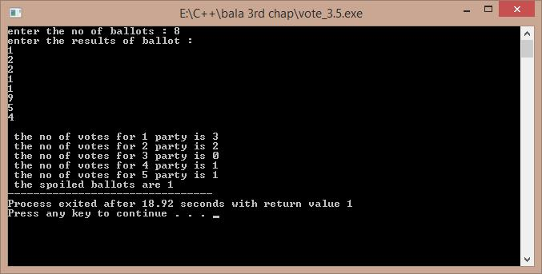

**3.6)**

ALGORITHM:-1)start

2)create a class which contains the data related to a player and functions

3)create a pointer in the main function to create a array of objects using new operator 4)input the values for each object and print them in a tabular form with the batting average 5)end

/*A program to tabulate the details of the cricket player with the batting average. Developed by Sekhar Karedla BE ¼ CSE-2,CBIT*/

#include<iostream> using namespace std; class player

{

char name[100]; int runs;

int inn; int t;

float avg;

public:

void getdata(); void display();

};

void player::getdata()

{

cout<<"enter name : "; cin>>name;

cout<<"enter runs , innings , times not out : "; cin>>runs>>inn>>t;

}

void player::display()

{

avg=float(1.0*runs/(inn-t)); cout<<name<<"\t\t"<<runs<<"\t"<<inn<<"\t"<<t<<"\t\t"<<avg<<"\n";

}

int main()

{

int n,i;

cout<<"\nenter the number of players : "; cin>>n;

player *p=new player[n];

cout<<"enter the details of "<<n<<" players : \n"; for(i=0;i<n;i++)

{

p[i].getdata();

}

cout<<"PLAYER NAME\t"<<"RUNS\t"<<"INNINGS\t"<<"TIMES NOT OUT\t"<<"AVERAGE\n"; for(i=0;i<n;i++)

{

p[i].display();

}

return 1;

}

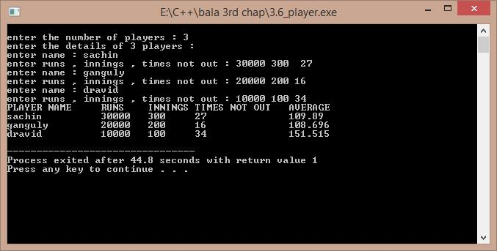

**3.7)a)**

ALGORITHM:-1)start

2)calculate the original value of sinx using cmath header file 3)calculate the sinx value obtained by eulers expansion 4)find the error and compare

5)end

/*A program to compare the original and obtained value of sinx , Developed by Sekhar Karedla CSE-2 BE ¼ ,CBIT*/

#include<iostream>

#include<math.h> using namespace std; int main()

{

long double s,t,x,i,j,n;

cout<<"enter x in degrees : "; //reading the degress cin>>x;

x=x*(3.141/180);

for(j=3;j<1000;j++)

{s=0;t=x;

for(i=2;i<=j;i++)

{

s=s+t;

t=t*-1*x*x/(2*(i-1)*(2*i-1)); //calculating sinx from euler formula

}

if(((s-sin(x))>-0.00000001)&&(s-sin(x))<0.00000001)

{

cout.precision(10);

cout<<"\nthe original value of sinx is : "<<sin(x); cout<<"\nthe obtained value of sinx is : "<<s; cout<<"\nthe order is : "<<j;

break;

}

}

return 1;

}

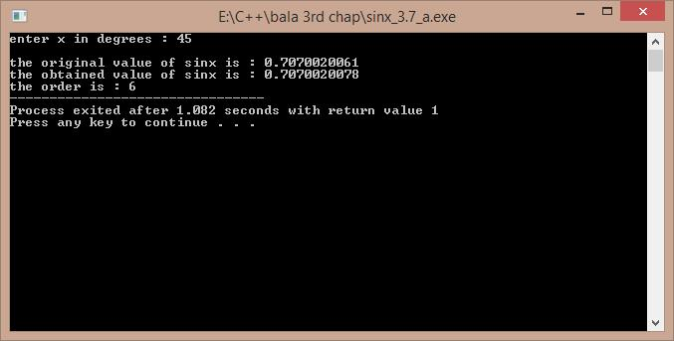

**3.7)b)**

ALGORITHM:-

1)reading the value of x from the user 2)calculating the sum using for loops 3)displaying the result

/*A program to calculate the sum of particular sequence , Developed by Sekhar Karedla CSE-2 BE ¼ ,CBIT*/

#include<iostream> using namespace std; int main()

{

float s,k,p,i,j,n,t;t=1; cout<<"enter N : "; cin>>n;p=1; for(i=1;i<=n;i++) {s=s+p;t=1;

for(j=0;j<i;j++)

{

t=t*(1/(i+1));

}

p=t;

}

cout.precision(10); cout<<"the sum is : "<<s;

return 1;

}

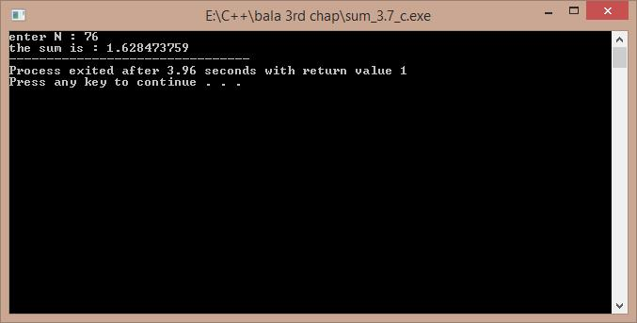

**3.7)c)**

ALGORITHM:-1)start

2)calculate the original value of cosx using cmath header file 3)calculate the cosx value obtained by eulers expansion 4)find the error and compare

5)end

/*A program to compare the original and obtained value of cosx , Developed by Sekhar Karedla CSE-2 BE ¼ ,CBIT*/

#include<iostream>

#include<math.h> using namespace std; int main()

{

float x,t,s,i,j;

cout<<"enter x in degrees : "; cin>>x;

x=x*(3.141/180);

for(j=0;j<1000;j++)

{

s=1;t=-(x*x)/2; for(i=0;i<=j;i=i+2)

{

s=s+t; t=t*-1*x*x/((i+3)*(i+4));

}

if(((s-cos(x))>-0.000001)&&((s-cos(x)<0.000001)))

{

cout.precision(10);

cout<<"\n the original value : "<<cos(x); cout<<"\n the obtained value : "<<s; cout<<"\n order : "<<j;

break;

}

}

return 1;

}

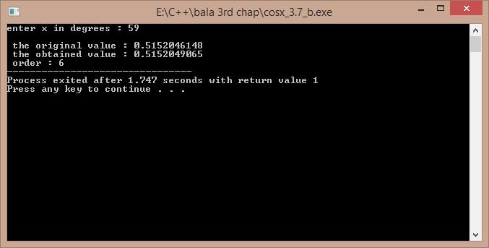

**3.8)**

ALGORITHM:-

1)start

2)we use two for loops for proper alignment

3)we store the results again in a file because viewing the results in the command prompt will cause the failure of alignment

4)we calculate the exp(-x) value for 0.1 increment

5)we store the values in a file

6)end

/*A program developed to show the results of exp(-x) in tabular form , Developed by Sekhar Karedla CSE-2 BE ¼ ,CBIT*/

#include<iostream>

#include<cmath>

using namespace std;

int main()

{

float i,j;float r;FILE *fp;int k;

fp=fopen("result3.8.txt","w"); //opening a file

fprintf(fp,"X"); fseek(fp,1,SEEK_SET);

for(i=0.1;i<=1.0;i=i+0.1) // setting the table headings fprintf(fp,"\t%f",i);

for(i=0.0;i<10.0;i=i+1.0)

{k=i;

fprintf(fp,"\n%d",k);

for(j=i+0.1;j<=i+0.9;j=j+0.1)

{

r=exp(-j);

fprintf(fp,"\t%f",r); // using fprintf to store the values in a file.

}

}

cout<<"\n the tabular form has been successfully stored in result3.8 ."; return 0;

}

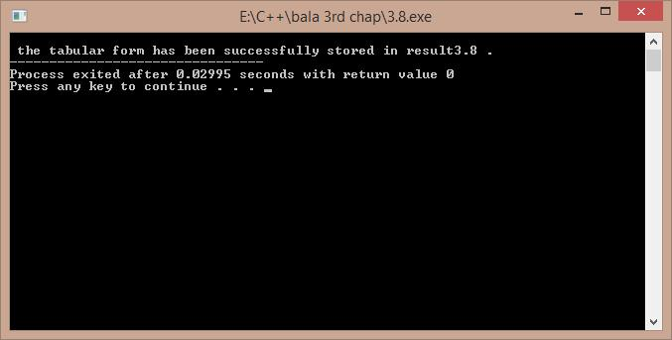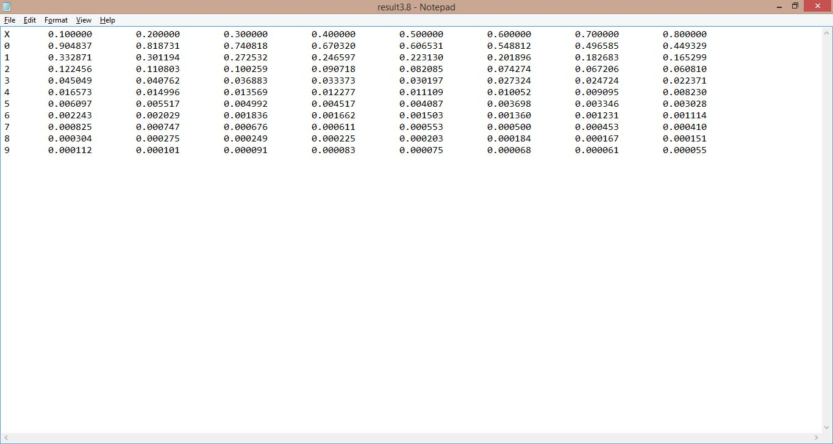

***THE CONTENTS OF THE RESULT3.8.txt:-***

|  |  |
| --- | --- |
| X | 0.100000 0.200000 0.300000 0.400000 0.500000 0.600000 0.700000 0.800000 |

1. 0.904837 0.818731 0.740818 0.670320 0.606531 0.548812 0.496585 0.449329
2. 0.332871 0.301194 0.272532 0.246597 0.223130 0.201896 0.182683 0.165299
3. 0.122456 0.110803 0.100259 0.090718 0.082085 0.074274 0.067206 0.060810
4. 0.045049 0.040762 0.036883 0.033373 0.030197 0.027324 0.024724 0.022371
5. 0.016573 0.014996 0.013569 0.012277 0.011109 0.010052 0.009095 0.008230
6. 0.006097 0.005517 0.004992 0.004517 0.004087 0.003698 0.003346 0.003028
7. 0.002243 0.002029 0.001836 0.001662 0.001503 0.001360 0.001231 0.001114
8. 0.000825 0.000747 0.000676 0.000611 0.000553 0.000500 0.000453 0.000410
9. 0.000304 0.000275 0.000249 0.000225 0.000203 0.000184 0.000167 0.000151
10. 0.000112 0.000101 0.000091 0.000083 0.000075 0.000068 0.000061 0.000055

**3.9)**

ALGORITHM:-

1)start

2)take the number of numbers input and create an array with new operator

3)input all number and take their sum , and hence calculate mean

4)use loops to calculate the variance by taking the difference from the mean 5)display the results

6)end

/* A program to calculate the standard deviation , variance , mean of the given numbers . Developed by Sekhar Karedla CSE-2 BE ¼ ,CBIT*/

#include<iostream>

#include<math.h> using namespace std; int main()

{

int n,s=0;

cout<<"enter the number of numbers : "; cin>>n;

int *p=new int[n]; int i;

cout<<"enter "<<n<<" numbers : "; for(i=0;i<n;i++)

{

cin>>p[i];

s=s+p[i];

}

float m,sd,v; m=(1.0/n)*s; float s1; for(i=0;i<n;i++)

{

s1=s1+((p[i]-m)*(p[i]-m));

}

sd=sqrt(s1);

v=sd*sd;

cout<<"\n\nvariance : "<<v<<"\nstandard deviation : "<<sd<<"\nmean : "<<m;

return 1;

}

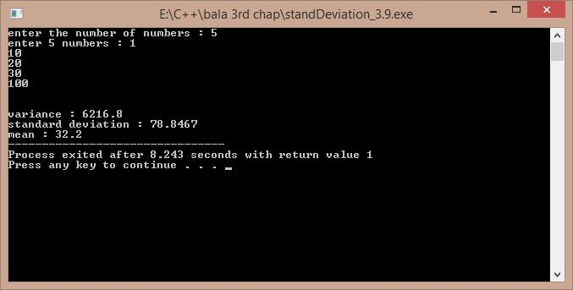

**3.10)**

ALGORITHM:-

1)start

2)input the number of units

3)use the given rates to compute the rate using if elseif statements

4)end

/* A program to calculate the current bill by the input of current units. Developed by Sekhar Karedla CSE-2 BE ¼ ,CBIT*/

#include<iostream>

using namespace std;

int main()

{

float u,sum;

cout<<"enter the units : "; //entering the units cin>>u;

if(u<100)

{

sum=u*60;

}

else if(u>100&&u<=300)

{

sum=(100*60)+(u-100)*80; //calculating the bill

}

else

{

sum=(100*60)+(200*80)+(u-300)*90;

}

sum=sum/100;

cout<<"the bill amount is : "<<sum<<" rupees"; return 1;

}

