**PROGRAMMING EXERCISE**

2.1)

#include<iostream> using namespace std; int main()

{

cout<<" Maths=90\n Physics=99\nChemistry=69"; return 1;

}

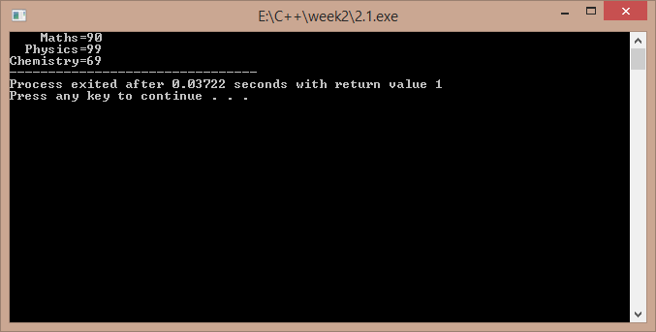

2.2)

#include<iostream> using namespace std; int main()

{

int a,b;

cout<<"enter two numbers : "; cin>>a>>b;

if(a>b)

cout<<"\nthe larger is "<<a; else

cout<<"\n the larger is "<<b; return 1;

}

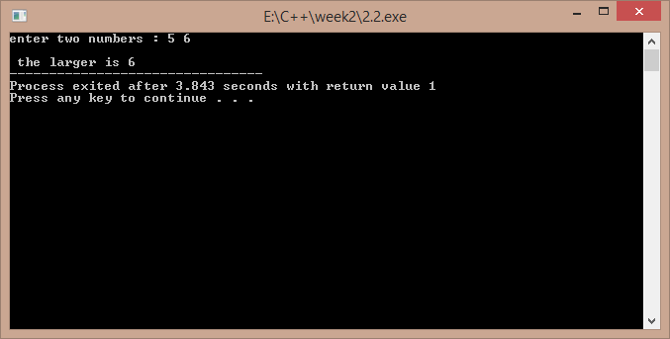

2.3)

#include<iostream> using namespace std; int main()

{

char ch;

cout<<"enter a character : "; cin>>ch;

cout<<"ASCII VALUE IS : "<<(int)ch;

return 1;

}

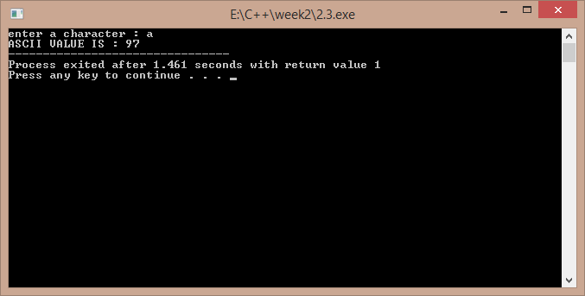

2.4)

#include<iostream> using namespace std; int main()

{

cout<<"enter a,b,c : "; int a,b,c,x; cin>>a>>b>>c;

x=a/b-c;

cout<<"\n the value of x is : "<<x; return 1;

}

a)

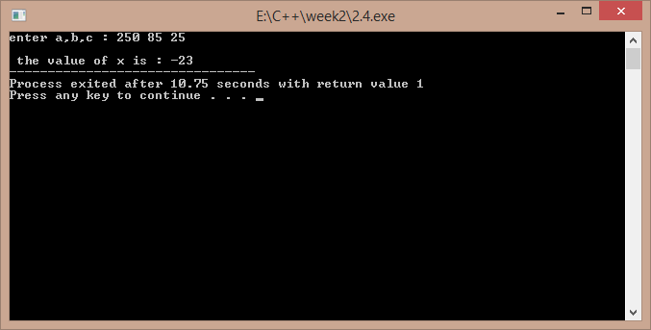

b)

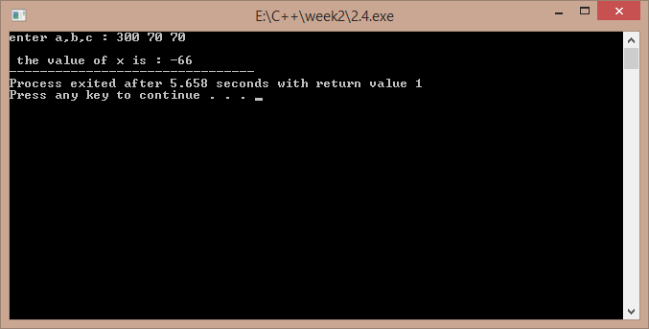

2.5)

#include<iostream>

using namespace std; int main()

{

float c,f;

cout<<"enter the temp in fahrenheit : "; cin>>f;

c=(5/9)*(f-32);

cout<<"temp in celsius is : "<<c; return 1;

}

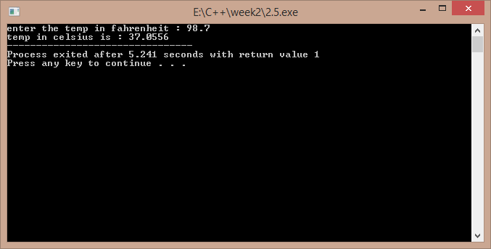

2.6)

#include<iostream> using namespace std; class temp

{

float f,c;

public:

void get(); void cel();

};

void temp::get()

{

cout<<"enter temp in fahrenheit : "; cin>>f;

}

void temp::cel()

{

c=5*(f-32)/9;

cout<<"temp in celcius is : "<<c;

}

int main()

{

temp t; t.get();

t.cel(); return 1;

}

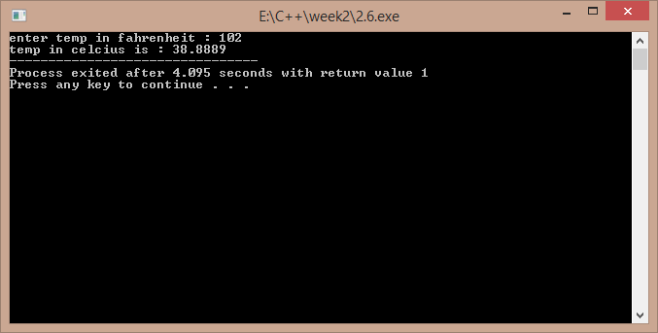

**DEBUGGING EXERCISE**

2.1)

#include<iostream> using namespace std; int main()

{

int i=0; i=i+1;

cout<<i<<͟ ͞;

/*comment\*/i=i+1; cout<<i;

}

‘ / ‘ should be removed from the 7th line

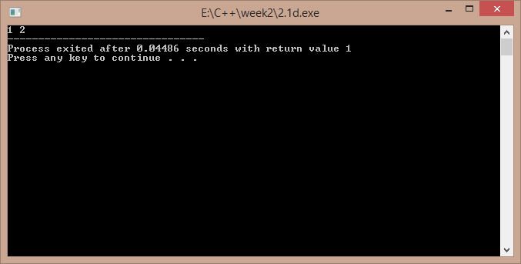

2.2)

#include<iostream> using namespace std; int main()

{

short i=2500,j=3000; cout<<"i+j="<<-(i+j);

return 1;

}

In 6th line insertion operator must be used , not the extraction operator ..

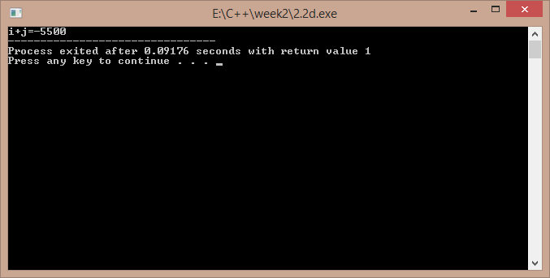

2.3)

#include<iostream> using namespace std; int main()

{

int i=10,j=5;

int modResult=0; int divResult=0; modResult=i%j;

cout<<modResult<<" "; divResult=i/modResult; cout<<divResult; return 1;

}

This code will generate a compiler error because in tenth line I is being divided by zero ..