## PROGRAMMING EXERCISE

**2.1)**

**//C++ program to print a desired output**

**#include<iostream>**

**using namespace std;**

**int main()**

**{**

**cout<<" Maths=90\n Physics=99\nChemistry=69";**

**return 1;**

**}**

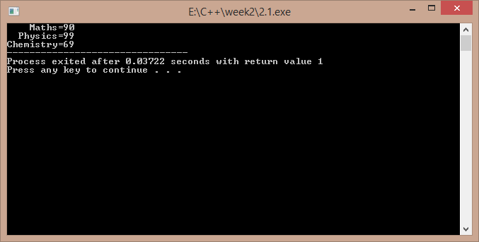

**2.2)**

**//a c++ program to find larger of two numbers**

**#include<iostream>**

**using namespace std;**

**int main()**

**{**

**int a,b;**

**cout<<"enter two numbers : ";**

**cin>>a>>b;**

**if(a>b)**

**cout<<"\nthe larger is "<<a;**

**else**

**cout<<"\n the larger is "<<b;**

**return 1;**

**}**

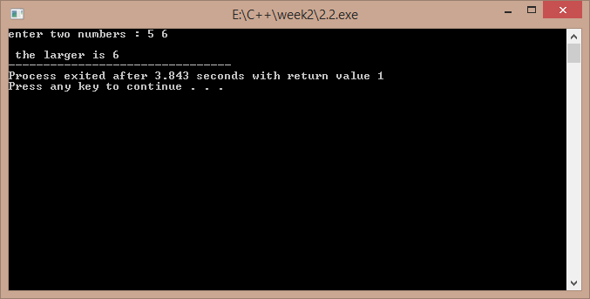

**2.3)**

**//c++ program to print the ascii value of a character**

**#include<iostream>**

**using namespace std;**

**int main()**

**{**

**char ch;**

**cout<<"enter a character : ";**

**cin>>ch;**

**cout<<"ASCII VALUE IS : "<<(int)ch;**

**return 1;**

**}**

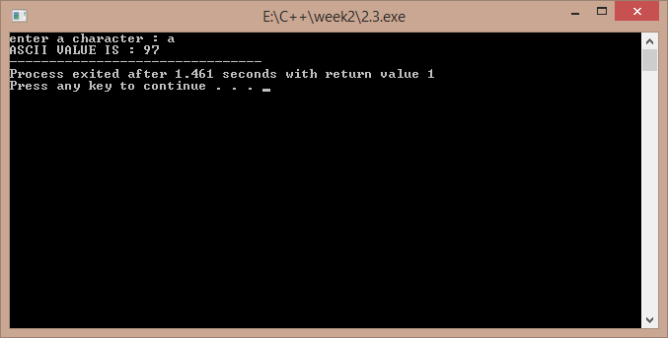

**2.4)**

**//c++ program to calculate an equation**

**#include<iostream>**

**using namespace std;**

**int main()**

**{**

**cout<<"enter a,b,c : ";**

**int a,b,c,x;**

**cin>>a>>b>>c;**

**x=a/b-c;**

**cout<<"\n the value of x is : "<<x;**

**return 1;**

**}**

**a)**

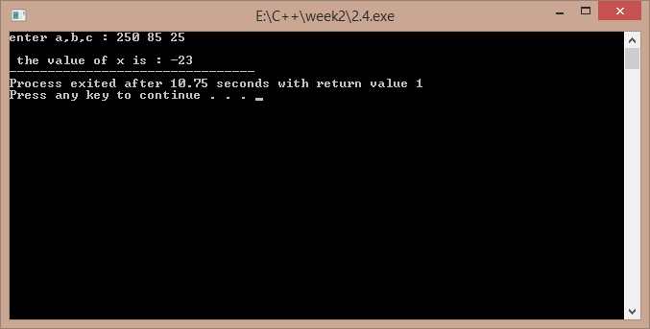

**b)**

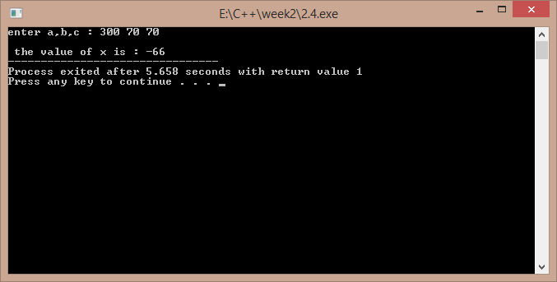

**2.5)**

**//c++ program to convert Fahrenheit to Celsius**

**#include<iostream>**

**using namespace std;**

**int main()**

**{**

**float c,f;**

**cout<<"enter the temp in fahrenheit : ";**

**cin>>f;**

**c=(5/9)*(f-32);**

**cout<<"temp in celsius is : "<<c;**

**return 1;**

**}**

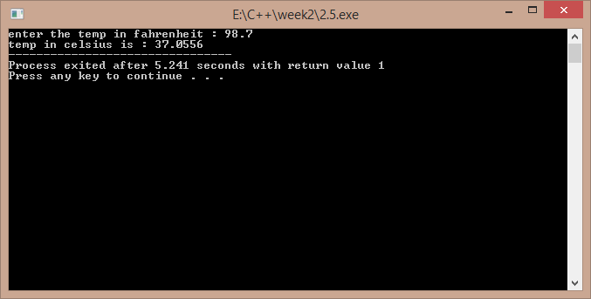

**2.6)**

**/*c++ program to convert Fahrenheit to Celsius**

**Using objects created from a class */**

**#include<iostream>**

**using namespace std;**

**class temp**

**{**

**float f,c;**

**public:**

**void get();**

**void cel();**

**};**

**void temp::get()**

**{**

**cout<<"enter temp in fahrenheit : ";**

**cin>>f;**

**}**

**void temp::cel()**

**{**

**c=5*(f-32)/9;**

**cout<<"temp in celcius is : "<<c;**

**}**

**int main()**

**{**

**temp t;**

**t.get();**

**t.cel();**

**return 1;**

**}**

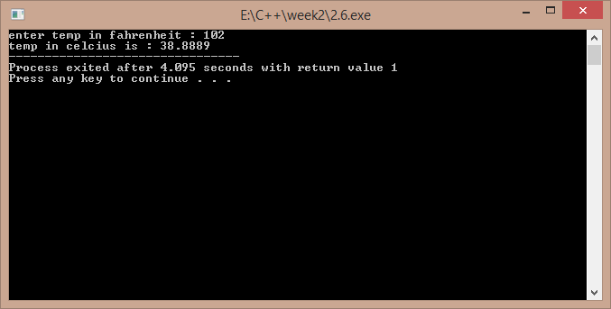

# DEBUGGING EXERCISE

**2.1)**

**#include<iostream>**

**using namespace std;**

**int main()**

**{  
 int i=0;**

**i=i+1;**

**cout<<i<<” “;**

**/*comment\*/i=i+1;**

**cout<<i;**

**}**

**‘ / ‘ should be removed from the 7th line**

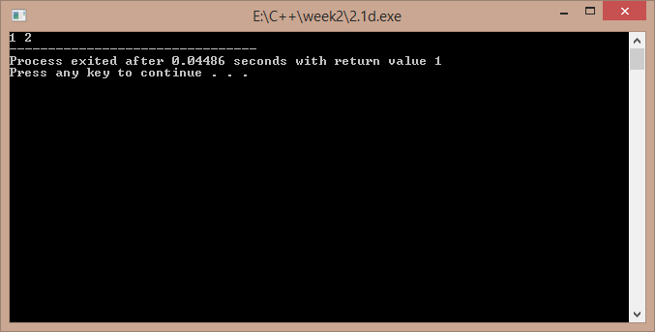

**2.2)**

**#include<iostream>**

**using namespace std;**

**int main()**

**{**

**short i=2500,j=3000;**

**cout<<"i+j="<<-(i+j);**

**return 1;**

**}**

**In 6th line insertion operator must be used , not the extraction operator ..**

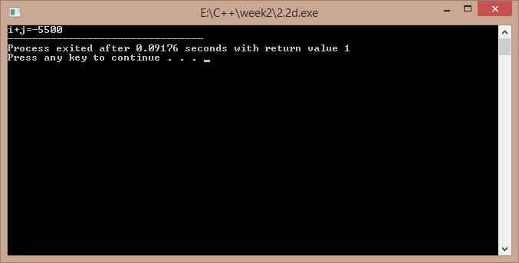

**2.3)**

**#include<iostream>**

**using namespace std;**

**int main()**

**{**

**int i=10,j=5;**

**int modResult=0;**

**int divResult=0;**

**modResult=i%j;**

**cout<<modResult<<" ";**

**divResult=i/modResult;**

**cout<<divResult;**

**return 1;**

**}**

**This code will generate a compiler error because in tenth line I is being divided by zero ..**