**1. INTRODUCTION**

**1.1 Purpose:**

Resources Present in college are usually very few and the requirements are very large in number. The main challenge for the person in authority is to allocate the requests reasonably and to make sure that no party is continuously rejected for some reason. Users on the other end have a hard time to make their requests manually by writing letters or any other form of written document. Hence in the system proposed a user friendly UI is designed where they can make requests easily, there will be proper means to store the previous history of allocations and there will means to make emergency requests.

**1.2 Scope:**

*Functionality Scope:*

* Create a user account by accepting information.
* Login to account and make requests.
* Maintaining a list of available resources and requests.

*Implementation Scope:*

The application is a web app so it is operation system independent. It is easier to run the software on any existing browser.

**1.3 Overview:**

This application enables users to create accounts with their details and access a list of available resources via those accounts. This makes reserving resources hassle-free and encourages students to use the college resources more often. Requests are added to overall requests table which is monitored by the admin , hence forth admin can make the necessary allotments.

**2. Literature Survey**

**2.1. Java Servlets**

**2.1.1. Introduction**

Servlet can be described in many ways, depending on the context.

* Servlet is a technology i.e. used to create web application.
* Servlet is an API that provides many interfaces and classes including documentations.
* Servlet is an interface that must be implemented for creating any servlet.
* Servlet is a class that extends the capabilities of the servers and respond to the incoming request. It can respond to any type of requests.
* Servlet is a web component that is deployed on the server to create dynamic web page.

**2.1.2. Java Servlets and Their Applications**

There are many advantages of servlet over CGI. The web container creates threads for handling the multiple requests to the servlet. Threads have a lot of benefits over the Processes such as they share a common memory area, lightweight, cost of communication between the threads are low. The basic benefits of servlet are as follows:

1. **Better performance:** because it creates a thread for each request not process.
2. **Portability:** because it uses java language.
3. **Robust:** Servlets are managed by JVM so we don't need to worry about memory leak, garbage collection etc.
4. **Secure:** because it uses java language.

**2.1.3. Architecture of Servlets**

**Servlet** technology is used to create web application (resides at server side and generates dynamic web page).**Servlet** technology is robust and scalable because of java language. Before Servlet, CGI (Common Gateway Interface) scripting language was popular as a server-side programming language. But there were many disadvantages of this technology. We have discussed these disadvantages below. There are many interfaces and classes in the servlet API such as Servlet, GenericServlet, HttpServlet, ServletRequest, ServletResponse, etc.

**2.2 Java Server Pages**

**JSP** technology is used to create web application just like Servlet technology. It can be thought of as an extension to servlet because it provides more functionality than servlet such as expression language, jstl, etc. A JSP page consists of HTML tags and JSP tags. The JSP pages are easier to maintain than servlet because we can separate designing and development. It provides some additional features such as Expression Language, Custom Tag etc.

Architecturally, JSP may be viewed as a high-level [abstraction](https://en.wikipedia.org/wiki/Abstraction_(computer_science)) of [Java servlets](https://en.wikipedia.org/wiki/Java_servlet). JSPs are translated into [servlets](https://en.wikipedia.org/wiki/Java_Servlet) at runtime; each JSP servlet is cached and re-used until the original JSP is modified.

JSP can be used independently or as the view component of a server-side [model–view–controller](https://en.wikipedia.org/wiki/Model%25E2%2580%2593view%25E2%2580%2593controller) design, normally with [JavaBeans](https://en.wikipedia.org/wiki/JavaBeans) as the model and Java servlets (or a framework such as [Apache Struts](https://en.wikipedia.org/wiki/Apache_Struts)) as the controller. This is a type of [Model 2](https://en.wikipedia.org/wiki/JSP_model_2_architecture) architecture.

JSP allows Java code and certain pre-defined actions to be interleaved with static web markup content, such as HTML, with the resulting page being compiled and executed on the server to deliver a document. The compiled pages, as well as any dependent Java libraries, contain Java bytecode rather than [machine code](https://en.wikipedia.org/wiki/Machine_code). Like any other Java program, they must be executed within a [Java virtual machine](https://en.wikipedia.org/wiki/Java_virtual_machine) (JVM) that interacts with the server's host [operating system](https://en.wikipedia.org/wiki/Operating_system) to provide an abstract, platform-neutral environment.

JSPs are usually used to deliver HTML and XML documents, but through the use of OutputStream, they can deliver other types of data as well.

The [Web container](https://en.wikipedia.org/wiki/Web_container) creates JSP implicit objects like pageContext, servletContext, session, request & response.

**2.3 JDBC Data Access**

Java JDBC is a java API to connect and execute query with the database. JDBC API uses

JDBC drivers to connect with the database. Before JDBC, ODBC API was the database API to connect and execute query with the database. But, ODBC API uses ODBC driver which is written in C language (i.e. platform dependent and unsecured). That is why Java has defined its own API (JDBC API) that uses JDBC drivers (written in Java language).

**3. SOFTWARE REQUIREMENT SPECIFICATIONS**

* **Software Requirements:**
* Operating System : Windows XP,7,8, Linux
* User Interface : Sublime Text Editor
* Programming Language : HTML,JSP,JAVA
* **Minimum Hardware Requirements:**
* Processor : 1.6 GHz processor
* RAM : 1 GB
* Operating System : Windows XP,7,8
* Disk Space : 1 GB

**4.DESIGN**

**(ER DIAGRAM)**

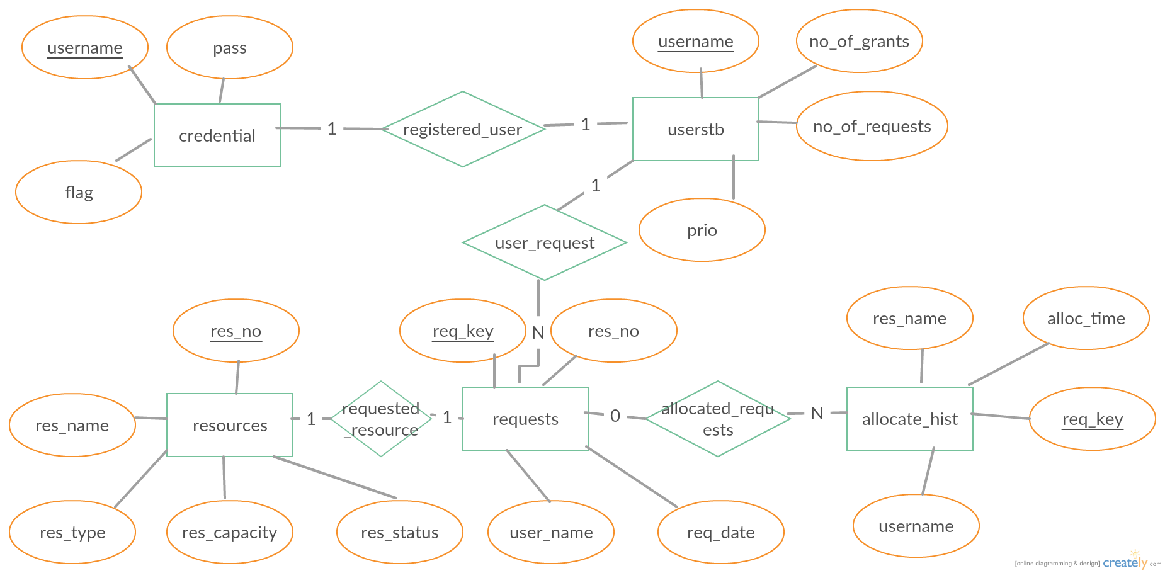

**(UML DIAGRAM)**

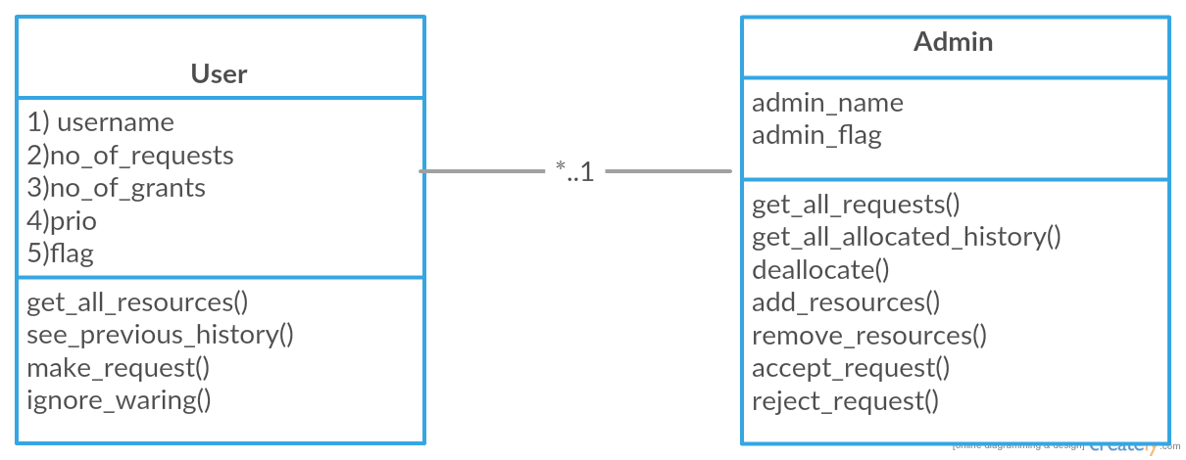

**5. IMPLEMENTATION**

**5.1 Module specification:**

The following web app is divided into two modules:

* Administrator: The administrator has the privileges to view the list of requests, registered users and the resources.
* User: This user has the privilege to request a resource after registering and logging in using username and password.

**5.1.1 Home Page:**

This page is common to both the administrator and user. This page has the options to login and register. Based on the login it is decided whether it is a user login or admin login.

**5.1.2 Administrator Account**

Administrator of this application has the privilege of viewing requests and all the data available in the database.

**Admin Page:**

After logging in using the correct username and password, administrator will be redirected to a page where he/she will be able to view all the data in the database like requests, allocate_hist, userstb. This page can be seen in fig.

The admin will be able to see all the previous requests and their status(accepted or rejected). To the admin all the requests will appear as a list , the admin will two options , either to reject the request or to allocate the request. Clicking on either button will take the admin to the corresponding message displaying page.

**Logout:-**

Pressing logout button terminates the session and takes the admin to the HOME PAGE.

**5.1.3 User Account**

User has the privilege to request a resource before hand by choosing a resource from the list of resources displayed.

**Register:**

To book a resource the user or student should be registered. To register user has to click on the register link on the home and enter all the details in the redirected page and click on register to register. This page can be seen in fig.

**Login:**

To login, the user should be registered before. After entering correct username and password, the user will be redirected to a page where a list of resources is displayed. Here the user can request the resource he/she needs by pressing the allocate button adjacent to request. On clicking that button, user is redirected to another page where message is displayed. This page and login page are shown in figs.

**Logout:**

On clicking on logout, the user will be redirected to the home page. The session gets terminated.

**Warning:-**

Warning page is shown to user if the requested resource has been already allocated on the same date. The user is further given two options, one is not to make a request, other is to make a request anyway , the user hence makes a urgent request. The admin has the ability to deallocate the resource for a user and allocate it for another user.

**5.2 Working**

The working of this web application involves fetching data from the database and comparing it with the entered data, updating the tables in database and performing different operations on it (CRUD operations). This is done with the help of using server side languages such as jsp and servlets which communicate with the database using JDBC connectivity.

We are also using session management to prevent unauthorized access of data and to maintain the session of the logged in user throughout the time.

1. **RESULT**

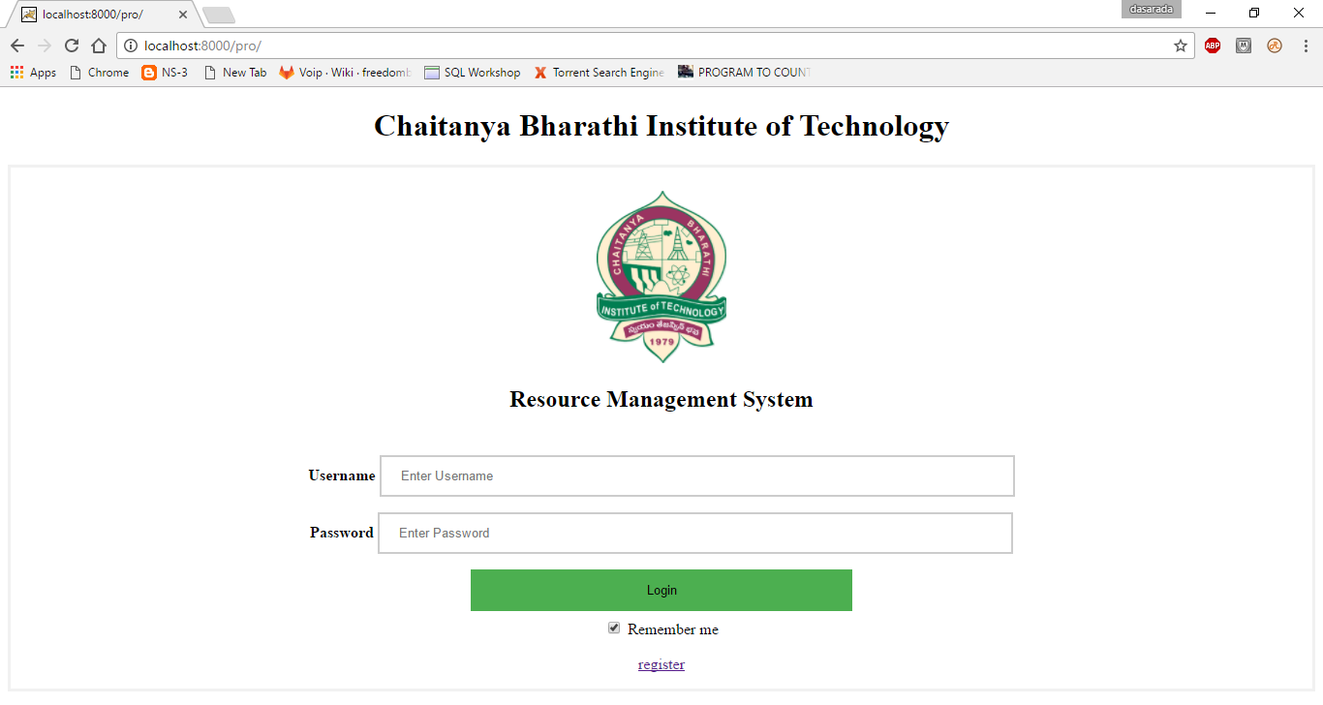

Fig 6.1 Home page for all users

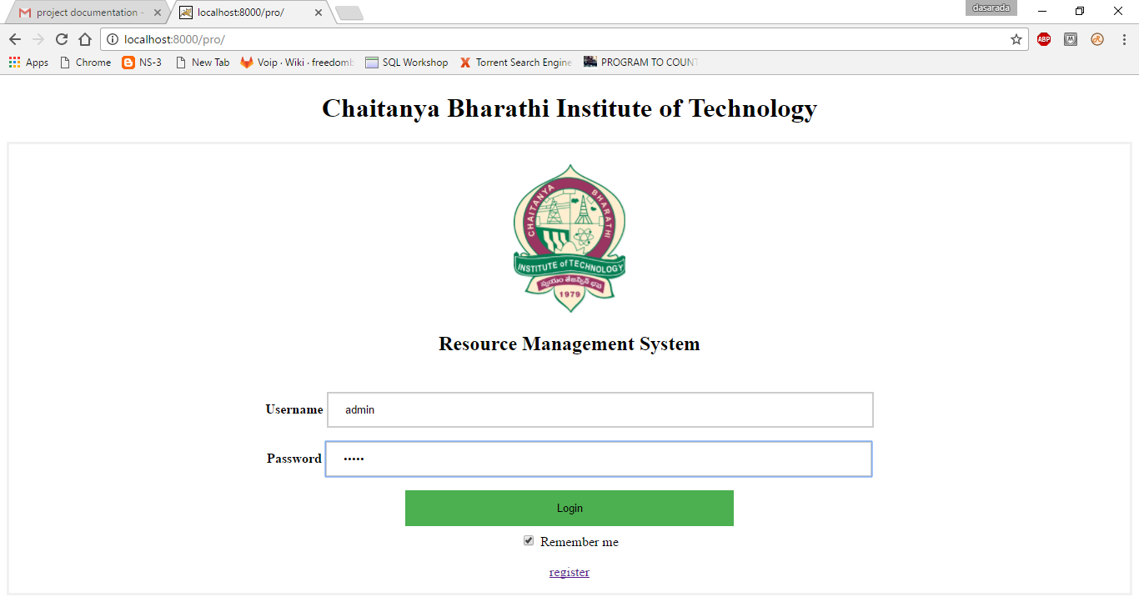

Fig 6.2 Admin Login page

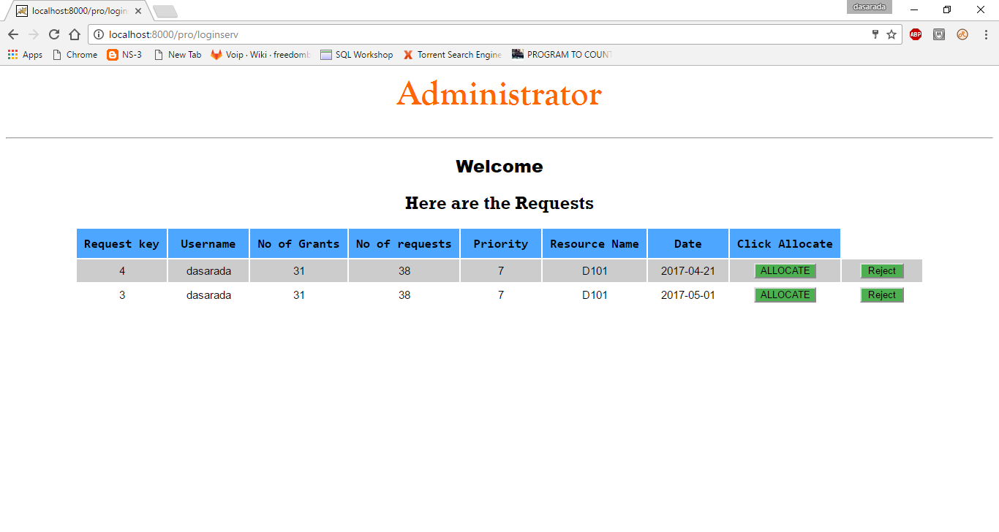

Fig 6.3 Admin page

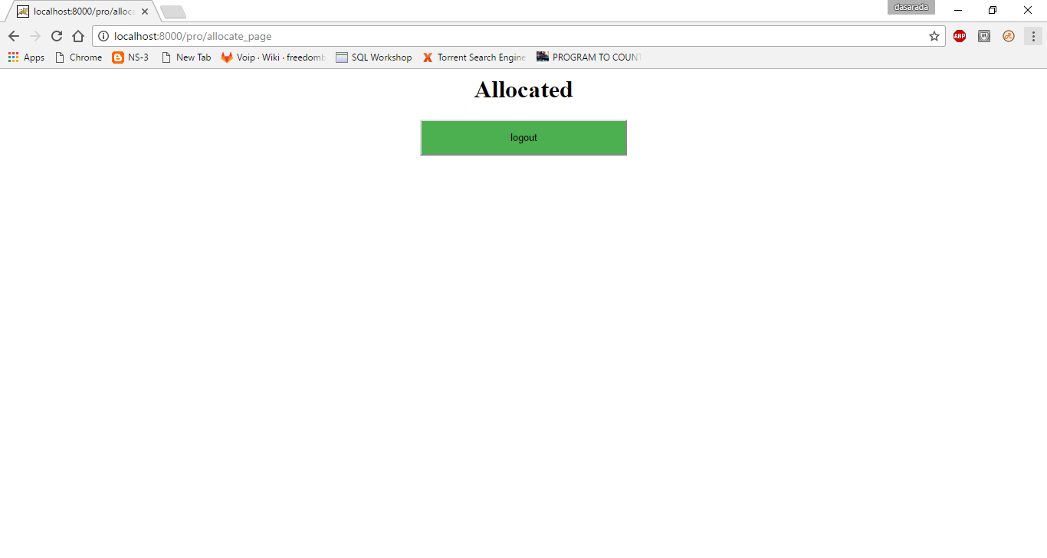

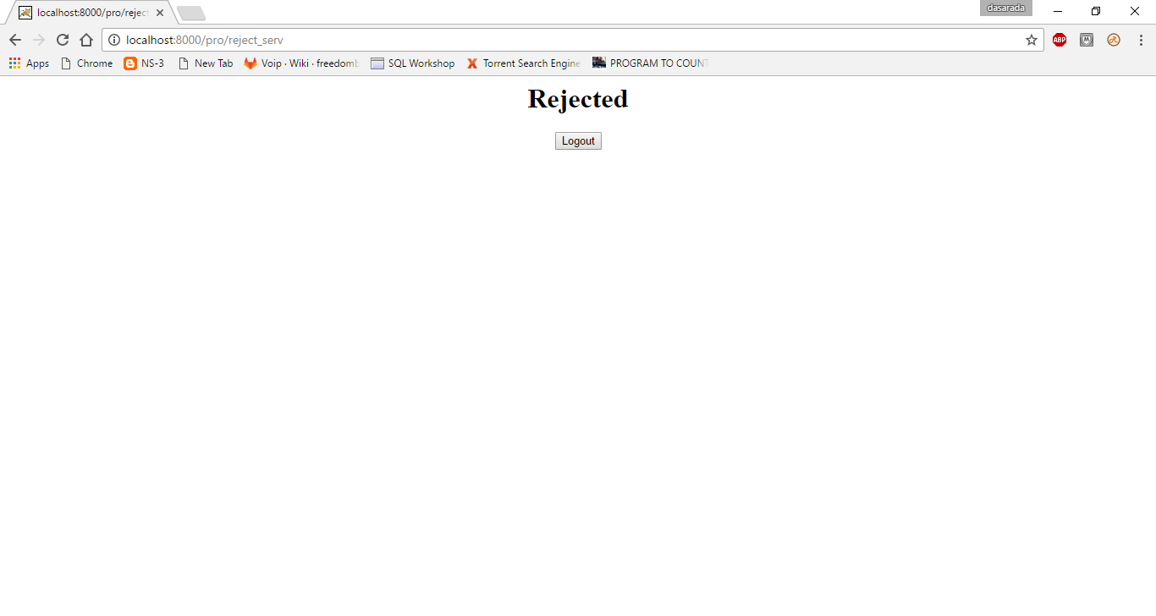

Fig 6.4 Admin logging out

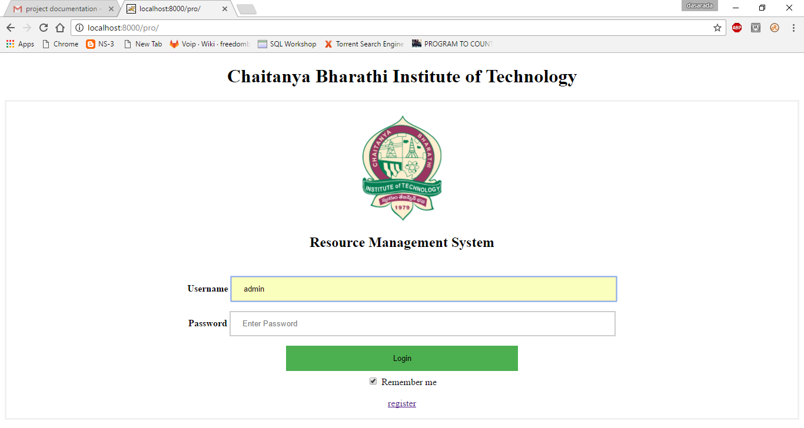

Fig 6.5 Admin redirected to home page after logging out

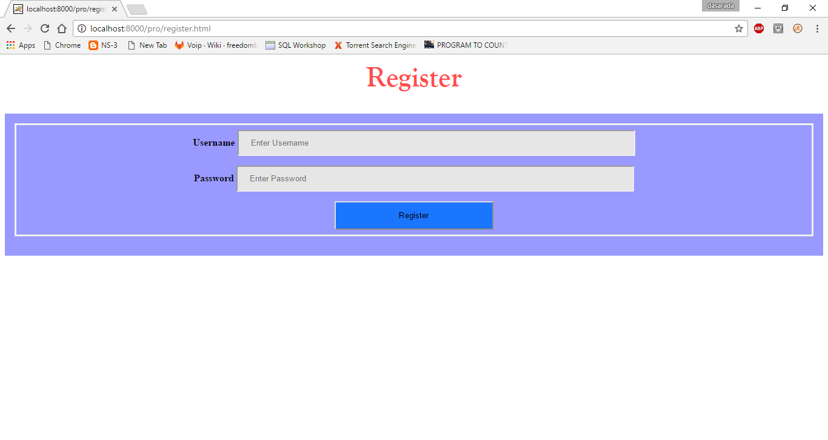

Fig 6.6 User Registration Page

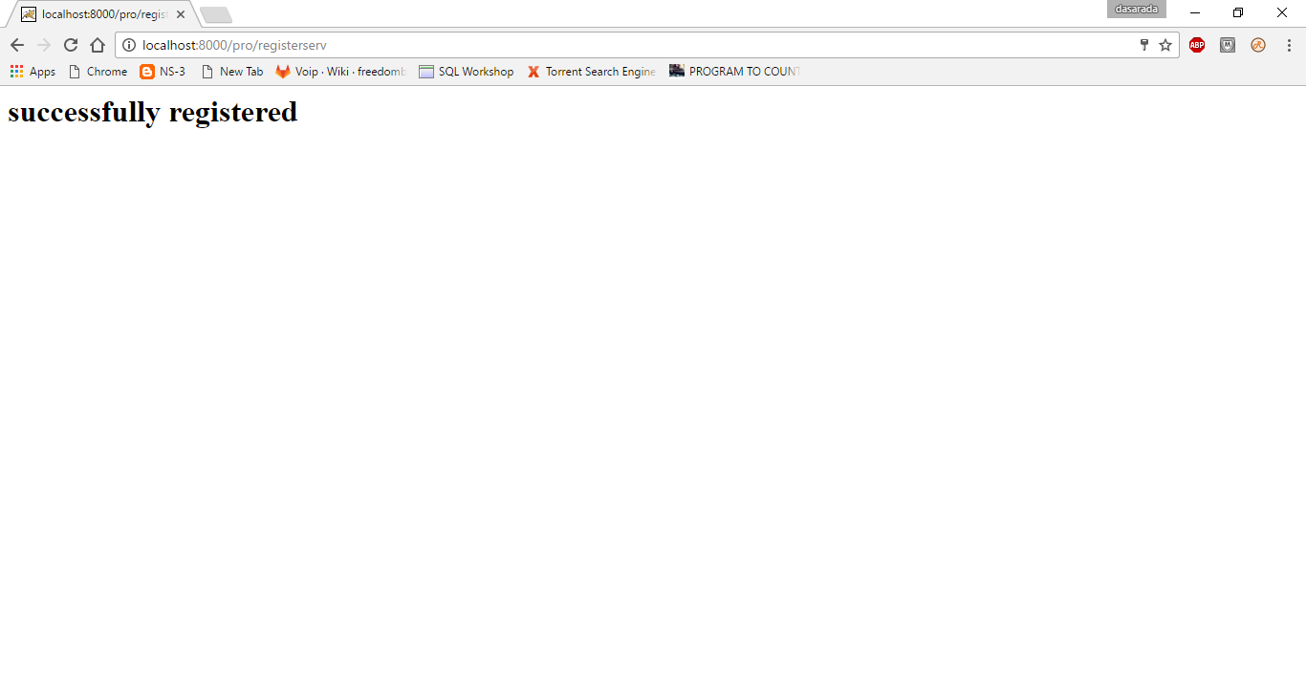

Fig 6.7 Successful User registration page

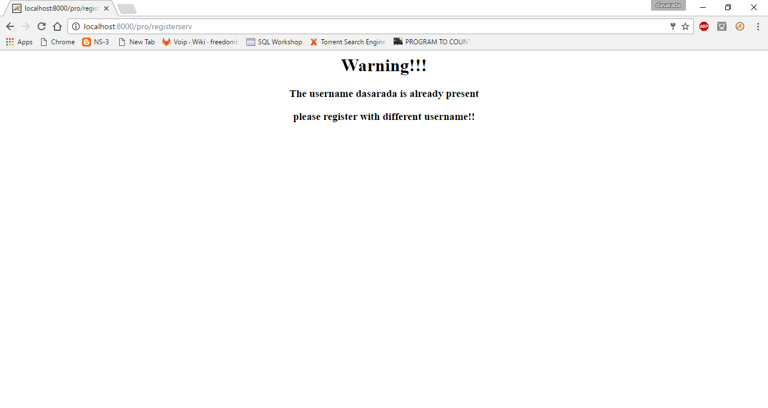

Fig 6.8 Register Page username warning

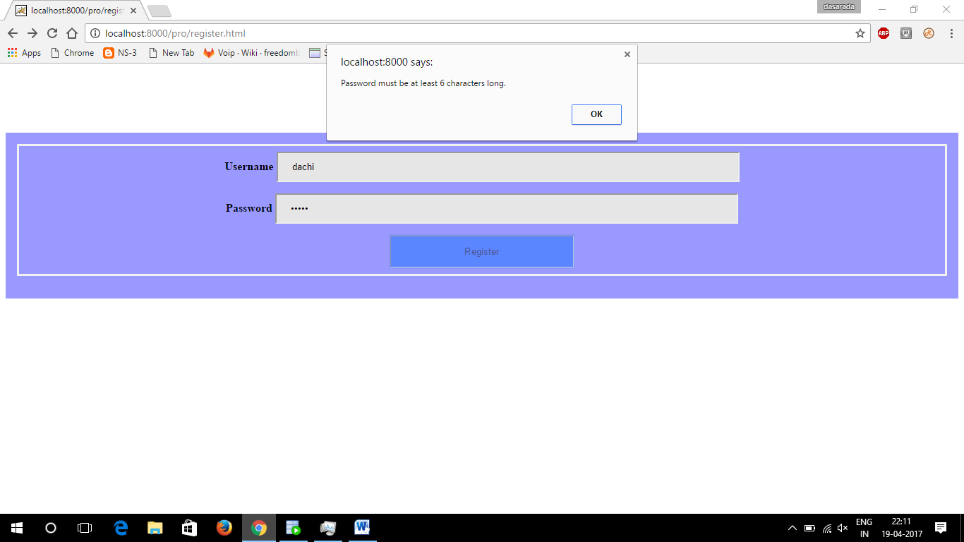

Fig 6.9 Register page Password warning

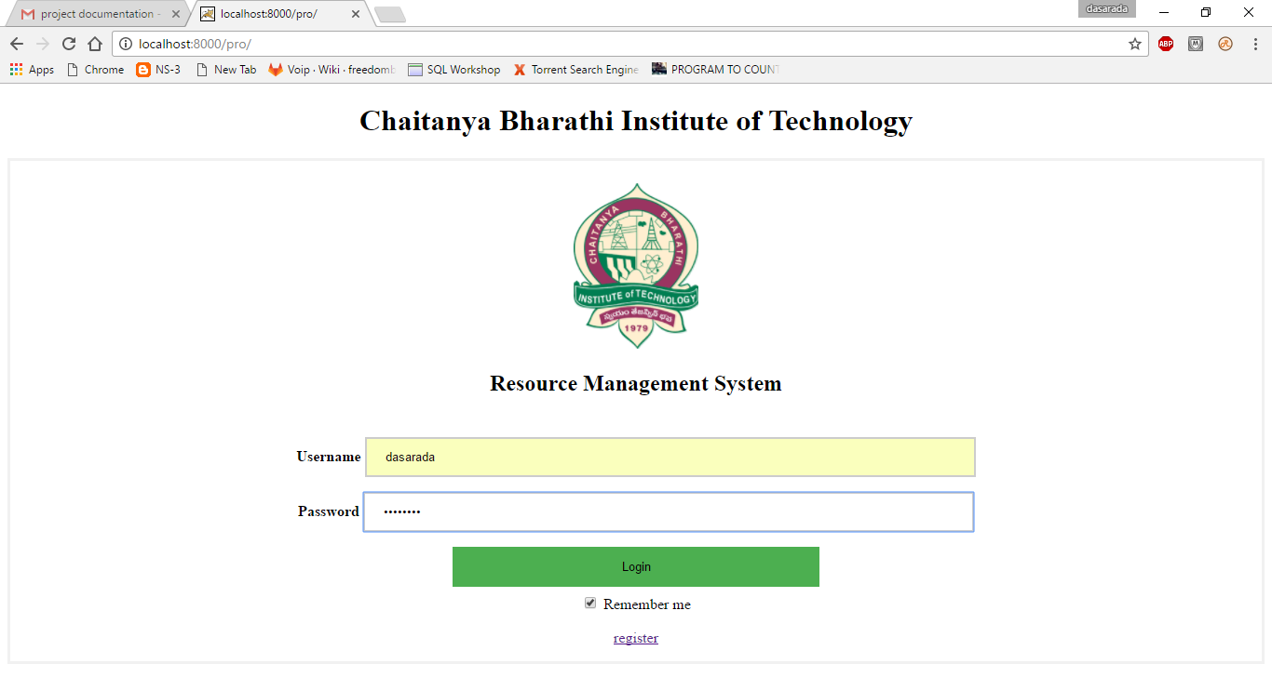

Fig 6.10 User Login page

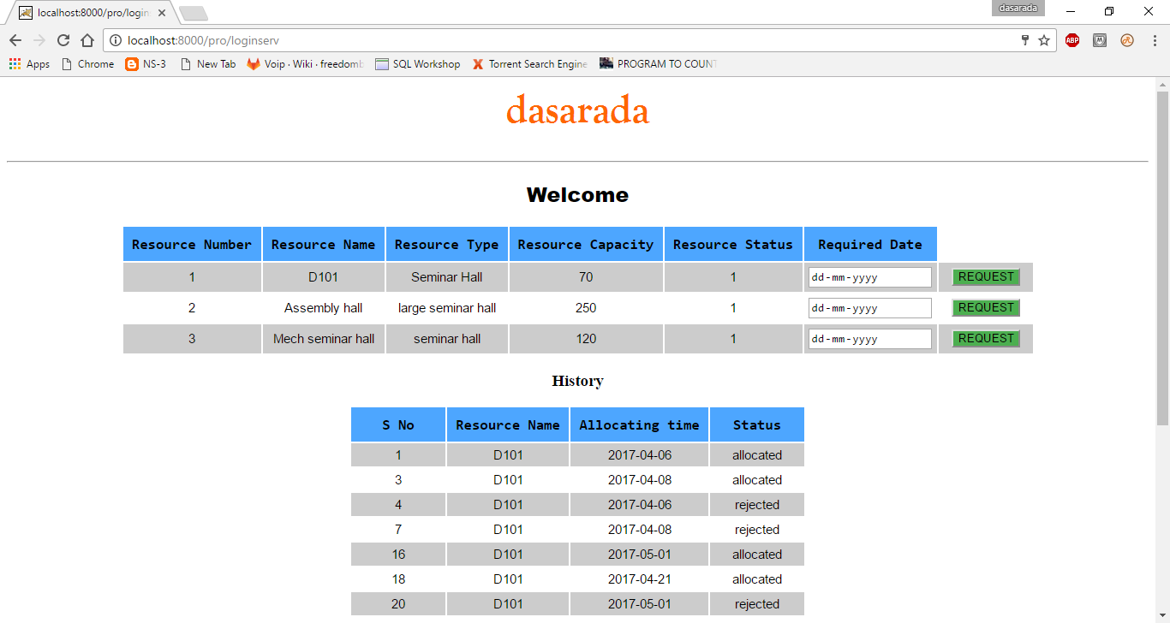

Fig 6.11 Requesting page

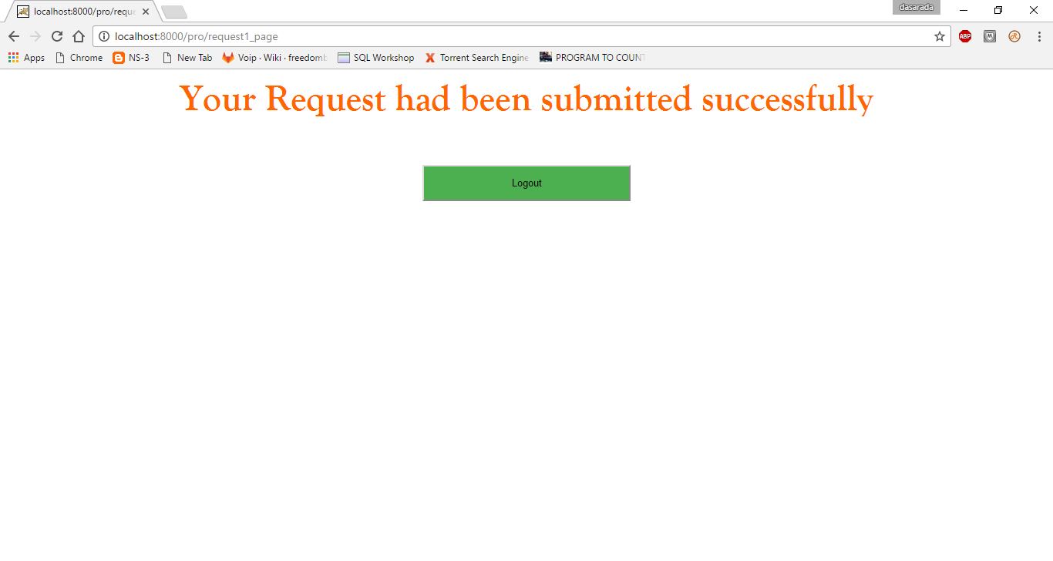

Fig 6.12 On successful booking

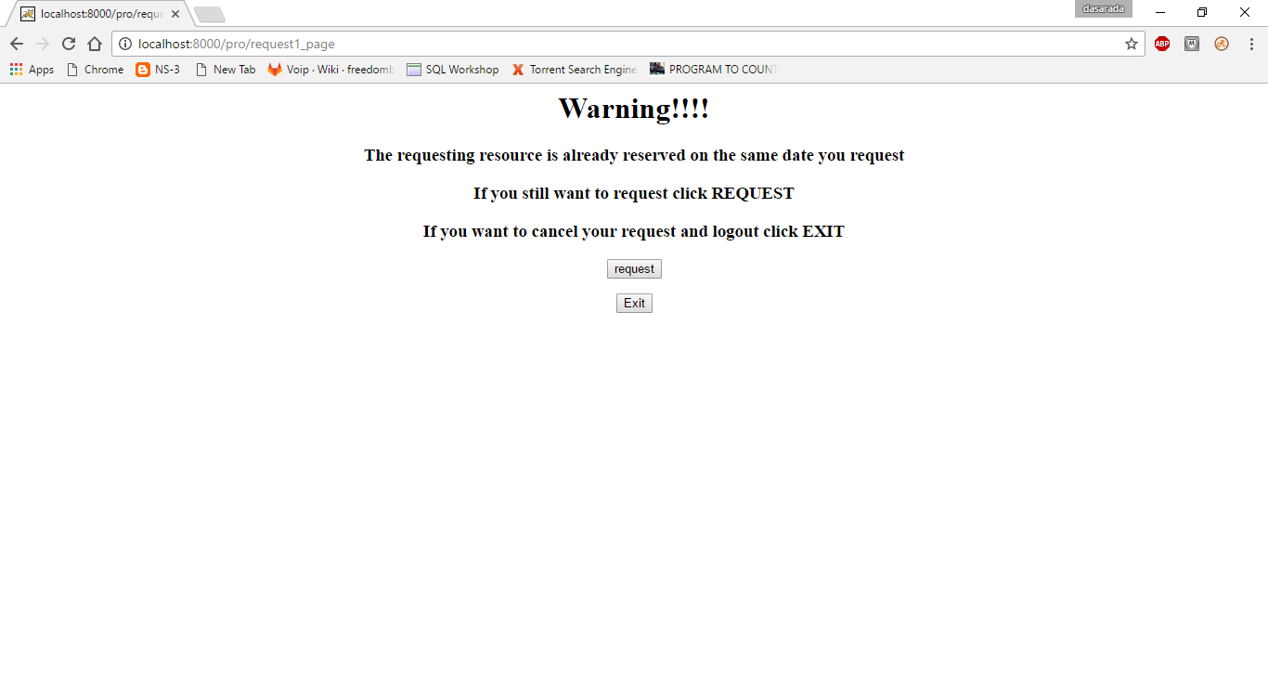

Fig 6.13 User Request warning page

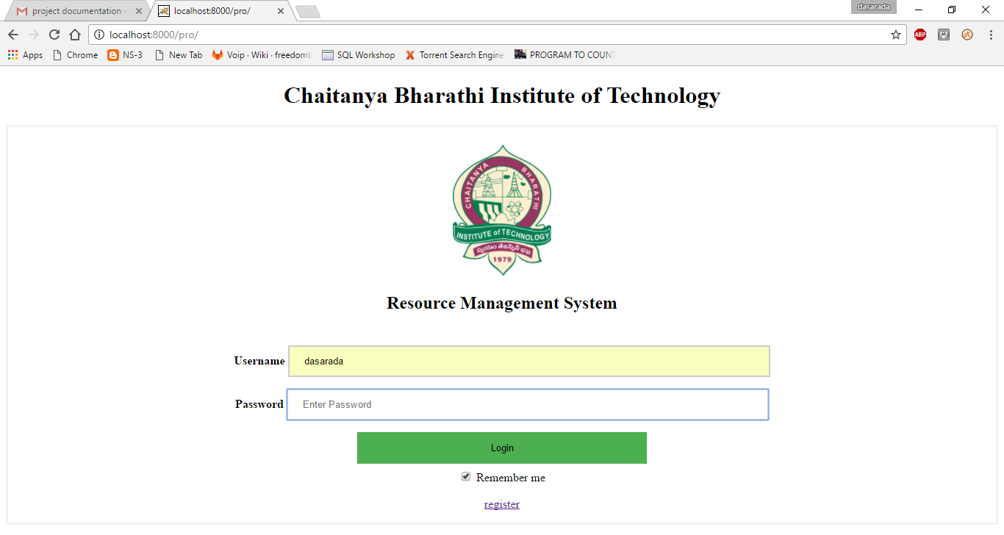

Fig 6.14 User redirected to home page after logging out.

**7. CONCLUSION**

Resource Management System is to automate the process of requesting and allocation of the available resources in an educational institution like Seminar Halls, Assembly Halls, Computer Labs, Canteen, Class rooms for various purpose such as Workshops, boot camps, guest lectures etc. This Automation is to reduce the hectic work of taking permissions of head of departments or concerned officials for various resources mentioned above, carrying request letters. It would save time of students and also avoids missing of classes for this work.

**8. BIBILOGRAPHY**

1. Tutorials Point.

http://www.tutorialspoint.com/

1. W3 Schools.

http://www.w3schools.com/

1. Code Academy.

https://www.codecademy.com/

1. Java Point.

http://www.javapoint.com/

1. Wikipedia

https://en.wikipedia.org/

1. Stack Overflow.

<https://www.stackoverflow.com/>

1. DBOracle.

http://www.dbaoracle.com/