PROGRAM:-

#include<stdio.h>
#include <netinet/in.h>
int main()
{
short s=0x56AB;
printf("value in deciaml:%d\n",s);
printf("big endian:%x\n",htons(s));
printf("little endian:%x\n",ntohs(htons(s)));
printf("final value : %d\n",ntohs(htons(s)));
}

OUTPUT:-
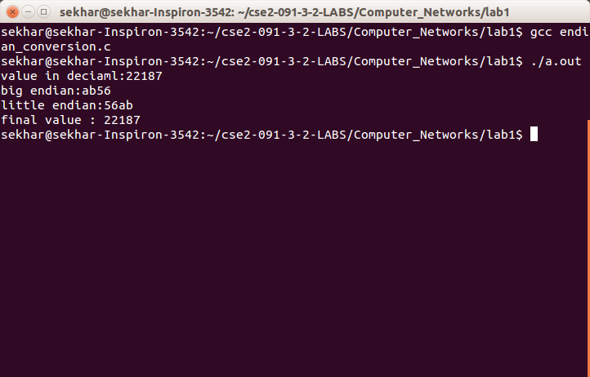

PROGRAM:-

SERVER:-

#include<stdio.h>
#include<netinet/in.h>
#include<sys/types.h>
#include<sys/socket.h>
void main(int argc,char *argv[])
{
char buf[100];
int s,len,n;
int sfd=socket(AF_INET,SOCK_STREAM,0);
struct sockaddr_in servaddr,client;
servaddr.sin_family=AF_INET;
servaddr.sin_port=htons(atoi(argv[1]));
servaddr.sin_addr.s_addr=inet_addr("192.168.0.104");
bind(sfd,(struct sockaddr*)&servaddr,sizeof(servaddr));
listen(sfd,5);
s=accept(sfd,(struct sockaddr*)&client,&len);
while(1)
{
n=recv(s,&buf,100,0);
buf[n]='\0';
if(n==0)
break;
printf("client: %s\n",buf);
int i;
for(i=0;buf[i]!='\0';i++)
buf[i]=toupper(buf[i]);
send(s,&buf,n,0);
}
close(sfd);
close(s);
}

CLIENT:-

#include<stdio.h>
#include<string.h>
#include<netinet/in.h>
#include<sys/types.h>
#include<sys/socket.h>
void main(int argc,char *argv[])
{
int sfd,s,len,n;char buf[100];
struct sockaddr_in servaddr,server;
sfd=socket(AF_INET,SOCK_STREAM,0);
servaddr.sin_family=AF_INET;
servaddr.sin_port=htons(atoi(argv[1]));
servaddr.sin_addr.s_addr=inet_addr("192.168.0.104");
connect(sfd,(struct sockaddr*)&servaddr,sizeof(servaddr));
int n1;
printf("enter the number of messages : ");
scanf("%d",&n1);int i;
for(i=0;i<n1;i++)
{
printf("enter a message :");
scanf("%s",buf);
n=strlen(buf);
send(sfd,&buf,n,0);
n=recv(sfd,&buf,100,0);
buf[n]='\0';
printf("%s\n",buf);
}
}
OUTPUT:-
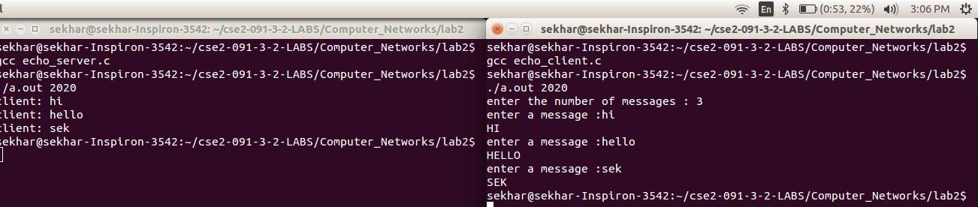
PROGRAM:-

SERVER:-

#include<stdlib.h>
#include<string.h>
#include<netinet/in.h>
#include<sys/types.h>
#include<sys/socket.h>
#include<stdio.h>
int main(int argc,char *argv[])
{
int sfd=socket(AF_INET,SOCK_DGRAM,0);
struct sockaddr_in s,server,client;int len,n,i,news,s1;
char buf[1000];
printf("before binding : ip %ld port no %d\n",(long)inet_ntoa(s.sin_addr),ntohs(s.sin_port));
s.sin_family=AF_INET;
s.sin_port=htons(atoi(argv[1]));
s.sin_addr.s_addr=inet_addr("192.168.0.104");
s1=bind(sfd,(struct sockaddr*)&s,sizeof(s));
while(1)
{
int temp=sizeof(client);
len=recvfrom(sfd,&buf,1000,0,(struct sockaddr *)&client,&temp);
printf("client = ");
printf("%s\n",buf);
printf("server = ");
scanf("%s",buf);
if(!strcmp(buf,"exit"))
{
printf("ENDING\n\nBYE");
exit(-1);
}
sendto(sfd,&buf,1000,0,(struct sockaddr *)&client,temp);
}
return 1;
}

CLIENT:-

#include<stdlib.h>
#include<string.h>
#include<netinet/in.h>
#include<sys/types.h>
#include<sys/socket.h>
#include<stdio.h>
int main(int argc,char *argv[])
{
int sfd=socket(AF_INET,SOCK_DGRAM,0);
struct sockaddr_in s,server,client;int len,n,i,news,s1;
char buf[1000];
//strcpy(buf,argv[2]);
//itoa(inet_ntoa(s.sin_addr),buf);
printf("before binding : ip %ld port no %d\n",(long)inet_ntoa(s.sin_addr),ntohs(s.sin_port));
s.sin_family=AF_INET;
s.sin_port=htons(atoi(argv[1]));
//s.sin_addr.s_addr=htonl(INADDR_ANY);
s.sin_addr.s_addr=inet_addr("192.168.0.104");
//printf("after inet : ip %ld port no %d\n",(long)inet_ntoa(s.sin_addr),ntohs(s.sin_port));
s1=bind(sfd,(struct sockaddr*)&s,sizeof(s));
client.sin_family=AF_INET;
client.sin_port=0;
client.sin_addr.s_addr=htonl(INADDR_ANY);
memset(client.sin_zero,'\0',sizeof(client.sin_zero));
bind(sfd,(struct sockaddr *)&client,sizeof(client));
int temp=sizeof(s);
while(1)
{
printf("client : ");
scanf("%s",buf);
if(!strcmp(buf,"exit"))
{
printf("ENDING \n\nBYE");
exit(-1);
}
//int temp=sizeof(client);
//len=recvfrom(sfd,&buf,1000,0,(struct sockaddr *)&client,&temp);
sendto(sfd,&buf,1000,0,(struct sockaddr *)&s,temp);
len=recvfrom(sfd,&buf,1000,0,(struct sockaddr *)&s,&temp);
buf[len]='\0';
printf("server = %s\n",buf);
//scanf("%s",buf);
}
return 1;
}

OUTPUT:-
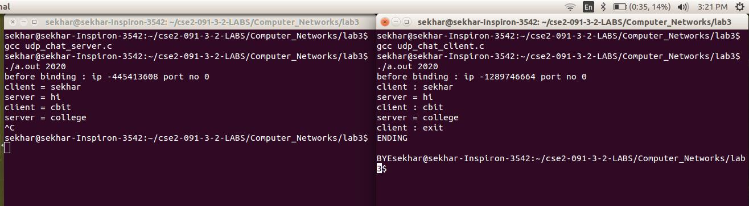

PROGRAM:-

from fractions import gcd
from random import randint
es=[]
def selecterandom(p,q):
phi=(p-1)*(q-1)
for i in range(3,phi):
if(gcd(i,phi)==1):
es.append(i)
print es
i=randint(0,len(es)-1)
print es[i]
return es[i]

p=input("enter p :")
q=input("enter q :")
n=p*q
phi=(p-1)*(q-1)
e=selecterandom(p,q)
#e=input("enter e :")
d=1
s=0
while(s!=1):
s=(d*e)%phi
d+=1;
d-=1
print("public key "+str(e)+" "+str(n))
print("private key "+str(d)+" "+str(n))

data=raw_input("enter the data to be encrypted : ")
list=[]
for k in data:
list.append(ord(k))
print list

print("encryption : ")
enc=[]
for k in list:
c=1
for m in range(0,e):
c=c*k
c=c%n
c=c%n
enc.append(c)
print enc
#output=''
#for k in enc:
# if output!='':
# output+=chr(k)
# else:
# output=chr(k)
#print output
print("decryption : ")
dec=[]
for k in enc:
c=1
for m in range(0,d):
c=c*k
c=c%n
c=c%n
dec.append(c)
print dec

output=''
for k in dec:
if output!='':
output+=chr(k)
else:
output=chr(k)
print output

OUTPUT:-

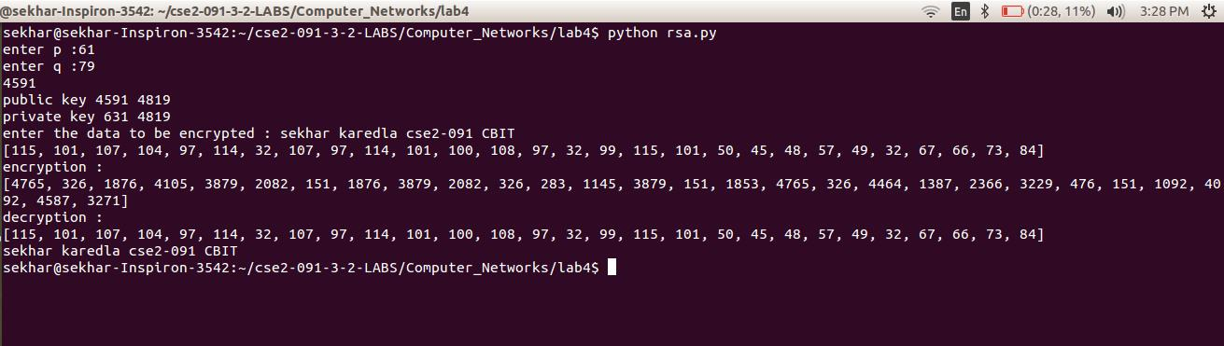

OUTPUT:-

