**PROGRAM:-**

**rpc_serv.py**

import xmlrpclib

from SimpleXMLRPCServer import SimpleXMLRPCServer

def is_even(n):

return n % 2 == 0

server = SimpleXMLRPCServer(("localhost", 8000))

print "Listening on port 8000..."

server.register_function(is_even, "is_even")

server.serve_forever()

**rpc_client.py**

import xmlrpclib

proxy = xmlrpclib.ServerProxy("http://localhost:8000/")

k=input("enter number:")

if proxy.is_even(k):

ans="even"

else:

ans="odd"

print str(k)+" is "+ans

**OUTPUT:-**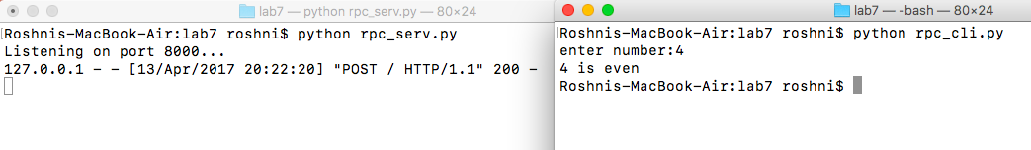

**PROGRAM:-**

**Bellmanford.c**

#include<stdio.h>

struct node

{

unsigned dist[20];

unsigned from[20];

}

rt[10];

int main()

{

int costmat[20][20];

int nodes,i,j,k,count=0;

printf("\nEnter the number of nodes :");

scanf(" %d",&nodes);

//Enter the nodes

printf("\nEnter the cost matrix :\n");

for(i=0;i<nodes;i++)

{

for(j=0;j<nodes;j++)

{

scanf(" %d",&costmat[i][j]);

costmat[i][i]=0;

rt[i].dist[j]=costmat[i][j];

//initialise the distance equal to cost matrix

rt[i].from[j]=j;

}

}

do

{

count=0;

//We choose arbitary vertex k and we calculate the direct distance from the node i to k using the cost matrix

//and add the distance from k to node j

for(i=0;i<nodes;i++)

for(j=0;j<nodes;j++)

for(k=0;k<nodes;k++)

if(rt[i].dist[j]>costmat[i][k]+rt[k].dist[j])

{

//We calculate the minimum distance

rt[i].dist[j]=rt[i].dist[k]+rt[k].dist[j];

rt[i].from[j]=k;

count++;

}

}while(count!=0);

for(i=0;i<nodes;i++)

{

printf("\n\nFor router %d\n",i+1);

printf("------------------------------------");

printf("\n|Destination\t|Via\t|Distance|");

printf("\n------------------------------------");

for(j=0;j<nodes;j++)

{

printf("\n|%d\t\t|%d\t|\t%d|",j+1,rt[i].from[j]+1,rt[i].dist[j]);

printf("\n____________________________________");

}

}

printf("\n\n");

return 0;

}

**OUTPUT:-**

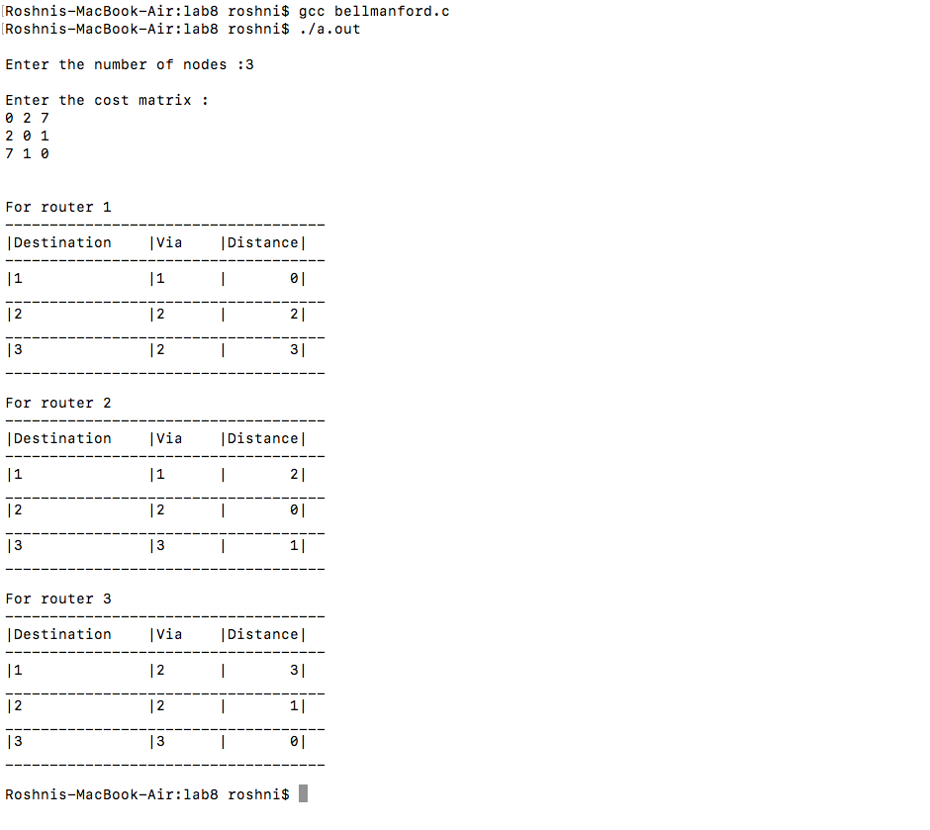

**PROGRAM:-**

**Djikstra.c**

#include<stdio.h>

//#include<process.h>

#include<string.h>

#include<math.h>

#define IN 99

#define N 6

int dijkstra(int cost[][N], int source, int target);

int main()

{

int cost[N][N],i,j,w,ch,co;

int source, target,x,y;

printf("\t The Shortest Path Algorithm ( DIJKSTRA'S ALGORITHM in C \n\n");

for(i=1;i< N;i++)

for(j=1;j< N;j++)

cost[i][j] = IN;

for(x=1;x< N;x++)

{

for(y=x+1;y< N;y++)

{

printf("Enter the weight of the path between nodes %d and %d: ",x,y);

scanf("%d",&w);

cost [x][y] = cost[y][x] = w;

}

printf("\n");

}

printf("\nEnter the source:");

scanf("%d", &source);

printf("\nEnter the target:");

scanf("%d", &target);

co = dijkstra(cost,source,target);

printf("\nThe Shortest Path: %d\n",co);

}

int dijkstra(int cost[][N],int source,int target)

{

int dist[N],prev[N],selected[N]={0},i,m,min,start,d,j;

char path[N],rev[N];

for(i=1;i< N;i++)

{

dist[i] = IN;

prev[i] = -1;

}

start = source;

selected[start]=1;

dist[start] = 0;

while(selected[target] ==0)

{

min = IN;

m = 0;

for(i=1;i< N;i++)

{

d = dist[start] +cost[start][i];

if(d< dist[i]&&selected[i]==0)

{

dist[i] = d;

prev[i] = start;

}

if(min>dist[i] && selected[i]==0)

{

min = dist[i];

m = i;

}

}

start = m;

selected[start] = 1;

}

start = target;

j = 0;

while(start != -1)

{

path[j++] = start+65;

start = prev[start];

}

path[j]='\0';

//strrev(path);

for(i=0;i<j;i++)

{

rev[i]=path[j-i];

}

printf("%s", path);

return dist[target]; }

**OUTPUT;-**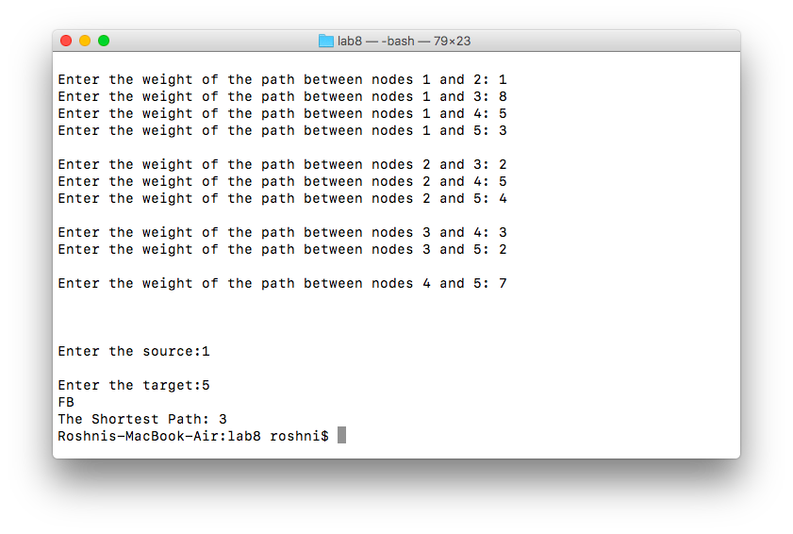

**PROGRAM:-**

slid_serv.c

#include<stdio.h>

#include<sys/socket.h>

#include<sys/types.h>

#include<netinet/in.h>

#include<string.h>

#include<stdlib.h>

#include<arpa/inet.h>

#define SIZE 4

int main(int argc, char *argv[])

{

int sfd,s,nsfd,len,i,j,status;

char str[100],frame[100],temp[100],ack[20];

struct sockaddr_in sa,ca;

sfd=socket(AF_INET,SOCK_STREAM,0);

//window size

if(sfd<0)

{

perror("Error");

exit(-1);

}

bzero(&sa,sizeof(sa));

sa.sin_family=AF_INET;

sa.sin_addr.s_addr=htonl(INADDR_ANY);

sa.sin_port=htons(atoi(argv[1]));

s=bind(sfd,(struct sockaddr*)&sa,sizeof(sa)); //assign a name to the server

if(s<0)

{

perror("Bind Error");

exit(-1);

}

listen(sfd,5);

len=sizeof(&ca);

nsfd=accept(sfd,(struct sockaddr*)&ca,&len); //take a connection request

printf(" Enter the text : ");

scanf("%s",&str);

//read a string to be transmitted

i=0;

while(i<strlen(str))

{

memset(frame,0,100);

strncpy(frame,str+i,SIZE);

//generate a frame

write(1," Transmitting Frames: ",23);

len=strlen(frame);

for(j=0;j<len;j++)

{

sprintf(temp," %d ",j+status);

strcat(frame,temp);

}

write(nsfd,&frame,sizeof(frame)); //Retransmit the error frame

}

i+=SIZE;

}

write(nsfd,"exit",sizeof("exit"));

printf("\nExiting.............\n");

sleep(2);

close(nsfd);

close(sfd);

return 0;

//End of transmission

}

slid_client.c

#include<stdio.h>

#include<string.h>

#include<stdlib.h>

#include<sys/socket.h>

#include<sys/types.h>

#include<netinet/in.h>

int main(int argc, char *argv[])

{

int sfd,lfd,len,choice,s,n;

char str[100],str1[100],err[100];

struct sockaddr_in saddr,caddr;

sfd=socket(AF_INET,SOCK_STREAM,0); //create an unnamed TCP socket

if(sfd<0)

{

perror("FdError");

exit(-1);

}

bzero(&saddr,sizeof(saddr));

saddr.sin_family=AF_INET;

//initialize the server address buffer

saddr.sin_addr.s_addr=inet_addr("127.0.0.1");

saddr.sin_port=htons(atoi(argv[1]));

s=connect(sfd,(struct sockaddr*)&saddr,sizeof(saddr));//connect to the sender

if(s<0)

{

perror("connect error");

exit(-1);

}

for(;;)

{

n=recv(sfd,&str,100,0);

//read the frames from the sender

if(!strncmp(str,"exit",4))

{

printf("Exiting.............\n");

break;

}

str[n]='\0';

printf("\nReceived message is: %s\n Are there any errors?(1-Yes 0-No): ",str);

scanf("%d",&choice);

if(!choice)

write(sfd,”-1",sizeof("-1"));

else

{

printf("Enter the sequence no of the frame where error has occured: ");

scanf("%s",&err);

write(sfd,&err,sizeof(err));

n=read(sfd,&str,20);

str[n]='\0';

printf("\n\nReceived the re-transmitted frames: %s\n\n",str);

}

}

}

**OUTPUT:-**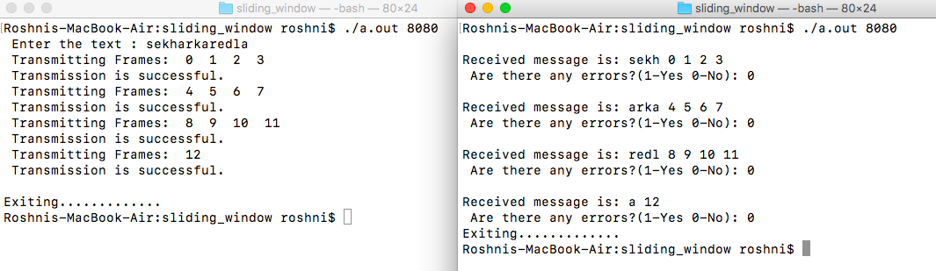

**PROGRAM:-**

ftp_serv.c

#include <sys/socket.h>

#include <netinet/in.h>

#include <string.h>

#include <stdio.h>

#include <stdlib.h>

/*for getting file size using stat()*/

#include<sys/stat.h>

/*for sendfile()*/

#include<sys/sendfile.h>

/*for O_RDONLY*/

#include<fcntl.h>

int main(int argc,char *argv[])

{

struct sockaddr_in server, client;

struct stat obj;

int sock1, sock2;

char buf[100], command[5], filename[20];

int k, i, size, len, c;

int filehandle;

sock1 = socket(AF_INET, SOCK_STREAM, 0);

if(sock1 == -1)

{

printf("Socket creation failed");

exit(1);

}

server.sin_family=AF_INET;

server.sin_port = htons(atoi(argv[1]));

server.sin_addr.s_addr = htonl(INADDR_ANY);

k = bind(sock1,(struct sockaddr*)&server,sizeof(server));

if(k == -1)

{

printf("Binding error");

exit(1);

}

k = listen(sock1,1);

if(k == -1)

{

printf("Listen failed");

exit(1);

}

len = sizeof(client);

sock2 = accept(sock1,(struct sockaddr*)&client, &len);

i = 1;

while(1)

{

recv(sock2, buf, 100, 0);

sscanf(buf, "%s", command);

if(!strcmp(command, "ls"))

{

system("ls >temps.txt");

i = 0;

stat("temps.txt",&obj);

size = obj.st_size;

send(sock2, &size, sizeof(int),0);

filehandle = open("temps.txt", O_RDONLY);

sendfile(sock2,filehandle,NULL,size);

}

else if(!strcmp(command,"get"))

{

sscanf(buf, "%s%s", filename, filename);

stat(filename, &obj);

filehandle = open(filename, O_RDONLY);

size = obj.st_size;

if(filehandle == -1)

size = 0;

send(sock2, &size, sizeof(int), 0);

if(size)

sendfile(sock2, filehandle, NULL, size);

}

else if(!strcmp(command, "put"))

{

int c = 0, len;

char *f;

sscanf(buf+strlen(command), "%s", filename);

recv(sock2, &size, sizeof(int), 0);

i = 1;

while(1)

{

filehandle = open(filename, O_CREAT | O_EXCL | O_WRONLY, 0666);

if(filehandle == -1)

{

sprintf(filename + strlen(filename), "%d", i);

}

else

break;

}

f = malloc(size);

recv(sock2, f, size, 0);

c = write(filehandle, f, size);

close(filehandle);

send(sock2, &c, sizeof(int), 0);

}

else if(!strcmp(command, "pwd"))

{

system("pwd>temp.txt");

i = 0;

FILE*f = fopen("temp.txt","r");

while(!feof(f))

buf[i++] = fgetc(f);

buf[i-1] = '\0';

fclose(f);

send(sock2, buf, 100, 0);

}

else if(!strcmp(command, "cd"))

{

if(chdir(buf+3) == 0)

c = 1;

else

c = 0;

send(sock2, &c, sizeof(int), 0);

}

else if(!strcmp(command, "bye") || !strcmp(command, "quit"))

{

printf("FTP server quitting..\n");

i = 1;

send(sock2, &i, sizeof(int), 0);

exit(0);

}

}

return 0;

}

ftp_client.py

#include <sys/socket.h>

#include <netinet/in.h>

#include <string.h>

#include <stdio.h>

#include <stdlib.h>

/*for getting file size using stat()*/

#include<sys/stat.h>

/*for sendfile()*/

#include<sys/sendfile.h>

/*for O_RDONLY*/

#include<fcntl.h>

int main(int argc,char *argv[])

{

struct sockaddr_in server;

struct stat obj;

int sock;

int choice;

char buf[100], command[5], filename[20], *f;

int k, size, status;

int filehandle;

sock = socket(AF_INET, SOCK_STREAM, 0);

if(sock == -1)

{

printf("socket creation failed");

exit(1);

}

server.sin_family = AF_INET;

server.sin_port = htons(atoi(argv[1]));

server.sin_addr.s_addr = htonl(INADDR_ANY);

k = connect(sock,(struct sockaddr*)&server, sizeof(server));

if(k == -1)

{

printf("Connect Error");

exit(1);

}

int i = 1;

while(1)

{

printf("Enter a choice:\n1- get\n2- put\n3- pwd\n4- ls\n5- cd\n6- quit\n");

scanf("%d", &choice);

switch(choice)

{

case 1:

printf("Enter filename to get: ");

scanf("%s", filename);

strcpy(buf, "get ");

strcat(buf, filename);

send(sock, buf, 100, 0);

recv(sock, &size, sizeof(int), 0);

if(!size)

{

printf("No such file on the remote directory\n\n");

break;

}

f = malloc(size);

recv(sock, f, size, 0);

while(1)

{

filehandle = open(filename, O_CREAT | O_EXCL | O_WRONLY, 0666);

if(filehandle == -1)

{

sprintf(filename + strlen(filename), "%d", i);//needed only if same directory is used for both server and client

}

else break;

}

write(filehandle, f, size, 0);

close(filehandle);

strcpy(buf, "cat ");

strcat(buf, filename);

system(buf);

break;

case 2:

printf("Enter filename to put to server: ");

scanf("%s", filename);

filehandle = open(filename, O_RDONLY);

if(filehandle == -1)

{

printf("No such file on the local directory\n\n");

break;

}

strcpy(buf, "put ");

strcat(buf, filename);

send(sock, buf, 100, 0);

stat(filename, &obj);

size = obj.st_size;

send(sock, &size, sizeof(int), 0);

recv(sock, &status, sizeof(int), 0);

if(status)

printf("File stored successfully\n");

else

printf("File failed to be stored to remote machine\n");

break;

case 3:

strcpy(buf, "pwd");

send(sock, buf, 100, 0);

recv(sock, buf, 100, 0);

printf("The path of the remote directory is: %s\n", buf);

break;

case 4:

strcpy(buf, "ls");

send(sock, buf, 100, 0);

recv(sock, &size, sizeof(int), 0);

f = malloc(size);

recv(sock, f, size, 0);

filehandle = creat("temp.txt", O_WRONLY);

write(filehandle, f, size, 0);

close(filehandle);

printf("The remote directory listing is as follows:\n”);

system("cat temp.txt");

break;

case 5:

strcpy(buf, "cd ");

printf("Enter the path to change the remote directory: ");

scanf("%s", buf + 3);

send(sock, buf, 100, 0);

recv(sock, &status, sizeof(int), 0);

if(status)

printf("Remote directory successfully changed\n");

else

printf("Remote directory failed to change\n");

break;

case 6:

strcpy(buf, "quit");

send(sock, buf, 100, 0);

recv(sock, &status, 100, 0);

if(status)

{

printf("Server closed\nQuitting..\n");

exit(0);

}

printf("Server failed to close connection\n”);

}

}

}

**OUTPUT:-**

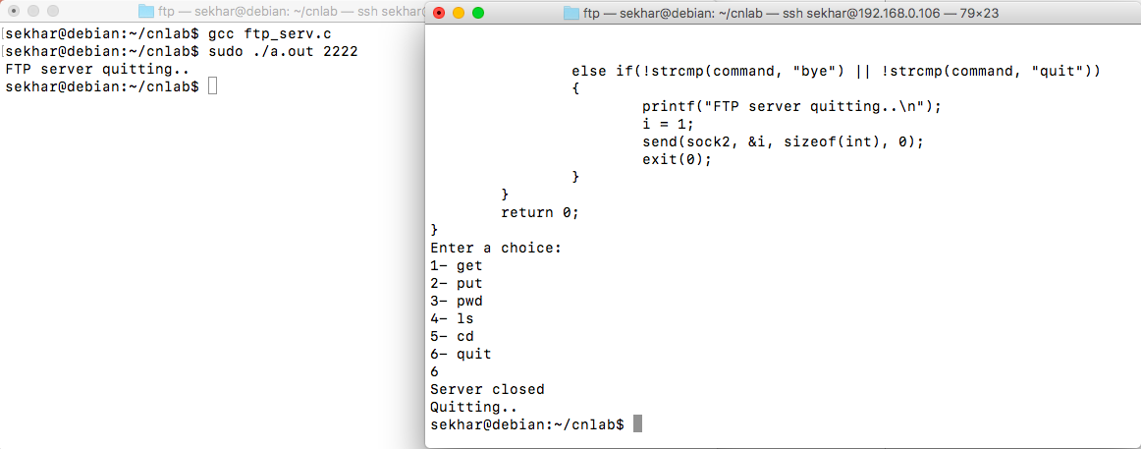

**PROGRAM:-**

ping_prog.c

#include <stdio.h>

#include <stdlib.h>

#include <fcntl.h>

#include <errno.h>

#include <sys/socket.h>

#include <resolv.h>

#include <netdb.h>

#include <netinet/in.h>

#include <netinet/ip_icmp.h>

#define PACKETSIZE 64

struct packet

{

struct icmphdr hdr;

char msg[PACKETSIZE - sizeof(struct icmphdr)];

};

int pid=-1;

struct protoent *proto=NULL;

/*--------------------------------------------------------------------*/

/*---checksum-standard 1s complement checksum ---*/

/*--------------------------------------------------------------------*/

unsigned short checksum (void *b, int len)

{

unsigned short *buf = b;

unsigned int sum=0;

unsigned short result;

for ( sum = 0; len > 1; len -= 2 )

sum += *buf++;

if ( len == 1 )

sum += *(unsigned char*)buf;

sum = (sum >> 16) + (sum & 0xFFFF);

sum += (sum >> 16);

result = ~sum;

return result;

}

/*--------------------------------------------------------------------*/

/*---display-present echo info---*/

/*--------------------------------------------------------------------*/

void display(void *buf, int bytes)

{

int i;

struct iphdr *ip = buf;

struct icmphdr *icmp = buf+ip->ihl*4;

printf("----------------\n");

for ( i = 0; i < bytes; i++ )

{

if ( !(i & 15) )

printf("\nX: ", i);

printf("1X ", ((unsigned char*)buf)[i]);

}

printf("\=n");

printf("IPv%d: hdr-size=%d pkt-size=%d protocol=%d TTL=%d src=%s ",ip->version, ip->ihl*4, ntohs(ip->tot_len), ip->protocol,ip->ttl,inet_ntoa(ip->saddr));

printf("dst=%s\n", inet_ntoa(ip->daddr));

if ( icmp->un.echo.id == pid )

{

printf("ICMP: type[%d/%d] checksum[%d] id[%d] seq[%d]\n",icmp->type, icmp->code, ntohs(icmp->checksum),icmp->un.echo.id, icmp>un.echo.sequence);

}

}

/*--------------------------------------------------------------------*/

/*---listener-separate process to listen for and collect messages--*/

/*--------------------------------------------------------------------*/

void listener(void)

{

int sd;

struct sockaddr_in addr;

unsigned char buf[1024];

sd = socket(PF_INET, SOCK_RAW, proto->p_proto);

if ( sd < 0 )

{

perror("socket");

exit(0);

}

for (;;)

{

int bytes, len=sizeof(addr);

bzero(buf, sizeof(buf));

bytes = recvfrom(sd, buf, sizeof(buf), 0, (struct sockaddr*)&addr, &len);

if ( bytes > 0 )

display(buf, bytes);

else

perror("recvfrom");

}

exit(0);

}

/*--------------------------------------------------------------------*/

/*---ping-Create message and send it.---*/

/*--------------------------------------------------------------------*/

void ping(struct sockaddr_in *addr)

{

const int val=255;

int i, sd, cnt=1;

struct packet pckt;

struct sockaddr_in r_addr;

sd = socket(PF_INET, SOCK_RAW, proto->p_proto);

if ( sd < 0 )

{

perror("socket");

return;

}

if ( setsockopt(sd, SOL_IP, IP_TTL, &val, sizeof(val)) != 0)

perror("Set TTL option");

if ( fcntl(sd, F_SETFL, O_NONBLOCK) != 0 )

perror("Request nonblocking I/O");

for (;;)

{

int len=sizeof(r_addr);

printf("Msg #%d\n", cnt);

if ( recvfrom(sd, &pckt, sizeof(pckt), 0, (struct sockaddr*)&r_addr, &len) > 0 )

printf("***Got message!***\n");

bzero(&pckt, sizeof(pckt));

pckt.hdr.type = ICMP_ECHO;

pckt.hdr.un.echo.id = pid;

for ( i = 0; i < sizeof(pckt.msg)-1; i++ )

pckt.msg[i] = i+'0';

pckt.msg[i] = 0;

pckt.hdr.un.echo.sequence = cnt++;

pckt.hdr.checksum = checksum(&pckt, sizeof(pckt));

if ( sendto(sd, &pckt, sizeof(pckt), 0, (struct sockaddr*)addr, sizeof(*addr)) <= 0 )

perror("sendto");

sleep(1);

}

}

/*--------------------------------------------------------------------*/

/*---main-look up host and start ping processes.---*/

/*--------------------------------------------------------------------*/

int main(int count, char *strings[])

{

struct hostent *hname;

struct sockaddr_in addr;

if ( count != 2 )

{

printf("usage: %s <addr>\n", strings[0]);

exit(0);

}

if ( count > 1 )

{

pid = getpid();

proto = getprotobyname("ICMP");

hname = gethostbyname(strings[1]);

bzero(&addr, sizeof(addr));

addr.sin_family = hname->h_addrtype;

addr.sin_port = 0;

addr.sin_addr.s_addr = *(long*)hname->h_addr;

if ( fork() == 0 )

listener();

else

ping(&addr);

wait(0);

}

else

printf("usage: myping <hostname>\n");

return 0; }

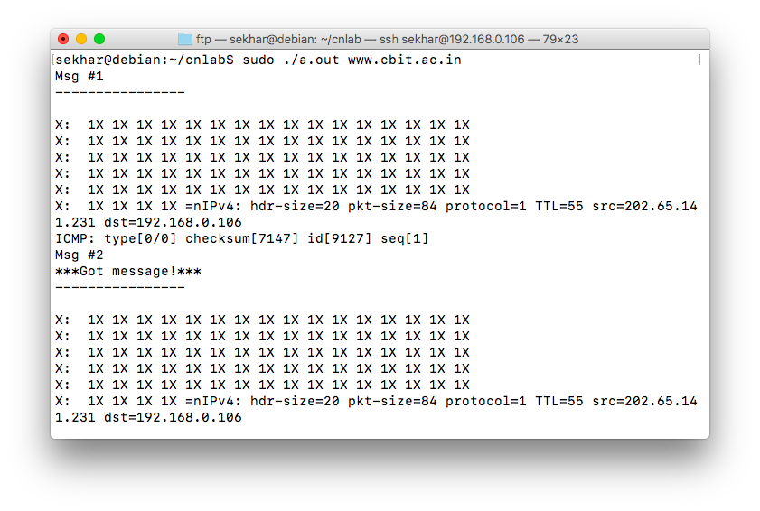

**OUTPUT:-**