OS LAB 6/7/2016

**ROLL NUMEBRS :-**

**160114733091 K.A.S.Sekhar**

**160114733092 M Dasarada Ram Reddy**

**160114733106 Raparthi Pranith Kumar**

**PROGRAMS:-**

**1) factorial:**

**read n**

**f=1**

**for((i=1;i<=n;i++))**

**do**

**f=`expr $f \* $i`**

**done**

**echo "$f"**

**OUTPUT:-**

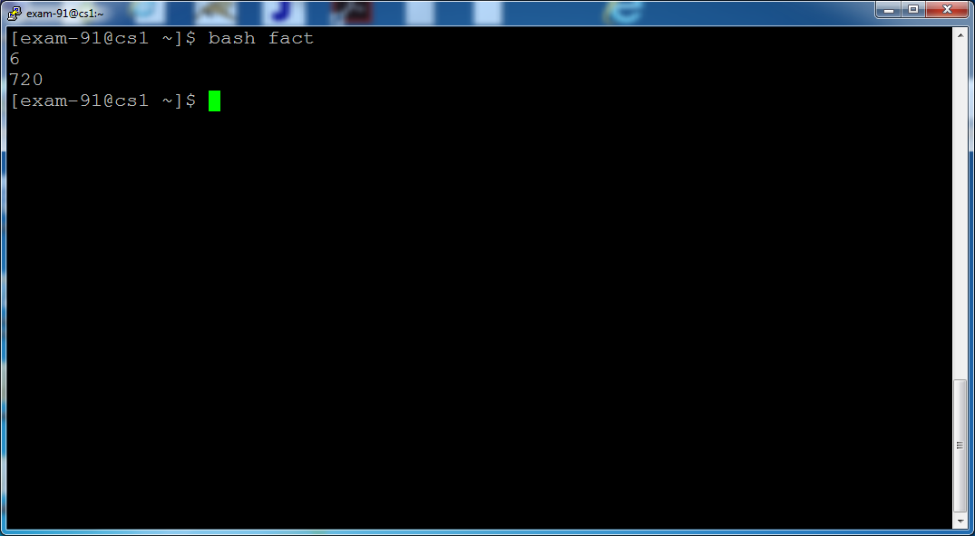

**2) fibonacci:**

**read n**

**a=0**

**b=1**

**c=0**

**for((i=1;i<=n;i++))**

**do**

**echo "$c"**

**a=$b**

**b=$c**

**c=`expr $a + $b`**

**done**

**OUTPUT:-**

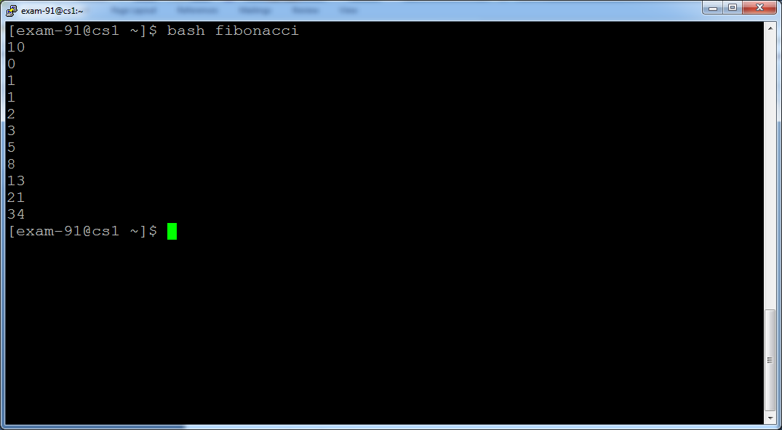

**3)** **reverse of a number :**

**read n**

**s=0**

**r=0**

**while test $n -ne 0**

**do**

**r=`expr $n % 10`**

**s=`expr $s \* 10`**

**s=`expr $s + $r`**

**n=`expr $n / 10`**

**done**

**echo "$s"**

**OUTPUT:-**

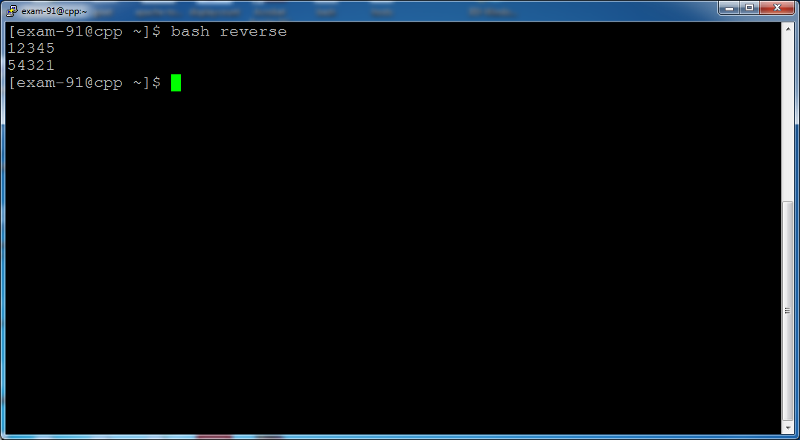

**4) simple calculator :**

**echo -e " press 1 to add \n press 2 to subtract \n press 3 to multiply \n press 4 to divide"**

**read ch**

**echo -e "\n enter two numbers :\n"**

**read a**

**read b**

**if test $ch -eq 1**

**then**

**expr $a + $b**

**elif test $ch -eq 2**

**then**

**expr $a - $b**

**elif test $ch -eq 3**

**then**

**expr $a \* $b**

**else**

**expr $a / $b**

**fi**

**OUTPUT:-(NEXT PAGE)**

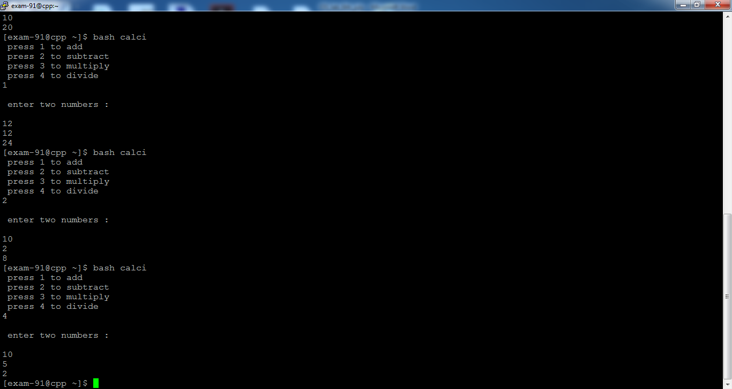

**THEORY:-**

->WHAT IS SHELL SCRIPTING?

                  Shells are interactive i.e shell accept command from users and execute them. User can also write series of commands to execute a specific task in a text file and execute them instead of giving commands in command prompt.

-> DECLARE A VARIABLE ?

a=0

b=1

->SYNTAX:-

if syntax:-

if test <condition>

then

statements

elif test <condition>

then

statements

else

statements

fi

while syntax:-

while test <condition>

do

statements

done

comparison of integers:-

|  |  |
| --- | --- |
| *n1* -eq *n2* | Integer *n1* is equal to integer *n2*. |
| *n1* -ge *n2* | Integer *n1* is greater than or equal to integer *n2*. |
| *n1* -gt *n2* | Integer *n1* is greater than integer *n2*. |
| *n1* -le *n2* | Integer *n1* is less than integer *n2*. |
| *n1* -lt *n2* | Integer *n1* is less than or equal to integer *n2*. |
| *n1* -ne *n2* | Integer *n1* is not equal to integer *n2*. |
|  |  |

switch case syntax:-

case item in

part1)

statements

;;

part2)

statements

;;

part3)

statements

;;

part4)

statements

;;

esac

until loop syntax:-

until test <condition>

do

statements

done

for loop syntax:-

for((initialization;condition;modification))

do

statements

done

ex:-

for((i=0;i<10;i++))

do

echo "$i"

done