Pre-requisites To Install Kubernetes
Since we are dealing with VMs, we recommend the following settings for the VMs:-
Master:
- 2 GB RAM
- 2 Cores of CPU
Slave/ Node:
- 1 GB RAM
- 1 Core of CPU

What is Kubernetes?
Kubernetes is a free and open-source container management system that provides a platform for deployment automation, scaling, and operations of application containers across clusters of host computers. With Kubernetes, you can freely make use of the hybrid,on-premise, and public cloud infrastructure in order to run deployment tasks of your organization.
The commands and procedures mentioned in this article have been run on an Ubuntu 18.04 LTS system. Since we will be using the Ubuntu command line, the Terminal, for running all the commands, you can open it either through the system Dash or the Ctrl+Alt+T shortcut.

Kubernetes Installation
The two-node cluster that we will be forming in this article will consist of a Master node and a Slave node. Both these nodes need to have Kubernetes installed on them. Therefore, follow the steps described below to install Kubernetes on both the Ubuntu nodes.

Step 1: Install Docker on both the nodes
Install the Docker utility on both the nodes by running the following command as sudo in the Terminal of each node:
$ sudo apt install docker.io
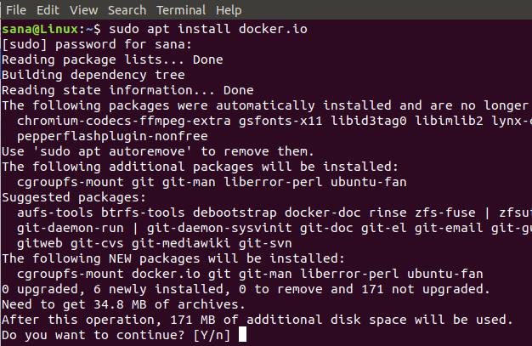
You will be prompted with a Y/n option in order to proceed with the installation. Please enter Y and then hit enter to continue. Docker will then be installed on your system. You can verify the installation and also check the version number of Docker through the following command:
$ docker --version
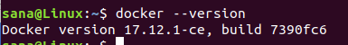

Step 2: Enable Docker on both the nodes
Enable the Docker utility on both the nodes by running the following command on each:
$ sudo systemctl enable docker
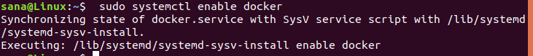

Step 3: Add the Kubernetes signing key on both the nodes
Run the following command in order to get the Kubernetes signing key:
$ curl -s https://packages.cloud.google.com/apt/doc/apt-key.gpg | sudo apt-key add
If Curl is not installed on your system, you can install it through the following command as root:
$ sudo apt install curl
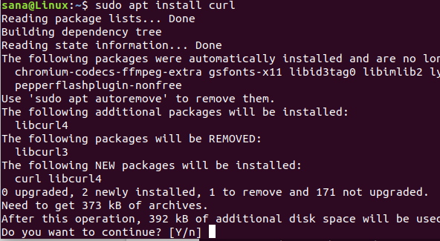
You will be prompted with a Y/n option in order to proceed with the installation. Please enter Y and then hit enter to continue. The Curl utility will then be installed on your system.

Step 4: Add Xenial Kubernetes Repository on both the nodes
Run the following command on both the nodes in order to add the Xenial Kubernetes repository:
$ sudo apt-add-repository "deb http://apt.kubernetes.io/ kubernetes-xenial main"
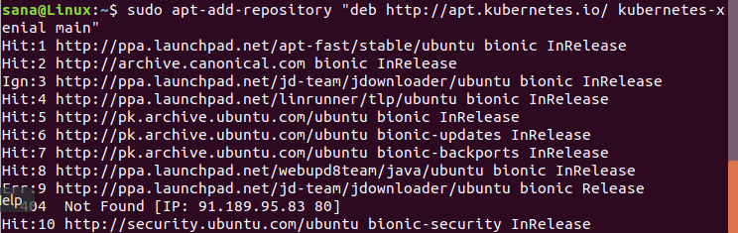

Step 5: Install Kubeadm
The final step in the installation process is to install Kubeadm on both the nodes through the following command:
$ sudo apt install kubeadm
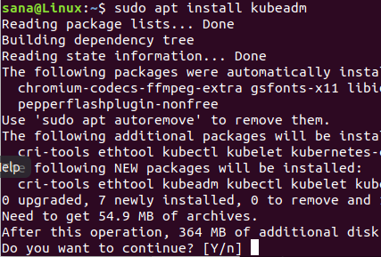
You will be prompted with a Y/n option in order to proceed with the installation. Please enter Y and then hit enter to continue. Kubeadm will then be installed on your system.
You can check the version number of Kubeadm and also verify the installation through the following command:
$ kubeadm version
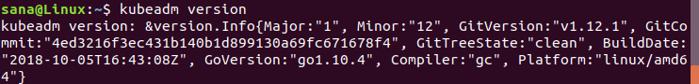

Kubernetes Deployment

Step 1: Disable swap memory (if running) on both the nodes
You need to disable swap memory on both the nodes as Kubernetes does not perform properly on a system that is using swap memory. Run the following command on both the nodes in order to disable swap memory
$ sudo swapoff -a

Step 2: Give Unique hostnames to each node
Run the following command in the master node in order to give it a unique hostname:
$ sudo hostnamectl set-hostname master-node
Run the following command in the slave node in order to give it a unique hostname:
$ hostnamectl set-hostname slave-node

Step3: Initialize Kubernetes on the master node
Run the following command as sudo on the master node:
$ sudo kubeadm init --pod-network-cidr=10.244.0.0/16
The process might take a minute or more depending on your internet connection. The output of this command is very important:
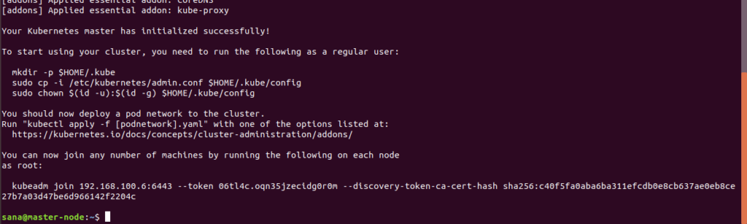
Please note down the following information from the output:
To start using your cluster, you need to run the following as a regular user:
mkdir -p $HOME/.kube
sudo cp -i /etc/kubernetes/admin.conf $HOME/.kube/config
sudo chown $(id -u):$(id -g) $HOME/.kube/config
You can now join any number of machines by running the following on each node
as root:
kubeadm join 192.168.100.6:6443 --token 06tl4c.oqn35jzecidg0r0m --discovery-token-ca-cert-hash sha256:c40f5fa0aba6ba311efcdb0e8cb637ae0eb8ce27b7a03d47be6d966142f2204c
Now run the commands suggested in the output in order to start using the cluster:
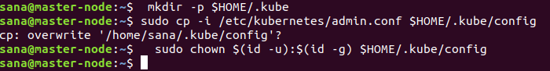
You can check the status of the master node by running the following command:
$ kubectl get nodes
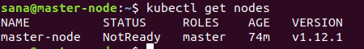
You will see that the status of the master node is “not ready” yet. It is because no pod has yet been deployed on the master node and thus the Container Networking Interface is empty.

Step 4: Deploy a Pod Network through the master node
A pod network is a medium of communication between the nodes of a network. In this tutorial, we are deploying a Flannel pod network on our cluster through the following command:
$ sudo kubectl apply -f https://raw.githubusercontent.com/coreos/flannel/master/Documentation/kube-flannel.yml

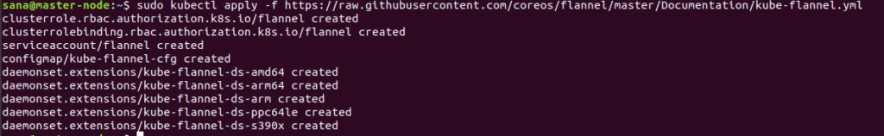
Use the following command in order to view the status of the network:
$ kubectl get pods --all-namespaces
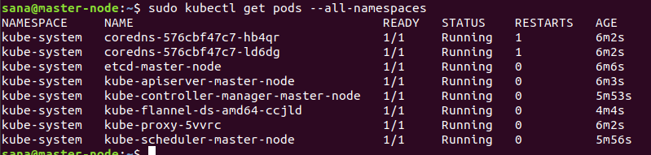
Now when you see the status of the nodes, you will see that the master-node is ready:
$ sudo kubectl get nodes
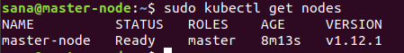

Step 5: Add the slave node to the network in order to form a cluster
On the slave node, run the following command you generated while initializing Kubernetes on the master-node:
$ sudo kubeadm join 192.168.100.6:6443 --token 06tl4c.oqn35jzecidg0r0m --discovery-token-ca-cert-hash sha256:c40f5fa0aba6ba311efcdb0e8cb637ae0eb8ce27b7a03d47be6d966142f2204c
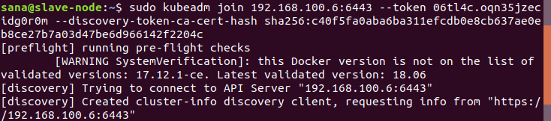
Now when you run the following command on the master node, it will confirm that two nodes, the master node, and the server nodes are running on your system.
$ sudo kubectl get nodes
This shows that the two-node cluster is now up and running through the Kubernetes container management system.

