Putty and Putty Gen download

<https://www.chiark.greenend.org.uk/~sgtatham/putty/latest.html>

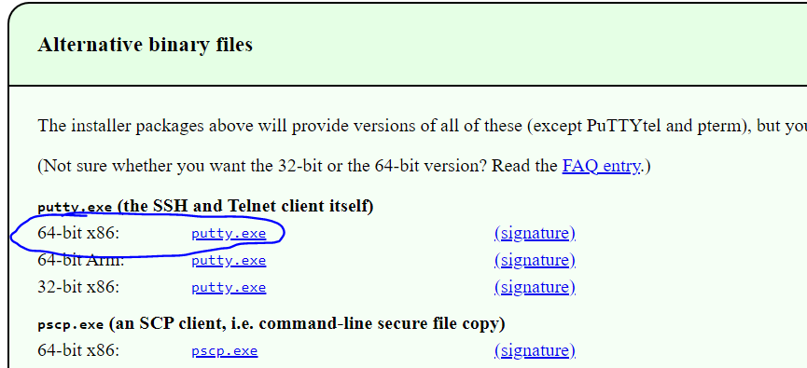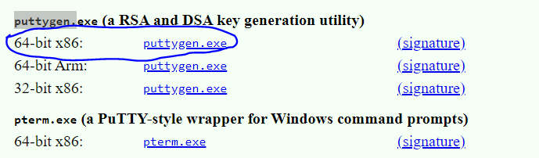

**How to create .ppk from .pem file:**

Open Puttygen > Click on Load >select the .pem file>save private key.

To connect using Putty:

**Copy the public ip of the instance**

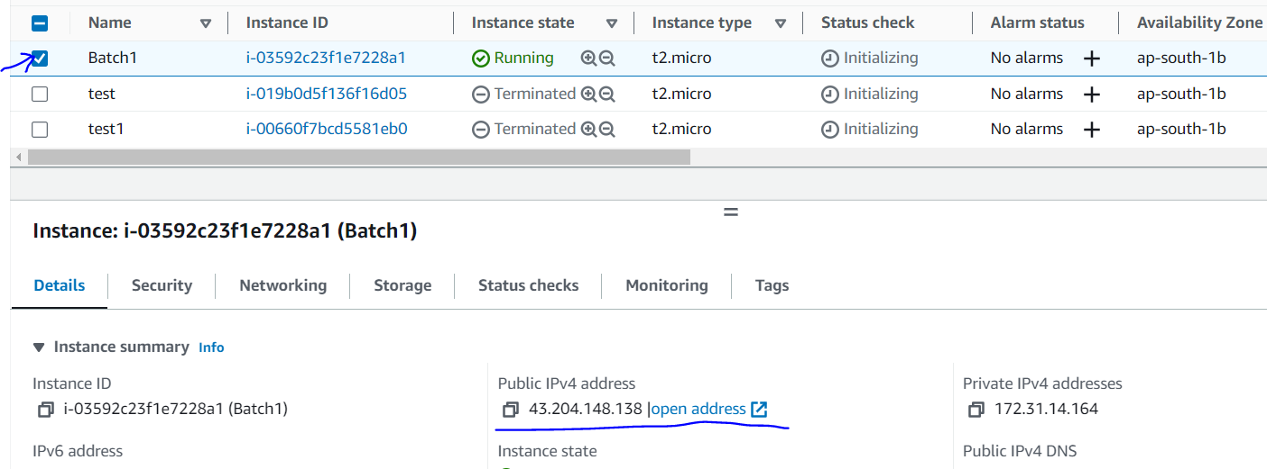

**Open Putty**

**Pasted the IP>go to SSH>Auth>credentials>browse and open**

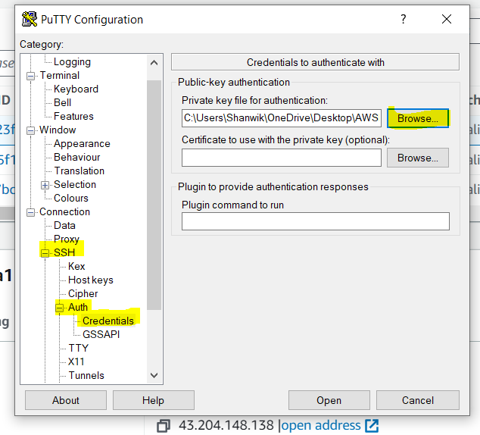

**UserName : Ubuntu**



To create file : cat > filename

To save the file : enter & ctrl +d

To view the files : ls

To view files detailed : ls -l

To create directory : midir <dir Name>

To change the directory : cd <dir Name>

To come out of directory : cd ..