Report on Customer Churn Prediction

**Customer Churn :** Customer churn prediction is the practice of determining and anticipating which clients are likely to discontinue their utilization of a product or service in the future. This task holds great significance for businesses operating within sectors such as telecommunications, subscription services, e-commerce, among others.

**Reasons of Customer Churn :**

1. Poor customer service

2. High prices

3. Lack of product or service quality

4. Better offers from competitors

5. Inconvenient location or access to services

6. Changes in personal circumstances

7. Lack of trust in the company

8. Ineffective communication with customers

**My Approach towards this Problem :**

1. Preprocess the given data and do data cleaning along with feature engineering.
2. Split the data into a training set and test set.
3. Apply multiple classification models on the training set.
4. Evaluate models on the basis of the test set and the one with the highest accuracy will be chosen for hyper parameter tuning.
5. Apply hyper parameter to the chosen model.

**Data Preprocessing:**

# The dataset has 100000 rows and 9 columns of data entries.

# There are no missing values in the data.

# Number of rows with duplicates are 0.

# Most of the columns are numeric but 2 coloumns are categorical.

We used one hot encoding to convert the categorical columns to numerical.

After the thorough analysis of the data, the next step is to preprocess it. This includes cleaning the data by removing any unnecessary or irrelevant information, handling missing values, and dealing with outliers. The data may also need to be transformed, such as scaling or normalizing the features. Additionally, feature selection or extraction techniques can be applied to reduce dimensionality and improve model performance. The goal of data preprocessing is to prepare the data for machine learning algorithms to effectively learn patterns and make accurate predictions.

## **EDA:**

1. **Gender VS Churn**

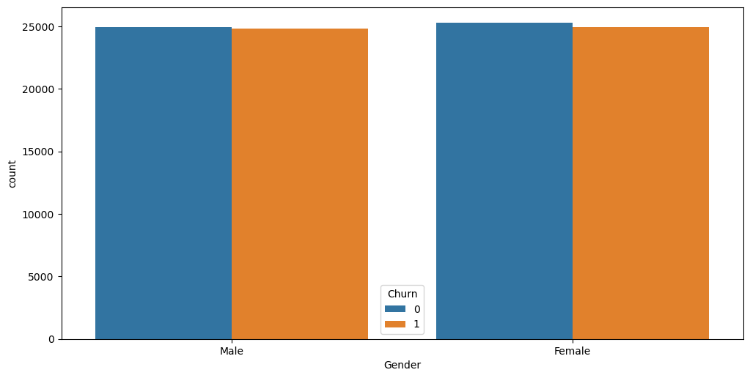

1. **Location VS Churn**

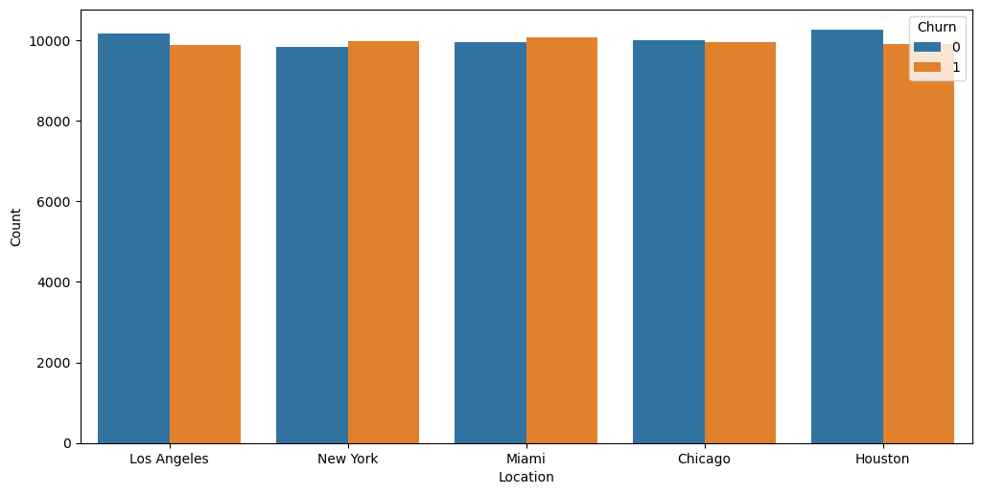

**Model Building:**

As our problem statement is classification based, so we tried different classification algorithms in order to find the model with highest accuracy.

About five (5) machine learning algorithms were evaluated on the resulting dataset. The algorithms include:

KNN, DecisionTreesClassifier, AdaBoostingClassifier, RandomForest and Logistic Regression.

**Model Evaluation:**

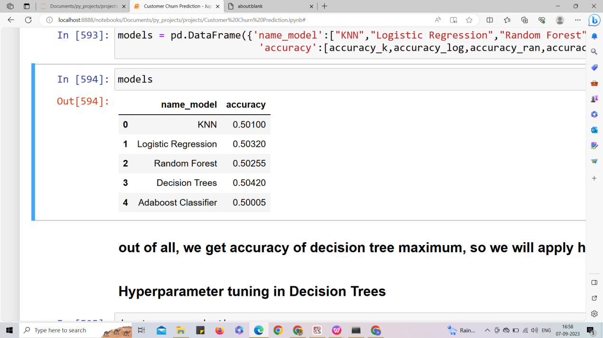

### out of all, we get accuracy of **decision tree** maximum, so we will apply hyperparameter tuning here**.**

In order to increase its accuracy, we did hyperparameter tuning using **GridSearchCV** as well and got the accuracy of parameterised model of around 53**%.**

# Conclusion

In summary, the utilization of machine learning for churn customer prediction is a valuable asset for businesses aiming to proactively retain customers and maximize profitability. By leveraging historical data alongside advanced algorithms, ML models can precisely identify customers who are at risk of churning. This predictive capability enables companies to implement targeted retention strategies such as personalized offers and improved customer service which ultimately results in reduced customer attrition rates. Consequently, organizations can enhance customer satisfaction while maintaining revenue streams and optimizing resource allocation. However, it is crucial to continuously refine and update these models to adapt to changing market dynamics and shifting consumer behavior patterns. Churn prediction through ML empowers businesses with informed decision-making abilities that allow them to enhance their relationships with customers while securing long-term success even amidst a competitive landscape.

# Recommendations

1. Use deep learning algorithms to analyze customer behavior data and identify patterns that indicate potential churn.

2. Utilize predictive modeling techniques to forecast which customers are likely to churn in the near future.

1. Regularly monitor customer satisfaction levels and address any concerns or issues promptly to improve overall retention rates.

4.. Offer incentives and rewards programs to encourage loyal customers to continue doing business with your company.

5. Leverage social media platforms and online forums to engage with customers and build relationships that foster long-term loyalty.