Word includes equation editor which makes available mathematical symbols and scientific functions in your document

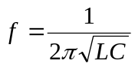

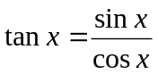

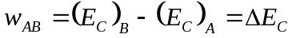

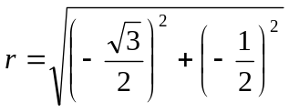

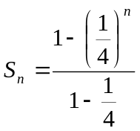

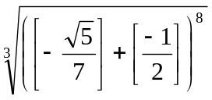

© ® € ™ ∞ ⅓ ℮

