PRIVATE YAHYA KEMAL COLLEGE
COMPUTER LESSON
2ND SEMESTER 1ST EXAM
10A …/03/2001
NAME , SURNAME:………………. SCORE:……..
QUESTIONS:
1-) Explain following statements in EDIT menu.
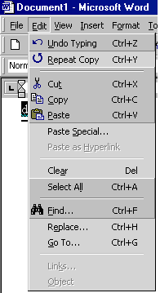

2-) Explain selected items in dialup networking properties:

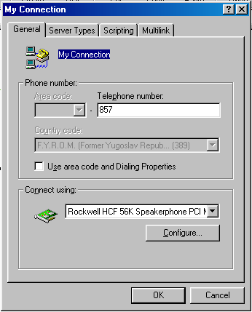

3-)
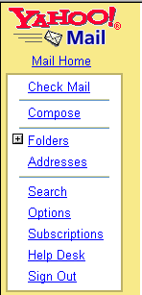

4-)


5-) How can you compose a new message by using Hotmail? Explain step by step

Good Luck! Each question 20 pts. Sefer Aydogdu

