PRIVATE YAHYA KEMAL COLLEGE
COMPUTER LESSON
2000/2001 EDUCATIONAL YEAR
1ST SEMESTER 1ST EXAM
10-A

NAME, SURNAME:……………………………… 23.10.2000

QUESTIONS:
(20 pts) 1.What does hardware mean? Explain and give three examples.
(15 pts) 2.Calculate following operations:
24 Mbyte = ? Kbyte
4096 Byte = ? Kbyte
1 Gbyte = ? Byte

(15 pts) 3.What does data mean?
(15 pts) 4.Draw the diagram of INPUT/OUTPUT devices.
(20 pts) 5.Write the means of terms below:
Mbyte ..:

CD-Driver..:

ROM.. ..:

RAM.. ..:

CPU.. ..:

(15 pts) 6.What is the function of accessibility Options? Explain.
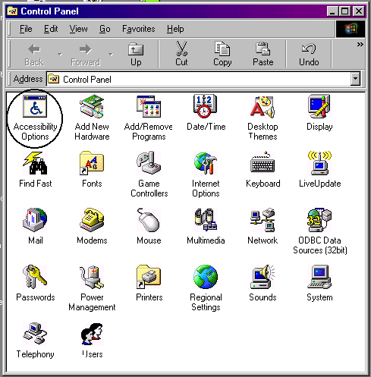
Good Luck!

Sefer Aydogdu

PRIVATE YAHYA KEMAL COLLEGE
COMPUTER LESSON
2000/2001 EDUCATIONAL YEAR
1ST SEMESTER 1ST EXAM
10-B

NAME, SURNAME:……………………………… 23.10.2000

QUESTIONS:
(20 pts) 1.What does software mean? Explain and give three examples.
(15 pts) 2.Calculate following operations:
124 Mbyte = ? Kbyte
8192 Byte = ? Mbyte
8 Gbyte = ? KByte

(15 pts) 3.What does system software mean? Explain and give an example.
(15 pts) 4.Draw the diagram of INPUT/OUTPUT devices.
(20 pts) 5.Write the means of terms below:
Kbyte ..:

Floppy..:

Mainboard:

HDD ..:

CPU.. ..:

(15 pts) 6.What is the function of Add new hardware? Explain.
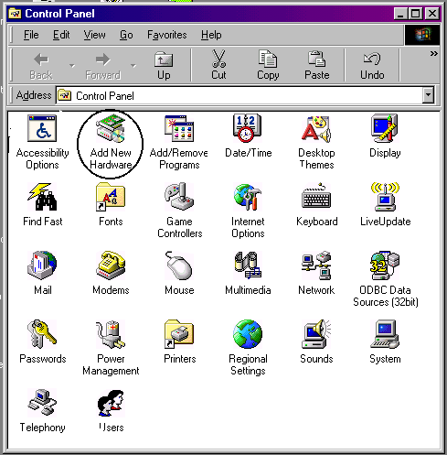
Good Luck!

Sefer Aydogdu

PRIVATE YAHYA KEMAL COLLEGE
COMPUTER LESSON
2000/2001 EDUCATIONAL YEAR
1ST SEMESTER 1ST EXAM
10-C

NAME, SURNAME:……………………………… 23.10.2000

QUESTIONS:
(20 pts) 1.What does system sotfware mean? Explain and give three examples.
(15 pts) 2.Calculate following operations:
11 Mbyte = ? Kbyte
2048 KByte = ? MKbyte
256 Mbyte = ? Byte

(15 pts) 3.How does a computer process data?
(15 pts) 4.Draw the diagram of INPUT/OUTPUT devices.
(20 pts) 2.Write the means of terms below:
BIT ..:

CD-ROM Driver..:

Monitor.. ..:

RAM.. ..:

ROM . ..:

(15 pts) 6.What is the function of add/remove programs? Explain.
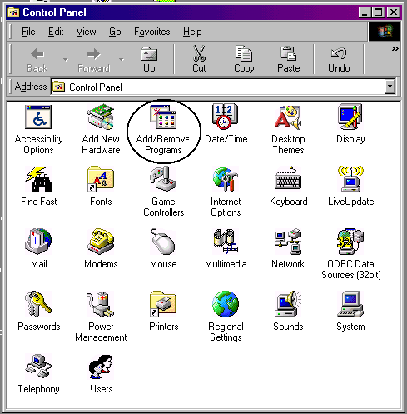
Good Luck!

Sefer Aydogdu

