PRIVATE YAHYA KEMAL COLLEGE
COMPUTER LESSON
2ND SEMESTER 2nd EXAM
10C 21.05.2001
NAME , SURNAME:………………. SCORE:……..
QUESTIONS:

- Explain selected items in Microsoft Powerpoint insert menu.
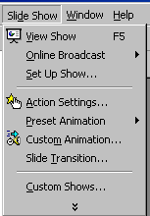

View Show:

Set up Show:

Action settings:

Custom Animations:

Slide Transition:

2. Explain selected items.
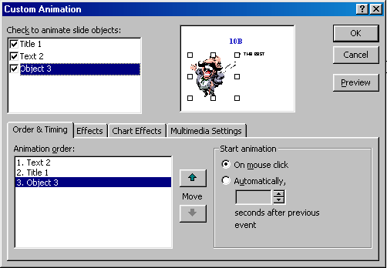

3.Explain toolbar menu of Photoshop 5.5?


4.Explain selected items.

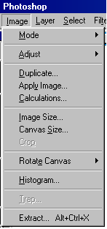

Each question 25 pts.
Good Luck!
SEFER AYDOGDU

