PRIVATE YAHYA KEMAL COLLEGE
COMPUTER LESSON
2ND SEMESTER 2nd EXAM
10B 21.05.2001
NAME , SURNAME:………………. SCORE:……..
QUESTIONS:

- Explain selected items in Microsoft Powerpoint insert menu.
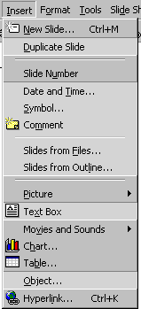

2. Explain selected items.
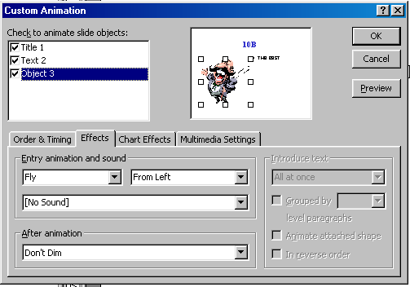

3.Explain toolbar menu of Photoshop 5.5?


4.Explain selected items.

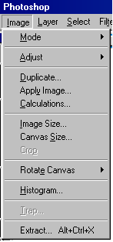

Each question 25 pts.

Good Luck!
SEFER AYDOGDU

