PRIVATE YAHYA KEMAL COLLEGE
COMPUTER LESSON
2ND SEMESTER 2nd EXAM
11C 25.05.2001
NAME , SURNAME:………………. SCORE:……..
QUESTIONS:

- Explain following items?
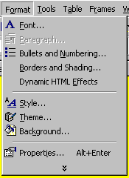

Fonts:

Bullets and Numbering:

Borders and Shading:

Style:

Background:

Properties:

2. Explain following items.
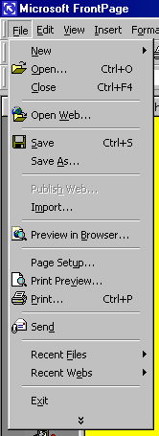
New:

Open:

Close:

Open Web:

Save:

Save as:

Import:

Preview in Browser:

Page Setup:

Print Preview:

Print:

Send:

3.Explain toolbar menu of Photoshop 5.5?


4.Explain following items.
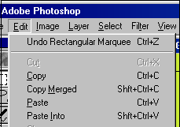
Edit:

Undo:

Copy:

Copy Merged:

Paste:

Layer:

Select:

Filter:

View:

Paste Info:

Each question 25 pts.

Good Luck!
SEFER AYDOGDU

