IQ-Test
1-17. | For each picture sequence on the left, find the picture that follows logically from one of the six on the right.

1 2 3 4 5 6

1 2 3 4 5 6

- 

1 2 3 4 5 6

- 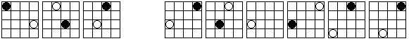

1 2 3 4 5 6

- 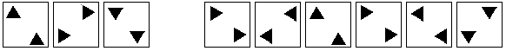

1 2 3 4 5 6

1 2 3 4 5 6

1 2 3 4 5 6

1 2 3 4 5 6

1 2 3 4 5 6

1 2 3 4 5 6

1 2 3 4 5 6

1 2 3 4 5 6

1 2 3 4 5 6

1 2 3 4 5 6

1 2 3 4 5 6

1 2 3 4 5 6

1 2 3 4 5 6

18-26. | Add to these successions of numbers the number which logically follows.

18. 1, 4, 7, 10, 13 ?

19. 37, 35, 33, 31, 29 ?

20. 4, 5, 7, 10, 14, 19 ?

21. 9, 10, 12, 13, 15, 16 ?

22. 40, 37, 35, 32, 30, 27 ?

23. 3, 6, 12, 24, 48, 96 ?

24. 13, 14, 28, 29, 58, 59 ?

25. 4, 12, 11, 33, 32, 96 ?

26. 13, 6, 10, 9, 7, 12, 4, 15 ?

Add the missing numbers and/or letters.

27.
3 | 12 | 8
7 | 28 | 24
5 | 20 | ?

28.
8 | 4 | 3 | 9
4 | 7 | 3 | 8
3 | 1 | 2 | ?

29.
4 | 12 | 6 | 18 | ?
4 | 2 | 6 | 3 | ?

