- E -
- Emergency Boot Disk
- Explorer (Windows)
- Extranet

Emergency Boot Disk
Emergency boot disk is the informal name for the Windows 98 StartUp disk (see the "StartUp Disk" entry for details). The purpose of the StartUp disk is to help you get back into your computer should the Windows 98 operating system fail for any reason. The StartUp Disk contains specialized boot files that will start the operating system from a single floppy disk, and then will attempt to restore operations to your PC as best as possible. Use of the StartUp disk should be as a last resort, because it is possible that it may overwrite some critical system information, possibly forcing you to reinstall one or more of your applications.

Explorer (Windows)
Explorer is the informal term for the Windows Explorer application that is used to maneuver throughout the Windows 98 file system. For further details, see the section titled "Windows Explorer."

Extranet
An extranet can be defined as a private network that usually uses the public telephone systems with Internet technology to share information or with
others either within your organization or on the outside. An extranet is sometimes an extension of an organization's intranet that makes internal information "public" to a specific audience.

- F -
- Favorites
- Files
- File Management
  - Moving Files
- Find
- Folders
- Fonts

Windows 98 Favorites are hyperlinks to Internet/intranet/extranet web sites. To use the Favorites list, follow these steps:
1. Click the Start button, and choose Favorites
2. Click any entry in the Favorites menu (you might need to click a folder or two to reach the web site you want to visit) to start your default web browser. The default web browser will probably be Microsoft Internet Explorer because it is integrated into the Windows 98 operating system. The browser automatically opens the file, folder, or web site that you have selected.

TIP: You must establish a connection to the Internet prior to opening a web browser; otherwise, the browser will not be able to find any sites. Although opening Favorites within Windows 98 starts the default web browser, it does not automatically complete the Internet connection.

When inside the Microsoft Internet Explorer Web browser, you can view the Favorites links that are available from the Start menu. As an added advantage, you can organize your favorites into various folders,
To organize your Favorites list, follow these steps:
1. To add a new site to your Favorites list, first visit the site you want to add
2. Click the Favorites menu option, and select Add to Favorites,
3. The Add Favorite dialog box appears. Click the Create In button if you want to add this favorite to an existing folder or to create a new folder within the Windows 98 Favorites section. In this instance, I plan to place the site I have selected in an existing folder named United States Government.
4. The dialog box expands to show the folder structure of your current Favorites area, Scroll down until you find the folder in which you want to place the site, and then click it.
5. Click the OK button to insert this web site into your Favorites section.
6. Click the Favorites menu option to confirm that the Favorite you just added has been successfully placed in the list., the CIA home page for kids has been successfully placed in the United States Government folder of my Favorites list.
To organize sites already in your Favorites list into folders, follow these steps:
1. Click the Favorites menu item and select Organize Favorites
2. The Organize Favorites dialog box, appears. Here you move, rename, delete, or open an existing Favorite.

NOTE: When organizing your Favorites folders, be practical and logical. Don't stuff everything into one spot, but at the same time, do not try to
over-organize and create so many different folders that it becomes impossible to find anything. You can use the standard file-management techniques for your Windows 98 Favorites just as you do for the rest of your computer.

Files
Files are the software creations that make all things possible in PC computing today. Every folder, word processing document, software application, and operating system feature is actually nothing more than a file. Thousands of files come with the Windows 98 operating system and with each software application that you load on your PC. Even more are created by these very same applications (in the form of word processing documents, spreadsheets, and the like).

File Management
It is strongly recommended that you devise some scheme for organizing and managing the files stored on your computer. Much like Microsoft organizes most of the applications installed on your computer in the Program Files folder, you can organize your own files in a manner that will make it easier to locate them for future use. If you had a folder called DATA that contains a series of subdirectories, each of which was named after the application that created its contents, for example, it would be very easy to find, use, modify, and back up these files as necessary. This file structure might look something like this:
C:\DATA
C:\DATA\EXCEL
C:\DATA\POWERPOINT
C:\DATA\PUBLISHER
C:\DATA\QUICKEN
C:\DATA\WORD
To organize and manage your files, you need to know how to do the following:
- Copy files
- Delete files
- Move files
3. Double-click the drive in which the file that you want to copy exists. If in doubt, start with the C: drive; it is usually the primary (if not the only) hard drive in a PC. This opens a window like the one
4. Double-click any folder to open it. Depending on how your files are organized on your computer, you might need to click a few folders to reach the one you're looking for.
5. Here you will find the file you want to copy--the shortcut for Microsoft Word (you can learn more about shortcuts in the section titled "Shortcuts"). Select this file by clicking it once with the left mouse button; then right-click the selected file and choose Copy from the ensuing shortcut menu, as shown in Figure F.14. The file you have selected is copied to the clipboard.
Figure F.14 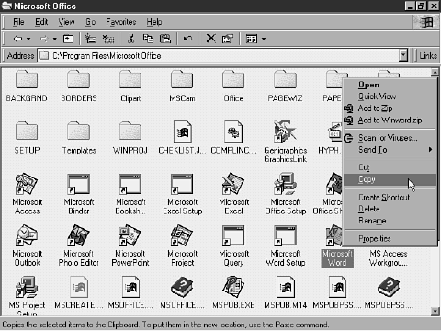

6. Move to the place where you want to paste the copy of the file--in this example, the Windows 98 desktop (you can reach this spot by minimizing or closing one or more of your open windows).
7. Right-click a blank portion of the desktop and choose Paste from the ensuing shortcut menu, as shown in Figure F.15.
Figure F.15 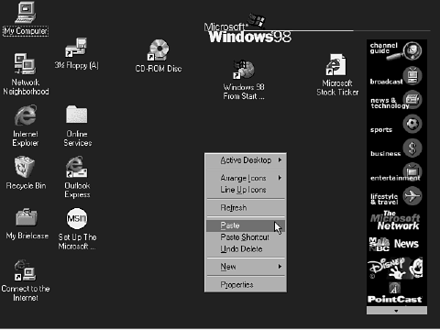

8. As shown in Figure F.16, the Microsoft Word shortcut file is pasted to the desktop.
Figure F.16 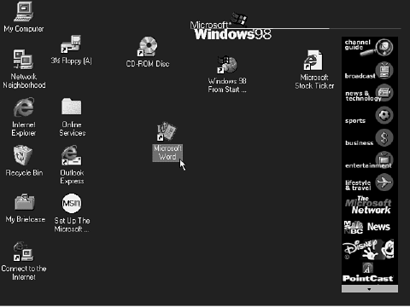
Deleting Files Removing files (documents, pictures, programs, and so on) from your computer can seem intimidating to a first-time user. But under Windows 98, this process is easier to understand and perform. To delete a file, follow these steps:
1. First, you must find the file you want to delete. In this example, double-click the My Computer icon, on the desktop.
2. The My Computer window, shown in Figure F.18, opens. If your window does not look like the one shown here, click the View menu option and then click Details to alter the screen layout so that it matches the one in the example.
3. Double-click the drive in which the file that you want to delete exists. If in doubt, start with the C: drive; it is usually the primary (if not the only) hard drive in a PC.
4. When you find the file you want to delete, click it to select it, as shown in Figure F.19. (In this example, the selected file is a graphics file named Frank & Genevieve Snow.TIF.)
Figure F.18 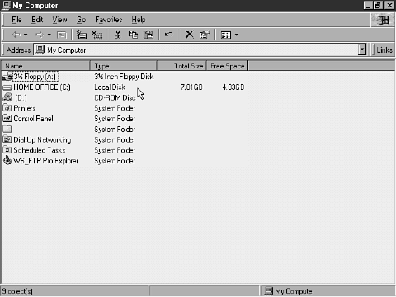

5. Right-click the selected file and select Delete from the ensuing shortcut menu, as shown in Figure F.20. This will remove the selected file from the window.
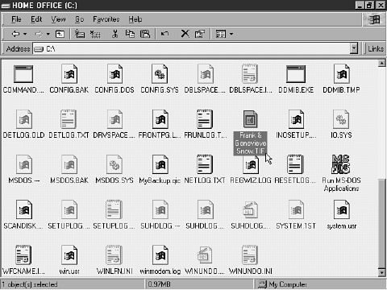
Figure F.19
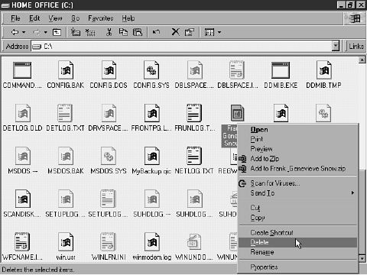
Figure F.20

TIP: An easier way to delete a file is to select it and then press the Delete key on your keyboard.

6. Close the C: window and return to the desktop by closing or minimizing all open windows. Then double-click the Recycle Bin icon on your desktop,

7. The file you deleted appears in the Recycle Bin. To delete it permanently from your system, right-click the Recycle Bin icon on the desktop, and choose Empty Recycle Bin from the ensuing shortcut menu
8. You will see a message box , asking you whether you really want to delete the files in the Recycle Bin. Click the Yes button to complete the deletion process.

Moving Files
To move a file such as a picture, a word processing document, or a spreadsheet from one folder to another on your computer is not as difficult as you might think. To move files around on your computer, you use a technique known as drag and drop. That is, you drag a file from one location and literally drop it into a new one. To move files around within Windows 98, follow these steps:
1. Start Windows Explorer by clicking the Start button, and choosing Programs, Windows Explorer, as shown in Figure F.24.
2. The Explorer window, shown in Figure F.25, opens. To find the file you seek, first find the folder where it resides. You might have to click a series of folders to reach the file you seek.
3. For the sake of example, suppose that the file you seek--a Word
document--is found in a subfolder of the Program Files folder: C:\Program Files\KMAN\DOWNLOAD. To reach this subfolder, click the plus sign (+) next to the Program Files folder, which can be found in the left pane, and then click the KMAN folder, which can be found in the right pane.
Figure F.24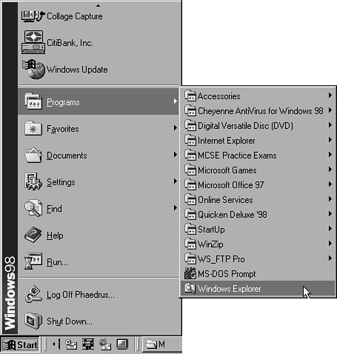

Figure F.25 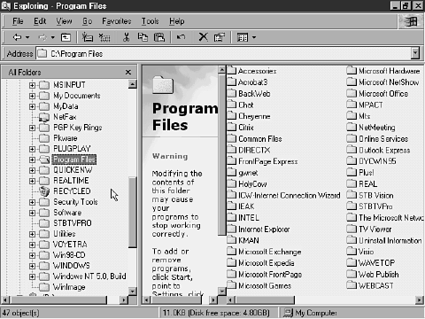
4. Click the DOWNLOAD folder in the left pane, and then click the file you want to move (Adolphson, Dave.doc), as shown in Figure F.26. (Notice that if you leave the mouse pointer over a Microsoft Word file, the name of the file's author appears.)
Figure F.26 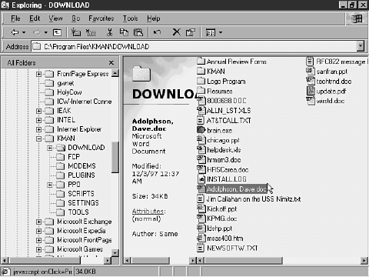

5. Using the scrollbar in the left pane, scroll to the folder where you want the file to be moved. Hold down the left mouse button and drag the file to its new location, as shown in Figure F.27. When the destination folder (in this example, KPMG-Styled Resumes) becomes highlighted, release the mouse button.
Figure F.27 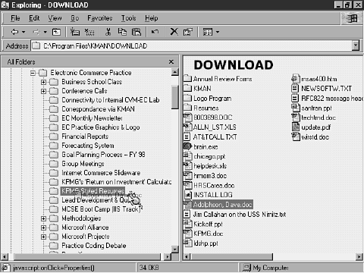

6. The file that you moved no longer resides in the DOWNLOAD file; it now resides in the KPMG-Styled Resumes folder, as shown in Figure F.28.
Figure F.28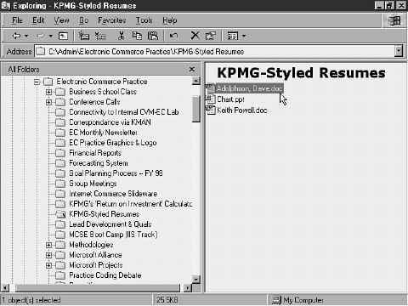

Swapping Files over a Direct Cable Connection
Files can be copied between two computers through the use of the Direct Cable Connection feature of Windows 98. After the two computers are connected, you just drag and drop files from one computer to the other (see the preceding section titled "Moving Files" for more information about drag and drop). The only difference is that although you drag and drop files between computers, you are actually leaving the original file on the first computer intact. In other words, this is a copy operation, not a move operation.

Find
The Find command under Windows 98 is greatly improved compared to the command in earlier versions of Windows. Not only can you search for files and folders, you can also search for friends on the Internet, computers on your network, and items in your address book. Finding Files and Folders To find files or folders on your computer, follow these steps:
1. Click the Start button, and then choose Find. You will see the Find menu, which contains the various Find options,
2. Click the first item, Files or Folders, to open the Find: All Files screen (with the Name & Location tab displayed), as shown in Figure F.30.
Figure F.30 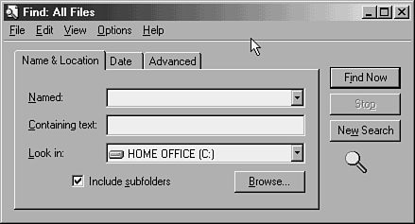

3. If you know the name of the file you seek, or if you can type some of the text that the file contains, the Name & Location tab is the screen for you. Type the name of the file you're looking for with its extension (.DOC, .PPT, .XLS, and so on) if you know it, and select the drive in which the file resides (such as the C: drive) from the Look In drop-down list. Alternatively, type some text that the file contains in the Containing Text text box.
4. To narrow a search, you can enter the date your file was created, last modified, or last accessed. To do so, click the Date tab of the Find: All Files dialog box, as shown in Figure F.31.
Figure F.31 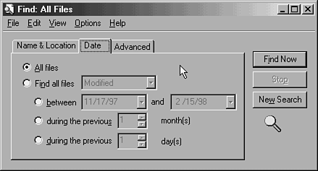

NOTE: Although this screen will search by a series of days or dates, you should still enter either a file name or a text string on the previous tab. Otherwise, you probably won't locate the file that you are looking for, because many files are automatically modified or accessed by the operating system without your realizing it.

5. If you leave this screen at its default setting, All Files, it instructs Windows 98 to search through all files from all dates, which doesn't exactly take advantage of this screen's functions. Instead, select the Find All Files option, and select either Created, Accessed, or Modified from the corresponding drop-down list box.
6. Click the Between xx and xx button to instruct Find to search the range of dates that you specify; click the During the Previous xx Month(s) button to instruct Find to search backward over the number of months you specify; click the During the Previous xx Day(s) button to instruct Find to search backward over the number of days you specify.
7. To narrow your search even further by searching by the file's size and type, click the Advanced tab,

NOTE: Entering information about the file's size is a quick way to limit a search. If you're looking for a graphic file, for example, you could select At Least from the Size Is drop-down list and enter 3 in the KB spinner box (because most graphic files exceed this size). This will speed the search, because the computer will not bother itself with the hundreds of files that are smaller than 3 KB.

8. Click the Find Now button to instruct Windows 98 to look for the file in question. Locations of matches are placed in the box that appears immediately below the Find screen,

TIP: If you need to stop a search in progress, click once on the Stop
button to end it.

Finding a Computer on Your Network Just as you can search for files on your computer, you can search for computers on your network. To use this search capability, follow these steps:
1. Click the Start button, and then choose Find. You will see the Find menu, which contains the various Find options,
2. Click the second item, Computer, to open the Find: Computer screen, shown in Figure F.35.
Figure F.35 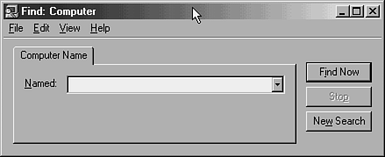

3. Type the name of the computer you are looking for in the Named field, and then click the Find Now button to initiate the search. When the Windows 98 search engine finds the computer that matches the search criteria, it places its name and location, as well as any comments about the computer (for Windows-based machines only), in the Found box
at the bottom of the search screen. In the example shown in Figure F.36, the computer is named phaedrus2, and the search process has located it in the Network Neighborhood.
Figure F.36 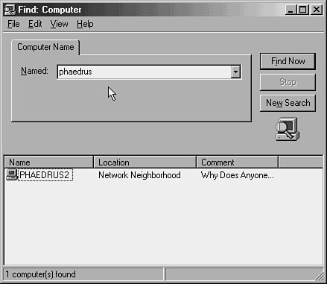

NOTE: Don't worry if you can't remember the entire name of the computer you're looking for; Windows 98 is forgiving. Suppose, for example, that you are looking for a computer named Phaedrus2 but, because you're unsure of the spelling, you just type Pha. The Find Computer option will still come up with the correct answer.

Finding Files on the Internet Windows 98 enables you to find files on the Internet directly from your desktop. To use this Find option, follow these steps:
1. Connect to the Internet either via the Windows 98 Dial-Up Networking feature or an online service such as AOL, MSN, or Prodigy.

TIP: If you do not have any type of Internet connection, this search is not for you.

2. Click the Start button, and then choose Find. You will see the Find menu, which contains the various Find options,
3. Click the fourth item, On the Internet, to start your default Internet browser (probably Internet Explorer). Because you connected to the Internet in step 1, your web browser automatically connects to Microsoft's World Wide Web site, which contains various Internet search engine options.

Folders
In the parlance of Windows 98, directories and subdirectories are known as folders. Simply put, folders are where all files and other directories are stored within Windows 98. To explore your folder structure, follow these steps:
1. Right-click the My Computer icon and choose Explore.
2. The My Computer window of Windows Explorer, shown in Figure F.50, opens. This window shows all the drives installed on this computer: a 3 1/2-inch floppy drive (the A: drive), a hard drive labeled HOME OFFICE (the C: drive), and a CD-ROM or DVD-ROM drive with a music CD in it (the D: drive). You will also find shortcuts to four of the more popular folders: Printers, Control Panel, Dial-Up Networking, and Scheduled Tasks.
Figure F.50 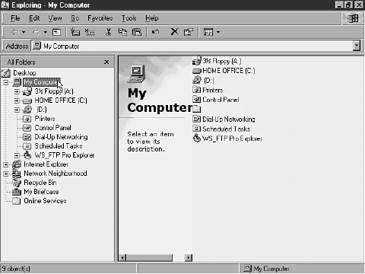
NOTE: You use Windows Explorer to maneuver around your hard drive. Explorer enables you to move, copy, create, and delete files and folders as necessary. For more information about Explorer, see the section titled "Windows Explorer."
3. Click the C: drive (labeled HOME OFFICE) entry in the left column; the pane on the right will change accordingly, All the icons you see in this view are folders.

Fonts
Fonts are used within Windows 98 to control how letters, numbers, and special characters look onscreen as well as when they are printed. Installing Fonts To install a font, follow these steps:
1. Click the Start button, choose Settings, Control Panel
2. Double-click the Fonts icon in the Control Panel window, shown in Figure F.53.
3. The Fonts window opens. Listed here are all the screen and print fonts that are already installed on your system. To add a new font to your system, click the File menu option, and choose Install New Font, as shown in Figure F.54.
Figure F.53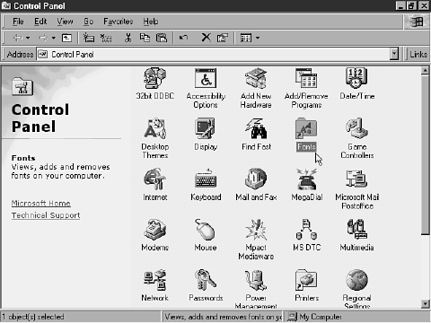
Figure F.54 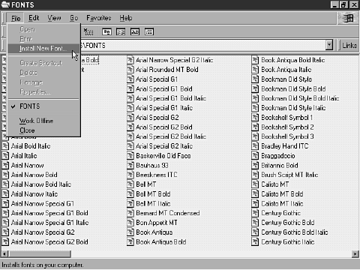
4. The Add Fonts dialog box, shown in Figure F.55, appears. In the bottom half of the window, find the folder or drive where the new font is to be installed.
5. In the List of Fonts box, click any font that you want to install (click the Select All button if you want them all).
Figure F.55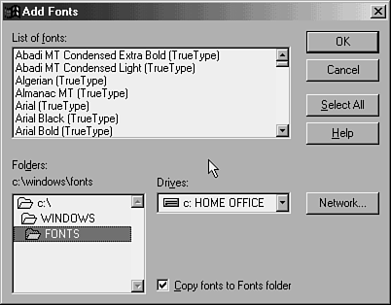

6. Check the Copy Fonts to Fonts Folder check box to create a copy
of all the fonts that you are installing and to put that copy into the C:\Windows\Fonts folder.
7. Click the OK button to proceed with the installation.
Deleting Fonts Deleting a font that you no longer want is just as easy as installing a new font. To delete a font, follow these steps:
1. Click the Start button, choose Settings, Control Panel,
2. Double-click the Fonts icon in the Control Panel window,
3. The Fonts window opens. Listed here are all the screen and print fonts that are already installed on your system. Right-click the font you want to delete, and choose Delete from the ensuing shortcut menu,

- G -
- Games

Games
Windows 98 comes with four built-in games:
- FreeCell
- Hearts
- Minesweeper
- Solitaire
To play any of these games, do the following:
1. Click the Start button, choose Programs, Accessories, and then Games; then choose whichever game you want to play
2. If you selected FreeCell as I did, the game opens on the desktop. To start a new game, click the Game menu option and choose New Game, If you need help learning how to play the game, click the Help menu option.

NOTE: As an alternative, you can press the F2 key on your keyboard to begin a new game.

Any additional games you install on your PC might not be placed in the same folder structure as FreeCell, Solitaire, Minesweeper, and Hearts. Many games install into their own default locations,

- I -
- Imaging
- Internet
- Internet Explorer 4.x
- Internet Explorer Menu
- Internet Mail Services

Imaging
The imaging component of Windows 98 has a variety of uses:
- It acts as the software for scanning information into your PC.
- It enables you to view, print, and manipulate received faxes.
- It enables you to view and print several types of graphical images.

NOTE: Eastman Software company, a division of Kodak, Inc., wrote the imaging software that Microsoft licensed and integrated into its Windows 98 product.

To use the imaging software, do the following:
1. Click the Start button, and choose Programs, Accessories, and then Imaging,
2. The main Imaging window is shown in Figure I.2. It is from this main screen that all of your viewing, editing, and/or printing of graphical images is done.
3. To view or print a graphical image that you already have on your computer, click File and then choose Open.
Figure I.2 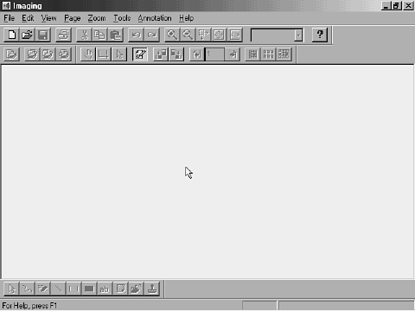
4. Navigate to the Windows 98 folder that contains the image you want to view or print.
5. Click the Open button to open the file that you have selected, and voila! The image appears inside the Imaging window. Print the image by selecting File and then Print.
Playing with the various features and functions of the imaging software is probably the best way to learn to use this tool. Additionally, you can consult the Imaging tool's built-in help system, or you can contact Kodak for assistance. To obtain Kodak's contact information, do the following:
1. Click Help, and then click About Imaging to open
2. Click the Contact Info button to obtain the necessary information.

Internet
The Internet, also known as Cyberspace, the Information Superhighway, and a billion other nicknames, is not just one giant network. It consists of tens of thousands or perhaps even millions of interconnected (or internetworked) networks. It was originally designed by the U.S. military as a post-nuclear war survival tool.
There are many components to the Internet, but the most commonly known ones are the World Wide Web (WWW), File Transfer Protocol (FTP), and Gopher sites (though Gopher is beginning to die off as of late).
To move to a site on the Internet, all you need to know is the TCP/IP address of the remote computer that houses the site, or that computer's domain name address (such as microsoft.com). With the advent of Internet browsers, GUI-based FTP software, and the sheer graphical nature of the WWW, maneuvering around the Internet has become much easier for the average lay person.

Internet Explorer 4.x
Internet Explorer (IE) 4 is the Web browser that is built into Windows 98. To use Internet Explorer, do the following:
- Double-click the Internet Explorer icon located on the Windows 98 desktop
- If you have not yet connected to the Internet--either through a Dial-Up Networking client or through a direct connection--

NOTE: For more information about connecting to the Internet, refer to the section titled "Dial-Up Networking."

If you have already connected to the Internet, you'll see a screen such as the one shown in Figure I.18.
Figure I.18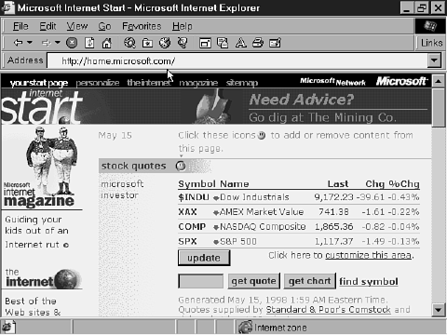
3. Click the View menu option to examine Internet Explorer's View options. These options enable you to configure how various features of Internet Explorer are displayed. For example, you can select the Text Labels option from the Toolbars sub-menu to place text labels on the IE toolbar (this places the text name of each icon directly below that icon's picture on the toolbar).

4. Click the Help menu option to reveal and configure the available help options, One of my favorite help options, Microsoft on the Web, enables you to connect directly to Microsoft's web site for timely information and product support.
Playing with the features and functions of the IE browser software is probably the best way to learn to use it. For more in-depth information about using Internet Explorer, you might want to consult any number of books dedicated to this topic. A great place to find books about Internet Explorer is Macmillan Computer Publishing's Internet web site (www.mcp.com).

Internet Explorer Menu
Many Internet tools come with the full Windows 98 installation. To access these tools, click the Start button, choose Programs, and then Internet Explorer. The following tools areavailable:
- Address Book
- Connection Wizard
- FrontPage Express
- Internet Explorer
- Microsoft Chat
- Microsoft NetMeeting
- NetShow Player
- Outlook Express
- Personal Web Server
- Web Publishing Wizard

Internet Mail Services
Built into Windows 98 is a series of messaging services such as Internet Mail, Internet News, and NetMeeting. These services are integrated into the Outlook Express software package. Outlook Express enables you to send and receive email to and from other users across the Internet--provided that you already have an established email account with an Internet service provider (ISP) such as Internet Illinois, or with an online service provider such as The Microsoft Network (MSN).
After you have connected to the Internet, it is possible to use Outlook Express to send and receive all email, as well as to read and participate in newsgroups (see the section titled "Outlook Express" for more information).

Keyboard
The keyboard that came with your PC is a very important piece of hardware. Without it, it would be virtually impossible to use your PC or any of the programs installed on it.
Although your keyboard might appear to be working just fine, Windows 98 provides a few configuration options that can help you tweak your keyboard to make it a bit more to your liking. To configure your keyboard, do the fol-lowing:
1. Click the Start button, select Settings, and then click Control Panel,
2. The Control Panel window, shown in Figure K.2, opens. Double-click the Keyboard icon.
3. The Keyboard Properties dialog box appears opened to the Speed tab, shown in Figure K.3. Configure the Character Repeat and Cursor Blink Rate settings.
Figure K.3 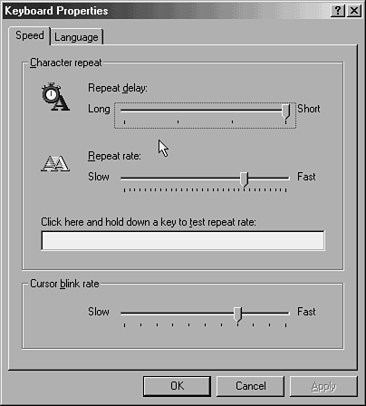

NOTE: The Character Repeat section of the Speed tab enables you to specify how quickly or slowly a character repeats itself on your computer's monitor if you hold down that character's key. Use the test box on the screen to determine through trial and error which setting is best suited to your tastes.
NOTE: The Cursor Blink Rate area enables you to specify how quickly or slowly the mouse cursor shown on your computer monitor blinks on and off. Play around with this setting until you discover the right one for you.

4. Click the Language tab to view the screen shown in Figure K.4. Here you can specify what language you want to use on your PC (the default setting is English (United States).
Figure K.4 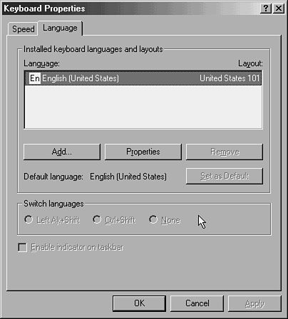

NOTE: You can specify that any of a number of languages be used, and you can increase the number of available languages by installing Windows 98's five additional language-support features (Baltic, Central European, Cyrillic, Greek, and Turkish). For information about installing these features, refer to the sections titled "Add/Remove Programs" and "Multilanguage Support."

5. To add another language, click the Add button and follow the prompts.

NOTE: If you install a language that you don't understand, it is possible to completely mess up your computing environment. This can be fixed only through this Keyboard Properties screen, so either memorize where the various buttons you'll need to use on that screen are placed, or make sure that you are fluent in the language you are installing.

6. When you are satisfied with your settings, click the OK button to exit the Keyboard Properties dialog box.

- M -
- Mail
- Menus
- Media Player
- Microsoft Office
- Microsoft Outlook Express
- Microsoft Windows 98 DOS and MS-DOS Prompt
- Modems
- Mouse
- Multilanguage Support
- Multimedia
- My Computer

Mail
Electronic mail (email) is the method by which you can communicate in writing with another user anywhere on the planet. Email can occur via a corporate network or series of internetworks, or via the Internet. To configure how email is handled by your Windows 98 system, do the following:
1. Right-click the Internet Explorer icon on the Windows 98 desktop and choose Properties from the ensuing shortcut menu,
2. Click the Programs tab in the Internet Properties dialog box to view the screen shown in Figure M.2.
Figure M.2 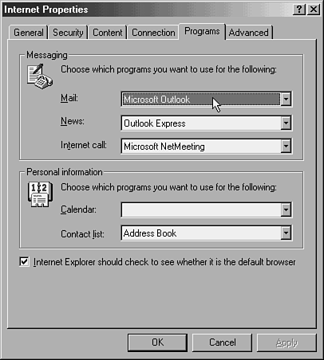

NOTE: The Messaging area enables you to choose which email package you want to use with the Internet Explorer browser, as well as which Internet news and call software you want to use.

3. Click the down-arrow button of the Mail text box to view the drop-down list box that lists the available email software packages that are compatible with the IE browser (see Figure M.3).
Figure M.3 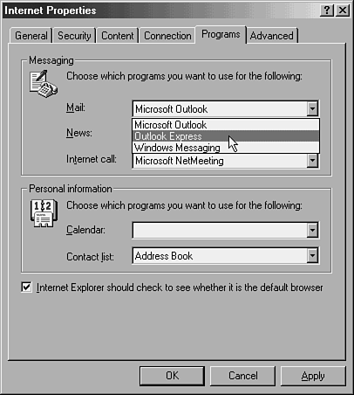

NOTE: If you have a full Windows 98 installation, you are presented with the Outlook Express and the Windows Messaging options. If you have Office installed on your machine, you'll also have the option of selecting Microsoft Outlook, as shown in Figure M.3.

NOTE: Outlook Express is my favorite, because it makes sending and receiving mail very easy.

NOTE: The Windows Messaging client software is also known as the Inbox or Exchange client, which can be very cumbersome and difficult to configure and use.

4. Click the email package of your choice to select it, and then click the OK button to accept the changes and to close the Internet Properties dialog box.
Check out the section titled "Microsoft Outlook Express" for information about reading and sending mail.

Menus
The menus found throughout Windows 98 enable you to easily access applications, data, and system utilities by using either your mouse or keyboard. When using your mouse to navigate menus, you simply click the menu and command you want. To use your keyboard, you must first determine which keyboard shortcut accesses the menu you need. To do this, simply look for the underlined hotkey in the menu's name. For example, the letter F in the File menu is underlined, indicating that F is the hotkey. Pressing the Alt+F key combination opens the File menu.

Media Player
Windows 98 Media Player enables you to play several types of files including ActiveMovie, Mpact MPEG Decoder, Video for Windows, Sound (WAV), MIDI Sequencer, and CD Audio files (you might be able to play a few other types, depending upon your computer's sound equipment). To use Media Player, do the following:
1. Click the Start button, choose Programs, Accessories, Entertainment, and then Media Player, as shown in Figure M.4.
2. The Media Player window, shown in Figure M.5, opens. To quickly determine which types of files are supported by your equipment, click the Device menu option to view a list of acceptable devices.
Figure M.4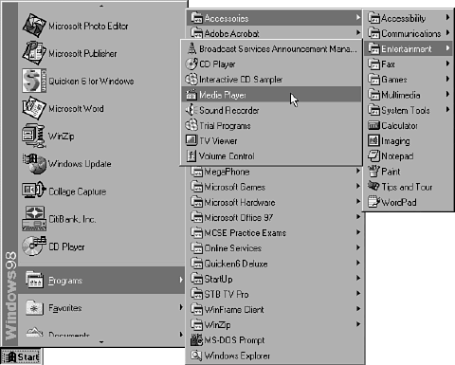

Figure M.5 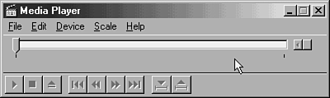

3. To select a media file for playing, click the File menu option and choose Open. The Open dialog box, appears.
4. Navigate to the folder containing the file you want to view, select the file, and then click the Open button. you are returned to the Media Player window, and the file you selected (in this case, Beethoven's Fur Elise) is ready to be played.
5. Click the Play button (the one on the far left that resembles a single right arrow). When the music starts, the marker on the timeline moves to show how much time has elapsed and how much is remaining,

Microsoft Office
Microsoft Office is the most popular of the three major office suites presently available in the computer marketplace (the other two are Lotus SmartSuite and Corel Office). Microsoft Office has two flavors: standard and professional. The standard version comes with Microsoft Word (a word processor), Microsoft Excel (a spreadsheet application), Microsoft PowerPoint (a business
presentation program), and Microsoft Outlook (a personal information manager/email client). The professional edition contains all the applications offered by the standard version, plus Microsoft Access (a database program).
Microsoft Office works very well with Windows 98, providing some additional integration in the realm of electronic messaging that you normally would not find in other office suites's products.

Microsoft Outlook Express
Microsoft Outlook Express is a slimmed-down version of the full-blown Microsoft Outlook email package that comes with Microsoft Office. Outlook Express provides a fully functional POP3 email client that can also access Internet newsgroups.
Outlook Express is able to handle multiple Internet mail connection points simultaneously, a feature not found in most other Internet email software. Suppose, for example, that you have an Internet mail account at work, another one at home, and a third at your spouse's school. Outlook Express enables you to send and receive email to and from all three Internet connections simultaneously instead of requiring you to log in and log out of each one individually. Starting Outlook Express To access Outlook Express, click the Start button and then choose Programs, Internet Explorer, and Outlook Express, as shown in Figure M.56. The Inbox folder of main Outlook Express window, shown in Figure M.57, opens.
Figure M.57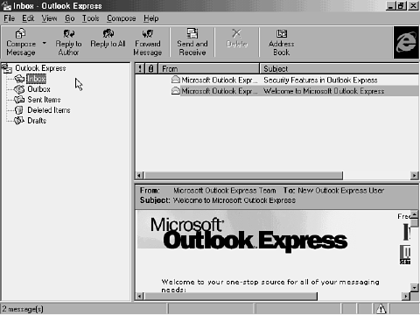

Composing a New Message To compose a message to be sent to another user on your LAN or across the Internet, do the following:
1. Click the Compose menu option and choose New Message Using.

NOTE: If you want to send a message without using stationery, simply choose New Message from the Compose menu.

2. Click the stationery you want to use.
3. In the ensuing Compose New Message screen, type the recipient's email address and then type your message.
4. Click the Send button to move the message to your Outlook Express Outbox folder.
Sending and Receiving Mail
To transmit messages from Outlook Express to other people on your LAN or across the Internet, and to receive messages that others have sent to you, click the Tools menu option and choose Send and Receive. All the messages in your Outbox folder are sent, and all messages waiting for you at your ISP or local post office are received and placed in your Inbox folder. Reading and Replying to Mail Reading email within Outlook Express is very easy:
1. Click the Inbox icon (located under the Outlook Express icon in the left pane) to select it. A list of messages (if there are any) appears in the right-hand pane,
2. Double-click any of the messages that appear in the list. The message you selected opens,
3. To reply to this message, click either the Reply to Author or the Reply to All button,
4. A Message Reply screen opens, as shown in Figure M.63. Type your reply and then click the Send button.
Figure M.63 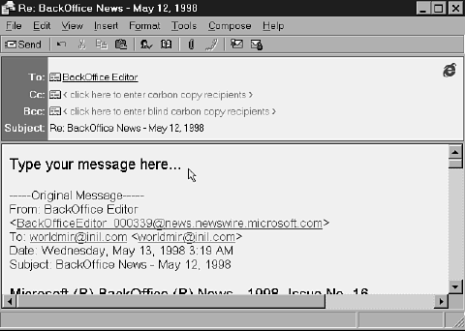

NOTE: You can send one or more message attachments with any email message from Outlook Express. To attach a file, either click the paper-clip icon or click the Insert menu option and choose File Attachment. You are then prompted to select the file you want to attach. Do so and then send the message as normal.

Configuring Outlook Express To reach the Outlook Express Options dialog box, where you can configure Outlook Express to better suit your needs, click Tools and then Options. The following screens are available:
- The General tab, enables you to configure how often Outlook Express checks for new messages, whether Outlook Express plays sounds when new messages arrive, and other aspects of how it performs.
- The Send tab, enables you to instruct Outlook Express as to how you want email and newsgroup messages to be created and sent, and to specify that a copy of all sent messages be logged.
- The Read tab, enables you to specify how incoming messages are downloaded and viewed.

NOTE: The Download xxx Headers at a Time option enables you to specify how many email message headers (that is, author and subject lines) you want to download during a single connection session. This can be useful in the event you get spammed (barraged with electronic junk mail). For example, suppose a spammer sends you dozens of messages about free trips, free cash, or whatever. If you download the header files for these types of messages, you can delete them on your ISP's mail server without downloading the full text of their messages to your PC.

NOTE: Click the Fonts button to specify the font in which all messages are displayed. Click the International Settings button to configure Outlook Express for use with other languages.

- The Spelling tab, enables you to configure how the built-in spellchecker for Outlook Express works. (If you are familiar with Microsoft Office applications such as Word, Excel, and PowerPoint, this screen will look familiar.)
- The Security tab, enables you to set security zones (like the ones in Internet Explorer), which permit you to configure how scripts and active content are used within HTML messages (click the Settings button to set these options). The Secure Mail and Digital IDs sections enable you to hide the content of your email messages.

NOTE: Click the More Info button in the Digital IDs section for information on this very complex topic.

- The Dial Up tab, enables you to automatically connect to the Internet or your email post office via a telephone line. Simply click the Dial this Connection checkbox and enter the name of the connection in the adjacent text box (you can get this information from your ISP).

NOTE: If you have a network (LAN/WAN) connection to the Internet or to your email post office, or if you do not use a modem, you should skip this section.

- The Advanced tab, enables you to set message logging options.
Establishing an Email Account You cannot participate in newsgroups or send email until you've established an account with an ISP. To establish an account, do the following:
1. In the main Outlook Express window, click the Tools menu option and select Accounts.
2. Click the Mail tab in the ensuing Internet Accounts screen to view any existing accounts (if you don't have an account, this tab is empty, as shown in Figure M.71).
Figure M.71 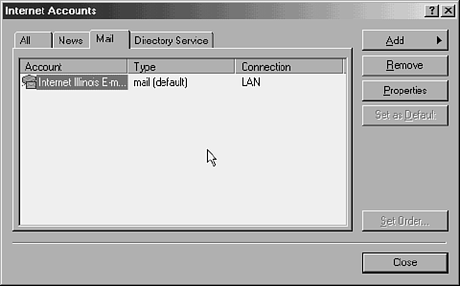

3. Click the Add button and select Mail from the ensuing shortcut menu. The first screen of the Internet Connection Wizard, shown in Figure M.72, appears.
4. Type the Display Name for your Internet mail account (this is the name that appears in the From field of outgoing messages) and click Next to continue.
Figure M.72 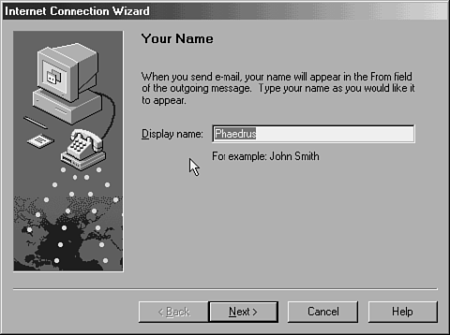

NOTE: I usually refrain from using my real name in this field, but if you are a corporate environment, this might not be a wise decision. (In other words, use your real name if you are at work.)

5. In the Internet E-mail Address window, shown in Figure M.73, type the email address assigned to you by your ISP or company email administrator, and then click Next to continue.
Figure M.73 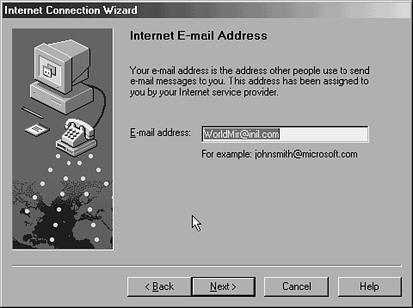
6. Enter the names of your email servers in the E-mail Server Names window, shown in Figure M.74. You must also specify the type of your incoming email server. If this is an ISP account, the email server is probably a POP3 mail server (when in doubt, use POP3 as your default). Click Next to continue.

NOTE: Contact your ISP or local email administrator if you need help filling out this screen.

7. The Internet Mail Logon screen, shown in Figure M.75, enables you to specify your user name and password, or to specify that Secure Password Authentication (SPA) be used. After you make your selection, click Next to continue.
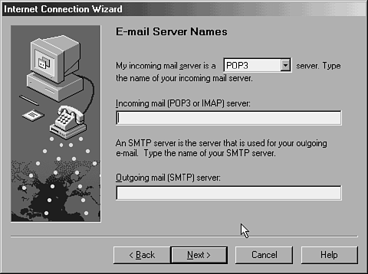
Figure M.74
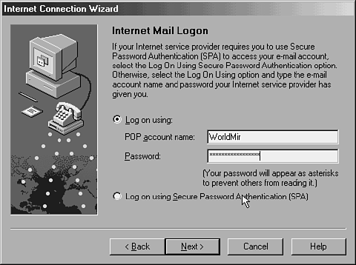
Figure M.75

NOTE: When you employ secure password authentication, your logon information is sent in an encrypted state, which means it will be more secure than a standard POP3 mail logon. The standard POP3 method is clear text, so just about anyone can determine what your user ID and password is, provided they have a sniffer somewhere between your machine and your ISP's server.

8. In the Friendly Name screen, type a name for your account that will be easy for you to remember, and then click Next to continue.
9. In the Choose Connection Type screen, select the method that best describes how you plan to connect to the Internet (in this example, I have chosen the Connect Using My Local Area Network (LAN) option because I use a cable modem connection, which means that I have a high-speed LAN connection directly to my ISP via the fiber optic cable TV lines in my area). Click Next to continue.

NOTE: If you connect to your ISP via a Windows 98 Dial-Up Networking connection at the beginning of a Windows 98 session and would like to start your email connection at will, you should select the Connect Using My Local Area Network (LAN) option. If you select Connect Using My Phone Line, your Outlook email software automatically tries to dial your connection to the Internet, even if you are already connected.
10. To save your settings, click Finish,. You are then returned to the Internet Accounts
11. Click the Close button to exit the Internet Accounts screen and return to the main Outlook Express window.

Microsoft Windows 98 DOS and MS-DOS Prompt
Despite the fact that Windows 98 is a GUI environment, DOS is still an important aspect of the operating system. To access and use the MS-DOS Prompt, do the following:
1. Click the Start button, choose Programs, and then MS-DOS Prompt, as shown in Figure M.85.
Figure M.85 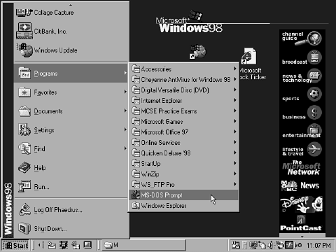
2. The MS-DOS Prompt window, shown in Figure M.86, opens. Simply type the command you want to execute and press Enter.
Figure M.86 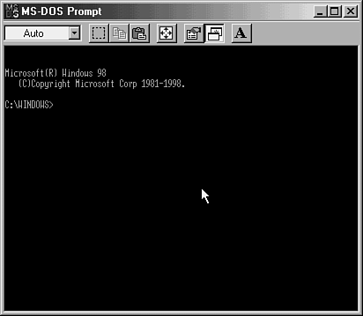
There are literally dozens of documented and undocumented DOS commands. However, there are a few commands that you should avoid unless you know how to use them properly:
- Fdisk
- Format
- Debug
- Sys
- Command
- Deltree

NOTE: A few DOS commands, such as Fdisk, Format, and Debug, should be used with extreme care. You should never play with these commands to figure out what they do or how to use them properly. For example, Fdisk and Debug both enable you to quickly and irrevocably destroy the contents of your entire hard drive.

Countless books and magazines cover the subject of disk operating systems such as MS-DOS, and you would be wise to invest in one before reconfiguring portions of Windows 98 through the DOS prompt.

Modems
The term modem literally means modulator-demodulator. In English, a modem is a hardware device that translates the bits of information from your computer into bits of data that an analog telephone line (such as the one you call your mom on every week) can understand enough to transport it to another computer's modem (where the process is reversed).
To see what modems you have installed in your computer, and for a quick lesson in determining whether a modem is working, do the following:
1. Click the Start button, choose Settings, and then Control Panel, as shown in Figure M.87.
2. Double-click the Modems icon in the Control Panel window, shown in Figure M.88.
3. The modem(s) listed in the General tab of the Modems Properties dialog box is installed in your computer (see Figure M.89). To determine whether that modem is properly communicating with Windows 98, click the Diagnostics tab.
Figure M.87
Figure M.88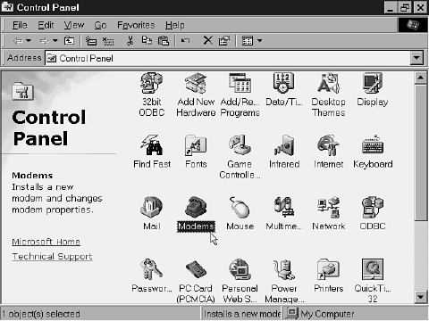

Figure M.89 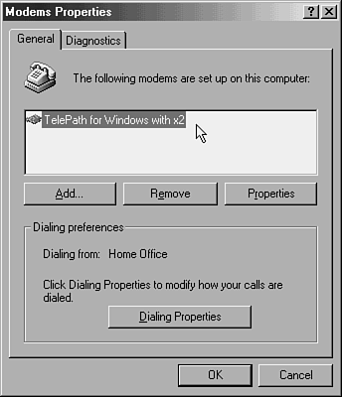

NOTE: If the top box in the General tab of the Modems Properties dialog box is empty, this means no dial-up modems are properly installed in your computer. However, it is also possible to see a cable modem installed and working properly appear in the box; but this is not the norm.

4. All the available communications ports are listed in the Diagnostics tab as is the name of the modem installed on each port (in the event you have more than one modem connected to your PC). Select a modem by clicking its port and then click the More Info button to check the communications capabilities of that modem.
5. The More Info screen appears. If the modem is working properly, as is the case in this example, then this screen contains useful information. For instance, you can determine which communications port and interrupt your modem uses. Click the OK button to return to the previous screen.

NOTE: If no responses are indicated in the box at the bottom, it is likely that the connection between your PC and the modem has failed, or that your modem is not working properly (perhaps because the wrong software drivers are loaded, or because the modem is broken).

6. Click the General tab in the Modems Properties dialog, and then click the Properties button to review and configure the highlighted modem in the Modem Name Properties dialog box (the General tab of this dialog is shown in Figure M.92).
Figure M.92 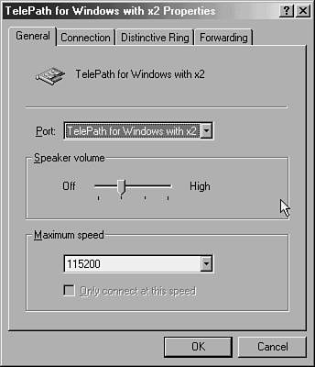

7. The General tab enables you to set the maximum speed at which the modem should attempt to connect, and how loud your modem is when it connects.

NOTE: If you have a 19.2Kbps modem, setting it at 57.6Kbps does not make your modem work faster; it only tells Windows 98 that maybe your modem can transmit information faster than it actually does.

8. Click the Connection tab to view information about how the parity data bits are set, how your call preferences are set, how well the port settings are configured, and how well your advanced settings are configured
NOTE: Windows 98 does an excellent job of configuring the settings in the Connection tab whenever a new modem is installed, so if you do not understand these complex terms, you can safely leave them alone.

NOTE: To access either port settings or advanced settings, click the Port Settings or Advanced button, respectively.

9. Click the Distinctive Ring tab to view the screen. This screen enables you to configure how the modem will sound if you are using it for inbound telephone calls.

NOTE: In order for you to be able to configure how your modem sounds, your telephone line must support distinctive ring services. Check with your local telephone company for more information.

NOTE: If no Distinctive Ring tab appears on your Modem Name Properties dialog box, it indicates that your modem device is incapable of supporting this option.

10. Click the Forwarding tab to view the screen. If applicable, click the This Phone Line Has Call Forwarding check box, and type the proper activation and deactivation codes for your line (your local telephone company should provide these codes to you).

NOTE: In order for you to be able to enter information in the Forwarding tab, your telephone line must support forwarding. Check with your local telephone company for more information.

NOTE: If no Forwarding tab appears on your Modem Name Properties dialog box, it indicates that your modem device is incapable of supporting this option.

11. Click the OK button to accept any changes. You are returned to the General tab of the Modems Properties dialog box.
12. Click the Dialing Properties button to open the screen. Here you set the location(s) from which you are dialing, as well as any special codes that must first be dialed to reach an outside line, in order to disable call waiting or caller ID, or to use a calling card. When you are satisfied with your selections, click OK to return to the Modems Properties dialog, and click OK again to accept your changes.
Figure M.96 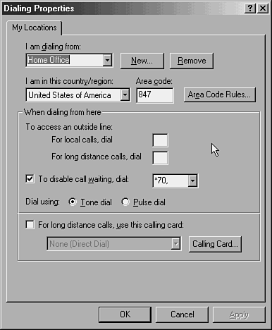

Mouse
The mouse is one of the most important pieces of hardware on your computer system. Without one, it is virtually impossible to be productive on a Windows 98 PC.
Most mice have two buttons: a primary one (usually the left button) and a secondary one (usually the right button). Some mice have a third button or a rolling ball or wheel (as is the case with the Microsoft IntelliPoint mouse) in the middle.
To configure your mouse to best suit your needs, do the following:
1. Install it according to your mouse manufacturer's specifications.

NOTE: Your mouse most likely has a tiny attachment on the end of the cable that plugs into a specific port on the back of your PC. (If your mouse's connection looks like the one for the keyboard, refer to your computer's documentation to figure out where your keyboard and mouse connections belong).

2. Install the software drivers that came with the mouse that you purchased (if this is a new computer with pre-installed software, chances are that your mouse software has already been installed for you).
3. Click the Start button, choose Settings, and then click Control Panel,
4. Double-click the Mouse icon in the Control Panel window

NOTE: The next several screens are for the Microsoft IntelliPoint mouse, which has a rolling wheel in addition to primary and secondary buttons. If you do not have this type of mouse, many of these screens will vary. In those cases, consult the documentation that came with your mouse so that you can configure it for Windows 98.

5. The StepSavers tab of the Mouse Properties dialog, has four timesaving options: SnapTo, Focus, ClickSaver, and SmartSpeed. These features give you the ability to make things happen faster with fewer mouse clicks or movements. Carefully read each option before making your choices.
6. Click the Pointers tab to view the screen. This tab enables you to change how your mouse pointer appears onscreen. To change your mouse pointer, click the down-arrow button next to the Scheme text box to view a drop-down list of available pointer schemes (in this example, the Mouse scheme has been selected).
7. Click the Apply button to accept the scheme you've selected.
8. Click the Basics tab to view the screen. Here you can specify how quickly your pointer moves, which button is the primary, which is the secondary (this is useful if you are left-handed), and the double-click speed.
9. Click the Visibility tab to view the screen. Click these options to specify whether you want your pointer to vanish while you type, to display pointer trails, or to automatically wrap to the opposite edge of the screen when you start a new line. You can also select the Sonar option, which displays a target around your mouse pointer whenever you press the Ctrl key on your keyboard.
10. Click the Productivity tab to view the screen. My personal favorite, the Odometer section, lets you see how far your mouse pointer has traveled across your monitor since the day you installed it.
11. Click the Wheel tab to view the screen. In addition to enabling you to scroll up and down screens by simply rolling the wheel forward or backward, the wheel can also act as a button when you press it. To change the button features of the wheel, click the down-arrow button to the right of the Button Assignment text box. Then you can select from the list of tasks the wheel can perform: double-click, get help (F1), start Windows Explorer, or open the Start menu. Press the wheel, and the action you assigned should occur instantly.
12. Click the Apply button to accept changes to the mouse wheel.
13. Click the OK button to exit the Mouse Properties screen.

Multilanguage Support
Microsoft Windows 98 provides a series of options that permit the support of other languages within the operating system. To install any of the language options, do the following:
1. Click the Start button, choose Settings, and then click Control Panel,
2. Click the Add/Remove Programs icon in the Control Panel Window,.

NOTE: For more information about the Add/Remove Programs feature, refer to the section titled "Add/Remove Programs."

3. Click the Windows Setup tab in the Add/Remove Programs screen.
4. Highlight the Multilanguage Support option in the Components list. A description of the component appears in the Description box, informing you of the available languages,
5. Place a check mark next to the Multilanguage Support option and then click the Details button to view the screen. This screen enables you to install only a portion of the multilanguage support (that is, you can install a single language instead of installing all of them).
6. Select the language you want to install and then click OK. The necessary files are installed.
7. Click OK in the Windows Setup tab to exit the Add/Remove Programs dialog box.
8. If prompted, insert the Windows 98 CD-ROM.
9. Reboot your computer.

Multimedia
The multimedia features of Windows 98 allow a computer to handle audio and video content in a more pleasing manner, as well as to provide you with a more user-friendly way in which to learn new things and perform tasks.
To view multimedia content in Windows 98, you can use the ActiveMovie control. For information on using ActiveMovie, refer to the section titled "ActiveMovie Control."

My Computer
The My Computer icon found on the Windows 98 desktop provides you with a quick means to explore your computer. Double-click it to open an Explorer-type window that enables you to peruse your hard drive just as you do with the Windows Explorer utility.

