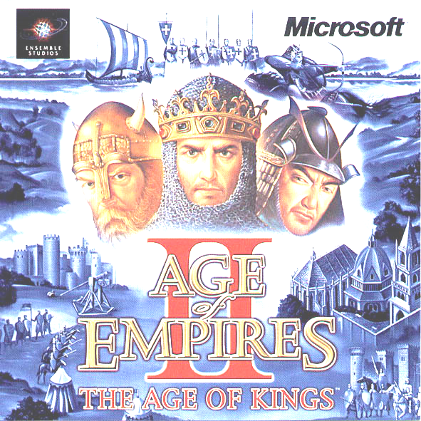
… And the winner is…

X-TECH
X-Tech

Biforkacioni
Biforkacioni

Last Heroes
Trials
(7B)

Last Heroes
(8A)
Illyrians
(7AB)
Biforkacioni
(7A)
Legendaries
X-Tech
King Lock
(7A)

X-Tech
(7A)

Legendaries
(6A)

The Kings
(4A)

The Tournament of “Age of Empires”

Class | Team Name | Players
4/A | The Kings | Arbër Pacolli  Korab Hoti
6/A | Legendaries | Triar Bajrami  Enis Reshani
7/A | X-Tech | Edon Asllani  Vigan Gashi
7/A | King Lock | Artin Deshishku  Fitim Pacolli
7/A | Biforkacioni | Altin Krasniqi  Astrit Abrashi
7/A-B | Illyrians | Shqiptar Novosella  Jon Krasniqi
7/B | Trials | Lorik Maxhuni  Leart Gorani
8/A | Last Heroes | Blend Dubova  Art Raifi

ICT
Department
Presents
ICT
Department
Presents

