Tutorial: Using AJAX and the Google Calendar API
[Note: much of the code comes from two examples I found on-line: one at http://ajax.phpmagazine.net/2005/11/ajax_rss_reader_step_by_step_t.html that shows how to use the Google Calendar API and the other from a source I came across several years ago that I could not re-locate to build dynamically a calendar for the current month. This was my first experience using AJAX techniques and also the Google Calendar API. There is much I do not fully understand. The error handling, including code I wrote, has not been completely tested by me. I would appreciate comments and suggestions. Note also that the Google Calendar is deemed to be 'beta', that is, possibly buggy and that has been my experience.]

Overview
These notes describe the use of so-called asynchronous JavaScript with XML to extract information from a Google calendar previously set up and use the information in a web page. The example can be viewed at newmedia.purchase.edu/~Jeanine/calendar/calwithgooglecalfancy4.html
When you first go to this URL, you will see:
Requesting data…
All Events

Depending on the speed of your connection and, perhaps, how busy Google is, you soon will see something like this:
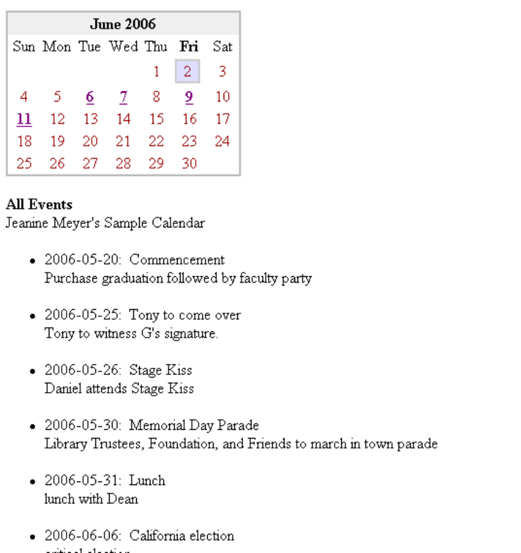

Below the words All Events, all events listed in the Google Calendar are displayed in order of date. Some of these are before the current month and some afterwards. It took some work to get the events in date/time order because the order that is returned from Google Calendar is order of posting into the calendar. You can choose to put some events in your own calendar and work immediately on your own code. The only essential difference is the php file to be explained below.

Notice that certain dates in the month are highlighted in some way. The current date (June 2nd) has a box around it. Other dates are a different color and underlined. (Yes, it is possible for the current day to be in a different color and underlined.) These represent the days/dates for which there is at least one booked event. Speaking in HTML terms, these numbers are <a> tags with onmouseover and onmouseout attributes specified. Moving your mouse over one of these will cause details of the first event for those days to be displayed.

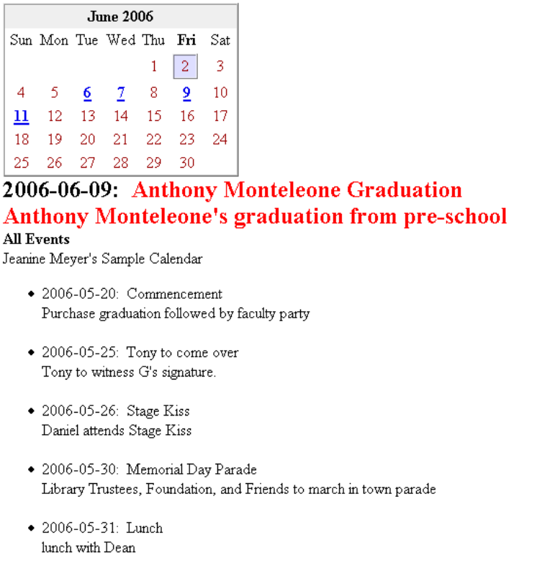

Technical concepts: google calendar api, xml http object, dynamic html, Date, try
I will cover the major technical concepts and then show and annotate each line of code.

To create your own version of this, you must get a Google gmail account, create a calendar, and get a URL to be included in one of the files. ASSUMING you have created a calendar, you need to
- go to gmail.google.com. You should see your mail.
- click on Calendar in the upper left corner. You now will see a page with Google Calendar Beta.
- on the top, towards the right, click on Settings.
- down slightly from the top, click on the tab Calendars.
- You will see a section entitled, My Calendars (yes, you can have more than one and it probably makes sense to set up one for experimentation). Click on the one you plan to use for this work. I named mine Jeanine Meyer’s Sample Calendar.
- you now see a page with information on this calendar. Scroll down to where it says Private Address and icons for XML and ICAL. Click on the XML one. A window will pop up with the URL you need to copy and paste into the php file to be described below.

The ‘asynchronous’ aspect of the code is that a special type of object is created to invoke a server-side script, in this case, one written in php, that, when complete, provides data in the form of an XML file to be examined. A function specified by setting a property of the object does the work of examining the XML. HTML is created dynamically and placed in the original document, specifically in a <div>. The original document remains on the screen until it is modified by the javascript. The server-side php script makes a call using what is called the Google calendar Application Programming Interface. The diagram below shows the different parts of the application. My part consists of 3 scripts/files:
- calwithgooglecalfancy3.html ( HTML with Javascript)
- style2.css, the stylesheet and
- eventrssfull.php, a very short php file.

Google calendar
php script
Html script
CSS stylesheet

The oval in the figure represents the object that does the work of making the call to the server-side program. The code to set this up is browser-dependent, namely one call for everything except Internet Explorer and one call for IE. The code is

if (window.XMLHttpRequest)
RSSRequestObject = new XMLHttpRequest()
else
if (window.ActiveXObject)
RSSRequestObject = new ActiveXObject("Microsoft.XMLHTTP")
else alert
("Cannot setup call to access google calendar using this browser.");

This is the suggested way to write browser-dependent code. It does not try to get the name of the browser. Instead, you can read the code as ‘saying’:

Does the method window.XMLHttpRequest exist? If it does, use it to define something called RSSRequestObject. If it does not exist, then does the method window.ActiveXObject exist? If it does, use it to define the object or, if not, send out an alert message.

Now, once RSSRequestObject is created, it can be used to make the call. For this application, this is done using the following statements (note: you will see that they do not appear all together in the code):

Backend = eventrss.php;

RSSRequestObject.open("GET", Backend , true);

RSSRequestObject.onreadystatechange = ReqChange;

RSSRequestObject.send(null);

The open method of the object sets up the type of transmission and that the call is to the php file named. The onreadstatechange property is set to ReqChange. This is the name of a function defined in the HTML file. Setting the property means that when the object is in the ready state, that is, when it has received the information from the server-side script, the ReqChange function will be called. The send method invokes the php file specified by the variable named Backend cited in the call of the open method. I assume, but have no experience with it, that it is possible to send data over to a server-side script. I also assume that POST can be used as well as GET.

The code that sets up and makes the call is in a function named RSSRequest. This function is invoked initially when the HTML is loaded by naming it in the <body> tag.

<body onload="RSSRequest();">

It also is invoked by being in a function that is itself invoked through a setInterval statement. This is to make sure the calendar data is updated regularly.

The ReqChange function does the work of extracting information. It does this with statements such as

var Summary = items[n].getElementsByTagName('Summary').item(0).firstChild.data;

My experience working with XML here and in other applications, is that it is easy to believe you are at a slightly different place in the XML tree than you actually are. In this case, items is an array of elements, with each corresponding to an event in the calendar. Each element items[n] is itself an XML subtree. The expression

items[n].getElementsByTagName ('Summary')

extracts an array of all elements with that tag name. It is an array even if there is only one such element which is the case here. Then, we look at the first (and only one) of these elements. We then look at the first child. This will be a text element and we look at its data.

The code works by building up a string, for example, cal, incrementally

cal += …

Note that the plus sign in this context is the string concatenation operator. The string then is displayed in the HTML document using statements such as

document.getElementById("monthly").innerHTML = cal;

The statement above assumes that the HTML <body> contains

<div id="monthly"></div>

The code that extracts the information on the entries concatenates the string data and puts all the information for an entry to be one element of an array. The array is then sorted and since the date and time are the first parts of all the elements, the resulting array is in time order. (To be more precise, the elements do have <li> tags at the start but all entries have them, so the sorting does correspond to the date and time.)

itemsstuffs = itemsstuff.sort();

This new array is used to make the listing of the events. It also is used when constructing the calendar for the current month.

The code to make the calendar for the month, the function producecalendar, goes through various calculations to build the headings, including highlighting the abbreviation for the day of the week that is the current day, and to make the blanks for the days in the week before the first day of the month: the month of June, 2006 started on a Thursday. I did the screen captures on Friday, June 2nd. The code then loops through each day of the month. The code, to be explained below, makes use of a variable named notyetscanned. Think of comparing two sorted lists to see if there are any matches.

The code needs to determine if the day being processed is listed in the itemsstuffs array. If it is, then html is generated to make this particular day be in an <a> element. The onmouseover attribute in the <a> tag is set to be a function call of the function showitem. The call includes an argument that is the index of the particular entry in the itemsstuffs array. The showitem function, invoked by the user moving the mouse over the indicated numeral in the month calendar, will put information about the event in the <div> area with id='feature'. [If there is more than one event entry for that day, only the first one will be displayed in this way.] If the argument is -1, then the empty string is inserted into the feature div. The call generated dynamically will be something like:

<span class='booked'><a onmouseover='showitem(5);' onmouseout='showitem(-1);' href='#'>6</a></span>

In this example, the numeral 5 is the string representation of notyetscanned. The html is produced by setting at the start:

var part1 = "<span class='booked'><a onMouseOver = 'showitem(";
var part2 = ");' onMouseOut='showitem(-1);' href='#'>";

Note: the inner single quotes are treated as ordinary characters within the string delimited by double quotes. This is a trick to getting strings containing quotation marks.

The values of part1 and part2 do not change. Within the producecalendar function, there is the line:
whichspan = part1 + notyetscanned + part2;

This line evaluates the variable notyetscanned to get a number, which, concatenated with a string, is turned into a string. The following line would be incorrect:
whichspan = "<span class='booked'><a onMouseOver = 'showitem(notyetscanned);' onMouseOut ='showitem(-1);' href='#'>";

Besides the fact that the single statement goes over multiple lines, the main problem is that the variable notyetscanned gets evaluated at the time of the call, so all the calls to showitem would get the same value, namely the length of itemsstuffs.

The calendar constructing code makes use of the JavaScript Date object and the many methods. You need to keep in mind that days of the week are indicated by numbers 0 to 6 and months of the year by numbers 0 to 11. The week starts with Sunday.

The code makes use of the JavaScript try and catch construction.

try { }
catch(e) { }

This is a way to prevent errors from being shown to the viewer. You put anything that may produce an error into the try clause. If there is an error, control goes to the catch clause. The variable e can be set to information on the error. In this application, there is no attempt to interpret the error. Instead, a variable is set another way.

Code
The php file named eventRSS.php looks (something like) this:

<?php | Normal php opener
$calendarURL = 'http://www.google.com/calendar/feeds/jeanine.meyer@gmail.com/private-…/basic'; | Here's where you insert your Private Address.  I've deleted the numbers for my calendar and put in 3 red dots
$feed = file_get_contents($calendarURL); | the call to the Google Calendar API specified to by your calendar
header('Content-type: text/xml'); | Sets content type of the file to be returned
echo $feed; | Generates/returns this file
?> | Normal php closer

Note that there also is a full format for the Google Calendar data. You can look at other html scripts on my site (http://newmedia.purchase.edu/~Jeanine/calendar/) that use this one or check out other information on-line for details on this. Note that time is part of the content data and that there may be a problem with the time zone.

The stylesheet style2.css defines look of plain and booked days and also the day event entry that is featured. The stylesheet simplified the display of the calendar of the month.

span.plain { | This is the style for contents of any span with class plain
color: #990000;
font-weight: normal;
} | Ends the style
span.booked {
color: #FF0000; | Color is over-ridden by being in an <a> element
font-weight: bold;
} | Ends the style
div#feature {
color: #FF0000;
font-weight: bold;
font-size: 1.5em; | Make the featured information by large[r]
} | Ends the style

The html with JavaScript file, calwithgooglecalfancy4.html, follows. It probably makes sense to start by noting the contents of the <body> element and then noting each of the functions. A calling map for the functions is

Function | Function | Called from/Invoked by
padding | Pads: 7 to 07 | makegdate
makegdate | Produces dates in form yyyy-mm-dd | Outside any function & in producecalendar
producecalendar | Produces month calendar | ReqChange
showitem | Puts entry data in feature div | From dynamically generated html with onmouseover and onmouseout
ReqChange | Does all the work extracting from xml | From setting of RSSRequestObject
RSSRequest | Sets up and makes call of php script | Onload in <body> and update_timer
update_timer | Invokes RSSRequest | From setInterval in <script> tag
HideShow | Toggles status div | ReqChange and RSSRequest

The code for the HTML file is:

<html><head><title>Monthly calendar with information from google calendar</title> | Usual HTML start
<link rel="stylesheet" href="style2.css" type="text/css" /> | Reference to the stylesheet file
<script> | Start of script element
<!-- Begin | Used to hide scripting from older browsers.  Code starts with fixed variables, including several arrays, and others used in the functions.
var day_of_week = new Array('Sun','Mon','Tue','Wed','Thu','Fri','Sat'); | Sets up names (the abbreviations) for the days of the week
var month_of_year = new Array('January','February','March','April','May','June','July','August','September','October','November','December'); | Sets up names for the months
var Calendar = new Date(); | All information on today's date
var year = Calendar.getFullYear(); | Returns year (note: getYear is not consistent in different browsers)
var month = Calendar.getMonth(); | Returns month: 0 to 11
var today = Calendar.getDate | Returns a day: 1 to 31
var weekday = Calendar.getDay(); | Returns a day. Used to determine which day to highlight in the header line for days.
function padding(sday) { | Function: Pads (adds a 0) as needed
sday = sday.length==1 ? '0'+sday : sday; | Conditional expression: 5 will go to 05, 12 will not change.
return sday;
} | End of function
function makegdate(yr,mn,dy) { | Function: constructs a string of the form yyyy-mm-dd
smonth = String(mn+1); | Need to add 1 and then convert to string
smonth = padding(smonth); | Pad if necessary
sday = String(dy); | Convert to string
sday = padding(sday); | Pad if necessary
var gdate = String(yr)+'-'+smonth+'-'+sday; | Combine
return gdate; | Return result
} | End of function
var part1 = "<span class='booked'><a onMouseOver='showitem("; | Constant start of booked days
var part2 = ");' onMouseOut='showitem(-1);' href='#'>"; | Constant second part of booked days (after the value pointing into the itemsstuffs array)
var notyetscanned = 0; | Used in checking for events
gtoday = makegdate(year,month,today); | The formatted form for today.
var DAYS_OF_WEEK = 7;
var DAYS_OF_MONTH = 31; | Special cases will come later
var cal; | This will hold the built-up month
Calendar.setDate(1); // Start the calendar day at '1' | Change the Calendar Date object to be the first of the month
var TR_start = '<TR>'; | Formatting of table row start
var TR_end = '</TR>'; | .. and end
var highlight_start = '<TD WIDTH="30"><TABLE CELLSPACING=0 BORDER=1 BGCOLOR=DEDEFF BORDERCOLOR=CCCCCC><TR><TD WIDTH=20><B><CENTER>'; | The box highlighting of the current day is done by making it a table by itself. To change the color, change the DEDEFF for the box and the CCCCCC for its outline.
var highlight_end = '</CENTER></TD></TR></TABLE></B>'; | This is the ending tags
var TD_start = '<TD WIDTH="30"><CENTER>'; | The tags for the start of an ordinary day
var TD_end = '</CENTER></TD>'; | … and the ending tags
function producecalendar() { | Function to produce the month
cal = '<TABLE BORDER=1 CELLSPACING=0 CELLPADDING=0 BORDERCOLOR=BBBBBB><TR><TD>'; | Start off the cal string with the starting tags for the outermost table.
cal += '<TABLE BORDER=0 CELLSPACING=0 CELLPADDING=2>' + TR_start; | This starts off the first row, which will hold the month and the year
cal += '<TD COLSPAN="' + DAYS_OF_WEEK + '" BGCOLOR="#EFEFEF"><CENTER><B>'; | This indicates the width plus the background color
cal += month_of_year[month] + ' ' + year + '</B>' + TD_end + TR_end; | Here is where the name of the month and the year (June 2006) get displayed
cal += TR_start; | Start the next row, which are the day headings
for(index=0; index < DAYS_OF_WEEK; index++) { | Start loop that will print Sun Mon and so on
if(weekday == index) { | Each time, check if it the current day
cal += TD_start + '<B>' + day_of_week[index] + '</B>' + TD_end;} | … if so, make this one bold
else { | If not
cal += TD_start + day_of_week[index] + TD_end;} | Print day in normal fashion
} | Ends loop for days
cal += TD_end + TR_end; | End this row
cal += TR_start; | Start of new row
for(index=0; index < Calendar.getDay(); index++) { | Loop to generate blanks until the first day of the month. This is under Sun through Wed in the June 2006 calendar.
cal += TD_start + ' ' + TD_end; | Output a TD element holding a blank
} | End loop
for(index=0; index < DAYS_OF_MONTH; index++) | This is the loop for all the days of the month (largest possible month)
{
if( Calendar.getDate() > index ) | Recall that this was set at 1 outside of the function, so the process will start. See statement below with comment on days of the month. I call this the inner clause
{
week_day =Calendar.getDay(); | Get the number for the day
if(week_day == 0) { | Is it the start of the week (Sunday)?
cal += TR_start; } | .. if so, start the row
if(week_day != DAYS_OF_WEEK)
{
var day = Calendar.getDate();
 | Make 2 determinations: does the date have any events and is it today
cdate = makegdate(year,month,day); | Generate a formatted version for the day
whichspan = "<span class='plain'>" | This is the default starting tag
whichspanend = "</span>"; | This is the default ending tag
cont = true; | Need to do this check at least once
while ((notyetscanned<itemsstuffs.length) && cont) { | Check the sorted array of events as long as there are events still to check and cont is true (meaning not past the day)
itemfull = itemsstuffs[notyetscanned]; | Get the entry
itemd = itemfull.substr(22,10); | Find the date within the entry
if (cdate == itemd) { | Is it [the same as] this day?
whichspan = part1+notyetscanned+part2; | … if so, form the correct whichspan
whichspanend = "</a></span>"; | And whichspanend
cont = false;} | Can stop searching
else if (cdate < itemd) {whichspan = "<span class='plain'>"; cont = false;} | Else check if the day is earlier than the next one of the event (whichspanend is okay)
else {notyetscanned++;} | Increment notyetspanned because there may be more entries to check
} | Ends the while loop
if( today==Calendar.getDate() ) { | Do the check for this being today
cal += highlight_start + whichspan+day+whichspanend+ highlight_end + TD_end; } | … if so, do special highlighting, incorporating the whichspan and the whichspanend.
else { | Else not today
cal += TD_start + whichspan+day+whichspanend + TD_end; } | … do simpler formatting
} | Ends the
if(week_day == DAYS_OF_WEEK) { | Check if end of week
cal += TR_end; } | ..if so, end row
} | Ends inner clause
Calendar.setDate(Calendar.getDate()+1); | Set up for next iteration. In cases of the shorter months, this will make Calendar.getDate() go to zero and the inner clause will NOT execute
} | Ends index loop
cal += '</TD></TR></TABLE></TABLE>'; | Put in final tags
document.getElementById("monthly").innerHTML = cal; | Put cal into its place in the body of the document.
} | Ends producecalendar function
function showitem(item) { | Function called from the onMouseOver action in the dynamically generated code
if (item>=0) { | If the parameter item is an index into the itemsstuffs array
item = itemsstuffs[item].substr(4); | … use it. Remove the initial <li>
item = item.replace('</li>',''); | Remove the </li> tag
}
else { | If not an index (this is the case when showitem is called by action of onmouseout
item = ""; } | Set up to put in the empty string
document.getElementById("feature").innerHTML = item; | Put material into the feature div
} | Ends showitem function
var RSSRequestObject = false; | This will be the special object
var Backend = 'eventrss.php'; | Points to the server-side (php) script
window.setInterval("update_timer()", 600000); | Google calendar checked every 10 minutes
if (window.XMLHttpRequest) | Trying to create the HTTP request object, first the non-IE way
RSSRequestObject = new XMLHttpRequest()
else | else
if (window.ActiveXObject) | … the IE way
RSSRequestObject = new ActiveXObject("Microsoft.XMLHTTP")
else
alert("Cannot setup call to access google calendar using this browser.");
function ReqChange() { | Function ReqChange: invoked when the request object is ready
// If data received correctly
if (RSSRequestObject.readyState==4) { | Error checking
if (RSSRequestObject.responseText.indexOf('invalid') == -1) | Invalid is false, so there is something to do
{
var node = RSSRequestObject.responseXML.documentElement; | This takes in the XML produced by the server-side program
var title = node.getElementsByTagName('title').item(0).firstChild.data; | Extracts the title: the name of the Google Calendar
content = '<div class="channeltitle">'+title+'</div>'; | Starting tags for what will be displayed
var items = node.getElementsByTagName('entry'); | items will be an array with an element for each event
if (items.length == 0) {
content += '<ul><li><div class=error>No events</div></li></ul>'; | Output if no events
} else { | Else …
var itemsstuff = Array(); | Start off an array, with each element being a string with all the information extracted for each event
for (var n=items.length-1; n >= 0; n--){ | Loop over items starting from the last
var itemTitle = items[n].getElementsByTagName('title').item(0).firstChild.data; | Extract event's title
var itemContent = items[n].getElementsByTagName('Summary').item(0).firstChild.data; | Extract event's content
try { | There may not be a published element, so do this within a try to prevent generating an error
var subdate = items[n].getElementsByTagName('published').item(0).firstChild.data; | .. if there is a published element, put this in subdate (more manipulation done later)
subdate = subdate.substr(0,10); | Extract just the date (this is the date the event was put into the calendar
var datepl = Summary.indexOf('When:'); | Look for when. This is the actual date
if (datepl>=0) { | If when is located…
subdate = Summary.substr(datepl+6,10); | Make the following characters be the date
} | End the true clause
else {  datepl = Summary.indexOf('First start:'); | Else… look for First start. This will indicate the date for a recurring event
if (datepl>=0) {  subdate = Summary.substr(datepl+13,10); | If first start located, extract those characters for the date
} } | End the if and the else clause
var itemPubDate = '<font color=black>'+subdate+':&nbsp; '; | Put in formatting
} | Ends the successful try clause
catch (e) { | If there was a problem
var itemPubDate = ''; } | Just make it the empty string
itemsstuff.push  ('<li>'+itemPubDate+'</font>'+itemTitle+'<br> '+itemContent+'</li><br>'); | Add new element to the array, pushing on data with some HTML tags.
} | Ends n loop building itemsstuff
itemsstuffs = itemsstuff.sort(); | Sort elements. This will sort in date order
producecalendar(); | Invoke the function to build the month calendar
content += '<ul>'; | Add to the content string, starting with the tag for bulleted lists.
for (var n=0;n<itemsstuffs.length;n++) { | Loop over elements in itemsstuffs array (the events)
content += itemsstuffs[n]; | For each one, concatenate to content
} | Ends this n loop
content += '</ul>'; | Add closing tag
} | Closes clause for valid data
document.getElementById("ajaxreader").innerHTML = content; | Display results
document.getElementById("status").innerHTML = "Calendar items read."; | This does not appear long enough to see
} | Closes outer loop for error check
else {document.getElementById("status").innerHTML = "<div class=error>Error requesting data.<div>"; | … else indicate error
}
HideShow('status'); | Toggle showing of status div
}
} | End of ReqChange function
function RSSRequest() { | Function setting up and making request
HideShow('status'); | Toggle status to display.
document.getElementById("status").innerHTML = "Requesting data ..."; | … Requesting data….
if (RSSRequestObject) { | If the request object has been set up
RSSRequestObject.open("GET", Backend , true); | …start the set up of the request by specifying the mode and the php file
RSSRequestObject.onreadystatechange = ReqChange; | Set the ReqChange function to handle the event of the request being accomplished
RSSRequestObject.send(null); | Send off the request
} | Ends the clause for the object existing
} | End the function
function update_timer() { | Function update_timer. Invoked by action of a setInterval called when document is loaded.
RSSRequest(); | Make request
} | End function
function HideShow(id){ | Function HideShow (more general than it needs to be for this script. It is only called with id set to 'status'.
var el = document.getElementById(id); | Get the status element
if(el.style.display=="none") | Check if its specially defined style.display attribute is set to "none"
el.style.display=''; | If so, switch this to empty string
else
el.style.display='none';
} | Ends function
</script>
<body onload="RSSRequest();"> | Will call RSSRequest on loading
<p> <div id="monthly"></div> | This is where month calendar will go
<div id="feature"></div> | This is the place when mouse is over a booked day
<div id="status" style="display:none"></div> | Status information
</p> <p> </p> | spacing
<b>All Events</b><br> | Before the listing of all events
<div id="ajaxreader"></div> | The place for the listing of all events
</body></html> | Ending tags

