Find Daniel: Client Side Image Map Application

HTML has the facility to specify areas in an image for distinct hyperlinks. One application of this is to take an image with family members or a band and set up distinct links for each person. A similar application is to take an image of a diagram or a (geographical) map and make different areas be distinct links. These notes describe the implementation of a ‘find Waldo’ type of game. In this case, I use a photo of my son’s graduation. The task for the visitor to the site is to Find Daniel.

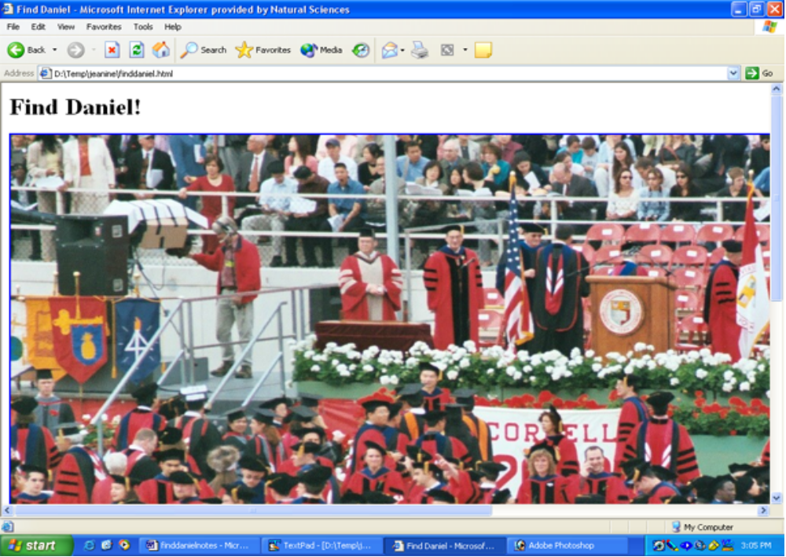
This facility is called ‘client-side image mapping’. At one point, the only way to do this type of operation was to use programming on the server, but later the facility was added to HTML, thus the term ‘client-side’. The HTML for my first version of the finddaniel.html is the following (the end of these notes shows an improved version):

<html>
<head>
<title>Find Daniel </title>
</head>
<body>
<h1>Find Daniel!</h1>
<img src="graduation0001.jpg" usemap="#map1">
<map name="map1">
<area shape="rect" coords="744,428,777,470" href="daniel.html">
<area shape="rect" coords="0,0,1520,1020" href="wrong.html">
</map>
</body>
</html>

What is different from standard HTML is the usemap attribute in the img tag and the map element. The usemap has as its value the name of the map element. The code is 'telling' the browser that this image will be part of a map. The name of the map element is preceded by a # sign here because it is in the same HTML file. There is only one map element for this application. You can imagine a situation with multiple maps and/or with the maps in other files for use by several HTML pages.

The map element contains area elements for each region to be designated as clickable. An area element has an attribute shape indicating the shape. In addition to rect for rectangles, you can specify circles and polygons. For each shape, the exact locations are indicated using the coords attribute. For rectangles, you need to determine the x and y values for the upper left and the lower right corners. For circles, you specify the center (x and y) and the radius, three numbers in all. For polygons, you specify the x and y for each of at least 3 vertices (corners).You can use Photo Shop or Paint Shop Pro to ascertain the coordinates. In Photo Shop, you use the Info panel and move the cursor with the mouse. Make sure the unit is pixels. In Paint Shop Pro, you will see the coordinates on the lower toolbar as you move the mouse around. Remember that the y (vertical) unit starts at the top, so the lower right hand corner is and should have y values greater than the upper left hand corner. Do not be alarmed if the numbers change if and when you repeat this operation. The pixel unit is very small (typically 72 pixels to an inch) and it is unlikely that you would move the cursor to the exact same spot two times in a row.

Lastly, the href attribute indicates the link. If you want the link to be within the same document, the position in the document is indicated using <a name="place"> ….. </a> and the href value would be href="#place".

For Find Daniel, we specify a rectangle around his head and then the whole image. If the code just specified the area around Daniel's head, the player could use the fact that the cursor only turns into a hand on specified areas to know which person was Daniel. We need a way to specify everything else. The HTML specification does refer to use of a shape= “default” option. However, this did not work in Microsoft Explorer! Instead, use the following technique. Specify the whole image in a second area element. Because the first area is checked first, this works.

The HTML file for a correct choice is daniel.html.
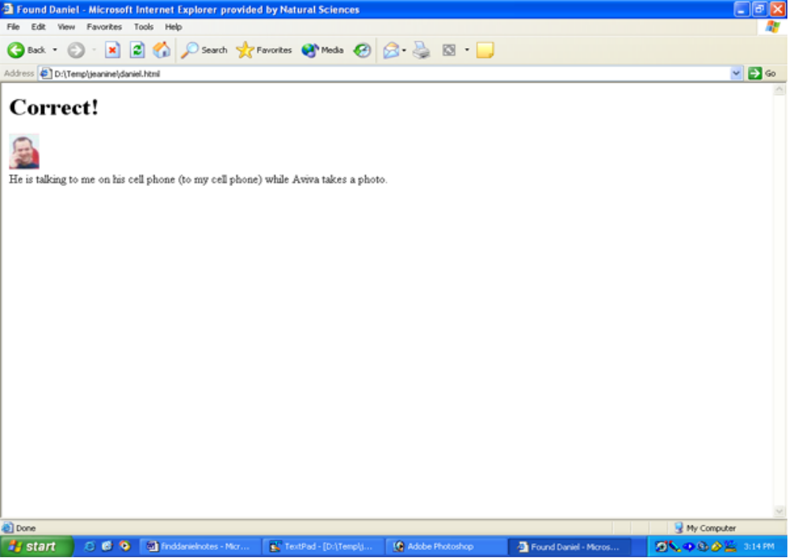
The HTML is
<html>
<head>
<title>Found Daniel </title>
</head>
<body>
<h1>Correct!</h1>
<img src="closeup.jpg">
<br>
He is talking to me on his cell phone (to my cell phone) while Aviva takes a photo.
</body>
</html>

The image, closeup.jpg, is made by selecting and copy-and-pasting in your graphics program. In Photo Shop, you use the rectangle selection tool to select the region you want, use Edit/Copy to get these pixels to the ClipBoard. Then go to File/New. The program knows to give you a canvas of the dimensions just copied. Then click on Edit/Paste. In Paint Shop Pro, you select, copy, and then paste into new image.

If the player picks wrong, then the link is taken to wrong.html.

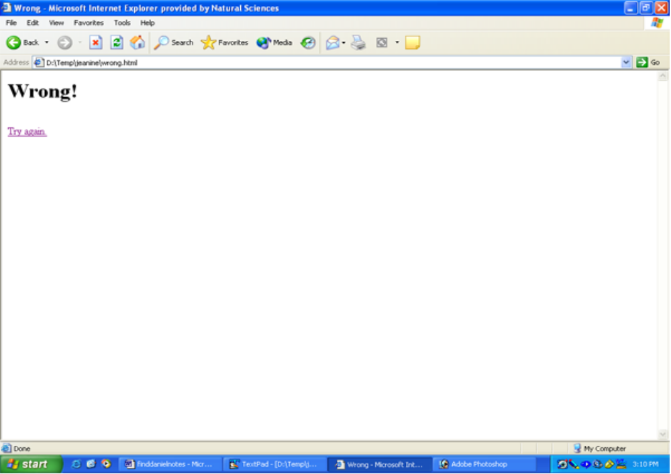The HTML for this file is:
<html>
<head>
<title>Wrong </title>
</head>
<body>
<h1>Wrong!</h1>
<br>
<a href="finddaniel.html">Try again. </a>
</body>
</html>

For this case, it is appropriate to put a link back to the original HTML page, which is what is done using the <a> element containing Try Again. as the contents.

Cautionary note: I made the decision to use the original, large photo even though this would require horizontal scrolling, generally considered a no-no. It seems appropriate for a 'find' application. If you are changing the dimensions of the image, you need to do that in the graphics program, and then determine the coordinates.

Improved version

The HTML file as presented has a flaw: the status bar indicates the value of the href link, that is the wrong.html or the daniel.html files as destinations. The task is to change the status bar to something else. The following code does the trick:

<html>
<head>
<title>Find Daniel </title>
</head>
<body>
<h1>Find Daniel!</h1>
<img src="graduation0001.jpg" usemap="#map1">
<map name="map1">
<area shape="rect" coords="744,428,777,470" onClick="window.open('daniel.html');"
onMouseOver="window.status='Where is Daniel?';return true;"
onMouseOut="window.status='Where is Daniel?'; return true;">
<area shape="rect" coords="0,0,1520,1020" onClick="window.open('wrong.html');"
onMouseOver="window.status='Where is Daniel?';return true;"
onMouseOut="window.status='Where is Daniel?';return true;">
</map>
</body>
</html>

The onMouseOver and onMouseOut attributes are set to change the contents of the status bar and then return true. The return true action prevents the browser from doing its default action. The onClick attribute performs the link, though it does this by opening a new window. It turns out that the latest Internet Explorer versions require this approach. In order not to keep generating new windows, the wrong.html script is now:

<html>
<head>
<title>Wrong </title>
</head>
<body>
<h1>Wrong!</h1>

<br>
<a href="javascript:window.close();">Try again. </a>
</body>
</html>

The href attribute closes the current window. This has the effect of going back to the finddaniel.html document.

