Tutorial: Overview of Flash

Concepts, skills and tools
Flash is a product for creating multimedia, interactive applications for use on stand-alone computers and, more typically, distribution on the Web. Flash has facilities for creating graphics and animations and this is probably the most common use. However, Flash also supports many features for accepting input from a user (in this text, we refer to the person using your Flash production as the player) and generating a customized response. This is done by the Flash designer/programmer writing code in ActionScript, the programming language for Flash. This tutorial provides an overview of Flash using as an example the creation of an animated set of instructions for folding an origami model called a wiggler. The tutorial starts 'general' and then gets specific. In particular, you will see a screen shot of the Flash interface with the Timeline of the completed project. The tutorial contains a section entitled Construction Plan with step by step instructions. You can decide on your own task for which you want to prepare instructions. You are advised also to take the built-in lessons provided as part of the Flash product: click on Help at the top and then Lessons.

You will use the following general programming concepts, skills and tools for:

- Planning (storyboarding) an animated sequence
- Writing code to handle an event
- Creating and using a variable

The Flash features used to construct this game include:
- Library
- Button symbols
- Timeline
- goToAndPlay statement
- labels for frames
- frame-by-frame animation
- Text fields

Description of the game
The application described in this chapter is following along animated instructions. The player can advance to the next sequence by clicking on the forward button. At any time, the player can return to the first frame. The instructions include text and graphics. The first screen shows a square. Text fields provide information. Two buttons are visible.
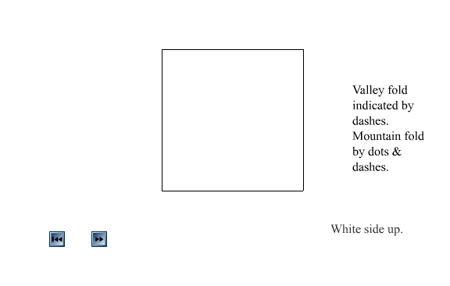
The following is a screen shot from the middle of an animated sequence, showing a fold in motion:

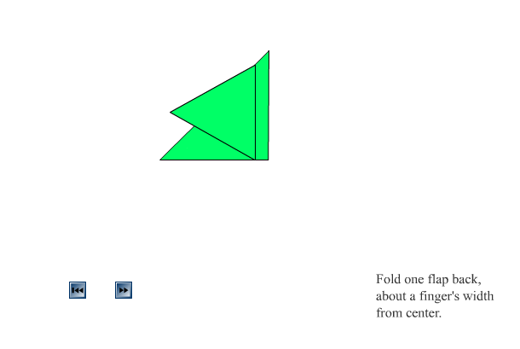

Here is a screen shot of a later frame, when folding is complete:
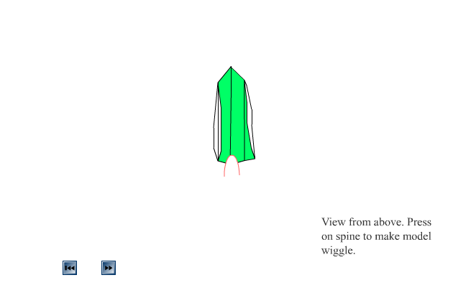

Key Design Issues
The role of the designer and programmer of an activity such as animated instructions is to produce the interface for the player to advance to the next step or return to the start and to produce the animated sequences. The key design tasks for this application are

- Show the player how to fold the model
- Build into the application ways of stopping and continuing the instructions under player control.

Solutions to each of these design and programming tasks are presented next. Use these suggestions as guidelines when building your own set of animated instructions.

Task: Show the player how to fold the model.
Logic: The instructions will consist of frame-by-frame animation, that is, sequences of snapshots of the paper being folded into the model along with text messages. Frame-by-frame animation refers to animation made up of sequences of images shown in quick succession.
Solution: Flash has many features making frame-by-frame animation feasible. These include drawing tools and the ability to select parts of a graphic for modification. The modification could be erasing, changing the color, or moving the part around. These facilities will be especially helpful for producing stylized drawings of paper being folded into a model. Flash also has text fields that can hold the messages.

Task: Build into the application ways of stopping and continuing the instructions under player control
Logic: As has been indicated, the instructions will consist of a sequence of frames showing the paper being folded into the model along with text messages. The default flow of operation is to continue from frame to frame. You need to keep this from happening. One approach is to build a button to advance through the next step and a button to return to the start.
Solution: You will insert code at certain of the frames to stop. You will also insert labels at certain of the frames. A variable, defined in the very first frame, will be used to hold the label of the next step. In those frames with the code to stop, you will place code to set the nextstep variable to the next label. Flash has buttons as a basic type of symbol and a way to program the handling of an event such as clicking on a button. You will put code in the event handler to go to the frame with label the value of the nextstep variable.

Preparing to program
Flash has a complex program environment, with many toolbars and panels. However, like many modern applications, it is not necessary to know everything to be productive. Flash produces what are termed movies. The main ideas of Flash are the Stage and the Timeline. The Stage is where content is placed, including graphics drawn directly on the Stage as well as symbols created individually and stored in the Library. Symbols can be graphics, buttons, or movies. (A Flash movie can contain movies within movies. This is actually fairly common.) The Timeline is a sequence of frames, frames to be displayed at specific frame rate, unless stopped by code. When you put something on the Stage, either by drawing it directly or bringing something in from the Library, you put it on the Stage at a specific frame. Here is the initial look of the Flash development environment:

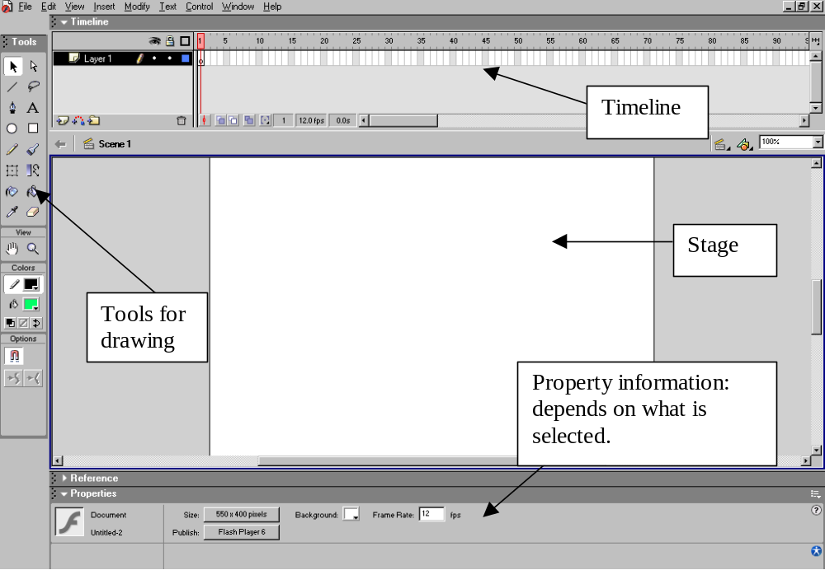

Notice the many drawing tools. In this application, we use line, pencil, paintbrush, rectangle, paint bucket and text tool (the A icon). The line and the pencil use the first swatch of color, shown above as black. This is called the stroke call. When you use the pencil, you can specify options to straighten out or smooth out the lines. The paintbrush and the paint bucket use the second swatch color, called the fill color. The text tool uses the fill color for the letters. The outline of the rectangle is in the stroke color and the inside is in the fill color. Double clicking on either swatch opens up a palette of colors.

The pointer at the top is for selecting areas on the stage. You can select parts of graphics or you can press down and drag to form a rectangle. The lasso allows you to make a free-hand selection. One thing you will notice is that Flash graphics are segmented. You can select (click with the pointer) parts of a drawing. A selection can be deleted, moved, or modified in various ways. The drawing below was made with the rectangle, line, and pencil (smooth option).
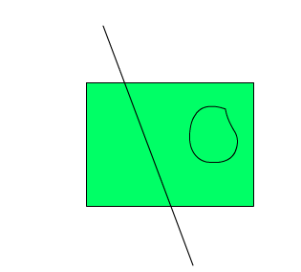

Using the pointer, you can click on 13 different parts! This was done to produce the following:

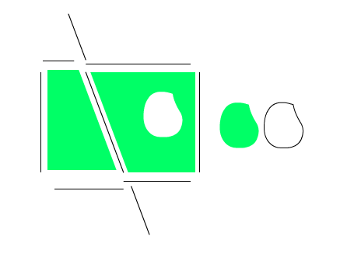
This may not seem like a useful thing to do, but it really helps in creating sequences of drawings such as required by the origami application: situations in which you need to make modifications of graphics. This facility also demonstrates that Flash, unlike many other drawing programs, works by creating what is termed vector graphics, and not bit-mapped graphics. Flash drawings are stored internally in a representation that allows the Flash runtime system to re-create the graphics. One example is that a rectangle is stored as rectangle with specific dimensions and not as the color settings of the pixels on the screen. This means that Flash files are smaller than they would be otherwise and the Flash graphics scale up and down well.

You can also use the pointer to select a rectangular area or the lasso to select a freeform area. When using either of these, the selected area shrinks to the content already on the screen. So if you begin with

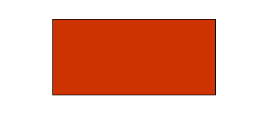
and then make a rectangular selection (the dotted lines are heavier than would be the case when you actually do this):

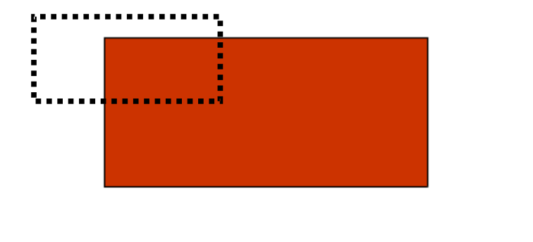
The resulting selected area will be:

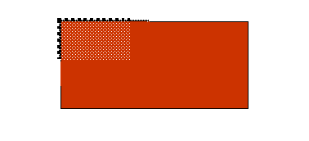
The same thing happens when using the lasso tool: the shape is still freehand, but it shrinks to the content on the Stage.

At this point, it makes sense for you to experiment with the drawing tools and/or start the built-in lessons.

You may add layers to the Timeline. This is similar to adding layers in drawing tools such as Photo Shop or Paint Shop Pro. You do this to organize your work to make it easier to find and to change things. The practice suggested in this text is to create a distinct layer for ActionScript and another for labels for the frames. The graphical content generally is simple enough to put all in one layer. However, in the case of cannonball (chapter ??), the ground and the target are placed in different layers so the target is behind the ground, giving the illusion that it is sinking into the ground when hit.

Text fields can be placed on the stage using the text tool: you click on the A icon and then make a box on the stage by pressing down and then dragging. The Properties panel at the bottom of the screen indicates font, font size and other properties. You type text and can use the enter key to get to a new line. In this application, you will use one or more text fields to give textual information to the player.

The general scheme for this application is to draw directly on the stage in successive frames images and text. However, this Flash movie is not intended to start and go to the end all at once. Instead, you will use ActionScript to control the action. In Flash, there are two places for ActionScript, as frame actions and as object actions. You will place ActionScript code to stop the action in certain frames. You will program the buttons to advance the flow to the next step. You will label the frames that start each of the steps and these labels will be the values of a variable named nextstep. Variables are explained below. The very first frame defines the variable and sets it to the first label. The frames that correspond to the last frame of each step set the variable to the next value and stop the action.

The screen shot below shows the part of the Flash screen dealing with the Timeline. You double click on Layer 1 to give this layer a specific name. You click on the leftmost plus (+) sign to add a layer. You can then double click on its name to give it a specific name. You then need to be careful to select the frame and the layer when you want to add something to the stage or add code.
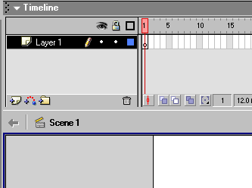

To add code, you click on the layer and frame and, if the Actions panel is not present, click on Window/Actions.

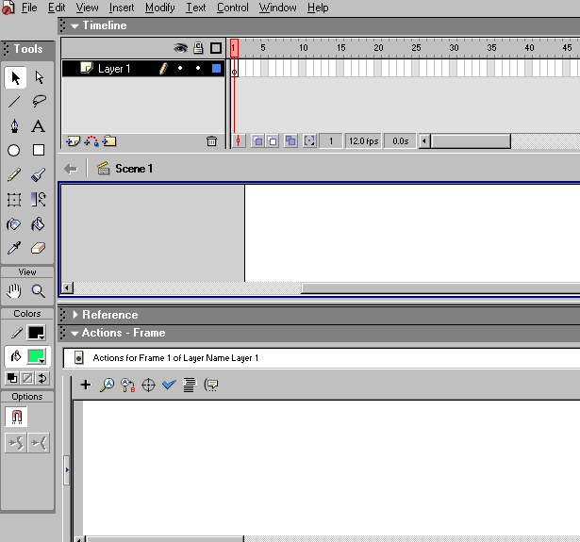

Notice that the Actions panel indicates: "Actions for Frame 1 of Layer Name Layer 1".

Flash provides two ways of programming actions: Novice and Expert. Novice works by letting the programmer click on choices and fill in parameters. We suggest using Expert mode. This is more efficient when you know what you are doing or are following directions. However, at some point, you can experiment with the Novice mode. It does serve to remind you of the names of Flash statements, functions and operators.

For this application, as hinted at earlier, you use a variable to hold the value of the label of the frame starting off the next step. Variables, common to all programming languages, refer to places that hold values. The values may vary, from which comes the name. In this application, nextstep will hold the name of the label. The code in the first frame sets up the variable, using a var statement. This tells the system: I will be using a variable named nextstep. The next line gives nextstep what will turn out to be the first of several values. It is called an assignment statement. The assignment statement, with its equal sign, should be read as make the variable on the left equal to whatever is on the right. The third line tells Flash to stop and not go on to the next frame.

var nextstep;
nextstep = "diagonal";
stop();

Though all programming languages have variables, the treatment varies (no pun intended) quite a bit. Many languages have something like the var statement, but require you to specify how the variable will be used, say to hold numeric values of strings of characters. Once specified, you cannot assign a different type of value. Flash does not do this.

The code in the last frame of the steps will not repeat the var statement, but will have the code to reset the variable and to stop.

At this point, it would be appropriate to wonder, where or how is nextstep used? The answer is that it is in the code for buttons. You cannot draw a button directly on the Stage, but must create a button symbol to be placed in the Library. To make a button, you insert click on Insert/New Symbol. A panel will pop up asking what type of symbol and the name of the symbol. You click on the Button option. You can give the symbol a name of your own choosing. You now have what looks like a new Stage. This is because you are editing something away from the main Scene. You will need to specify 4 images for the up, over, down and hit areas of the button. You can make them all the same. The built-in lessons cover this very well. An alternative at this point, is to use one of the buttons already created. Flash has many graphics already created. This means that instead of drawing your own button, you can go to Window/Common Libraries/Button, and find one you like. A reasonable choice would be something like a forward play button. You click and drag the button to the stage.

The action suggested for this application is to specify what happens when the player releases the left (normal) mouse button over the button graphic. To program this, select the button graphic you have just copied to the stage and in the Actions panel, type what is shown in the screen shot. This uses a built-in Flash procedure to go to the frame indicated and start playing frames. The procedure uses the value specified between the parentheses, called the parameter or argument of the procedure. In this case, it will be whatever the value of the variable nextstep is. You will see uses of goToAndPlay with frame numbers and with label values.

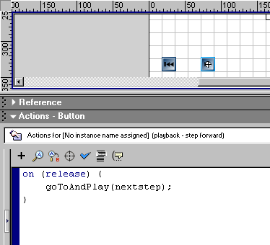

Notice in the screen shot the heading: Actions – Button. Under it the phrase is Actions for [No instance name assigned] (playback – step forward). The playback – step forward is the name for the built-in symbol from the Common Library.

Final Timeline, Stage, Library
It is generally a good idea to know where you are heading. Here is a screen shot of the Flash environment after creating the application (yours will not necessarily be as long):

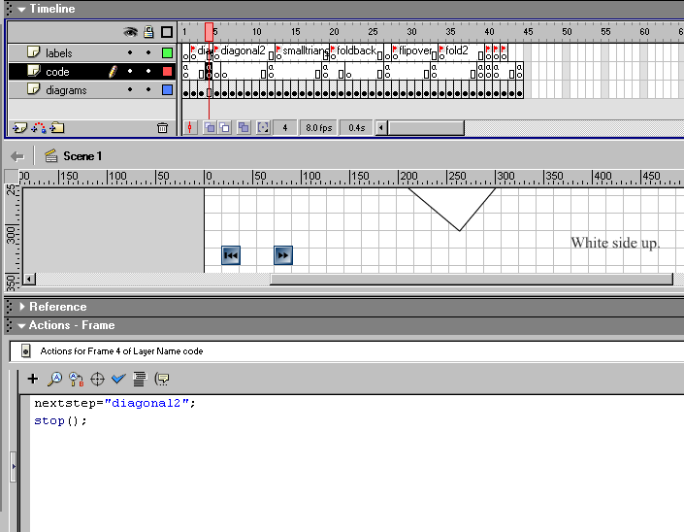

Notice that the Timeline has three layers: diagrams, code and labels. The Timeline cursor is at frame 4, which appears to be the last frame of the first sequence. The label for frame 5 is "diagonal2". The code in the code layer for frame 4 sets the nextstep variable to "diagonal2" and stops the progression of frames. The pattern is ActionScript in the layer named code in a frame and then a label for the next frame.

You can see a portion of the Stage: it has two buttons, what is the corner of the drawing of a piece of paper, and a text field that says White side up. This application does not have any symbols in the Library. The buttons came from the Common Library.

If you 'play' the completed example and examine the Timeline, you can detect that what is happening is that each time you click the forward button, you see a succession of frames that stops. You then click the forward button, and advance to the next sequence.

Construction plan
Re-name the first layer diagrams and then add and name two more layers: code and labels. This is done using the Timeline panel.

Prepare/Acquire symbols
Symbols such as buttons cannot be drawn directly on the Stage. You either create a symbol with button behavior or acquire one from the Common Library. For this application, click on Window/Common Library/Buttons to see many possibilities for buttons indicating play and return to start. Make sure the first frame, diagrams layer is selected. Then click and drag the buttons to the stage.

Program frame and object actions
If the Actions panel is not visible, make it appear by clicking Window/Actions. If the Actions panel has been minimized, click on the arrow to expand it. Select the code layer, first frame. Write the following code (substitute for "diagonal" whatever is a meaningful name for the first step of your activity).

var nextstep;
nextstep = "diagonal";
stop();

This places the code 'in the frame'. Now you will program the code for the button actions. Select the diagrams layer, frame 1. Click on the forward button. In the Actions panel, enter:

on (release) {
goToAndPlay(nextstep);
}

Click on the back to start button. In the Actions panel, enter:

on (release) {
goToAndPlay(1);
}

Content to Stage/Timeline

Click on the A icon and create a text box. Type in the text box the initial instructions. In our origami example, we have two textboxes: one has general instructions and the other specific instructions. The one with specific instructions will be updated for each step. Be sure you have selected the first frame and the diagrams layer so that this material are in the correct frame and layer.

Draw whatever graphics you want to be displayed immediately directly on the Stage.

You will do the following over and over for each step of your instructions. Click on the next frame in the diagrams layer. Click on Insert/Keyframe. This will copy everything that was in the first frame. This includes the buttons, the text fields and the other graphics. You can change what is there. The practice we followed for the origami instructions was to
- erase the text field with the general instructions (select using the pointer and then hit delete);
- click on the A icon and select the text field for specific instructions. Change the text.
- Keep the graphics the same as the previous frame.

Click on the labels layer, same frame. Insert a keyframe. Make the label of this frame whatever you set nextstep to in the first step (or the prior step as you continue this process).

Now, click on the next frame of the diagrams layer. Insert a keyframe. Make a small change to the graphics. Continue in this manner: insert keyframe and change graphics; insert keyframe and change graphics until you are done with that step. Click in the code layer at the last frame and insert a keyframe. Add code to this frame (using the Actions panel). It will be

nextstep="diagonal2";
stop();

At the very last frame, in the code layer, put in
stop();

At this point, you should appreciate the advantages of variables. The code

goToAndPlay(nextstep);

which is what happens when the forward button is clicked always works. What changes is the value of the variable nextstep.

Do one step and test the program by clicking on Control/Test Movie. Once it works, keep going!

You now need to sketch out the progression of diagrams, deciding the places you want the program to stop. For any sequence, the last frame, code layer, of the sequence has the code to set a new value for nextstep and to stop. Say the new value is X. The next frame, labels layer, needs to have the frame label X. You need to insert a keyframe into this position for each layer. You enter the frame label using the Property panel.
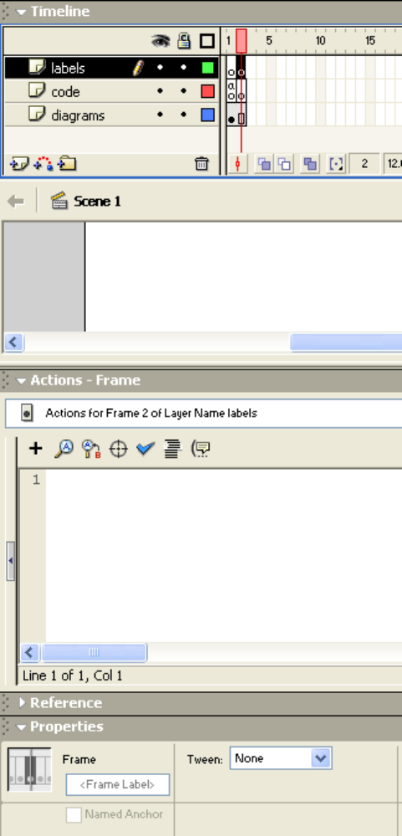

Tips and warnings

A common error is to attempt to put something (content, code, label) in a frame that is not a keyframe. The panels will not allow it or what you are trying to put goes somewhere else. To recover, insert the keyframe and try again.

When you click on a frame, all the content of the frame is selected. You may want to click someone on Stage where nothing is present and then click on what you want. When you insert a keyframe, everything is copied over and is selected. Again, you may want to click outside everything and then selectively select (!) what you want.

Remember the Undo command under Edit. You can use it again and again.

Related Flash features
Flash has many drawing tools. Explore and experiment. Flash Help takes you to an on-line reference section.

As you could tell from your quick look at the Common Library, Flash provides many symbols.

One major feature of Flash is the tweening capability. This allows you to put graphics into two frames, separated by several frames and then request Flash to generate images that go in between. Motion tweening is used when you take a symbol and move it. You can even 'tween' along a path. Shape tweening works for changes in shape. The built-in lessons give examples of tweening.

This application used the release event to trigger the action for the button. Flash provides for many other possibilities. You can explore these using the on-line reference or the Novice mode for the Actions panel.

Ideas for enhancements & other applications
- Prepare cooking instructions for a recipe.
- Prepare instructions for changing a tire.
- Prepare instructions for giving CPR.

Exercises & discussion questions

- Define the following terms: frame, timeline, stage, symbol, button, movie, keyframe, release event.
- Compare and contrast frame action and object action.

