Flash 5/MX: Cannonball lab UPDATES FOR FLASH 8

NOTE: I have made updates to fit Flash 8. The changes are
- that the use of the var name for input and dynamic text boxes does not work with the up-to-date Flash players. Instead, the instance name must be set and the .text property used.
- My educational version of Flash 8 did not appear to have Sounds as one of the Common Libraries. I describe alternative ways to get sounds.
- The startdrag function was used in place of the startdrag method.

Animation (movement of images on the screen) can be produced using Flash in several different ways. For this application, your code will simulate the ballistics of a cannonball leaving the cannon, traveling in a [parabolic] arc, and either hitting the ground or hitting a target. You will NOT use frame animation: create graphics of a cannonball in different positions in a sequence of frames. You will not use tweening.

The following figure shows the application after a firing of the cannon. Notice that the cannonball has fallen on the ground. The application begins with the cannonball off-stage. Your code will move the ball to the end of the cannon when the FIRE button is pressed.

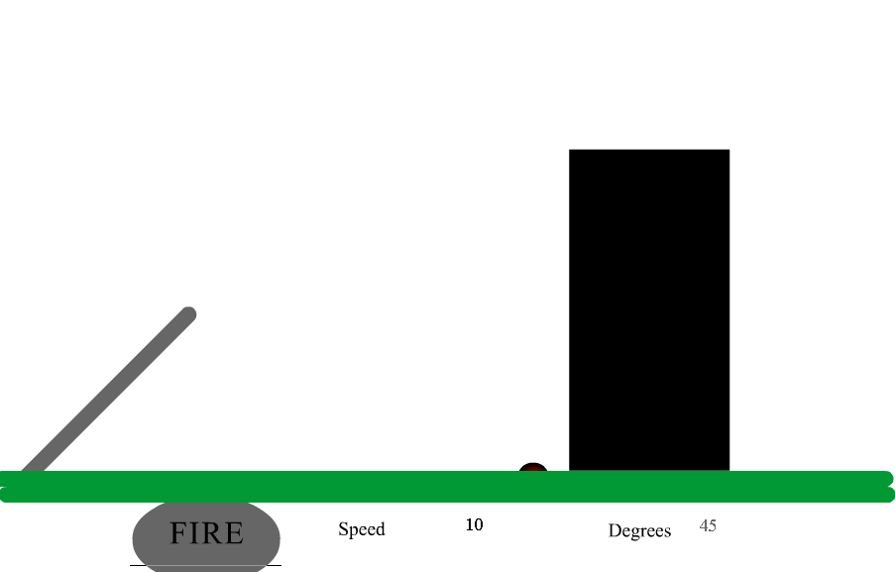

Here is what the screen looks like after a hit (achieved because the player has changed the angle of the cannon and the speed).

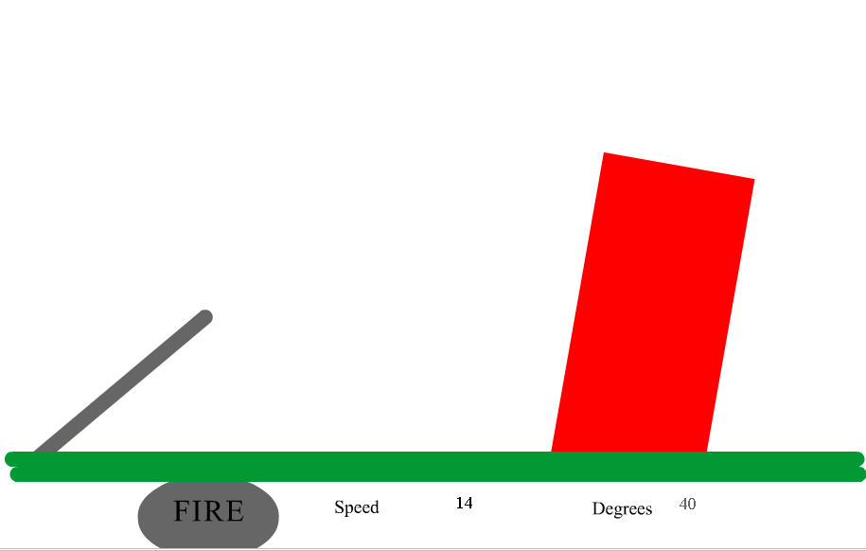

Here are the critical features required to implement this application:

- Calculation of the flight path of the cannonball based on the initial speed, the angle of the cannon and the effect of gravity. The critical concept for ballistics involves separating the initial motion of the cannonball into vertical and horizontal components (also known as resolving the vectors). The cannonball leaves the cannon at an angle. In the simplified world we simulate here (no air resistance, for example) the horizontal motion continues at the same velocity (speed). The vertical motion, however, is affected by gravity. This is what causes the arc (the parabolic) path. The equations for this turn out to be just a few lines of code in the function that handles the on (release) event for the Fire button and a few more in a script in frames on the movie time line.
- A way to make incremental changes in the position of the ball to simulate flight. This will be done by using ActionScript to write what are termed frame actions to make adjustments to the position of movie clip we call ball.
- A way to check if the target has been hit or if the ball has reached ground level. It turns out that this is done in script in two different places. The code to determine if the ball has hit the ground is done in a frame action. The code to determine if the ball has hit the target is done in what is termed the enterFrame clip event of the target.
- A way for the player to control the path by changing the speed and the angle and to move the target. To make this a game, we need to provide a way to get input from the player. We do this using Input Text fields. The values the player puts in these fields are used in the calculation of the path.

Note: in our project the name of the target instance is target1. This is to inspire you to think about more and different targets. It could also have been target. In any case, there is no relationship between this specific instance and the Tell Target construction used in older versions of Flash, but generally unnecessary in Flash 5.

These graphics are quite stylized. After you get something working, you can enhance the look-and-feel of the application.

Prepare the following as symbols and then create instances on stage. Give the symbols the names indicated (using the Instance panel in Flash 5 and the Properties panel in Flash MX). You may ask why, with the graphics being so simple and only one of each thing, do I have to make each one a movie clip? The answer is that this approach makes several things possible: you can refer to the symbols by name, refer to and change properties such as _x, _y, and _rotation, use the hitTest method and you can write event handlers. The latter means you can arrange for something to happen each frame and something to happen when the player presses down or releases the mouse. Note the registration point (also called the origin or the nominal position) for the graphics. Position and movement, including rotation, is in terms of this registration point shown as cross-hairs when you select the object.

Symbol name & type | Instance name | Graphics | Associated events, usage
ball movie clip | ball | Circle, registration point upper left corner (not center) | Properties referenced and modified by frame scripts and event handlers.
cannon movie clip | cannon | Horizontal line, registration point left end | _x and _y referenced to position ball.  _rotation changed based on an Input text field; referenced to determine angle
ground movie clip | ground | Two (thick, horizontal) lines, registration point mid-point. | _y referenced during flight
target movie clip | target1  There is only 1 target, but you may choose to add more. | Rectangle, with registration point at lower left corner | Clip event (enterFrame) used for detecting a hit.  Clip events mousedown and mouseup used in dragging
firebutton button | Need to place Dynamic Text field named caption on the button. | oval, with Dynamic text field. | on(release) is a call to _root.firecannon located in the first frame, actions layer

Because of how we want the target rectangle to tilt when it is hit, you need to make sure the rectangle's registration point is the lower left corner, as shown below:

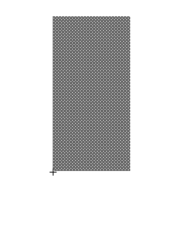
This will cause the rectangle to pivot from the lower left corner. Do not think for a moment that we knew this ahead of time.

You need to put on the screen the 4 text fields: REMEMBER: for FLASH 8, set the instance name NOT the var name for the Input text fields.

Name | Contents | Type | Usage
 | Speed | Static | Label next field
speed | Initially 10 | Input | Player types in new speed
 | Degrees | Static | Label next field
anglein | Initially 45 | Input | Player types in new angle.

We propose that you program this application in stages. This gives you a chance to test the application as you go along.

Stage I. Make the ball move in an arc on the screen.
Stage II. Add the test for hitting the target.
Stage III. Add the color change and the sound when the ball hits the target.
Stage IV. Add the feature to move (drag) the target.
Stage V. Add the target leaning over.

CAUTION: When you create a new keyframe, unless you create a blank keyframe, Flash will copy all the content that was in the previous keyframe. This generally is what you want. If you later go back and add something to an earlier frame, this content does not automatically get added to the existing frames that follow. If you want the new material to be part of other frames, you must do add it explicitly. The copy and paste-in-place commands can be used. This also applies to object action code. If you add or change object action code in one frame, you must do the same thing for the other frames, if that is what you want.

Stage I. The requirements for coding divide into what is done to set up the motion of the ball and what is done to move the ball iteratively along its path. The setup is done in response to pressing the button labeled FIRE. The iterative movement is done in frame actions.

Display the Actions panel (Flash 5: Window/Actions) or Expand it (Flash MX and Flash 8). In the Control dropdown menu, make sure Enable Simple Button Actions is NOT checked. To test the program, you may need to change this to being checked. Click on the Fire button instance on the stage. In the Actions panel, click the arrow to get to Expert Mode and type in:

on (release) {
_root.firecannon();
}

This means: when the button is released (that is, the player presses down with the mouse over the button and then releases it), call the function firecannon that is defined in the main movie. We could put the code here, but it is considered a good practice to centralize the code. We will give an example of another way later. The firecannon function will be defined in the first frame. Before doing this, you need to do some set up of layers and frames.

Name the first and only layer of the main movie board. Add a new layer and name it actions. You will put all the code in the actions layer. Add another layer and call it labels. You need to have 3 keyframes in each layer. This means you need to add two keyframes to each one. Flash8: Insert/Timeline/Keyframe.
Click in the second frame of the labels layer. Flash 5: in the Frames panel (Window/Panels/Frame), give this frame the label continue. Flash MX and Flash 8: in the properties panel, type in continue in the Frame textbox. A flag will appear in the frame.

You will now put code in the first frame of the actions layer. The code sets up variables and defines the firecannon function. The inflight variable will be true or false depending on whether the ball is in-flight. As you will see, the firecannon routine sets inflight to be true. Watch out for where it is set to false. The now, then, and elapsed variables are used to calculate the time. Notice that then is set in firecannon by a call to getTimer.

Recall from the introduction that the characteristic arc of projectile motion occurs because the horizontal velocity remains the same but the vertical velocity changes. The ball is shot from the cannon at an angle. Your code will determine the initial horizontal and vertical components of the ball's motion using trigonometry.

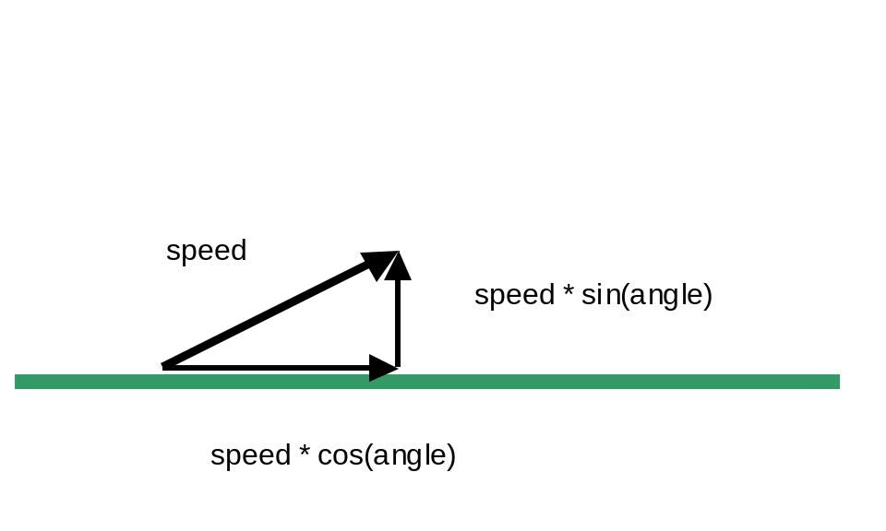
The variable hspeed is set to the horizontal component in firecannon. You need two variables for the vertical component because it is changing due to the effects of gravity. The variable gravity holds the value of gravity per 1/12th of a second. (This appears more serious than it really is. The units could be whatever we want, but this value seems to work out well.) The vspeed1 variable will hold the value at the start of the increment of time and the vspeed2 will hold the modified value. Your code will average the two to determine the distance moved during that unit of time.

The code, with explanation, is shown in the table.

var inflight; | Indicates whether cannonball is moving or not
var then; | Used for time calculation
var now; | Used for time calculation
var elapsed; | Used for time calculation
var hspeed; | Horizontal speed. Does not change.
var vspeed1; | Vertical speed at start of time interval.
var vspeed2; | Vertical speed at end of time interval
var gravity = 9.8/12; | Gravity (9.8 m/sec squared is rate of gravity)
var angle; | Angle of cannon
var speedx = 10; | Initial value of speed
var angleinx = 45; | Initial value of anglein
function firecannon() { | Function definition
speedx = speed.text; | Re-set just in case player has changed the text field
angleinx = anglein.text; | Re-set
inflight = true; | Set inflight to true
cannon._rotation = -anglein;  FLASH 8:  cannon._rotation = - anglein.text; | Moves the cannon instance according to input text value
ball._x = cannon._x +cannon._width +(.5* ball._width); | Positions ball instance at tip of cannon by changing x value and
ball._y =cannon._y -cannon._height-(.5*ball._height); | … changing y value
angle =anglein.text * Math.PI/180; | Converts the angle specified in the input text to a value in radians
ball._visible = true; | Makes ball visible (it will be set to not visible when it hits the target
hspeed = Math.cos(angle)* speed;  FLASH 8:  hspeed = Math.cos(angle)* speed.text; | Calculate horizontal speed based on angle and speed in input text.
vspeed1 = -Math.sin(_root.angle)* speed;  FLASH 8:  vspeed1 = -Math.sin(angle)* speed.text; | Calculate vertical speed based on angle and speed in input text.
vspeed2 = vspeed1; | Both speeds are the same, initially.
then = getTimer(); | Get the current time to be the first 'then' time
gotoAndPlay("continue"); | Go to continue frame
} | End of function

Here is more explanation of the statements. The commands (all assignment statements) do the following:
- FLASH 8: The variables speedx and angleinx are set with the initial values of the (visible) dynamic text fields. These variables will be used to prevent these text fields from reverting back to initial values if the player changes them.
- Function definition of firecannon
- The speedx and angleinx variables are now set to their current values. These will be different if the player has made a change.
- set inflight to be true.
- set the rotation of the cannon according to the player input from the Input text field named anglein. Note: my implementation needed the sign to be changed. If this does not work for you, change it!
- and 4. Position the ball to be at the tip of the cannon. Depending on how you drew the cannon and moved it to the stage, you may need to alter things.
- For the computation done, we need the angle to be in radians as opposed to degrees. (Haven't you ever wondered why there are 360 degrees to a circle? The answer is that there is no reason. The radians method is an intrinsic measure: there are 2 times pi radians in a circle.) This line performs that function.
- Make the ball visible. (It will be made invisible if it hits the target.)
- Set hspeed to be the horizontal component of the initial velocity.
- Set vspeed1 to be the vertical component of the initial velocity.
- Set vspeed2 to be the same value as vspeed1.
- Set the then variable to be the time now (when firecannon is invoked).
- Go to the continue frame. This concludes the definition of the function

Once the flight is set up, the code in the next two frames will produce the animation. That is, the frame labeled continue will be entered and its frame script (code) executed. Then the flow will go to the next frame. In that third frame, control will be sent back to the continue frame.

The task of the code in the second frame is to move the ball if the ball is 'in flight'. The code is an if statement testing the inflight variable. The clause following the test does all the work. Think of an interval of time. The code works with the now and then variables holding values for the time at the start of the interval and the end of the interval. Gravity changes the vertical speed during that interval. The code calculates the vertical speed at the end of the time interval and averages the starting and ending speeds. The ball is positioned based on the horizontal and average vertical speeds. The code also checks if the ball has hit the ground. Note: the test for the ball hitting the target will be added later in the next stage of coding.

Click on the second frame, which is the frame labeled continue, of the action layer. Enter the following:

speed.text = speedx;
anglein.text = angleinx;
if (inflight) {
now = getTimer();
elapsed = 12*(now - then)/1000; //units of 12ths
ball._x += hspeed * elapsed;
vspeed1 = vspeed2;
vspeed2 = vspeed1 + gravity* elapsed;
ball._y += elapsed * (vspeed1 + vspeed2)*.5;
if ((ball._y + ball._height) > ground._y) {
inflight = false;
ball._y = ground._y - ball._height;
}
then = now;
}

Going over the code: the speedx and angleinx variables are used to set the value of the input text fields. This is required in Flash 8, where text fields are treated differently than in prior versions of Flash. Next, the code checks if the ball is inflight:
if inflight is true, everything happens. Conversely, if it is not true, then nothing happens. This code, that is, the if condition, is actually executed many times with the negative result. It is only when the player clicks on the FIRE button that inflight is set to true and something substantive happens in this frame. So let us suppose that inflight is true. Then the code will determine the current time (actually milliseconds since the program began). The code determines the elapsed time in the units of 12ths of a second. The ball is then moved horizontally (the _x property) incrementally (using the += form of the assignment statement) speed times time (hspeed * elapsed) units over. To do the vertical move, the code computes the 'new' velocity. That is, the vspeed1 variable is set to be what the vspeed2 variable was. Then vspeed2 is set to the velocity modified by gravity. The last step is to compute the increment in the new vertical (_y) position based on the average of the two speeds.

The if statement tests if the ball has fallen below the ground. The greater than is used because vertical coordinates ( _y values) increase moving down the screen. If this is the case, then inflight is set to false.

The last statement is to set the then variable to the now variable. This makes things ready for the next iteration.

There is one more frame action to write. Click on the third frame in the action layer.
Type in this code:

speed.text = speedx;
anglein.text = angleinx;
if (inflight) {
gotoAndPlay("continue");}
else {
stop();
}

As was the case for the previous frame, the values of the text fields are set to the values set at the time the firecannon function was invoked. Next, if inflight is true (if the flight of the ball is still going on), go to continue. Otherwise, stop.

You can test what you have done. Click on Control/Test Movie. To get information on function calls or how variables have been set, you can use the built-in function trace:

trace("message");

or

trace("variable name xxx is "+ xxx);

to debug your program. Perhaps this story will help you: I tried my program and the cannon rotated up to 45 degrees, the cannonball appeared at the tip, and floated right down to the ground, where it stopped. What was the problem? It did not have any initial horizontal speed. I checked the speed textbox and noticed that it was Static and not Input. The program was using a value of zero instead of the 10 in the box. I clicked on the text and changed it from Static to Input in each of the 3 frames and the program works. To test it adequately, you should change the values of the speed and the angle.

Stage II. The check for hitting the target is done using what is termed a clip event handler. With the Actions panel displayed, click on the target. Type in the following:

onClipEvent (enterFrame) {
if (this.hitTest(_root.ball)) {
_root.ball._visible = false;
_root.inflight = false;
}
}

The _root. in the references to ball and inflight is to direct ActionScript to the ball movie clip and the inflight variable in the scope of the main movie. Scoping provides a way for complex applications to be built up, when, for example, different people are working on the same application, and more than one decides to use the same name for an object or variable.

You can then select and copy this code. Go to the next frame, select the target again, and put the code into the actions layer for that frame. Repeat for the last frame.
The event is the entering of any (and every) frame of the target1 movie clip. There is just one frame, but this still means the code is executed periodically. The code executes the hitTest method for this movie clip. The 'this' has a special meaning here: it is the movie clip for which this event handler has been set up.

The method (functions associated with objects are called methods) does the calculation of any intersection between this (the target1) clip and the _root.ball clip. The intersection is based on what is termed the bounding rectangles. This is good enough for this situation since the target IS its bounding rectangle and the ball's bounding rectangle is close enough to the ball itself. In other applications, you may need to use a different form of the hitTest method.

If there is any intersection, then the next two lines of code (the ones within the brackets) are executed. The code makes the ball invisible and sets inflight to be false. This will mean that the next time inflight is checked, it will be false. This, in turn, means that the ball would not be moved again and also, when frame 3 is reached, the action will be stopped.

Test the movie. To do the test, you need to remember what happened previously when no check was made AND also do the test for speed and angle values that cause the ball to hit (that is, appear to hit) the target and values that do not. Faster speeds and lower angles such as what is indicated above will make the ball hit the target.

Stage III. This stage adds drama to the program. The goal is to make two things happen if and when the ball hits the target: change the color of the target and make a sound. The technique is specific to Flash. Flash has color objects and sound objects. You can use Help to find out more about each of these and make your application different and more dramatic. For now, click on the first frame of the action layer. Add the following:

var zap = new Color(target1);
var soundc = new Sound(); //controller for sound
soundc.attachSound("buckethit");
var okforsound;

The zap variable is set to be a Color object associated with the target1 instance. When your code detects a hit, it will use zap to change the color of the block that is the target.
Similarly, soundc is a Sound object. The attachSound associates something called buckethit to soundc. We need to do something to produce buckethit. This is done in two steps, assuming that you have Sounds as one of the Common Libraries:

- With the Library for this project open, open up Window/Common Libraries/Sounds and click and drag Bucket Hit (or whatever sound you like) into the Library. You can close the Common Library to make more space on the screen. You can do some editing of your copy of the sound if you like.
- Flash 5: With this sound selected, click on Options and then Linkage. A panel entitled Symbol Linkage Properties will appear. Click on Export this symbol and type in the name buckethit. Flash MX: With this sound selected, right click and then click on Linkage. Click on Export to ActionScript and type in the name buckethit.

If you do not have Sounds as one of the Common Libraries, you need to acquire a sound.
If (like me), you have the sound in a Flash document created using Flash MX, you can open that document, select and copy the buckethit sound in the Library, open up the new document you are creating, make sure the Library panel is open, and do Edit/Paste. The Paste in Center may be the option available.

Another alternative is to record sound. Using a Windows XP computer, from the start button, click on All Programs/Accessories/Entertainment/Sound Recorder. Record a sound by clicking on the red circle (record button) and then clicking the solid rectangle stop button. Next save the file: File/Save as…. You will need to give the file a name. Use buckethit. I made a sound by dropping a telephone book. Next, in Flash 8, use File/Import/Import to Library. In the Library panel, right-click and then click on Linkage or double-click to get a panel that includes the Linkage panel. Set the Export to ActionScript and Export to first Frame. Make sure there is a name (the file name may be inserted for you already). The sound is now ready to be referenced by ActionScript in your application.

You need to modify what you have in two places: the firecannon function and the clip event when the code has detected a hit. In the firecannon function, you need to add the lines:
zap.setRGB(0x000000); //color to black
okforsound = true;

The argument to the setRGB method of the color object named zap is in the form of a hexadecimal color code. You may recognize this from other applications.

Now, at this point, you should have an idea of where you need to add some code. Where is the determination made that the target has been hit? Answer: in the on ClipEvent (enterFrame) routine. Modify it (click on the target and what you already have should appear) to be:
onClipEvent (enterFrame) {
if (this.hitTest(_root.ball)) {
_root.zap.setRGB(0xFF0000);
_root.ball._visible = false;
_root.inflight = false;
if (_root.okforsound) {
_root.soundc.start(0, 1);
_root.okforsound = false;}
}
}

The new lines are in italics. Notice there are 3 closing brackets: one to close the clause for the inner if testing if the sound needs to be started, one to close the clause for the if testing if the target has hit the ball, and one closing the onClipEvent definition.

The setRGB of the zap Color object is set to the hexadecimal code for red. You can determine these hex codes by clicking on the color patches in the Tools toolbar. The if statement testing okforsound is done to prevent the sound from happening again and again. You just want the 'hit' to be heard once per flight. Of course, if you have another sound clip, you may want it to continue.

The _root. is used prior to the zap, ball, etc., in the onClipEvent because of scope rules. Note that it is never wrong to include _root if the code refers to something in the main movie, including code in the main movie and so I may have used it when it was not necessary rather than struggling to figure out if there was a scoping problem.

Test the movie. This means testing for hitting the target and not hitting the target and also testing again after a hit and a not-hit.

Stage IV. Adding the capability for the player to move the target turns out to be pretty simple because support for dragging is built-in. With the Actions panel open, click on the target1 instance. You will see the clip event you have already written. Add the following (to all 3 frames):

onClipEvent (mouseDown) {
if (this.hitTest(_root._xmouse, _root._ymouse)) {
startdrag(_root["target1"],false); }
}
onClipEvent(mouseUp) {
stopdrag();
}

Make sure this new code is outside of the {} for the onClipEvent(enterframe). The new coding sets up two event handlers: one for the event of the mouse button being down anyway on the screen and the other for the mouse button going up. In the mouseDown clip event, the hitTest method is used again, but this time with x and y positions of the mouse instead of another movie clip. This checks if the mouse is/was on top of the target (the this) when the player clicked down. If this is the case, then your code calls the startdrag function. The first argument for this function is the movie clip to be made draggable. The second argument for this call of startdrag is given as false. The alternative (true) would make the mouse move the target from the corner of the rectangle instead of its original position somewhere on the rectangle. Try it to see what this means. The second event handler is called whenever the mouse button goes up. The call to stopdrag is a general call. All dragging is stopped. You do not have to be more discriminating.

NOTE: There is a startdrag function, with the first argument indicating what movie clip and a startdrag method, in which the statement in the clipevent would be
this.startdrag(false);
This approach did NOT work in Flash 8.

If you want to keep the player from moving the target up into the air, create a new variable in frame 1 of the actions layer:

var origy = target1._y;

and in the firecannon code, add:

target1._y =origy;

This stores the original vertical position and then re-sets target1 to that y position at each firing of the cannon. You can still lift the cannon up to meet the cannonball, if that is what you want to do.

Stage V. Now we will make the target gradually lean over when it is hit. We need to spread something over several frames, but still not go on forever. Your code will do this by setting up a new variable in the first frame of the actions layer:

var oktofall;

In firecannon, add the line:

oktofall = 0;

Back to the event handler that makes the check for the ball hitting the target, add the following if clause (within the clause taken if the hit has happened):

if (_root.oktofall<10) {
_root.oktofall += 1;
_root.target1._rotation += 1;
_root.target1._y += .3;
}

What this does is cause the rotation of the target1 to increase (tilt) and also the vertical position to go slightly lower on the screen. You can experiment with this. The tilting goes on for 10 iterations, that is, 10 frames because the variable oktofall is initialized to zero in the firecannon function and then incremented by one each time this code is executed. When oktofall is 10, the if test will fail and nothing [more] will happen.

Test the movie to see what happens. If the rectangle that is the target falls in front of the ground, you need to make changes. You do this by adding a new layer and move the ground instance to it. You will need to insert 2 more keyframes (for a total of 3) in this new layer and cut the ground instance from the board layer and paste in place it into each frame of the ground layer. When you make your own version of this application with more graphics, you may construct even more layers.

Now, if you want, you can leave the program as is. If you want the target to be restored to its original rotation and its original vertical (y) position, add the following lines to firecannon. Notice that the horizontal positioning, which the player could have changed by dragging, will not be restored to the original position.

In the variables section of frame 1 of the actions layer:

var origrotation = target1._rotation;

In firecannon,
target1._rotation = origrotation;

Test the program. Correct and enhance as you wish.

The most important lesson of this tutorial is doing the application incrementally. The exact division into stages is not critical and you may have done it differently. For example, you could have made the very first stage not check for the ground. The ball would have kept on going until you stopped the movie. Doing development this was is an example of the adage: make haste slowly. You will be much more productive if you learn this lesson.

Summary: This application consists of a movie clip with 4 layers and 3 frames:
- The graphical content of the movie is on two layers. One is called board and contains the cannon, the cannonball (stored off-stage), the target, and Static and Input text fields for the speed and the angle). The second layer is called ground and contains the graphic representing the ground.
- The code is contained in a layer called actions. The first frame has the var statements for the variables and definitions of functions. The flight of the cannon is simulated by action in the second and third frame.
- A layer is used just to hold a text label for the second frame. This is not necessary—the code could refer to frame 2 OR the corresponding frame of one of the other layers could be given a name. However, it is good practice and preparation for more complex applications.
- Four event handlers (object actions) are used in this application: the on (release) event of the button calls the firecannon function (located in the first frame of the action layer). The onClipEvent(enterFrame) of the target instance (named target1) does the checking if the target had been hit and the subsequent action. The onClipEvent(mouseDown) and onClipEvent(mouseUp) events handlers are programmed to implement dragging of the target.
- The code uses a sound object (declared in the first frame of the action layer) to which it attaches an exported sound we named buckethit. You may be able to get this from a Common Library or by recording your own sound. The code also uses a Color object associated with the target.

