Flash Lab: rock paper scissors

This tutorial will guide you in implementing the playground game, rock-paper-scissors. It assumes some familiarity with the basics of Flash. Take the built-in lessons. This application will demonstrate use of ActionScript. You can use your Flash knowledge (from the built-in lessons) to enhance this game.

Note: this tutorial is intended to serve people using several different versions of Flash (Flash 5, Flash MX and Flash 8) and, related to that, shows different ways to specify event handling. The screen shots are mainly from Flash MX, so if you are using a different Flash, your screen will look somewhat different. Change happens, so make the effort.

Here is a screen shot of a stage in the game: the player has clicked on the paper image; the ‘computer’ plays rock and so the player wins.
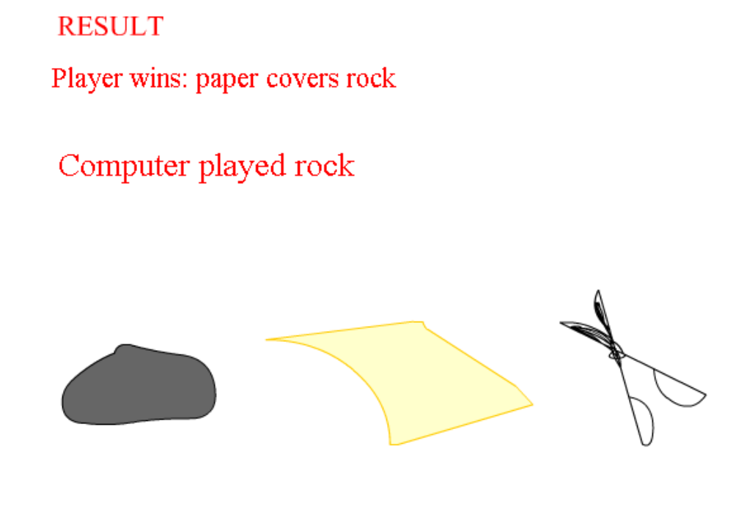

The critical requirements to implement this game are
- a way for player to indicate a move. This will be done using button symbols that show the appropriate image.
- a way for the program to generate a move for the computer that cannot be predicted and in which any of the three choices are equally likely. This will be done using the so-called pseudo-random functions of Flash.
- a way of calculating the results, that is, applying the rules of rock-paper-scissors
- a way to display the results.

The first step is to create the 3 buttons. Click on Insert/New Symbol. Make the new symbol Button and give it an appropriate name (for example, rock, paper, or scissors). When creating a button, you have the option to use different graphical content for the UP, OVER, DOWN, and HIT frames. This is up to you. Remember to Insert/Keyframe
(for Flash 8, this is Insert/Timeline/Keyframe)

in each of the frames (the first one is done for you). Change the graphics if you want. Then go on to the next button. You will do this 3 times, for each of the possible player moves. Return to main movie (also known as Scene 1) by clicking on it at the top, or going to Edit/Edit Movie.

Change the name of the first (and only) layer so far by double clicking on it. Name it board. You will place the graphical content in this layer. If the Library panel is not visible, click on Window/Library. In turn, move each of the 3 button symbols to the stage.

Add a new layer by clicking on the leftmost icon on the bottom of the layers panel:
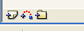

Name the new layer actions. You will put into the first frame of this layer the code for handling the player action. Insert a keyframe into this first frame. (It may be done automatically.) Click into the Actions panel. Flash MX: Be sure you are in Expert mode. Flash 8: you do not want Script Assist.

For the procedural style of coding, you need to give instance names to each of the buttons. Any name would do, but a good convention is to use names such as rockbtn, paperbtn and scissorsbtn. You do this in the Properties panel, under where its says Button: erase where it shows <instance name> and write in the corresponding name for each of the buttons.

You need to write code to establish how a certain event, the click and releasing of the rock button, is to be handled. Specifically, when the event of releasing the mouse button when on top of this button symbol (namely, the graphic you created to represent a rock) happens, Flash invokes the function computerturn with an argument of "rock". You have not created computerturn yet, but you will soon. This tutorial describes two different ways to do this. ONLY DO ONE! Repeat the process for paper and scissors. Be sure to change the argument "rock" to "paper" and "scissors", respectively.

Old way to set up event handling: Make the Actions panel appear (Click on Window/Actions). Click on the rock button. In the Actions panel, click on the right pointing arrow and select Expert mode. (The system may switch back to Normal mode, so you may need to do this again.) Then enter the following into the panel:

on (release) {
computerturn("rock");
}
You will repeat this for the other two buttons, changing the parameter in the call to computerturn to "paper" and then to "scissors", respectively.

*** end of old way

New way to set up event handling: Click on the timeline, actions layer. Open up the Actions panel. Write the following:

rockbtn.onRelease = function () {
computerturn("rock");
}
paperbtn.onRelease = function () {
computerturn("paper");
}
scissorsbtn.onRelease = function () {
computerturn("scissors");
}

*** end of new way

The old way and the new way do the same thing: set up the event handler, that is, what is to be done on the event of pressing down and then releasing the buttons representing rock, paper, and scissors moves.

You now need to create 3 text fields. If the Tools panel is not visible, click on Window on the toolbar and then Tools. You also need the Properties window to be visible, so if it has been minimized, click on the triangle pointed to by the arrow.

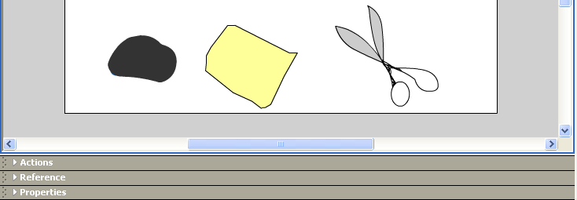

The Flash interface should look like this:
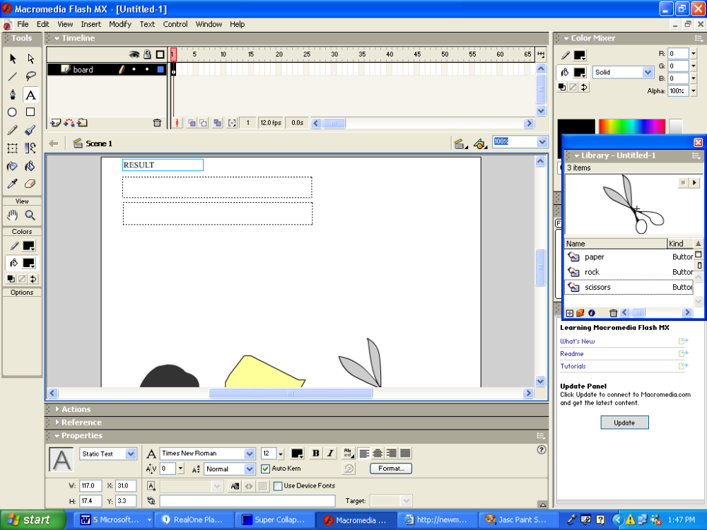

Create a text field (by default it will be a Static text field) by clicking in the A in the Tools window and then on the Stage and pressing and dragging a rectangle. Enter in the characters RESULT. You can change the color, font and size, if you wish. Create another text field. Make this one a Dynamic Text field by clicking on the pulldown arrow next to where it shows Static Text. Dynamic Text is the second option. Change the name to result. Create another dynamic text field and name it computermove. So you will have 3 text fields: one static (without a name, but with contents the string “RESULT”), one dynamic text field named result and another dynamic text field named computermove. These are all in the board layer, first (and only) frame.

Click on the actions layer, first and only frame and open the Actions panel. If you used the old style of specifying event handling, there is nothing there. If you used the new style, there is the 3 statements specifying the onRelease event handling.

The next fragment of code places a message into one of the dynamic textboxes prompting the player to make a choice. This is done very simply: the name of the textbox is placed on the left-hand side of an = sign. The equal sign indicates an assignment statement. The right-hand side is the character string that you want 'in' that textbox.
computermove = "Make a choice";

The next few lines of code set up an array holding the options for the computer's move. ActionScript, like other programming languages, have things called variables. A variable holds a value. The value may change, which is the reason for the term 'variable'. An array is a type of variable. An array holds a set of values. Each value is specified by giving an index. The code that calculates the computer's move produces a number, one of 0, 1 or 2. We set this up the options array to translate these numbers into the terms of the game.

var options=new Array();
options[0] = "rock";
options[1] = "paper";
options[2] = "scissors";

The next part of the code is the definition of the function computerturn that was mentioned previously. The first line indicates the name of the function and the name of any argument passed to the function. In this case, the variable player will hold the thing that was the argument in the call of the function. At this point, assuming you have done everything so far, you know that the arguments will be one of "rock", "paper", or "scissors".

Older Flash systems had a built-in function Random which when called with an argument of 3 will return 0, 1 or 2. However, the expression Math.floor(Math.random()*3) is now the preferred way to do this. This also is the JavaScript way.

By using this output of this function as an index into the options array, the code will produce one of the three elements. The code then puts that value into the variable named computer. Actually, one line of code does 4 things:
- create a variable named computer
- generate a random choice from 0, 1, or 2
- use that result to get an element from the options array. This will be "rock", "paper" or "scissors"
- assign that result ("rock", "paper", or "scissors") to the variable computer

The next line of code constructs a string made up of concatenating "Computer played " with whatever is now in the variable computer. The plus sign does the concatenation operation. When Flash 'sees' a plus sign, it looks to see what kinds of data are present. If the data type is character string (also called string or text), then Flash concatenates. If the data type is numeric, Flash performs an arithmetic add. The concatenated string is placed in the dynamic text field named computermove that you created.

The rest of the code does what it appears to do, namely apply if tests to various conditions. The == symbol means 'equal to'. It is used to distinguish it from the assignment statement meaning of the single equal sign. The && symbol means AND: both parts must be true. The curly brackets set off what is done when the conditions are true. Notice these actions are all putting something into the dynamic text field called result.

function computerturn (player) {
var computer = options[Math.floor(Math.random()*3)];
computermove= "Computer played " + computer;
if (computer == player) {
result="TIE"; }
if (computer=="rock" && player=="scissors") {
result= "Computer wins: rock breaks scissors"; }
if (computer=="paper" && player=="rock") {
result="Computer wins: paper covers rock"; }
if (computer=="scissors" && player=="paper") {
result="Computer wins: scissors cuts paper"; }
if (player=="rock" && computer=="scissors") {
result = "Player wins: rock breaks scissors"; }
if (player=="scissors" && computer=="paper") {
result = "Player wins: scissors cuts paper"; }
if (player=="paper" && computer=="rock") {
result = "Player wins: paper covers rock"; }
}

Now the coding of the buttons should make sense. When a player clicks and releases any of the buttons, a call is made to the function computerturn. The calls differ in that what is called the argument, the value in parentheses, will be either "rock", "paper" or "scissors".

This is the basic game. Try the game out by clicking on Control/Test movie.

Addition of animated results
You can enhance the game by displaying an animation as the result of play. That is, show a rock breaking a scissors, a paper covering rock, or a scissors cutting paper, depending on the situation. Your game will show the same animation if the computer wins or the player wins. If there is a tie, there will be no animation. You can use any knowledge you have of Flash to produce these animations. In particular, go over the lessons on tweening to produce a smooth animation of moving graphics.

Here is one way to do it. Notice that I made the decision to make these animations be on the board to the right of the buttons. The buttons do not move.

What you will do is add 3 animations to the movie. This is 3 distinct sequences of frames on the timeline. The start of these animations will be labeled "Rockbreaks", "Scissorscuts", and "Papercovers". The code in the function computerturn will use the gotoAndPlay function to go to the appropriate place. On the actions layer, you will add the ActionScript: stop() at the end of each animation. You will create these animations by cel by cel animation. You will add a new layer to hold the frame labels. This is not strictly necessary but it is an organized way to do things. The board layer holds all the graphical content, the actions layer holds the ActionScript code and the labels layer holds labels. Labels are made by Inserting a keyframe and then writing in the label under Frame in the Properties panel.

The next screen shot shows the situation when a labels layer has been created and labels put in frames 5 and 15.

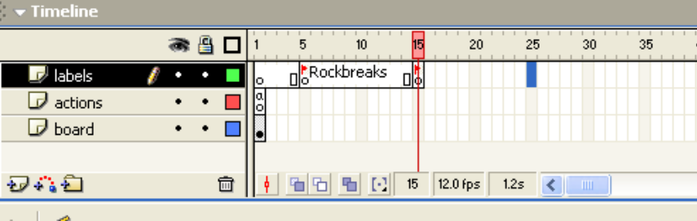

The label in frame 15 is not displayed but it is there as indicated by the flag. The next step is to insert a keyframe (you need to insert keyframes before adding labels) in frame 25. The following figure shows the screen after inserting a keyframe. Notice the Properties panel at the bottom:

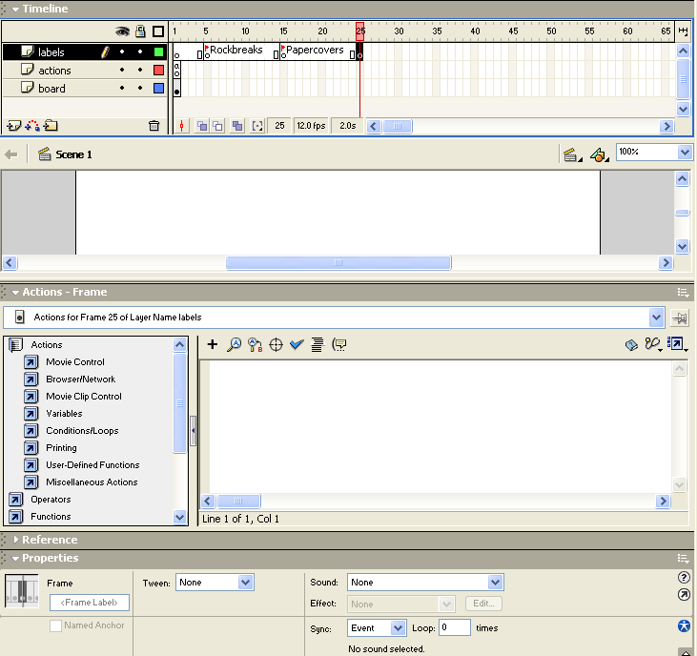

Where the arrow is pointing, replace <Frame Label> with Scissorscuts.

You can create the sequences of frames for the animations and then put in the labels or put in the labels first as we have done. Notice that the animations can be different lengths. Do not be concerned about being economical with frames. We inserted labels at frames 5, 15 and 25. Do not forget to use the Insert dropdown menu to insert a keyframe before attempting to put in the labels.

Now you need to create the animations. The mechanics are to insert keyframes starting from 5 and then 15 and then 25 for each of the 3 sequences desired. Put a different picture in each frame. Then insert a keyframe into the actions layer at the last frame of each animation and put in the code
stop();

You also need to put in a stop in the very first frame.

My approach to creating the animations was to re-use the drawings already made for the buttons. For the rock breaks scissors animation, I did the following:

Use Windows/Library to get the library holding the symbols. Double click on scissors to edit this symbol. You will not be changing anything. Select the whole graphic representing the scissors. Click on Edit/Copy. Now return to Scene 1 (return to editing the whole movie as opposed to just this symbol). Select the frame in the board layer under the Rockbreaks flag. This is frame 5. Insert a keyframe. Click on Edit/Paste. You will need to move the scissors to the upper corner. Click on Modify/Transform/Rotate. Handles will appear that allow you to rotate the scissors. Now do a similar procedure to get a copy of the rock graphic: double click on the rock button in the library. Select and copy the rock symbol. Return to editing the main movie. Select the next frame in the boards layer. Insert a keyframe. Click on Edit/Paste. Now move the rock graphic to the top of the stage, partially above the stage. This is partially off-stage! Click on the next frame. Insert a keyframe. Move the rock graphic down. Repeat this a couple more times. Now move the rock on top of the scissors. You can go back to the scissors graphic in scissors button and select pieces of it to copy and paste to show the scissors breaking apart.

Here is a screen shot showing the fifth frame (the one starting the rockbreaks sequence):

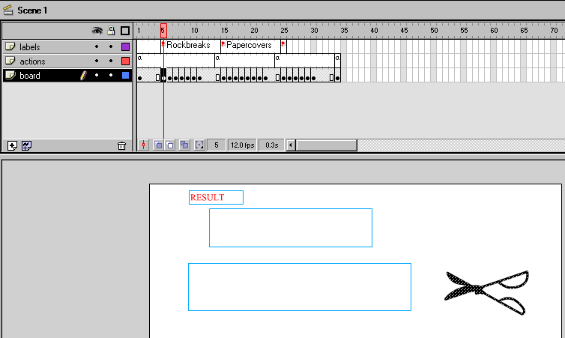

Now, we show just the section of the stage for the next 6 frames. The next frame will just show some of the rock.
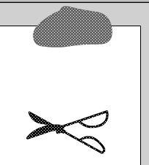

Now the rock is falling towards the scissors:
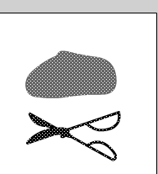

Now it hits the scissors:

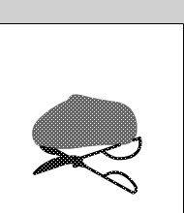

Now it crushes the scissors:

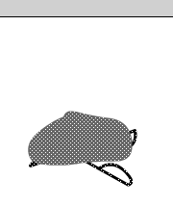

Now pieces of the scissors fly off:

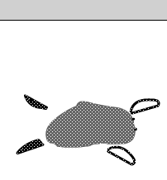

The other sequences are constructed in similar ways. The paper covering rock is the easiest. The scissors cutting paper requires cutting off pieces of the scissors so it appears to be under the paper.

The last step is to modify the computerturn function to go to the appropriate sequence. The code is the following:

if (computer=="rock" && player=="scissors") {
result= "Computer wins: rock breaks scissors";
gotoAndPlay("Rockbreaks") }

if (computer=="paper" && player=="rock") {
result="Computer wins: paper covers rock";
gotoAndPlay("Papercovers")}
if (computer=="scissors" && player=="paper") {
result="Computer wins: scissors cuts paper";
gotoAndPlay("Scissorscuts") }
if (player=="rock" && computer=="scissors") {
result = "Player wins: rock breaks scissors";
gotoAndPlay("Rockbreaks") }
if (player=="scissors" && computer=="paper") {
result = "Player wins: scissors cuts paper";
gotoAndPlay("Scissorscuts")}
if (player=="paper" && computer=="rock") {
result = "Player wins: paper covers rock";
gotoAndPlay("Papercovers") }

We use the same animation whether it is the computer or the player winning.

Try the game!

