Flash 5/MX: Memory/Concentration game

The game called memory or concentration consists of cards placed face down on a table. The player (Note: more than one player can play this game, but the application described here assumes just one player.) turns over two cards. If they match (matching can mean one thing for a deck of playing cards in which, for example, a 2 of hearts matches any other 2, and another for a smaller set of cards), the cards are removed from the playing surface. If they do not match, they are turned back to the blank side. When all the cards are matched, play ends.

Building a computer implementation of a physical game involves making design decisions. For the application described here, the player selects a card by clicking on it. The program makes 'the computer' 'take away' or 'flip back' the cards after a suitable waiting time. The use of quotation marks here is somewhat pedantic, but is done to make two points: 'the computer' will do what you program it to do, nothing more or less. The cards are not taken away: they are made invisible. Similarly, nothing is flipped over. A different, but related graphic will be made to appear. The cards are mixed up when the player clicks on a certain button. This can be done at any time.

Players can be devious or perhaps a better term is enthusiastic! Mike Mazar, who came upon my site, noticed that a player could reveal many cards by clicking fast. I put in a fix that I believe works. See the end of this document.

Here are screen shots of our implementation. There are only 8 cards. This seemed the minimum to us to establish how to do the application. You can scale up this application to as many as you want. See comments below on scaling up the number of pairs. The button to "Flip back" was made as part of the process of building and debugging the application.

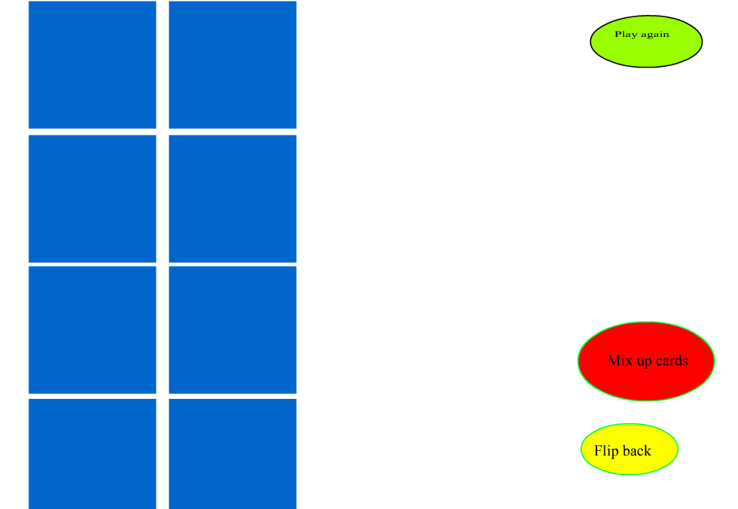

Here is the screen after two non-matching cards have been selected and before they are 'flipped back'.

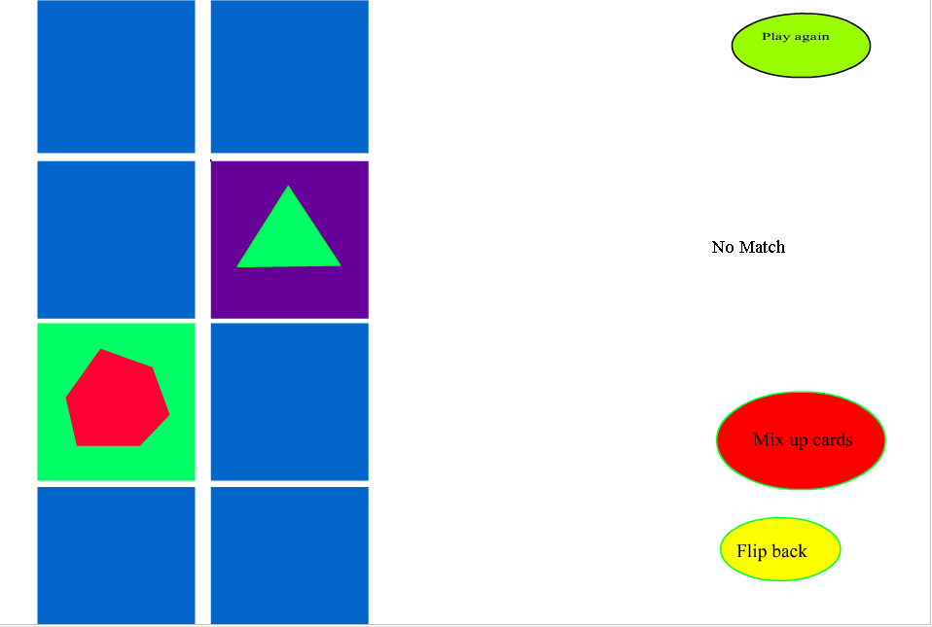

Here is a screen capture at a point where some pairs have been removed.

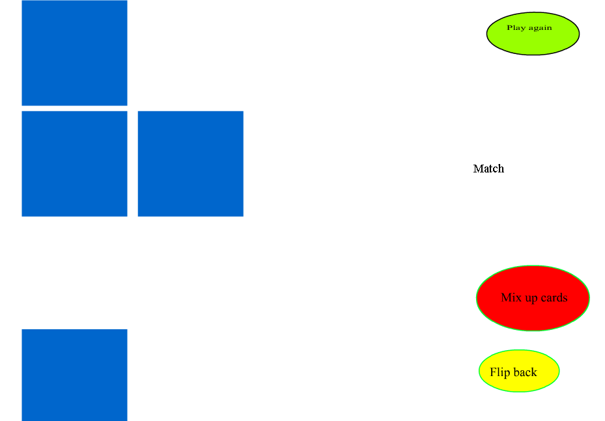

The implementation of this game required the following features:
- Designing something to be a card: that is, packaging together a blank, button graphic with specific, distinct designs so that when the player clicked on one blank graphic, the associated face would appear and, depending on conditions, flipping back to the blank image. You will create a movie clip symbol for each distinct pattern. Here this means 4 movie clips that are named circlecard, polygoncard, trianglecard and rectanglecard. You will create a button symbol and then place this symbol in the first frame of each of the 4 distinct cards. The matching clips will be created using a method called duplicateMovieclip.
- Grouping together these cards in some way for operations such as mixing the cards up and starting (and re-starting) the game. The code to do this involves user-defined objects. You will define what is termed a constructor function called Makecard. It will set up an object that holds information on each of the cards. Lastly, an array called cards will hold references to all the cards.
- Pausing the game to allow the player to see the results of his or her selections. Computer operations are so fast that this pause must be put in explicitly. This required the subtlest programming of the application. You will define an empty movie clip (called timermonitorinstance) and place an instance of it in another movie clip (called timersetup). The timersetup contains frame action code (variable definitions and a function called starttimer) and on ClipEvent (enterFrame) code for the timermonitorinstance. The sole purpose of this empty movie clip is to have this event handler. The function starttimer is called by the function called when any of the buttons representing the backs of cards are pressed and released.

One theme of this lab is packaging things together; another is making copies or near-copies of things. By the way, the terms 'object' and 'group' have specific, technical meanings in Flash and so we try to only use them when they really apply.

Begin with a new project. Make a button symbol, name it buttonback, and put in a graphic of a simple, solid rectangle. Use Window/Info to make the Info panel appear. Select the rectangle (hold down the shift key and click on each of the 4 sides of the rectangle to select the outline and the fill area) and make the rectangle an exact size (width and height) and position (X and Y), say 100 by 100, and at 0,0 by entering those numbers into the Info panel. Insert keyframes into the remaining 3 frames of the buttonback. This will replicate the rectangle shape in each frame.
Now make and name 4 graphic symbols: all rectangles, same size and position. However, put images in them such as a circle, triangle, polygon and rectangle and matching names. Make a new symbol, this one a movie clip, and call it circlecard. Add a new layer and name it actions. Our intent here is to always separate graphical content from frame actions. In the first layer, first frame, bring in the buttonback button symbol. Insert a keyframe in the second frame. In the second frame, first layer, bring in the circle graphical symbol. Select the first frame, actions layer, and put in the code:

var whichcard;
stop ();

The variable whichcard will point to an object created to hold information about the card. We use the term 'object' in its Flash, technical meaning.

Select the second frame, actions layer, and put in the code:

stop();

Now, select the first layer, first frame, select the buttonback symbol, and write the following code in the Action panel. This is not code 'in the frame' but instead associated with buttonback, which is a button.

on (release) {
_root.turnover(this);
}

The _root is used to avoid any problems with scoping, that is, calling a function from one of the movie clips contained in the main movie. The root is the main movie. You will place most of your function definitions in the main movie.
Reviewing what you have done: you have created a movie clip called circlecard. It contains two frames. The frame actions cause the flow of control to stop at each frame. One frame holds what looks like the back of a card. It is also a clickable button. The other frame holds the face or front of the card. When the button is clicked, a function named turnover is called. You can safely assume that you will write turnover later and place it in the main movie. The turnover function is called with a parameter named this. The this term is a built-in construct in ActionScript. It serves a special function: here it will be a pointer to this circlecard instance. The same turnover function will be called when any of the cards is clicked, so we need a way to pass along a reference to the specific card and this does the job.

You will now create 3 near-copies of circlecard. Each of these 4 will be duplicated during execution of the project. To create the 'near-copy', right-click the mouse on circlecard in the Library. Select Duplicate. Re-name the copy: rectanglecard. Now double click on rectanglecard in the Library list. You do this to make changes to the copy, not the original. What do you need to change? The answer is: just the contents of the 2nd frame, first layer. Repeat for trianglecard and polygoncard.

Go back to the main movie (click on Scene 1 or Click on Edit Movie under Edit or click on the left pointing arrow). Name the first layer board and add a new layer called actions. In the first frame of the board layer, bring in instances of circlecard, rectanglecard, polygoncard, and trianglecard: you do this by click and dragging on the symbol name in the library to move an instance of the symbol into the main movie. You give the instance a name by typing in a name in the Property panel where it says <instance name>. Name them circle1, rectangle1, polygon1, and triangle1. Click in the first frame of the actions layer and write the following code:

function turnover(card) {
trace(card._name);
}

This is just to check what you have done so far. The trace function is very useful for debugging. In this case, we make use the of _name property that every instance has. You will change this function. Test the program using Control/Test Movie. Click on each card. The trace window should appear and print out the name of the clip instance clicked on. Since just the back of the card, that is, the contents of the first frame, will be displayed, you will need to remember where you put which card to check if it is correct. Actually, the way these things usually happen, it will work correctly or not work at all.

Now, we get back to work creating the set of cards. You will define a new object class that will hold information on a card. You will then make 8 instances of that class, using the instances of the cards you have already made plus duplicates. You also need to position the cards on the screen.

The Makecard function is what is called a constructor. It is a standard practice to start constructor functions with an upper-case letter. It constructs a new object when called with the new operator (see below). In this case, the new object has properties that point to a movie clip that is one of circlecard, trianglecard, etc.; give a name to the card, an x and y position, and indication of whether or not the card is to be removed. The name field will be the same for matching cards and this is what the code uses to check for matches. The constructor function also re-positions the movie clip. It sets a value 'in' the movie clip to point to this object. Notice the use of this as a reference to the new object being created. Place this code in the first frame, actions layer of the main movie.

function Makecard(name, x, y, cardm) { | Function header
this.card = cardm; | Make the card property of this object be the instance named by cardm
this.name = name; | Make the name property of this card the name 'named' by the name argument
this.card._x = x; | Position the instance horizontally using the x argument
this.card._y = y; | Position the instance vertically using the y argument
cardm.whichcard = this; | Go into the instance named cardm and set the whichcard variable to point at this object
this.remove = false; | Set the remove property to be false.
}

The next piece of code to be placed in the first frame, actions layer creates duplicate movie clips, creates the Makecard objects, and positions the associated graphics on the screen. The variables ux and uy give starting off positions for the cards.
The duplicateMovieClip is a method of movie clip objects. It is a way to create instances dynamically (during the execution of the application). The second parameter of the call to this method is a depth indicator and must be unique if you do not want a prior duplicated clip to go away.

ux = 5; | Start the positioning on the board at this x value …
uy = 1; | … and this y value. This is very close to the upper left corner.
function makecards() { | Function definition to make the cards
card1 = new Makecard("circle", ux, uy, circle1); | The card1 will point to the circle1 already created. Makecard positions it. Notice the name is circle.
circle1.duplicateMovieClip("circle2",0); | Duplicate circle1 and name this instance circle2.
card2 = new Makecard("circle",ux+110, uy, circle2); | The card2 will point to circle2. It is to the right of card1. Notice the name is 'circle'.
card3 = new Makecard("polygon", ux, uy+105, polygon1); | The card3 points to the polygon1 card. It is in the left column, under card1.
polygon1.duplicateMovieClip("polygon2",1); | Duplicate polygon1 to make polygon2. The 1 parameter is necessary to not wipe out card2 or card1 at levels 1 and 0.
card4 = new Makecard("polygon",ux+110, uy+105, polygon2); | The card4 points to polygon2. It is positioned at second row, second column.
 | Go over the next few lines yourself!
card5 = new Makecard("rectangle", ux, uy+208, rectangle1);
rectangle1.duplicateMovieClip("rectangle2",2);
card6 = new Makecard("rectangle",ux+110, uy+208, rectangle2);
card7 = new Makecard("triangle", ux, uy+312, triangle1);
triangle1.duplicateMovieClip("triangle2", 3);
card8 = new Makecard("triangle", ux+110, uy+312, triangle2);
cards = [card1, card2, card3, card4, card5, card6, card7, card8]; | Make cards be an array consisting of all the cards.
nc = 8; nm = 4; | Set nc to be number of cards and nm to be number of possible matches.
}

If you wanted to make a bigger number of cards than 8 (or, rather 2 times 4), you might consider having a systematic set of names such as img1, img2, etc. You would then write code to generate clips img11, img12, img21, img22, and so on. You also need to change the placement of the cards produced by the expressions involving ux and uy.

The function makecards to make all the cards is invoked in the following code. Note that a check is made if the Boolean value cardsmade is not true. This code also goes in the first frame, actions layer. At that time, other variables are set so that play can start. Notice also in the makecards function that the number of cards is placed in the variable nc and the number of matches is placed in the variable nm. The cards are, in our words, packaged together into an array called cards. Notice that this is not in a function and gets executed when the frame is opened. However, the body of the if clause is only executed once, since the variable cardsmade is set to true within the clause.

if (cardsmade!=true) {
makecards();
numofmatches = 0;
firstturn = true;
cardsmade=true;
}

Now, we go back to the most important function, the one that handles the logic for what happens when a card (button back of a card) is clicked on. You can remove the trace function, or leave it until everything is working. The following variables are necessary and some have already been mentioned. You can place these var statements before any of the function definitions.

var firstturn;
var secondpick;
var firstpick;
var cardsmade;
var nc;
var nm;
var cards;
var numofmatches;

The critical concept here is that of the first turn and the second turn. The player clicks on one card and the turnover function must do something to prepare for when the player clicks on a second card. It is only after clicking on two cards that code can test for a match. The code also keeps track of the number of matches made. If a match has been made, the remove property defined in the Makecard function is set to true. Another function, to be described below, makes use of that information.

function turnover(card) { | Function header. The argument will indicate the card selected.
var first;
var second;
result = "" | Reset the result to empty. This will only be noticed if it is a first turn (first of two picks)
card.gotoAndPlay(2); | reveals face of card
if (firstturn) { | If a first turn
firstpick = card; | … save a pointer to the card in firstpick
firstturn = false; } | And set firstturn to false
else { | (not a first turn)
firstturn = true; | Set firstturn to true for the next pick.
secondpick = card; | Save a pointer to the card
first = firstpick.whichcard.name; | Obtain the name of the firstpick card
second = card.whichcard.name; | Obtain the name of the secondpick card
if (first==second) { | Compare the two…being the same means it was a match
numofmatches = numofmatches + 1; | Increment number of matches
if (numofmatches==nm) { result = "You won"; } | If the game is over (all matches made), set result to "You won".
else { result = "Match"; } | Else set result to "Match".
firstpick.whichcard.remove = true; | Mark firstpick card for removal
card.whichcard.remove = true; | Mark card (which is the secondpick card) for removal
} | End the clause for match
else { result = "No Match"; } | Else (not a match): set result to say so.
trace ("call to timer routine"); //to be replaced | Debugging code
trace ("number of matches " + numofmatches); | Debugging code
} | End clause for not firstturn
} | End function definition.

The trace function shown here will be replaced by the real call to the timer routine. You need to add a Dynamic text field, with the variable name result to the board layer, first frame. (If you do not do this, nothing will be displayed.) You can then test the program. Of course, no cards get flipped back or removed, but you can test if there are matches.

You will now add more functions to the actions layer, first frame. The removecards function is invoked after the timer action. The removal is really only making the movie clip not visible. The program also 'flips back' by resetting the frame of the corresponding movie clip to the first frame (where the buttonback is). This is all done with a for loop. The for loop goes through the whole deck of cards, not just the last two cards.

function removecards() {
var i;
for (i=0; i<_root.nc; i++) {
if (_root.cards[i].remove) {
_root.cards[i].card._visible = false;
}
else {
_root.cards[i].card.gotoAndStop(1);
}
} }

If you want to test this routine now, you can put in _root.removecards() after the two trace statements OR put in a button called Flip back as shown in the code. Make the button on (release) action be _root.removecards(). That is, create a button, make the first frame anything you wish, insert keyframes in the rest of the frames, and bring it into the main movie. While the button is selected, in the Actions panel, write:

on (release) {
_root.removecards();
}

This is just for incremental testing and debugging and so you may resist doing so, but it is a good thing to do. Test your program. If you put the call to removecards in the turnover function, you will not see the second card. The action is too fast. When it works, you will have debugged a substantial part of the project.

The restoreall function is invoked by the player to start a new game. It restores all the cards to being visible, sets the remove property of each card back to false, and sets the frame of the movie clips all to 1, the button back position. The program also sets numofmatches to zero and firstturn to zero. You need to create a new button symbol with a caption something such as Play Again, make an instance in the board layer of the main movie, and make the on(release) event handler a call to _root.restoreall().

function restoreall () {
var i;
for (i=0; i<_root.nc; i++) {
_root.cards[i].remove = false;
_root.cards[i].card._visible = true;
_root.cards[i].card.gotoAndStop(1);
}
numofmatches = 0;
firstturn = true;
}

You can test this program to see if the cards get restored properly.

You may be thinking that this is a pretty easy game to play because the position of the cards is fixed. The next program changes that. You need to add a button that will invoke it.

function mixup() {
var i;
var j; var k;
var oldx; var oldy;
for (i=1; i<=16; i++) {
j = random(nc);
k = random(nc);
//swap positions of the jth and kth cards
oldx = cards[j].card._x;
oldy = cards[j].card._y;
cards[j].card._x = cards[k].card._x;
cards[j].card._y = cards[k].card._y;
cards[k].card._x = oldx;
cards[k].card._y = oldy;
}
}

There are other ways to mix up cards, some more efficient than this one. You can work on that for extra credit! What this does is make 16 swaps of a randomly chosen pair of cards. By the way, if the random values (j and k in the code) are equal, the code makes the swap anyway. The swap is made in the position of the cards, not in any of the other properties. Notice that the local variables oldx and oldy are needed to store values temporarily. Creating a button to call mixup (the shuffling function) is another example of something done for debugging. You will make faster progress if you test parts of your project individually and then together with the rest of the application. Later, you will put in calls to mixup. For example, you can place one in the restoreall function, right before the closing bracket:

_root.mixup();

Now is the time to write the code to perform the pause. Create a new layer on the main movie. Note: these different layers are just to make things clear. You could put everything in one layer, but we advise against it. Call the new layer process. Now create a new movie clip symbol and call it timermonitorinstance. It will be absolutely empty! Create a second new movie clip symbol. Call it timersetup. It will not contain any visible content, but just code. Create a new layer. Call the first layer actions and the second layer process. Place an instance of the timermonitorinstance in the first frame of the process layer and call it timermonitorinstance. (The instance name in the timersetup movie clip is the critical thing.) In the first frame of the actions layer, put the following code:

var timeractive; | Set to true if timing is to occur
var timerend; | Will be set to the calculated end time
var timerfunc; | Set to the function to call when the timing interval has elapsed
function starttimer(msec, func) { | Function to setup the timing
timerend= getTimer() + msec; | Calculate when the timing interval is to end
timeractive = true; | Set the timeractive to true.
timerfunc = func; | Store the function to be called.
}
stop(); | Do not continue, namely do not loop to this frame again.

Click on the small circle that represents the timermonitorinstance. In the Action panel, write the following code:

onClipEvent (enterFrame) { | Every time the single frame of timermonitorinstance is entered (which happens continually), do the following
with (_parent) { | Using the variables of the parent of this instance—timersetupinstance
if (timeractive && timerend<=getTimer()) { | If the timing is going on and the interval still hasn't elapsed yet…The getTimer accesses the clock.
timeractive = false; | Reset timeractive to false
timerfunc(); | Invoke the function stored away in timerfunc. See below (this will be removecards
} | End the if clause
} | End the with clause
} | End the onClipEvent definition.

Place an instance of the timersetup symbol on your main movie. You can place it off-stage, though since it has no content, it can be anywhere. Name it timesetupinstance. You will insert a call to starttimer where you now have the trace functions. The call will be:

timersetupinstance.starttimer(1000,removecards);

These instances work as follows: the onClipEvent for the timermonitorinstance keeps getting called. The code checks the variables that have been declared in timersetup. The timeractive variable will have been set to true if a call is made to the starttimer function. If it has not been set to true, nothing happens. When starttimer is called, timerend is also set to the time at that moment plus the amount indicated by the first parameter. We indicate here the value 1000, which means 1 second. Returning to the clipevent handler: if timeractive is true and also the current time is greater than that held in timerend, then timeractive is set to false and the function indicated by the original call to starttimer is invoked. In our case, this is the removecards function. This implements the pause.

Test the movie. Remove (or, better, comment out) any debugging statements. You can also remove the Flip back button. Put in a call to mixup() when the project starts and in the restoreall function. Enjoy.

Summary: The main movie has 1 frame and 3 layers: board, action and process. The board layer initially holds 1 instance of each of the 4 'cards': instances of the movie clips polygoncard, trianglecard, circlecard and rectanglecard, two buttons and a Dynamic text field. The action layer contains the var statements for several variables plus the definitions of the functions turnover, Makecard, makecards, removecards, restoreall, and mixup. The board is completed by a call to makecards, which calls Makecard to create a card object. Part of this is a call to duplicateMovieClip to duplicate the 'seed' card. The process layer contains an instance of the movie clip timersetup. The timersetup movie clip itself contains an empty movie clip called timermonitorinstance. The 'card' instances are each 2 frame, 2 layer (board and action) movie clips. The first frame, board layer contains a button. The release action for the button is a call to the turnover function in the 1st (and only) frame, action layer of the main movie. The second frame, board layer of each card instance is a graphic.
The project needs to be modified for your players by removing all debugging code and inserting calls to mixup() after the call to makecards() and in the restoreall function.
Fix for fast clicking: Define a variable called oktowork and initialize it to be true. Make this the condition for doing anything in the turnover function. Set this variable to false in the code for the second card. Now the question is where to re-set this variable back to true. The place is the removecards function.
function turnover(card) {
if (oktowork) {
var first;
var second;
result = ""
card.gotoAndPlay(2); //reveals face of card

if (firstturn) {
firstpick = card;
firstturn = false; }
else {
oktowork = false;
firstturn = true;
secondpick = card;
first = firstpick.whichcard.name;
second = card.whichcard.name;
if (first==second) {
numofmatches = numofmatches + 1;
if (numofmatches==nm) { result = "You won"; }
else { result = "Match"; }
firstpick.whichcard.remove = true;
card.whichcard.remove = true;
}
else { result = "No Match"; }
timersetupinstance.starttimer(1000,removecards);
}
} // ends the if (oktowork) clause
}

function removecards() {
var i;
for (i=0; i<_root.nc; i++) {
if (_root.cards[i].remove) {
_root.cards[i].card._visible = false;
}
else {
_root.cards[i].card.gotoAndStop(1);
}
}
oktowork = true;
}

