Tutorial: Using Flash, php and MySql, keep persistent information; Flash radio and push button components

A typical Flash application, like a simple HTML web page, does not collect and store data on the server computer. To store information, you need to use a file or a database and connect to the file or database using so-called server-side or middleware software. Similarly, a typical php application accepts form data from a HTML form and produces an HTML document. This example demonstrates using Flash and php to store data in and extract data from a MySql database. Both php and MySql are considered Open Source tools.

The application keeps track of votes cast for 4 choices. It is intended to represent a polling application, not a voting application. Please note that a real voting application would need to incorporate features to allow only legitimate voters to vote and to only vote once. A debate is going on now concerning various systems for electronic voting. One feature considered critical by many, though not all, is that the system produce a paper trail for each vote. This toy application does not include any of these features. The intent is to demonstrate how Flash can connect to a php script.

Before continuing, one more warning: A basic contract with an Internet Service Provider generally would not include support of php scripts or MySql (or any other) database. This application and tutorial assumes php and MySql support and, moreover, assumes that a table has been created and initialized to hold the polling data.

It is assumed that the reader has some background using Flash. This document will explain the features of the application, not give step-by-step instructions on how to replicate it.

The initial screen for the Flash interface is the following:
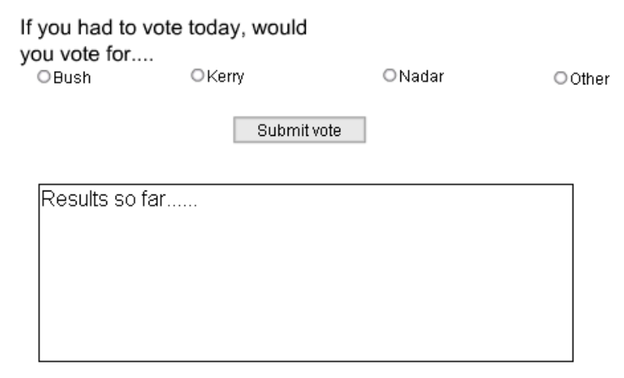
If the person responds by clicking on the radio button next to Other and then Submit vote, the following screen results (at this point for this application. I do not know where these 'votes' came from—perhaps my students).

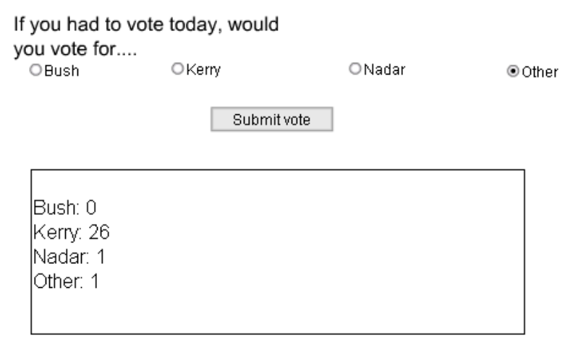

The Flash interface consists of
- the static text field with the words "If you had to vote today, would you vote for …."
- 4 radio button components
- 1 push button component
- A dynamic text field, marked as accepting HTML tags and with a boundary

There are two layers: one layer, named board, holds all the graphics; the other layer, called actions, holds the ActionScript. This is not necessary but is a standard way to organize an application.

The static text field is created in the usual way, using the text tool (icon A).

The radio buttons are created by clicking on the radio button icon on the component panel and dragging a button to the Stage. The screen shot below shows the Property panel as set up for the Bush button. In this case, the label and the data are similar. That does not have to be the case. Notice also the Group Name. All four buttons would have the same group name. This works to make the Flash engine make sure that only one button is clicked. Notice that there is no Change Handler. This is because for this application, we wait for the 'voter' to click on the Submit Vote push button. The Initial state and the Label Placement were left unchanged. You need to do this for as many times as you want choices.
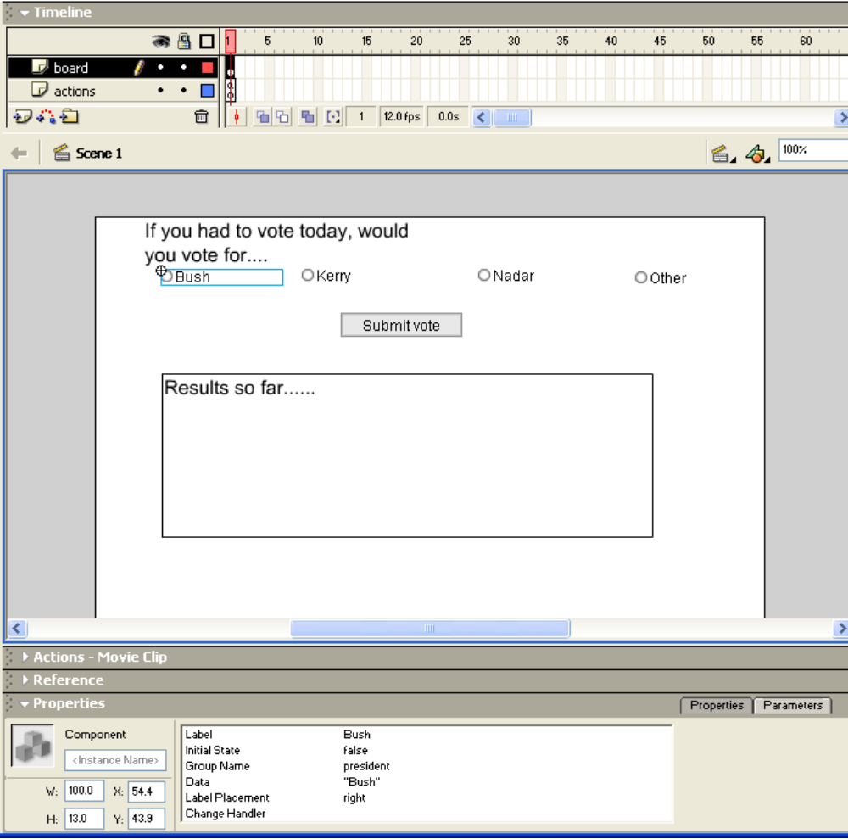

The next figure shows the screen when the push button is selected. As with the radio button, you click on the push button icon in the components panel and drag an instance to the Stage. The key properties to change are the Label and the Click Handler. The gotoserver is a function defined in the actions layer, frame 1 (only frame) of the Time line.

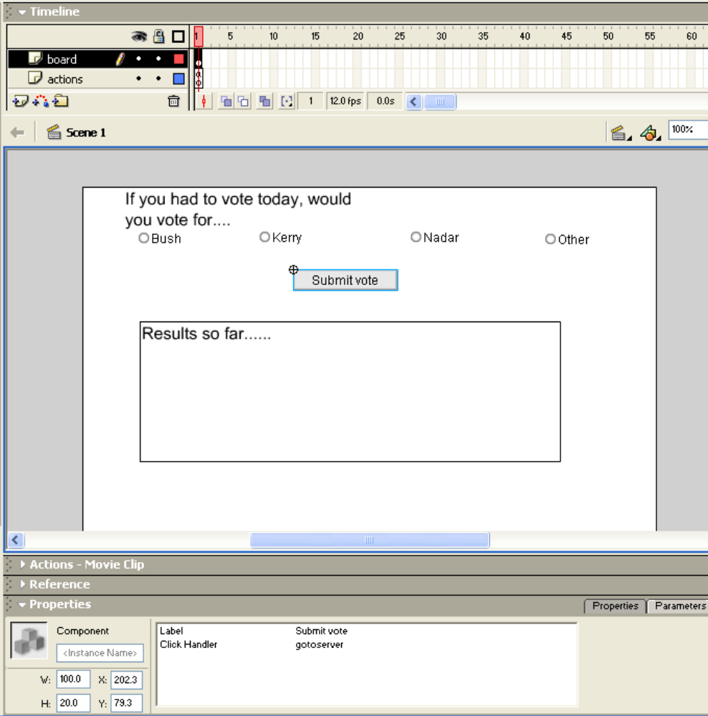

The dynamic text field is created using the text tool (the A), choosing Dynamic (as opposed to Static or Input). Notice that the name display is entered into the instance name position and not the Var position. Notice also that the options are selected for Multi-line, HTML (the <> icon) and border. The HTML tag support is limited to tags such as <b> for bold, <br> for line break, and (not used here) <a> for hyperlink. There is no support for table tags and if you use <p>, you need to use </p> to get noticeable results. When the text field was created, the words Results so far…. were entered into the field. This will be over-written by the results of the php script.
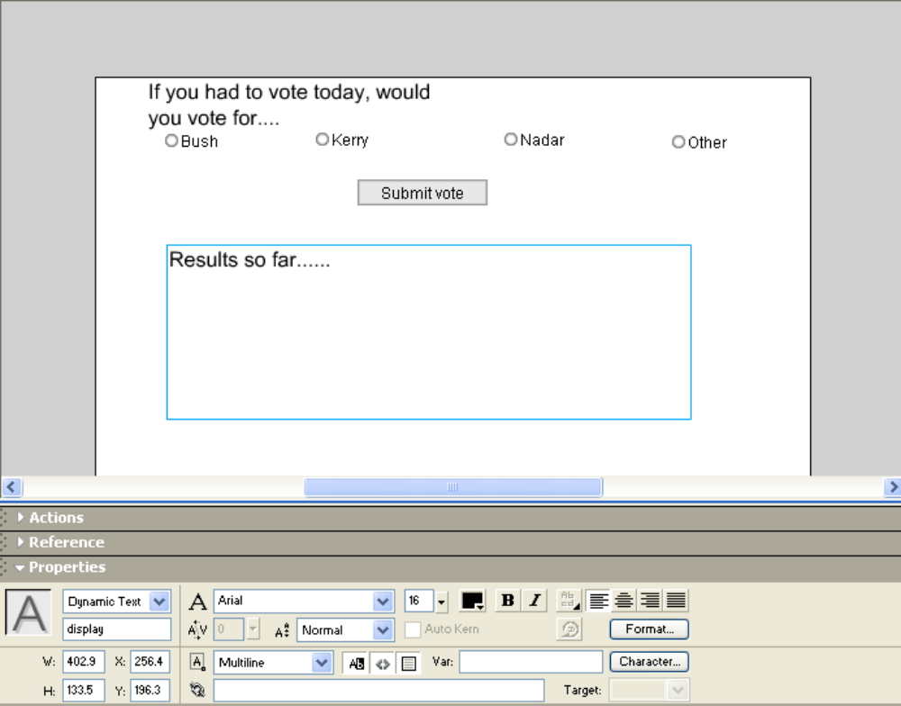

The next logical step is to show and explain the gotoserver function. It and another function are coded into the actions layer, frame 1, using the Actions panel. This is frame code, not associated with any object. Note: the push button component definition has made the connection between the gotoserver function and the event of clicking the button.

The screen shot shows all the Action script:

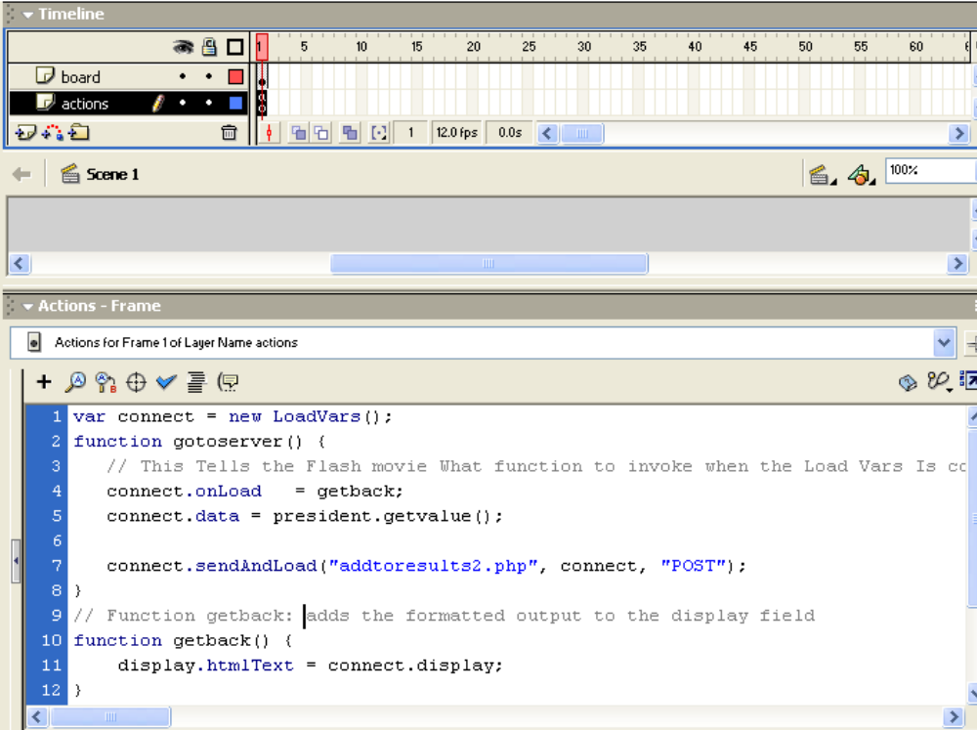

The variable connect is defined using the LoadVars() function. That is, it is an object of type LoadVars, created to carry information to and from the php script. The function gotoserver does three things.

connect.onLoad = getback; specifies that when the Load operation is complete, call the function getback. Notice that this is all this statement does. It does not initiate the call to the php script.

connect.data = president.getvalue(); defines a new property of the connect object. The new property is named data. Its value is extracted from the president radio button group and is the value of that group: "Bush", "Kerry", etc.

connect.sendAndLoad("addtoresults2.php", connect, "POST"); makes the call to the file on the server named addtoresults2.php. The connect object is used to bring back information (all the examples I have seen use the same LoadVars object, but, presumably, this could be different). Lastly, the method of transmission is POST. People familiar with HTML forms will remember the choice of GET versus POST.

The call to the php script may take some time. When it is done, the getback function will be invoked. This code contains no error checking for the file not existing or some other problem. The getback function takes the display property, presumably set in the php script and assigns it to the display dynamic text field instance using the htmlText property. This means that whatever is assigned is interpreted as HTML text.

The php file must take the data, access and update the appropriate record in the MySql database, then access all the records (all 4) in the database, format the results, and return this string of characters to the Flash program. Structured Query Language, SQL, is used to access the database. The table in the database is named votes. Each record has two fields (actually, each record has an id field, but that is not used.): candidate and votescast. In php, variable names start with dollar signs. The setting of the data sent back to the other program is done using the name you decide on (here, display) and print statements, starting with print "&display = ";

Here is the code (with my user name, password and database name replaced by question marks. You will need to change this to values for your account):

<?php | Delimiter starting php
// Incoming Variables.. | comment
$data = $HTTP_POST_VARS['data']; | Extracts the data input variable
$host="localhost"; | Specifies that the database is on this server computer
$user="????"; | Replace with allowed user name
$password="?????"; | Replace with password for that user
$DBname="??????"; | Replace with database name
$link=mysql_connect($host,$user,$password); | Establish the link from php to the MySql database
print "&display="; | Print statement to start setting of display
$query = "UPDATE votes SET votescast = votescast+1 WHERE candidate = '" .$data . "'"; | Define the SQL query: update the one record with candidate field equal to the value sent over in the data variable
$result = mysql_db_query($DBname,$query,$link); | This statement does the query. No error checking is done!
$query = "SELECT * FROM votes"; | Define another query, this one extracting all the records from the votes table.
$result = mysql_db_query($DBname,$query,$link); | This statement does the query, return the results in the $result variable. This is called a recordset.
while ($row=mysql_fetch_array($result)) { | The while statement uses a built-in function in php that extracts an associative array corresponding to a row in the $result recordset. It will return false when there are no more rows (meaning no more records).
print "<br>"; | Output a line break tag.
print $row["candidate"]; | Output the element of the $row array corresponding to "candidate"
print ": "; | Output a colon and a space
print $row["votescast"]; | Output the element of the $row array corresponding to "votescast"
print " <br>"; | Output a line break
} | Close the while
?> | Close php

This is the application! I wrote two more php scripts (in addition to scripts defining the table and initializing it with 4 records), none connected to Flash. One reset the values to zero and the other showed the values.

More on php can be found in my book: Creating Database Web Applications with PHP and ASP, Charles River Media, publishers.

