Flash lab: skiing game: going through gates, timed

This lab will provide ideas and methods for implementing a 'thumb-twitching', racing game in which the player guides a skier down a mountain, constrained to travel through gates. The player can speed up or slow down as well as move (angle) left or right. The object of the game is to make it down the mountain in the least amount of time.

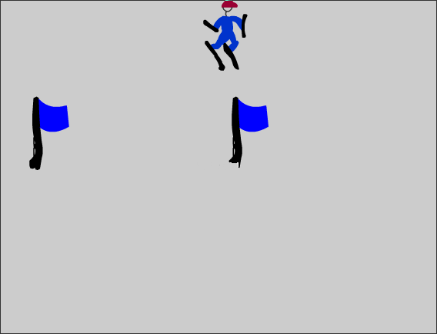

If the skier misses a gate or goes off course, the game is over. (The gate missed is indicated by a red mark.) The screen shot below also shows the press to start button, directions, and the results, including elapsed time.

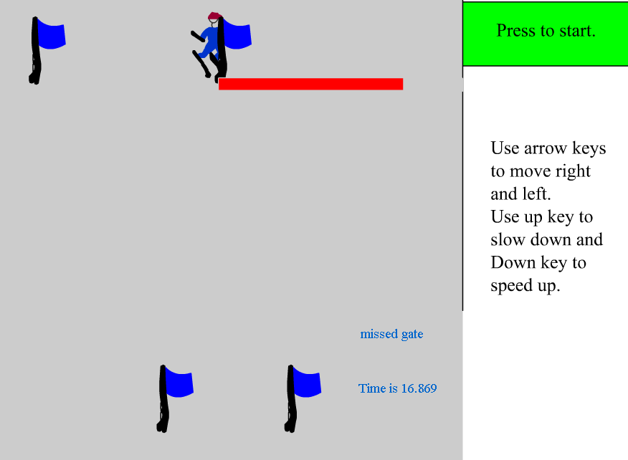

Movement left or right is done by adjusting the angle of motion.

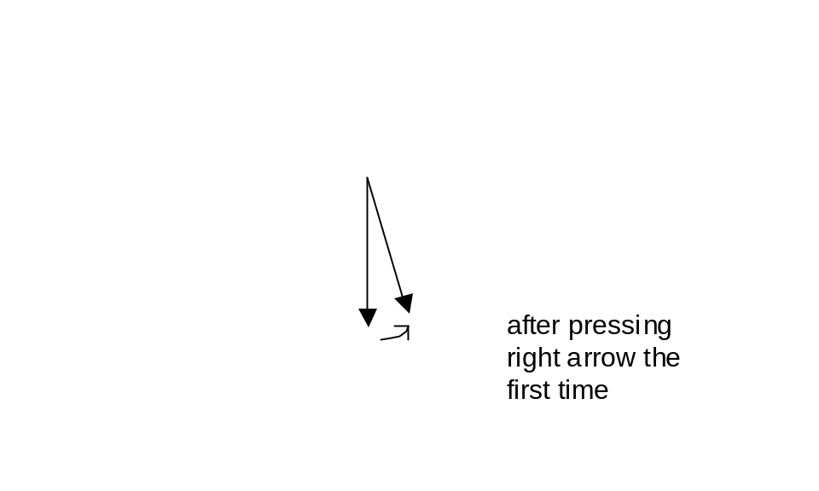

The critical requirements for you, the program, are to
- construct the mountain, that is, create the course and the gates. The mountain is a tall rectangle (see next point). Each gate consists of 4 distinct movie clips: the two flags and two forbidden regions represented by movie clips that hold rectangles. These forbidden regions are made invisible and become visible only if hit by the skier (indicating a missed gate). The current implementation has 4 gates, with positions hard-coded in the program. A good enhancement would be to make all aspects of the gates (vertical placement and width) random within reasonable constraints.
- make the skier move down the mountain. Your programming will accomplish this by moving the mountain movie clip up the screen. Only some of the clip representing the mountain will be visible at any time. It is also necessary to move the gates. The game is over when the mountain has been moved up all the way. To be more specific, since the player can use the right and left arrow keys to change the angle of skier motion, the mountain and the gates move in both x and y. The initial setting has only vertical and no horizontal movement. The critical variables are unit and angle. The unit variable is affected by the up and down arrows. The player can slow the motion down but not below a fixed minimum amount. There is no enforced limit to how fast the skier can go (this should probably be an enhancement.) From the unit and angle variables, the displacements are calculated and stored in variables named xspeed and yspeed.
- calculate the elapsed time. This is done using the getTimer() global function.
- detect missed gates. This will be done by use of the enterframe clip events for the forbidden areas (see above). Note that duplicated movie clips share any clip event code. The code will call the hitTest method for the corresponding clip with the skier the target argument. If there is a hit, then the code sets the oncourse flag to false so that the game stops.
- respond to the player action of hitting the arrow keys to make the skier move left or right. The keydown clip event is exactly what is required here. Your code for handling this event will determine which key was pressed, change the angle. I chose to limit the angle, thus preventing the skier from skiing horizontally or even up the mountain. For example, if the arrow pointing right is pressed, then the following two lines are executed:
_root.angle += .1; // this increments the angle by .1
_root.angle = Math.Min(_root.angle,_root.rightlimit);
- respond to the player action of hitting the up and down keys, to slow down or speed up. The same keydown clip event is used. The variable unit is changed (though it can never be less than zero).
- report to the player when the game is over. You will place dynamic text fields on the screen. These hold the elapsed time, a message if the skier went off course and a message if a gate was missed.

The content of this game consists of 5 symbols and 3 text fields
Symbol name | Type | Instance(s) | Graphical attributes
courseA | Movie clip | Single instance: courseA | Rectangle 400 by 1200 pixels
skier | Movie clip | Single instance: skier | Drawing of skier
flag | Movie clip | 4 times 2 created as parts of gates | Drawing of flag
forbidden | Movie clip | 4 times 2 created as parts of gates | Red rectangle
start | Button | Used to call startgame | Rectangle with text field

One text field is static and holds directions for the game (see above: "Use arrow keys…"). A dynamic text field called resultgate will hold the message that a gate was missed. A dynamic text field called resulttime will hold the elapsed time. These two fields need only be present in the third frame (board layer).

All but the start button are located off-stage. The function, buildcourse, positions courseA and skier and creates (using duplicateMovieClip many times) and positions the gates. The function restorecourse does just that: re-positions courseA, skier and gates to the initial position. Each gate as indicated previously consists of two flag instances and two forbidden instances. The forbidden instances are invisible initially and made visible only if the skier collides with them. A gate is set up as an object, with its own properties. All the gate objects (4 in this implementation) are made to be elements of an array called gates. This is used to move the gates.

The code for this game is in the frames and in clip events associated with the skier and the forbidden clips. There are 3 frames. The code in the first frame consists of global variables and function definitions. The code in the second frame moves the skier down the mountain by moving the course and the gate elements. Movement can be both horizontal and vertical, depending on the angle of motion. Code in the third frame checks to see if the skier is off-course, if the skier is still in motion as indicated by a Boolean variable oncourse, and if the course has been completed. If the run is completed or the run has ended because of a missed gate or going off the course, then the elapsed time is calculated and displayed. If the skiing is to continue, then gotoAndPlay is used to go to the frame labeled "continue", which is the 2nd frame.

The following screen capture shows the timeline as well as the contents of the ActionScript in the second frame. This is the code that simulates the motion by moving the course and each element (gate) in the gates array (each gate is made up of 4 items). More formally, a gate is an object we have defined to have an array called items as one of its properties. The gates array has as elements the gate objects.

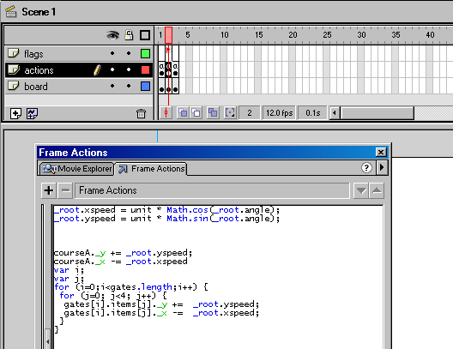

Begin implementation of the game by creating the 5 symbols (courseA, skier, flag, forbidden and the button). NOTE: if you have created the other skier program, you can open that movie, open the Library, open a new application, and click-and-drag the courseA and the skier from the Library for the old project into the new project. You are copying the symbols—they remain in the old project.

Rename the original layer board and create 2 more layers, naming them actions and flags. Selecting the board layer, first (and so far only) frame, add instances of courseA, skier, flag and forbidden off-stage, naming the instances courseA, skier, flag and forbidden. Then add an instance of the button to the stage. Create a static text box on the stage with the directions.

This application has many global variables. The following table indicates the variable name, function, initial setting and how (where) it is accessed and changed.

Variable name (proceeded by var in code) | Function | Initial setting | How/where used
oncourse | Indicates skier in motion |  | Set to true by startgame  Checked in 3rd frame. Set to false in 3rd frame (if off-course) and in clipframe for the forbidden instances
nl | Keeps track of number of levels | nl = 0; | Used and incremented in buildcourse
unit | Base speed | unit = 10; | Will change by up and down arrows
angle | Angle of skier path | Angle = Math.PI*1.5; | Changed in keytest  Accessed in 2nd frame to calculate xspeed and yspeed
xspeed | Horizontal motion |  | Calculated (based on unit and angle) & used in 2nd frame
yspeed | Vertical motion |  | Calculated (based on unit and angle) & used in 2nd frame
starttime | Holds starting time for skier run | Set in startgame | Used in code in frame 3 to calculate elapsed time
rightlimit | Furthest right most angle that skier is allowed to go | rightlimit=Math.Pi*1.75; | Used in keytest
leftlimit | Furthest left most angle that skier is allowed to go | leftlimit = Math.Pi*1.25; | Used in keytest
gates = New Array(); | Will hold each gate object |  | Set in buildcourse  Used in 2nd frame
hcw | Holds the size of half the course | hcw = .5 * courseA._width; | Used in code in 3rd frame to check if off course
coursenotbuilt | Indicates if course has not yet been built | coursenotbuilt=true; | Set to false in buildcourse.  Checked by startgame.

The first part of the code in the first frame, actions layer is, therefore:
var oncourse; | Flag for being on course
var nl; | Keeps track of levels for created instances
var unit; | Unit of incremental distance. Changed by up and down arrows
var angle; | Holds angle. Changed by left and right arrows
var xspeed; | Horizontal speed
var yspeed; | Vertical speed
var starttime; | Start time of run
nl = 0; | Level indicator
angle = Math.PI * 1.5; | Initialize (note unit is radians not degrees)
var rightlimit; | Right limit of allowable angle
rightlimit = Math.Pi * 1.75;
var leftlimit; | Left limit of allowable angle
leftlimit = Math.Pi * 1.25;
unit = 10; | Initial unit
var gates = new Array(); | Gates will hold all the gates
var hcw; | Used to detect being off course
hcw = .5 * courseA._width; | … half of course width
var coursenotbuilt; | Flag
coursenotbuilt=true; | Set to true

Before going on with the code, here is background concerning the angle of motion. The skier starts off (virtually) skiing straight down (vertically) the mountain. However, the player can alter the angle of motion so that vertical and horizontal motion occurs. The mathematics for doing this involves what is called resolving the vectors. The trigonometric functions cosine and sine are used to compute the horizontal and vertical displacements (I call them xspeed and yspeed). ActionScript has these built-in functions. They require the angle to be in radians, not the more familiar degrees, but easy enough to use once you accept what they are. The diagram below indicates the initial angle plus what I have set as the left and right limits. Note: you can omit the code to enforce a limit. In which case, it will be possible for the skier to ski up the mountain. If you do that, you should decide what will end the run if the skier (virtually) travels all the way back up the mountain. I use the Greek letter for the mathematical constant 'pi'.
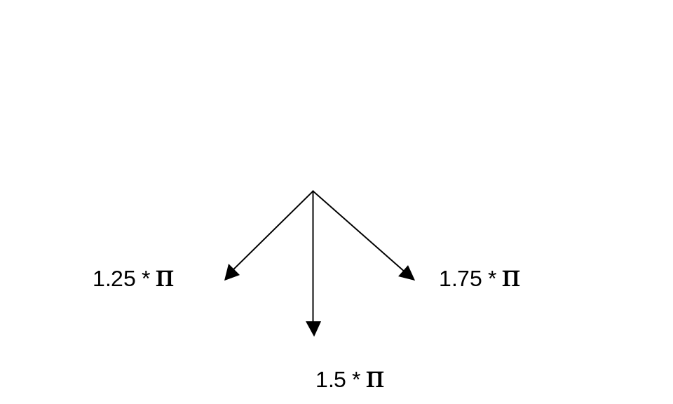

The code in frame 1 consists of the definitions of the following functions:

Function name | Function | How/when called
Buildcourse() | Positions courseA and skier.  Creates the gates. | Called in startgame if coursenotbuilt is true
Restorecourse() | Re-positions courseA, skier and all the gates. | Called in startgame if coursenotbuilt is false
Makegate(i, ypos, x1pos,x2pos) | Creates a gate object by creating 2 flags & two forbidden instances, other properties | Called in buildcourse
startgame() | Calls buildcourse or restorecourse | Called by on (release) object action of button
keytest() | Responds to player hitting arrow keys by adjusting angle or unit | Called by onClipEvent (keyDown) object action of skier
outofgate(thisx) | Checks if skier has run into forbidden region indicated by the parameter thisx. | Called by onClipEvent (enterframe) object action of each forbidden instance

Please note that this code is not particularly efficient: the check if the skier has gone outside the gates is done for each frame for each forbidden instance (all 2 times 4 equals 8 of them). An alternative approach would be to check if the skier has reached the first frame and then if the skier has reached the second, etc. If you do this, you may choose to redesign the gate to include the inside of the gate as opposed to the outsides.

I implement a gate as an object. An object in ActionScript (and many other programming languages) is a way to package together different types of data and procedures. The procedure that creates instances of an object is called a constructor. The term instance, which also applies to movie clips and other symbols, is the term for a particular example of an object. In this project, a gate will be constructed by a function called Makegate. The function is called with parameters indicating the number of the gate and the vertical and two horizontal positions specifying the gate. Note that the first letter of a constructor, that is, a function that creates an instance of an object, is capitalized. This is a convention in ActionScript and other languages. A gate object will hold an array called items. The elements of items are the two flags and two forbidden instances. A gate object will also hold the position information. The instance information is used to re-position the gate for each frame to simulate the skier moving down the mountain. The position information is used to reset the gates if the player hits the start button to re-start the game. The buildcourse function calls Makegate four times. Each time, the object returned is added to the gates array using the push method. This is an easy way to add an element to an array since you do not have to keep track of the index number.

Here is the code for building the course:

function buildcourse() { | Function header
var i; | Used for various loops
_root.courseA._x =0; | Move courseA to visible stage
_root.courseA._y = 0;
nl++; | Start off levels with 1
var gate = new Makegate(0, 400, 30, 190); | Hard coding (explicitly has values) for the 1st gate (index 0)
gates.push(gate); | Add this gate to the gates array
var gatea = new Makegate(1, 700, 140, 250); | Make gate
gates.push(gatea); | Push onto gates array
var gateb = new Makegate(2, 930, 200, 370); | Make gate
gates.push(gateb); | Push onto gates array
var gatec = new Makegate(3, 1130, 90, 220); | Make gate
gates.push(gatec); | Push onto gates array
_root.skier._x = .5 * courseA._width; | Position the skier in x
_root.skier._y = 50; | … and in y
_root.skier.swapDepths(1); | Make skier be on top of courseA.
}

You can experiment with the positioning of the gates and increase or decrease the numbers. You can also take the challenge of implementing a game with random positioning and number of gates.

Note that the names gate, gatea, gateb, gatec as well as the names of the instances of the flag and forbidden instances are never used again. Instead, the gates are referenced as elements of the gates array.

Here is the code for Makegate, the function that will construct (build) a gate instance. A gate is defined by a number, unique for each gate, a vertical (y) position, and two horizontal (x) positions indicating the position for each flag.

function Makegate(i, ypos, x1pos, x2pos) { | Function header. Parameters hold index of gate and the positions of gate: one y value and 2 x values.
nl++; | Increment level variable
var fln; | Will hold generated instance name for left flag
var frn; | … right flag
var fbl; | … left forbidden region
var fbr; | … right forbidden region
fln = "flagleft" + i; | Create names
frn = "flagright" + i;
fbl = "fbleft" + i;
fbr = "fbright" + i;
flag.duplicateMovieClip(fln,nl++); | Create the left flag clip by duplicating the flag instance (held off stage)
flag.duplicateMovieClip(frn,nl++); | …. Right flag
forbidden.duplicateMovieClip(fbl,nl++); | Create the left forbidden region by duplicating the forbidden region instance held off stage
forbidden.duplicateMovieClip(fbr,nl); | ….left forbidden region
_root[fbl]._visible = false; | Make the left forbidden region invisible
_root[fbr]._visible = false; | Make the right forbidden region invisible
this.items = new Array(); | Make this object (the gate) have a property named items that is an array
this.items[0] = _root[fln]; | Make the 0th element point to the fln instance
this.items[1] = _root[frn]; | Make the 1st element point to the frn instance
this.items[2] = _root[fbl]; | Make the 2nd element point to the fbl instance
this.items[3] = _root[fbr]; | Make the 3rd element point to the fbr instance
for (i=0; i<4; i++) { | Use loop to position all 4 elements in y to the ypos value that was an argument to the call of Makegate
this.items[i]._y = ypos;
}
this.items[2]._y -= 20; | Adjust the forbidden regions slightly
this.items[3]._y -= 20;
this.oldy = ypos; | Add a property to this object called oldy and save the ypos in it.
this.oldx1 = x1pos; | Add a property to this object called oldx1 and save x1pos in it.
this.oldx2 = x2pos; | Add a property to this object called oldx2 and save x2pos in it.
this.items[0]._x = x1pos; | Set the x values according to the arguments: left flag
this.items[1]._x = x2pos; | … right flag
this.items[2]._x = 0; | Make left forbidden region start at the left of the stage (0)
this.items[2]._width = x1pos-20; | Adjust the width of the left forbidden region to be close but not quite at the left flag.
this.items[3]._x = x2pos + 20; | Set the right forbidden region to start just past the right flag
this.items[3]._width = courseA._width - (x2pos+20); | Adjust the width to reach to the right edge of the course.
}

The global variable nl is used to make sure that the new movie clip instances are created on distinct levels so one does not displace a previous one. Notice also that once a movie clip instance is created using the duplicateMovieClip method it can be referenced using _root[name].

Recall that the items array (for each gate) holds the left flag, the right flag, the left forbidden and the right forbidden instances. The positioning and the width of the forbidden instances as well as the position of the two flags are all specified in terms of the parameters: one y value and two x values. The tweaking of several of the positions by 20 pixels is done to allow the skier to touch the flag itself. You can experiment with these values.

The skier is set into motion by the player clicking and releasing the start button. You must select the button and, in the Action window, specify:

on (release) {
_root.startgame();
}

The startgame code, located in the first frame, actions layer, is:

function startgame() {
if (coursenotbuilt) {
buildcourse();
coursenotbuilt = false;
}
else {
restorecourse();
}
oncourse=true;
_root.resultgate="";
_root.starttime=getTimer();
gotoAndPlay("continue");
}

As has been indicated in previous tutorials, placing all or most of the code in one place is a good practice. The object actions, such as this one for handling the start button, are calls to functions located in the frames.

The action in the startgame function is either to build a (new) course or restore the old course. In either case, the oncourse flag is set to true, the resultgate dynamic text field is erased, the startime variable is set to be the current time and action then goes to the flag labeled continue.

The action in restorecourse is to re-position the course and the gates. Notice in the code that follows that there is a loop within a loop for the items (different parts) that make up a gate. Notice also that the outer loop uses the length property for the number of gates. This makes it easy to vary this number. This code also sets the forbidden instances to invisible, just in case any were made visible in the previous run.

function restorecourse() { | Function definition
courseA._x = 0; | Reset courseA
courseA._y = 0;
for (j=0; j<gates.length; j++) { | Loop for all gates
for (i=0; i<4; i++) { | Inner loop: for each gate, for all 4 items
gates[j].items[i]._y = gates[j].oldy; | Reset the y position to the stored oldy (original y)
} | End inner loop.
gates[j].items[2]._y -= 20; | Adjustment of forbidden regions
gates[j].items[3]._y - 20; | …
gates[j].items[2]._visible = false; | Set back to being invisible
gates[j].items[3]._visible = false;
gates[j].items[0]._x = gates[j].oldx1; | Set x value
gates[j].items[1]._x = gates[j].oldx2;
gates[j].items[2]._x = 0;
gates[j].items[2]._width = gates[j].oldx1-20;
gates[j].items[3]._x = gates[j].oldx2+20;
gates[j].items[3]._width = courseA._width - (gates[j].oldx2-20);
} | End loop through gates array
} | End function

The keytest function is invoked whenever the keyDown event happens when the skier is 'in' a frame. Select the skier (it will be off-stage) in frame 1, board layer. In the Action panel, enter the following code:

onClipEvent (keyDown) {
_root.keytest();
}

In frame 1, actions layer, add the function definition for checking if the player has hit any arrow keys. Notice that there are 4 checks for the 4 relevant key values. The expression Key.isDown(Key.Right) returns true if Key.RIGHT is the code for the key currently pressed down.

function keytest() {
if (Key.isDown(Key.RIGHT)) {
_root.angle += .1;
_root.angle = Math.Min(_root.angle,_root.rightlimit);
}
if (Key.isDown(Key.LEFT)) {
_root.angle -= .1;
_root.angle = Math.Max(_root.leftlimit,_root.angle);
}
if (Key.isDown(Key.UP)) {
_root.unit -= 2;
if (_root.unit<1) {
_root.unit = 1;
}
}
if (Key.isDown(Key.DOWN)) {
_root.unit += 2;
}
}

The Math.Min and Math.Max functions return the minimun and maximum, respectively, of their arguments. This code implements the constraint I decided to put on changing the angle. The value of .1 for the change in angle is appropriate because the angles are in radians where 1 radian is around 57 degrees (more exactly 180/(2* Π)).

One more function to go: the outofgate function is invoked by the object action relating to the forbidden movie clip. Click on the instance of forbidden (off stage in the first frame, board layer. In the Action panel, enter

onClipEvent (enterFrame) {
_root.outofgate(this);
}

In the first frame, actions layer, enter:

function outofgate(thisx) {
if (thisx.hitTest(_root.skier)) {
_root.oncourse=false;
_root.resultgate = "missed gate ";
thisx._visible = true;
}
}

Notice that it is necessary to pass the function outofgate a parameter so that it knows what forbidden instance to make visible. The value passed in the calling code is this, a special built-in variable meaning the instance associated with this code. In the called function, outofgate, the parameter name I use is thisx. To put it another way, this is an ActionScript built-in variable name that changes depending on the circumstances. The parameter name thisx was my invention.

The one last line of code in the first frame, actions layer is

stop();

This is necessary to prevent action from happening before the player clicks on the start button.

Add keyframes to all layers for two more frames. Select the second frame, flags layer, and, using the Windows/Panels/Frame panel or the Properties panel, name this frame continue. Select the 3rd frame, board layer and insert two dynamic text fields: one named resultgate and the other resulttime. Now here is a subtle, not so subtle thing you need to do: select the 2nd frame, board layer, select the skier, and delete this instance. Repeat for the 3rd frame. If you do not do this, one of these other skiers will be used for the hitTest in place of the one you have positioned on the slope.

The second frame, with the label continue, causes the apparent movement of the skier. In the second frame of the actions layer, put:

_root.xspeed = unit * Math.cos(_root.angle);
_root.yspeed = unit * Math.sin(_root.angle);

courseA._y += _root.yspeed;
courseA._x -= _root.xspeed
var i;
var j;
for (i=0;i<gates.length;i++) {
for (j=0; j<4; j++) {
gates[i].items[j]._y += _root.yspeed;
gates[i].items[j]._x -= _root.xspeed;
}
}

All the gate parts for all the gates and the course all move the same amounts in x and in y. These values are computed using the trig functions. Notice the loop within a loop for the gates. I suspect that the use of the qualifier _root is not strictly necessary.

Action proceeds to the next frame since there is no stop command. That is, the default is for Flash movies to proceed from frame to frame. The 3rd and last frame checks if the skier is to keep going down the mountain. The code is

if ((courseA._x<-hcw) || (courseA._x>hcw)){
_root.oncourse = false;
resultgate = "Off course";
}

if (_root.oncourse && ((-courseA._y)< courseA._height)) {
gotoAndPlay ("continue");
}
else
{

resulttime = "Time is " + String((getTimer()-_root.starttime)/1000);
stop();
}

The first if statement checks if the skier is off-course. This is done in terms of the present location of courseA because it is what moves, not the skier. The second if test checks two things: is the variable oncourse still true and is it not true that the courseA instance been moved up (back) its whole height indicating that the skier has skied all the way down the mountain. If these are both true, then play continues, that is, action goes to the continue label. The else clause, taken when the game is over, uses getTimer to get the current time, sets the resulttime text field and issues a stop.

Summary: This project holds 5 symbols (4 movie clips and one button). These are all in the board layer. The courseA movie clip is a large rectangle, only some of which is visible at a time. A nice enhancement would be to decorate the rectangle or put some additional obstacles on it. Gates are implemented as objects. Each object holds duplicate movie clips of two flag instances and two instances of the movie clip called forbidden. The timeline for the project consists of 3 frames and 3 layers. The first layer is named board and holds all the graphical content. The second layer is called actions and holds the code. The third layer is called flags and holds the frame labels. The second is labeled continue. When the skier is doing down the course, control flows from frame 2 to frame 3 to frame 2 and so on. The code for the project is in the 3 frames (in the actions layer) plus calls to functions in object actions for the button, the skier and the forbidden area. The functions are all defined in the first frame, actions layer. Lastly, there is one static text field and two dynamic text fields. The former gives instructions regarding the arrows and the two dynamic text fields report the time and if a gate was missed or the skier went off course. There is a single instance of the skier, in the first frame. The code creates multiple instances of flags and forbidden regions. The layout of gates is 'hard coded' in the buildcourse function. Variations would be to prepare several courses, choosing one using the random facility, or creating courses dynamically each time using random for positioning.

