Drawing program: Lesson on components, shared objects, xml, and loading images

This is a application, very much in draft stage, for drawing and saving stick figures made up of circles (ellipses), rectangles, and jpg images. The user/player selects options from a listbox to be placed on the stage. The player can drag objects around the stage and also change the dimensions of the objects. The current state of the drawing may be saved in the form of an xml document using a special feature in Flash called shared objects. The application makes use of Flash MX components for pushbuttons and for listboxes.

See http://actionscript-toolbox.com/saveShapes.php for ideas on capturing curves either point by point or as Bezier curves. This also was my source for Flash shared objects. I used actionscript-toolbox.com/samplemx-loadjpg.php to find out how to load a jpg image.

Rotation is problematic, since it does change the width and height of movie clips and is not reversible.

Here is a screen shot of a drawing in process.

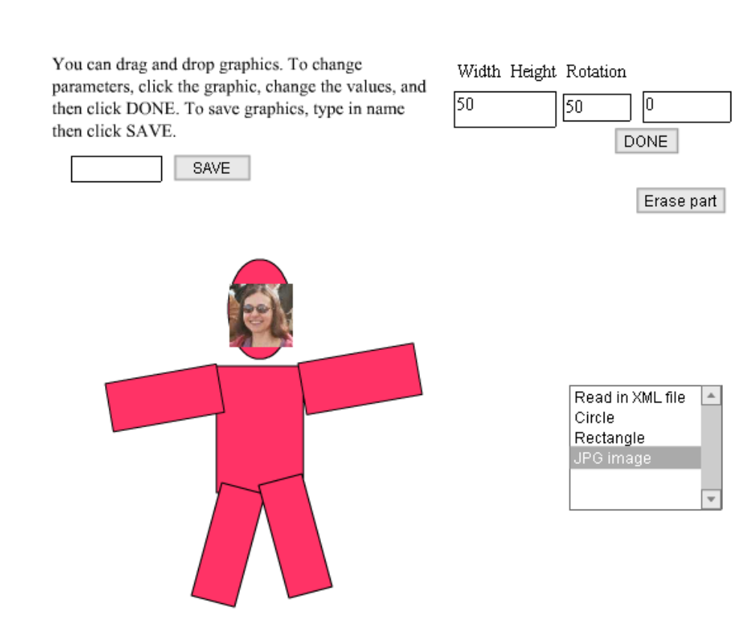

Development

Here is the Flash interface showing the timeline (one frame, two layers) and the Stage:
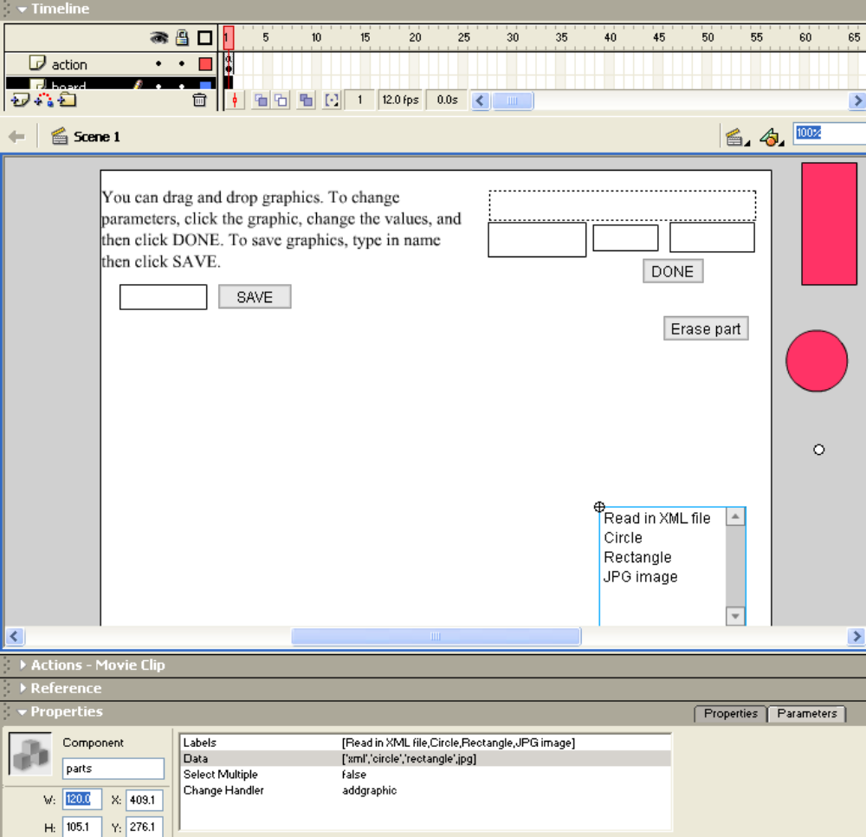

Note that the selected object is the component for a listbox (select menu). The property window indicates the visible items, the data values passed to the handler, and the specification of the change handler to be the function addgraphic.

The buttons (SAVE, Erase part, DONE) are pushbutton components and the (selected) menu is a listbox component. The stage has 4 (1 and 3) input text fields. Above the 3 input text fields on the right is a dynamic text field that serves as a label for the input text fields.

Notice the 3 'off stage' movie clips. These are 'seed' clips for the 3 types of graphics: circle (ellipse), rectangle, and image. The code uses the duplicateMovieClip methods of these movie clips to produce the new graphic parts of the drawing. The small circle is the empty movie clip that is the seed for images. This movie clip has the following variables to be used to hold information on the graphical item.

var savedfname; //the jpg file name
var nxpos;
var nypos;
var nwidth;
var nheight;
var nrotation;

Each of these seed clips has ActionScript code to allow for dragging and also to set up the text input fields to accept data to change the dimensions. For example, the following shows the event handlers for the movie clip named imageseed:

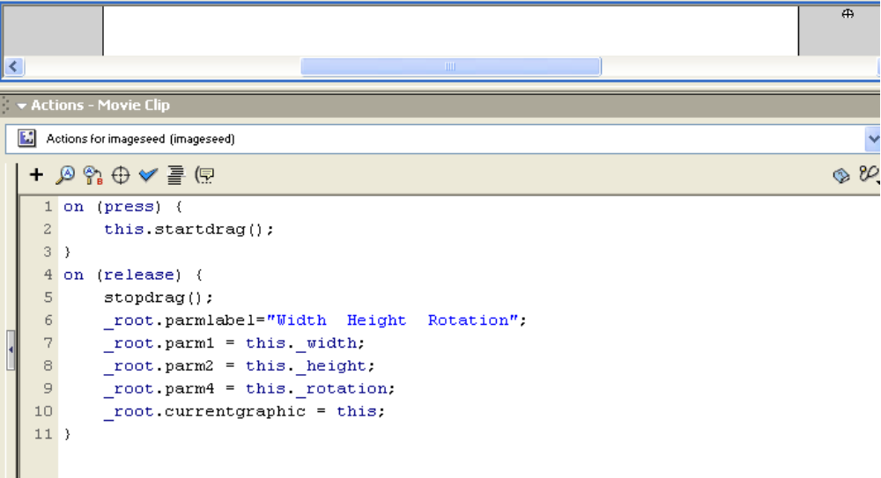

The event handlers for the circle and the rectangle are similar.

If the player selects Read in XML file, he or she is prompted for a name. The name refers to a Flash shared object, not a stand-alone XML file. An alternative approach would be to go through middleware (for example, asp or php or Cold Fusion) which would access XML or a standard database. If the player selects image, he or she is prompted for the name of the jpg file (located in the same folder as the Flash movie). In this case, the file is a standard file.

Frame ActionScript

The contents of the actions layer of the one and only frame is given below. Note that the invoking of a function can be through its specification in a component (for example, addgraphic) or by setting the value of a property such as onComplete or onLoading.

var ns; //used to give unique values for duplicateMovieClip
ns = 1;
var nxpos; //holds data used to store info on graphical items
var nypos;
var nwidth;
var nheight;
var nrotation;
var currentgraphic;
var graphics = new Array(); // holds all graphics
var jpgflag;

//definition of function called during loading of shared object
function showprogress() {
_root.parmlabel = "loading: "+this["innerplace"].getBytesLoaded();
}

//sets up so any movie clip M has a method called loadjpg. This is done
//by including the term prototype
//note the jpg is loaded into a movie clip within the movie clip M.
MovieClip.prototype.loadjpg = function(picName,h) {
this.createEmptyMovieClip(h,1);
this._visible = false;
this[h].loadMovie(picName);
var id=setInterval(function (mc) {
if (mc[h]._width>0) { //indicates loading complete
mc._alpha = 99;
clearInterval(id);
mc._visible= true;
mc.onComplete(); //call function set at call to loadjpg
}
else { // keep loading
mc.onLoading();
}
}, 80, this); //ends call of setInterval
} // ends definition of loadjpg method

//positions a new image in a standard place and adds it to the array of graphics.
function placeAndPushnew() {
this._x = 100;
this._y = 300;
graphics.push(this._name);
}

//positions the (re-)loaded image into the position, and with the rotation and
//width indicated by the data read in
function placeAndPushold() {
trace("placeandpushold, this.nxpos "+this.nxpos);
this._x = this.nxpos;
this._y = this.nypos;
this._rotation = this.nrotation;
// trace("placeandpushold, this.nwidth "+this.nwidth);
this._width = this.nwidth;
this._height = this.nheight;
graphics.push(this._name);
}

//called by the component when there is a new selection
function addgraphic(component) {
var graphicname = component.getvalue();
var newn;
switch (graphicname) {
case "xml":
_root.parmlabel="Type name, then click DONE";
_root.parm1 = "";
_root.parm2.border = FALSE; //doesn't work
_root.parm2 = "";
currentgraphic ="";
jpgflag = false;
break;
case "jpg":
_root.parmlabel="Type fname then click DONE";
_root.parm1 = "";
_root.parm2=".jpg";
currentgraphic = "";
jpgflag = true;
break;
case "circle":
newn = "circle"+ns;
circleseed.duplicateMovieClip(newn, ns++);
_root[newn]._x = 100;
_root[newn]._y = 300;
break;
case "rectangle":
newn = "rect"+ns;
rectseed.duplicateMovieClip(newn, ns++);
_root[newn]._x = 100;
_root[newn]._y = 300;
break;
case "line":
newn = "line"+ns;
lineseed.duplicateMovieClip(newn, ns++);
_root[newn]._x = 100;
_root[newn]._y = 300;
break;
}
if ((graphicname != "xml") && (graphicname != "jpg")) {graphics.push(newn);}
}

//this is the save to shared object operation
//works using graphics array to build the xml tree
//specified by the component to handle clicking on SAVE button
function outputxml() {
var xmlout = new XML();
var xmle1 = xmlout.createElement("graphic");
var xmle2;
xmlout.appendChild(xmle1);
for (i=0; i<(ns-1);i++) {
xmle2 = xmlout.createElement("part")
gn = graphics[i];
if (gn != "") {
xmle2.attributes.NAME = gn;
xmle2.attributes.XPOS = _root[gn]._x;
xmle2.attributes.YPOS = _root[gn]._y;
xmle2.attributes.WIDTH =_root[gn]._width
xmle2.attributes.HEIGHT=_root[gn]._height;
xmle2.attributes.ROTATION=_root[gn]._rotation;
if (gn.substr(0,3)=="ima") {
xmle2.attributes.FNAME = _root[gn].savedfname;
}
xmle1.appendChild(xmle2);
} //ends if for actual gn (not erased)
}
so = SharedObject.getLocal(_root.parm3);
so.data.savedXML = xmlout;
so.flush();
// the flush does the saving to a special area on the user's hard drive for
// Flash shared objects
}

//called by the component to handle clicking on the DONE button
//such as jpg file name, circle or rectangle or line dimensions
function handledone() {
var gn;
if (currentgraphic!="") {
gn = currentgraphic._name;
stem = gn.substr(0,3);
switch (stem) {
case "ima":
case "cir":
case "rec":
currentgraphic._rotation = parseFloat(_root.parm4);
currentgraphic._width = parseFloat(_root.parm1);
currentgraphic._height = parseFloat(_root.parm2);

_root.parm4 = currentgraphic._rotation ;
_root.parm1 = currentgraphic._width ;
_root.parm2 = currentgraphic._height ;
break;

} // ends switch

} // ends if currentgraphic != "", meaning parms for graphics
else
if (jpgflag) { //reading in jpg image file
fname =_root.parm1 + ".jpg";
newn = "image" + ns;
trace("about to load "+fname+" into "+newn);
imageseed.duplicateMovieClip(newn, ns++);
_root[newn].savedfname = fname;
//store file name in variable in clip
_root[newn].onComplete = placeAndPushnew;
_root[newn].onLoading = showprogress;
_root[newn].loadjpg(fname,"innerplace");

}
else // reading in xml in shared object
{
so = SharedObject.getLocal(_root.parm1);
savedxml = so.data.savedXML;
_root.setupfromxml (savedxml);
} //ends else this is handling of DONE for file name
} // ends function handledone

//reading in previously saved xml
//adds to graphics array
function setupfromxml (savedxml)
{
var fnames;
stuff = savedxml.firstChild.childNodes;
for (var i=0; i<stuff.length; i++) {
newn = stuff[i].attributes.NAME + ns; //to prevent clash with other parts
nxpos = stuff[i].attributes.XPOS;
nypos = stuff[i].attributes.YPOS;
nrotation = stuff[i].attributes.ROTATION;
nwidth = stuff[i].attributes.WIDTH;
nheight = stuff[i].attributes.HEIGHT;
stem = newn.substr(0,3);
switch (stem) {
case "cir":
circleseed.duplicateMovieClip(newn,ns++);
break;
case "rec":
rectseed.duplicateMovieClip(newn,ns++);
break;
case "lin":
lineseed.duplicateMovieClip(newn,ns++);
break;
case "ima":
imageseed.duplicateMovieClip(newn,ns++);
fnames = stuff[i].attributes.FNAME;
_root[newn].savedfname = fnames;
_root[newn].nrotation = nrotation;
// need to save values for placeandpushold
_root[newn].nxpos = nxpos;
_root[newn].nypos = nypos;
_root[newn].nwidth = nwidth;
_root[newn].nheight = nheight;
break;
} // ends switch on name
if (newn.substr(0,3)=="ima") {
_root[newn].onComplete = placeAndPushold; //will position then
_root[newn].onLoading = showprogress;
_root[newn].loadjpg(fnames,"innerplace");
}
else { //for all but images, position part here
_root[newn]._rotation = nrotation;
_root[newn]._x = nxpos;
_root[newn]._y = nypos;
_root[newn]._width = nwidth;
_root[newn]._height = nheight;
graphics.push(newn); }
} // ends for loop over graphics parts
} // ends function definition

//erases the selected graphic
//specified to handle the Erase part pushbutton.
function erasepart() {
var notfound = true;
if ((currentgraphic == "")|| (currentgraphic == undefined)) {
parmlabel = "Select part then click erase...";
}
else
for (i=0; i<(ns-1) && notfound;i++) {
if (currentgraphic._name == _root[graphics[i]]._name) {
notfound = false;
_root[graphics[i]].removeMovieClip();
graphics[i]="";
} // end if clause upon finding currentgraphic
} // end loop
} // end function definition

