Basic Cannonball lab

Note: consult the other cannonball tutorial to add features such as dragging the target, making the target tilt, and adding sound.

Animation (movement of images on the screen) can be produced using Flash in several different ways. For this application, your code will simulate the ballistics of a cannonball leaving the cannon, traveling in a [parabolic] arc, and either hitting the ground or hitting a target. You will NOT use frame animation: create graphics of a cannonball in different positions in a sequence of frames. You will not use tweening.

The following figure shows the application after a firing of the cannon. Notice that the cannonball has fallen on the ground. The application begins with the cannonball off-stage. Your code will move the ball to the end of the cannon when the FIRE button is pressed.

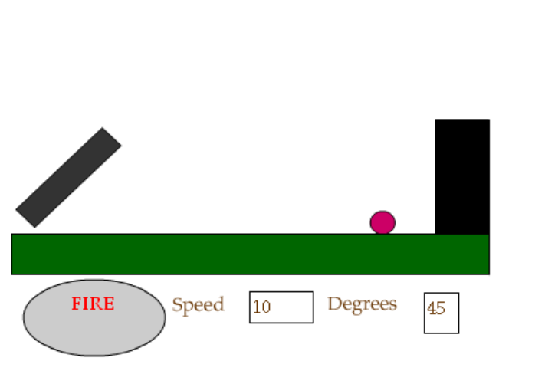

Here is what the screen looks like after a hit (achieved because the player has changed the angle of the cannon and the speed).

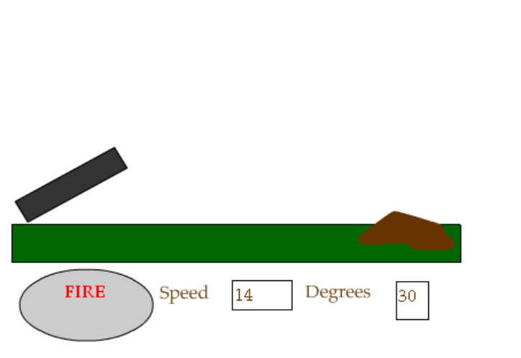

Here are the critical features required to implement this application:

- Calculation of the flight path of the cannonball based on the initial speed, the angle of the cannon and the effect of gravity. The critical concept for ballistics involves separating the initial motion of the cannonball into vertical and horizontal components (also known as resolving the vectors). The cannonball leaves the cannon at an angle. In the simplified world we simulate here (no air resistance, for example) the horizontal motion continues at the same velocity (speed). The vertical motion, however, is affected by gravity. This is what causes the arc (the parabolic) path. The equations for this turn out to be just a few lines of code in the function that handles the on (release) event for the Fire button and a few more in a script in frames on the movie time line.
- A way to make incremental changes in the position of the ball to simulate flight. This will be done by using ActionScript to write what are termed frame actions to make adjustments to the position of movie clip we call ball.
- A way to check if the target has been hit or if the ball has reached ground level. The code to do this is done in ActionScript in a frame. If the ball does hit the target, it changes to a pile of rubble.
- A way for the player to control the path by changing the speed and the angle and to move the target. To make this a game, we need to provide a way to get input from the player. We do this using Input Text fields. The values the player puts in these fields are used in the calculation of the path.

Note: in our project the name of the target instance is target1. This is to inspire you to think about more and different targets. The name could be anything. (Note: In any case, there is no relationship between this specific instance and the Tell Target construction used in older versions of Flash, but generally unnecessary in Flash 5.)

These graphics are quite stylized. After you get something working, you can enhance the look-and-feel of the application.

Prepare the following as movie clip symbols and then create instances on stage (this is done by dragging the symbols from the Library to the Stage. Keep in mind that this actually creates a movie clip instance. The original symbol is still in the Library.) Give the instances the names indicated (using the Properties panel). You may ask why, with the graphics being so simple and only one of each thing, do I have to make each one a movie clip? The answer is that this approach makes several things possible: you can refer to the symbols by name, refer to and change properties such as _x, _y, and _rotation, use the hitTest method and you can write event handlers. The latter means you can arrange for something to happen each frame and something to happen when the player presses down or releases the mouse. Note the registration point (also called the origin or the nominal position) for the graphics. Position and movement, including rotation, is in terms of this registration point shown as cross-hairs when you select the object.

Symbol name & type | Instance name | Graphics | Associated events, usage
ball movie clip | ball | Circle, registration point center | Properties referenced and modified by frame scripts and event handlers.
cannon movie clip | cannon | Horizontal line, registration point left end. IMPORTANT: the cannon will rotate from its registration point. | _x and _y referenced to position ball.  _rotation changed based on an Input text field; referenced to determine angle
ground movie clip | ground | Two (thick, horizontal) lines, registration point mid-point. | _y referenced during flight
target movie clip | target1  There is only 1 target, but you may choose to add more. | Rectangle, with registration point at lower left corner | Clip event (enterFrame) used for detecting a hit.  Clip events mousedown and mouseup used in dragging
firebutton button | firebutton  Need to place Dynamic Text field named caption on the button. | oval, with Dynamic text field. | on(release) is a call to _root.firecannon located in the first frame, actions layer

The target symbol is a multipe-frame movie clip. The first frame is a rectangle.

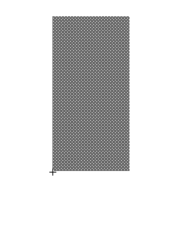
You can add the other frames later as will be described below. Any instance of the symbol on the Stage then will show the new symbol. This is an example of a good practice: start simple and elaborate and refine later.

You need to put on the screen the 4 text fields: REMEMBER: for FLASH 8, set the instance name NOT the var name for the Input text fields.

Name | Contents | Type | Usage
 | Speed | Static | Label next field
speed | Initially 10 | Input | Player types in new speed
 | Degrees | Static | Label next field
anglein | Initially 45 | Input | Player types in new angle.

We propose that you program this application in stages. This gives you a chance to test the application as you go along.

Stage I. Make the ball move in an arc on the screen.
Stage II. Add the test for hitting the ground and then making the ball stop moving
Stage III. Add the test for hitting the ground and then making the ball invisible.
Stage IV. Modify the application to make the target movie clip go to its second (and subsequent) frames when hit by the ball.
Stage V. Modify the code so that the target is reset to the initial frame when the fire cannon button is clicked.

CAUTION: When you create a new keyframe, unless you create a blank keyframe, Flash will copy all the content that was in the previous keyframe. This generally is what you want. If you later go back and add something to an earlier frame, this content does not automatically get added to the existing frames that follow. If you want the new material to be part of other frames, you must do add it explicitly. The copy and paste-in-place commands can be used. This also applies to object action code. If you add or change object action code in one frame, you must do the same thing for the other frames, if that is what you want.

Name the first and only layer of the main movie board. Add a new layer and name it actions. You will put all the code in the actions layer. Add another layer and call it labels. You need to have 3 keyframes in each layer. This means you need to add two keyframes to each one. Flash8: Insert/Timeline/Keyframe.
NOTE: the layering suggested here is the recommended good practice. You will see examples of more layering and of less layering. You also may use layers to control the graphical display.

Stage I. The requirements for coding divide into what is done to set up the motion of the ball and what is done to move the ball iteratively along its path. The setup is done in response to pressing the button labeled FIRE. The iterative movement is done in frame actions.

Click in the second frame of the labels layer. Flash 5: in the Frames panel (Window/Panels/Frame), give this frame the label continue. Flash MX and Flash 8: in the properties panel, type in continue in the Frame textbox. A flag will appear in the frame.

You will now put code in the first frame of the actions layer. A rough outline of the code in the first frame is: set up the event handling for the button, set up the variables using var statements and define the firecannon function.

The inflight variable will be true or false depending on whether the ball is in-flight. As you will see, the firecannon routine sets inflight to be true. Watch out for where it is set to false. The now, then, and elapsed variables are used to calculate the time. Notice that then is set in firecannon by a call to getTimer.

Select the actions layer, frame 1.

Display or Expand the Actions panel if it is not expanded (if it is minimized, you can click on the downward arrow. If it is totally absent or minimized, go to the Window dropdown menu and click on it.

You will use the procedural style of coding, with all the ActionScript ‘in’ frames. This means, for example, that to set up the event handling for the button, you enter the code in the first frame:

firebutton.onRelease = firecannon;

This means: when the button is released (that is, the player presses down with the mouse over the button and then releases it), call the function firecannon that is defined later in this frame.

In order to continue explaining the code, starting with frame 1, we need to review some physics and mathematics!

First here is the physics:

Recall from the introduction that the characteristic arc of projectile motion occurs because the horizontal velocity remains the same but the vertical velocity changes. The ball is shot from the cannon at an angle. Your code will determine the initial horizontal and vertical components of the ball's motion using trigonometry.

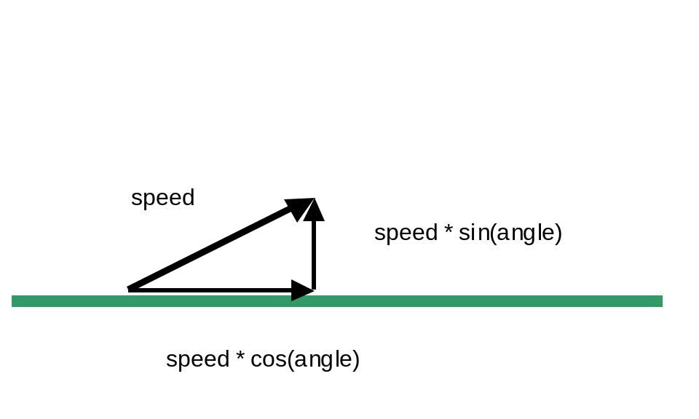
The variable hspeed is set to the horizontal component in firecannon. You need two variables for the vertical component because it is changing due to the effects of gravity. The variable gravity holds the value of gravity per 1/12th of a second. (This appears more serious than it really is. The units could be whatever we want, but this value seems to work out well.) The vspeed1 variable will hold the value at the start of the increment of time and the vspeed2 will hold the modified value. Your code will average the two to determine the distance moved during that unit of time.

Next, here is some mathematics (actually computer technology, too): How do you measure angles? What units are used? For the computation done, we need the angle to be in radians as opposed to degrees. (Haven't you ever wondered why there are 360 degrees to a circle? The answer is that there is no reason. The radians method is an intrinsic measure: there are 2 times pi radians in a circle.) The Flash program is a hybrid: some commands expect angles in degrees and some expect radians. (Most computer languages are either a hybrid like Flash or ‘expect’ radians in all situations.)

The statement:

angle =anglein.text * Math.PI/180;

converts the angle that has been entered, first by you the programmer, of 45 and then by the player, in degrees to the radians required by the trigonometric functions sine and cosine.

Back to the code, the next thing you do is set up the variables needed:

var inflight; | Indicates whether cannonball is moving or not
var then; | Used for time calculation
var now; | Used for time calculation
var elapsed; | Used for time calculation
var hspeed; | Horizontal speed. Does not change.
var vspeed1; | Vertical speed at start of time interval.
var vspeed2; | Vertical speed at end of time interval
var gravity = 9.8/12; | Gravity (9.8 m/sec squared is rate of gravity)
var angle; | Angle of cannon
var speedset = 10; | Initial value of speed
var angleinset = 45; | Initial value of anglein

The variables speedset and angleinset can be viewed as internal variables shadowing the values of the Input text fields. These are needed to make sure that once the player changes them, the new values are reflected in all the frames.

The remaining code is the definition of the firecannon function. It is given next with explanation in the table. (DON’T copy the explanation. In fact, don’t copy and paste at all: think through each line. You will be better off in the end!)

function firecannon() { | Function definition
speedset= speed.text; | Re-set just in case player has changed the text field
angleinset = anglein.text; | Re-set
inflight = true; | Set inflight to true
cannon._rotation = - anglein.text; | Moves the cannon instance according to input text value
ball._x = cannon._x +cannon._width +(.5* ball._width); | Positions ball instance at tip of cannon by changing x value and
ball._y =cannon._y -cannon._height-(.5*ball._height); | … changing y value
angle =anglein.text * Math.PI/180; | Converts the angle specified in the input text to a value in radians
ball._visible = true; | Makes ball visible (it will be set to not visible when it hits the target
hspeed = Math.cos(angle)* speed.text; | Calculate horizontal speed based on angle and speed in input text.
vspeed1 = -Math.sin(angle)* speed.text; | Calculate vertical speed based on angle and speed in input text.
vspeed2 = vspeed1; | Both speeds are the same, initially.
then = getTimer(); | Get the current time to be the first 'then' time
gotoAndPlay("continue"); | Go to continue frame
} | End of function

Here is more explanation of the statements. The commands (all assignment statements) do the following:
- The speedset and angleinset variables are now set to their current values. These will be different if the player has made a change.
- set inflight to be true.
- set the rotation of the cannon according to the player input from the Input text field named anglein. The negative sign is needed because we want a counter-clockwise angle.
- Position the ball to be at the tip of the cannon. Depending on how you drew the cannon and moved it to the stage, you may need to alter things. It also depends on the registration points of the cannon and the ball.
- Make the ball visible. (It will be made invisible if it hits the target.)
- Set hspeed to be the horizontal component of the initial velocity.
- Set vspeed1 to be the vertical component of the initial velocity.
- Set vspeed2 to be the same value as vspeed1.
- Set the then variable to be the time now (when firecannon is invoked).
- Go to the continue frame. This concludes the definition of the function

Once the flight is set up, the code in the next two frames will produce the animation. That is, the frame labeled continue will be entered and its frame script (code) executed. Then the flow will go to the next frame. In that third frame, control will be sent back to the continue frame.

The task of the code in the second frame is to move the ball if the ball is 'in flight'. The code is an if statement testing the inflight variable. The clause following the test does all the work. Think of an interval of time. The code works with the now and then variables holding values for the time at the start of the interval and the end of the interval. Gravity changes the vertical speed during that interval. The code calculates the vertical speed at the end of the time interval and averages the starting and ending speeds. The ball is positioned based on the horizontal and average vertical speeds. The code also checks if the ball has hit the ground. Note: the test for the ball hitting the target will be added later in the next stage of coding.

Click on the second frame, which is the frame labeled continue, of the action layer. Enter the following:

speed.text = speedset;
anglein.text = angleinset;
if (inflight) {
now = getTimer();
elapsed = 12*(now - then)/1000; //units of 12ths
ball._x += hspeed * elapsed;
vspeed1 = vspeed2;
vspeed2 = vspeed1 + gravity* elapsed;
ball._y += elapsed * (vspeed1 + vspeed2)*.5;
then = now;
}

Going over the code: the speedset and angleinset variables are used to set the value of the input text fields. This is required in Flash 8, where text fields are treated differently than in prior versions of Flash. Next, the code checks if the ball is inflight:
if inflight is true, everything happens. Conversely, if it is not true, then nothing happens. This code, that is, the if condition, is actually executed many times with the negative result. It is only when the player clicks on the FIRE button that inflight is set to true and something substantive happens in this frame. So let us suppose that inflight is true. Then the code will determine the current time (actually milliseconds since the program began). The code determines the elapsed time in the units of 12ths of a second. The ball is then moved horizontally (the _x property) incrementally (using the += form of the assignment statement) speed times time (hspeed * elapsed) units over. To do the vertical move, the code computes the 'new' velocity. That is, the vspeed1 variable is set to be what the vspeed2 variable was. Then vspeed2 is set to the velocity modified by gravity. The last step is to compute the increment in the new vertical (_y) position based on the average of the two speeds.

The last statement is to set the then variable to the now variable. This makes things ready for the next iteration.

There is one more frame action to write. Click on the third frame in the action layer.
Type in this code:

speed.text = speedset;
anglein.text = angleinset;
if (inflight) {
gotoAndPlay("continue");}
else {
stop();
}

As was the case for the previous frame, the values of the text fields are set to the values set at the time the firecannon function was invoked. Next, if inflight is true (if the flight of the ball is still going on), go to continue. Otherwise, stop.

You can test what you have done. Click on Control/Test Movie. To get information on function calls or how variables have been set, you can use the built-in function trace:

trace("message");

or

trace("variable name xxx is "+ xxx);

to debug your program. Perhaps this story will help you: I tried my program and the cannon rotated up to 45 degrees, the cannonball appeared at the tip, and floated right down to the ground, where it stopped. What was the problem? It did not have any initial horizontal speed. I checked the speed textbox and noticed that it was Static and not Input. The program was using a value of zero instead of the 10 in the box. I clicked on the text and changed it from Static to Input in each of the 3 frames and the program works. To test it adequately, you should change the values of the speed and the angle.

NOTE: there is nothing to stop the ball. That is, working correctly, means that you will see the ball move in an arc. You need to close the window to stop the action. Test the ball with different speeds and angles.

Stage II. Check for hitting the ground.

In the code for frame 2, within the true-clause for checking if the ball is inflight, add a new if clause:

if ((ball._y + ball._height) > ground._y) {
inflight = false;
ball._y = ground._y - ball._height;
}

The if statement tests if the ball has fallen below the ground. The greater than is used because vertical coordinates ( _y values) increase moving down the screen. If this is the case, then inflight is set to false and ball’s vertical position is altered slightly to rest on the ground.

Stage III. The check for hitting the target is done in the same place as the check for hitting the ground.

if (target1.hitTest(ball._x,ball._y)) {
inflight = false;
ball._visible = false;
}

The hitTest method (functions associated with objects are called methods) does the calculation of any intersection between this (the target1) clip and the _x and _y positions of the ball clip. This means that the hitTest will return true only when the center of the ball has hit the target. If you want a slighting blow to be a hit, you may consider using the bounding box form of the hitTest (look up hitTest using HELP in Flash). The good news about this movie clip versus x, y position form of hitTest is that if you change the target to an irregular shape, it will produce the right answers.

If there is any intersection, then the next two lines of code (the ones within the brackets) are executed. The code makes the ball invisible and sets inflight to be false. This will mean that the next time inflight is checked, it will be false. This, in turn, means that the ball would not be moved again and also, when frame 3 is reached, the action will be stopped.

Test the movie. To do the test, you need to remember what happened previously when no check was made. You need to do the test for speed and angle values that cause the ball to hit (that is, appear to hit) the target and values that do not. Faster speeds and lower angles such as what is indicated above will make the ball hit the target. You should check for the ball falling in front of the target, on the target and up and over the target.

Stage IV. This stage adds drama to the program: show the target changing if and when it is hit by the ball.

You need to do two things. First, go to the target symbol in the Library. If the Library is not visible, go to the Window dropdown menu and select it. Double click on the target symbol so you are editing this symbol. You will see only one frame holding the simple rectangle. Open the Actions panel and add the code:

stop();

This is so the target1 movie clip instance does NOT play the next frame until your code specifies going to the next frame.

Go to the timeline and add more keyframes, changing the graphics to make it appear that the target is crumbling. This is a time when you could use frames as well as keyframes. Keyframes can have changes in the graphics and can contain ActionScript. Ordinary frames cannot. Do as many as you would like. In the last one, insert

stop();

as ActionScript in the frame.

Here is a screen shot showing my Flash development when I was doing this:

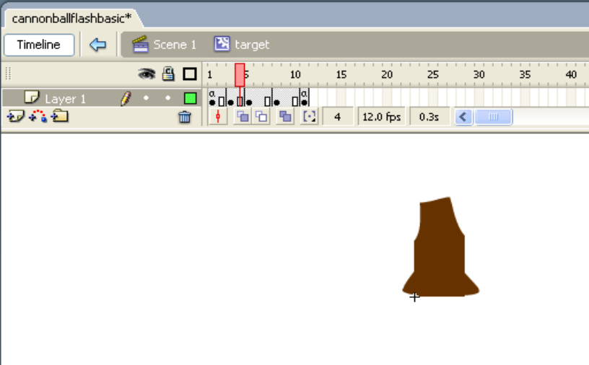

The screen shot shows a frame in the middle of the sequence. The frames on the timeline a’s contain code: in both cases a stop command.

Go back to editing the main movie by clicking on Scene 1. In the actions layer, frame 2, in the Actions panel, change the second, inner if statement to be the following:

if (target1.hitTest(ball._x,ball._y)) {
inflight = false;
ball._visible = false;
target1.gotoAndPlay(2);
}

What you need to do is add the one line instructing the target1 instance to advance to frame 2. I put the whole if statement in for clarity. If you are thinking about what you are doing, this will work!

Test the program. Again: this means testing that the program does the correct thing when the ball hits the target and when it does not hit the target.

Stage V. Modify the program so you can re-start the game by restoring the original target.

It is common in games and other applications to have code to initialize the situation and also to re-initialize. Here is one such situation. We want the player to be able to play the game again. However, the target now looks like rubble. What do we do? The answer is the include the statement:

target1.gotoAndStop(1);

in the firecannon function. You can make this the first statement in the function. An alternative approach would be to add a button to perform the re-set function. Test the application and see if it works, that is, that pressing and releasing the button after a hit restores the target AND then does the correct thing.

You can modify this application in many ways to make it your own. You can look at the other tutorials for suggestions.

The most important lesson of this tutorial is doing the application incrementally. The exact division into stages is not critical and you may have done it differently. Doing development this was is an example of the adage: make haste slowly. You will be much more productive if you learn this lesson.

Summary: This application consists of a movie clip with 3 layers and 3 frames:
- The graphical content of the movie is on the board layer. It includes the cannon, the cannonball (stored off-stage), the target, and Static and Input text fields for the speed and the angle.
- The code is contained in a layer called actions. The first frame has statement setting up the button action (see next), the var statements for the variables and the definition of a single function named firecannon. The flight of the cannon is simulated by ActionScript in the second and third frame as code outside any function.
- The event handling of the event of the button being released is set up by giving the button a name and then specifying the event handling as the function firecannon.
- In later Stages, the target symbol is enhanced by adding frames. Code in the function and in frame 2 modifies the target1 movie clip instance of the target symbol to play frame 1 and stop or play frame 2 and go to the end of the added frames.

