Tutorial: Simplified Minesweeper

Minesweeper is a game of luck and logic. The grid of squares represents a minefield. Mines are distributed randomly in the cells. Initially, all cells appear as blank tiles. The player clicks on a cell. If the cell contains a mine, the game is over. If the cell does not contain a mine, the application computes the number of adjacent mines. If there are no adjacent mines, the application does the calculation for all the adjacent cells, expanding recursively whenever a cell is examined with no adjacent mines. A player can use logic to make informed decisions on which cells to examine, though it is possible for there to be a situation when the player has to guess. The game is timed.
The minesweeper present on many computers makes use of the right mouse button and a button combination in addition to the primary mouse button. The right button is used to mark a cell as having a flag. The game described here only uses the primary mouse button. The goal is to click on all the cells not containing mines. The player does nothing to the cells that he or she believe contain mines. When ready, the player clicks on a button labeled check. If all the cells have been examined except the ones containing mines, the player wins. The player loses if a cell containing a mine is clicked or if the player clicks on the check button while there were still cells without mines that had not been clicked.
The game described here differs in two more subtle ways from most commercial minesweeper implementations. It is possible to lose on the first move. The number of mines can vary.
Here is a screen shot showing a game that ended when the player clicked on a mine in the second move of the game:
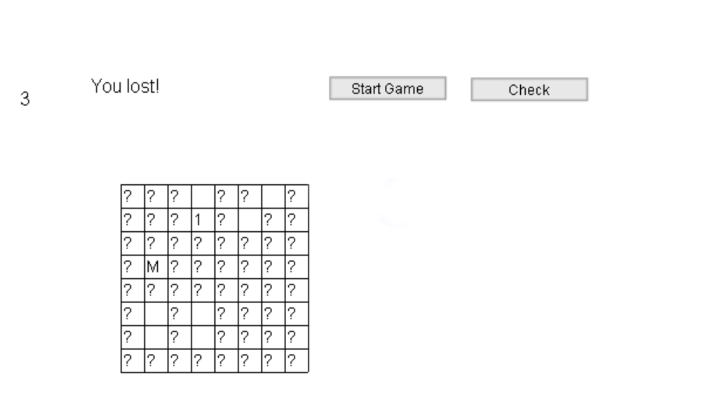
The blanks represent where there were mines. The "M" is the cell where the player clicked to end the game. The question marks indicate cells that should have been examined. Notice that the 1, the result of the first move, is adjacent to one mine

Critical features
This section describes the strategies used for specific features. The next section describes the implementation is stages.
Changing the design of the game to accommodate just using simple mouse clicks: since right-clicking appears to be less well-supported in Flash, it is necessary to change the design of the game. Since mine sites are to be indicated by the absence of clicking, there needs to be a way for players to indicate that they are done. We use a button, labeled Check. This invokes a function called check. The player wins if only cells with mines remain blank, otherwise the player loses. There are alternatives. See the end of the document for another approach.
Construction of the grid: the minefield is produced using the duplicateMovieClip method of a seed movie instance named cellseed. This movie clip symbol contains a dynamic text field named show. It also contains data in the form of ActionScript variables which hold a Boolean named bomb, to be set to true or false, and variables row and col that will hold the row and column position of the cell. Note: the coding and the write up use the terms 'bomb' and 'mine'. The duplicated movie clips are given names of the form "cell" + row + "x" +column, for example, cell3x4.
Random distribution of mines: the layout function, initiated by a start button, will use the expression Math.random() < odds, where, in the case indicated here, odds is 10/64. This should produce approximately 10 mines.
Building the game without needing to play it: to ease the task of implementing the game, while still keeping the random nature of it, the layout function will have the statement: _root[newname].show = "B"; This will put a B where mines are. Comment the line out when the application is done.
Making cells respond to mouse clicks: one approach is to set onClipEvent(mousedown) for each cell movie instance (that is, for the seed, which would carry over to each duplicated movie clip instance). The code would do a hitTest using the mouse position. I took another approach. There is a movie clip instance that is essentially empty (I gave it some graphics to see it easier). It has a onClipEvent(mousedown) event handler. The code in this event handler does the calculation to determine what cell was clicked. It may not be noticeable, but I assumed that this would invoke considerably less computation than having all cells do a hitTest. This approach works when a set of movie clip instances are arranged in a logical fashion. It would not work for the jigsaw puzzle pieces in that application.
Responding to player action, including checking for a mine, during the adjacency test, and, if called for, expanding the examination to adjacent cells: After being called as a result of a mousedown event, the expand function checks the indicated cell using the bomb var 'in' the cell movie instance. If there is a mine, the game is over, with appropriate indication in text fields. The check function is called to reveal the unexamined cells, and, by contrast, the mines. If there is not a mine, the bomb var of the adjacent cells are examined and the sum is calculated. If this turns out to be zero, that is, no adjacent mines, then the expand function is called for each of these adjacent cells. This may lead to certain cells being determined to have no adjacent mines and so yet more cells examined. This is an example of recursion. For it to work, the programmer (you and I) needs to make sure that relevant data is local so that values are not over-written. It is also necessary to be sure that the recursion will stop. This is true in this case because the grid is finite and the function is not called for cells that have already been examined.
Determining neighboring cells: As indicated above, it is necessary to determine the neighbors of any cell. The getbounds function will do a calculation, based on the row and column of a cell, taking into account being on the edges, and return 4 numbers indicating the up, down, left, right bounds of a rectangle. This rectangle can be as small as 2 by 2 or as large as 3 by 3. This information is used with the naming convention described above ("cell1x1").
Time the game: the approach I took to timing was to use the frame nature of Flash. The first frame contains the function definitions. I inserted a keyframe in frame 12. Assuming a frame rate of 12 frames/second, if the game is being played (indicated by a variable named playing), a dynamic text field named timerfield is incremented (the contents are converted to a number, this number incremented, and then result stored back in the field).

Development plan
The following stages were used to build the application.

Stage 1: produce a grid.
As has been done for other applications, name the first layer actions and add a layer and name it board. The frame actions code will go (only) in the actions layer. For the first 4 stages there will only be one frame. In the last and fifth stage, you will add more frames.
The first stage will produce just a grid, but this is actually a substantial step forward. One symbol is defined in the Library: a movie clip named cell, with one dynamic text field named show. An instance of this symbol is placed 'off-stage' and given the name cellseed. The size of the text field is set using the Info panel to make it precisely 20 by 20. This number is captured in the var unit. This could be made more flexible if the application is enhanced to accommodate different size grids. During run-time, unit and other variables would be changed and the size of the cellseed instance would be changed.
The variables defined are the following:
var hc = 8; | horizontal size = number of columns
var vc = 8; | vertical size = number of rows
var nl = 0; | level indicator, used when creating new movie clips
var firstrow = 100; | position above first row
var firstcol = 100; | position to the left of first column
var unit = 20; | size of each cell
var odds = 10/64; | odds for any cell holding a mine

The function layout, invoked directly in the frame code, generates the table. It uses nested for statements to do the grid. The cell instance names are generated according to the positions. An if statement, using Math.random() and the odds variable is used to determine the placement of the mines. The show text field in each instance is set to blank or "B", to reveal the location of the mines, during development. This will be removed when it is time to publish the movie.

function layout () {
for (i=1; i<=hc; i++) {
for (j=1; j<=vc; j++) {
newname = "cell"+j+"x"+i;
cellseed.duplicateMovieClip(newname,nl++);
_root[newname]._y = firstrow + (j-1)* unit;
_root[newname]._x = firstcol + (i-1)* unit;
_root[newname].bomb = false;
_root[newname].show = " ";
if (Math.random()<odds) {
_root[newname].bomb = true;
_root[newname].show = "B";
}
}
}
}
layout();

Name this movie mine1a and test it. You should see the grid with a random placement of B's. There may be more or less than 10.

Stage 2: Detect player clicking on cell and determine if it hits a mine or calculate number of adjacent mines
As indicated above, I chose to use what is sometimes termed a listener instance in place of making all the cells respond to a mousedown event. Create a movie symbol, name it listener and move an instance of it 'off-stage'. With this instance selected, insert the following action code:
onClipEvent(mouseDown) {
var tc = Math.floor((_root._xmouse-_root.firstcol)/_root.unit)+1;
var tr = Math.floor((_root._ymouse-_root.firstrow)/_root.unit)+1;
cname="cell"+tr+"x"+tc;
_root.expand(_root[cname]);
}

Here is a screen shot showing the Flash development environment:
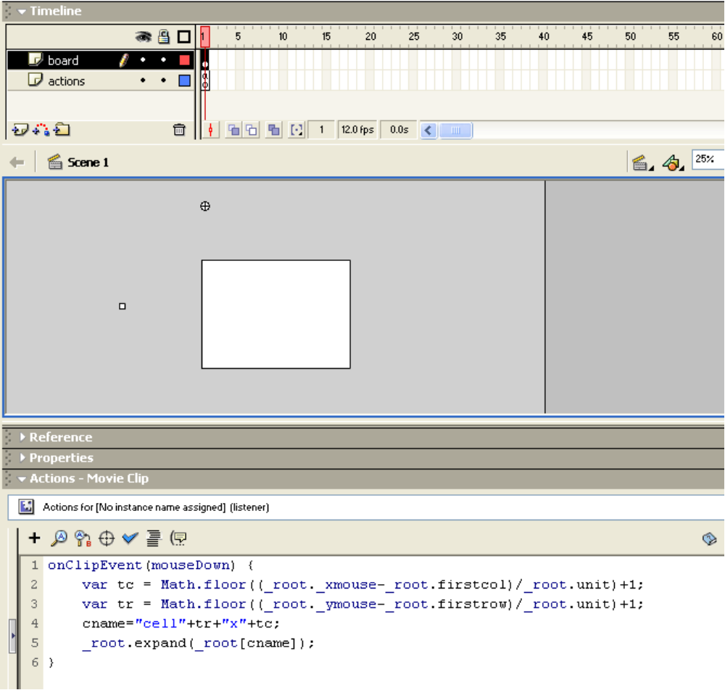
The selected instance is the listener movie clip. The white square to the left of the stage is cellseed.
Whenever and wherever the mouse button is pushed down, this event handler is invoked. The first two lines calculate the column and row of the cell. The name is generated and then the expand function is called with the particular cell instance passed as the parameter. This uses the Flash feature that _root[name of instance] will be the instance. This is a situation of needing to be careful to distinguish the thing versus the name of the thing. This code will need to be adjusted in later stages when mousedown could happen away from the grid.
The expand function needs to test for mines and do calculations. For this stage, the coding is:
function expand(cell) { | Parameter indicates cell instance
if (cell.bomb) { | check for mine (using bomb var in instance)
trace("Hit a mine"); | For now, output message using trace
} | End if true clause
else { | If not a mine/bomb
getbounds(bounds,cell.row, cell.col); | Invoke function to get adjacency area
sum = 0; | Initialize sum to zero
for (i=bounds[0];i<=bounds[1];i++) { | Outer loop
for (j=bounds[2];j<=bounds[3];j++) { | Inner loop
cname = "cell"+i+"x"+j; | Generate name of adjacent cell
if (_root[cname].bomb) { | Check for it having a mine/bomb
sum++; | … if it is, increment sum
} // end if bomb | Close true if clause
} // end j for | Close inner loop
} // end i for | Close outer lop
cell.show = sum; | Store sum in text field (to be displayed
} // end else not on a mine | End else clause
} //end function | End function

Note in the above code, the cell itself is checked in the nested for statements. Since it was determined not to have a mine/bomb, it will not contribute to the sum. This was easier than putting in an extra check.
The getbounds function does 4 distinct calculations to determine the neighbors.
function getbounds(bounds, row, col) {
bounds[0] = Math.max(1, row-1);
bounds[1] = Math.min(vc, row+1);
bounds[2] = Math.max(1, col-1);
bounds[3] = Math.min(hc, col+1);
}

Note that the parameters for this function are bounds, an array with 4 elements that will be set by the function and the row and col (for column} of the cell for which it is calculating the bounds of the adjacent cells. The var statement is in the expand function:

var bounds = new Array(4);

Readers and students who know something about parameter passing may wonder how the values of bounds are set when, generally, parameters are passed 'by value'. This works because what is passed is the address of the array.

Name this application mine2a and test it. A grid will be generated with the mines indicated by the Bs. The game does not stop if you click on a mined cell. Here is a screen shot after 4 player clicks (two on mines):
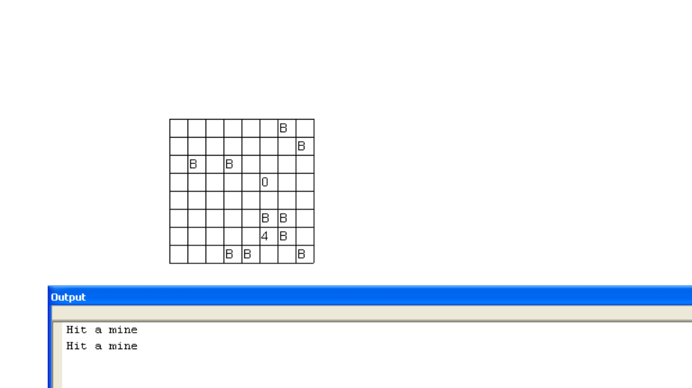

Stage 3: Detect need to call expand recursively
Functions that call themselves are sometimes termed 'recursive functions'. (Actually, the definition of recursive functions is much more general, but this is a common, informal definition.) Just to make sure we have the right spot, insert after storing the sum variable into cell.show, the following:

if (sum==0) {
trace("recursive call");
}

Name this file mine3a and test it. The message in the output panel should show up if and only if the sum is zero. Actually, the more likely problem is that some syntactic error may occur.

Stage 4: Make the call to expand for the adjacent cells of any examined cell with no adjacent mines
When a clicked cell has no adjacent mines, the task is to call expand for all the adjacent cells. The challenge here is to not call expand again for any cell that has already been examined. This determination is made using the show field for a cell. If it is [still] blank (or, more accurately, holding the blank character—it is not the empty string), then expand is invoked. Replace the trace statement indicating a need to make the recursive call with the following
for (i=bounds[0];i<=bounds[1];i++) { | Loop over rows
for (j=bounds[2];j<=bounds[3];j++) { | Loop over columns
cname = "cell"+i+"x"+j; | Construct name of cell instance
if (_root[cname].show ==" ") {expand(_root[cname]);} | Check if this cell needs to be examined and if it does, call expand
} // ends j | End inner loop
} // ends i | End outer loop

You need to convince yourself that it is necessary to do the nested looping again. It is only when you have determined that a cell has no adjacent mines that you can then examine the adjacent mines.
Name this mine4a and test it. You get the same message in the output panel when clicking on the (visible) cells with mines (the Bs), but when you click on a cell with no adjacent mines, multiple cells will be examined with the counts shown.

Stage 5: Finish up the application by adding buttons to start and to check and adding timing.
It could be that this stage could have been subdivided, but I did not do it. These starting and stopping situations need to be tested all at once. The tasks are to add buttons (using the pushbutton component) to start the game and to check the results. Since it was also possible to start a new game, rather then create the grid cell instances all over again, I use a variable named created to check if the instances have been created.
Add two new global variables:
var playing;
var created;

To the layout function, change the code starting with the cellseed.duplicate to
if (!created) {
cellseed.duplicateMovieClip(newname,nl++);
_root[newname]._y = firstrow + (j-1)* unit;
_root[newname]._x = firstcol + (i-1)* unit;
_root[newname].row = j;
_root[newname].col=i; }

At the end of the layout function, add these lines

result = "";
playing = true;
created = true;
timerfield = "0";

This erases any past result information, sets these two 'flag' variables to true, and sets the timerfield, which acts like a clock, to zero.

The expand function now needs to end the game if a mine cell is clicked on. Replace the trace statement with the following:
if (cell.bomb) {
cell.show = "M";
check();
result="You lost!";
playing = false;
}

The check function (to be written—be patient) will put something in the result text field, but if and when it is called in this context, the result will be "You lost!".
Add a pushbutton, give it the label Start Game and the handler layout. Remove the call to layout from frame 1.
Next, add a pushbutton and give it the label Check and the handler check. This function still has to be written.
Add two dynamic text fields: one var named timerfield and the other var name result.
Next, in frame 12, add keyframes in the board and the actions layer.
The next step is to make modifications to the clipevent for the listener movie clip. The code will be explained next, but here is a screen shot:
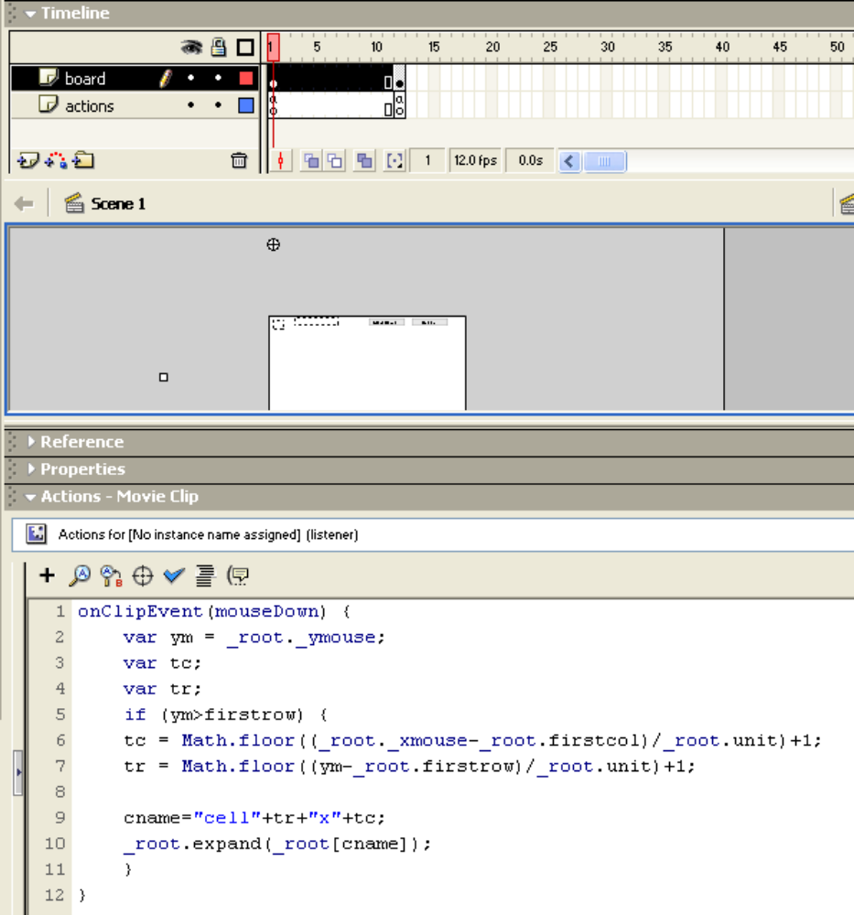
The clipevent code needs to be changed so as to ignore mousedowns for the two buttons. This is done using the if test with the ym variable that has been set to hold the y (vertical) position of the mouse. It works because the grid is below the buttons.
The code in frame 12 will adjust the timefield value to indicate the elapsed seconds. This uses the basic frame feature of Flash. The code also checks if the game is still in process. A variable named playing holds this information.
Now to the check function. It needs to go through the whole grid, using nested for loops, and check if the only unexamined cells, indicated by show text fields being " ", hold mines. The check function also sets playing to false. This is necessary when this function is invoked by the player clicking on the Check button as opposed to the expand function determining that the player has clicked on a mined cell.
function check() { | Function header
var i; | local variable used for looping
var j; | local variable used for looping
var cname; | local variable used to hold cell names
playing = false; | Make sure to indicate game over
var oksofar = true; | local variable initialized to true. Will be changed if any unexamined cells.
for (i=1;i<=hc; i++) { | Outer loop over columns
for (j=1;j<=vc; j++) { | Inner loop over rows
cname = "cell"+j+"x"+i; | Construct name of cell
if (_root[cname].show==" ") {//left unmarked | Check if unexamined
if (!_root[cname].bomb) { //was not a bomb | If it is NOT a mined cell
oksofar = false; | flip oksofar to false (this is bad!)
_root[cname].show = "?"; | Insert question mark, indicating to player that this should have been set
} | End true clause for not being a mine
} // ends left unmarked | End true clause for left unmarked
} | End inner loop
} | End outer loop
if (oksofar) { | Is oksofar [still] true
result = "You won!"} | result is that player won
else { | else
result = "You lost!"; | result is that player lost
} | End else clause
} | End function

Now to the Action code in frame 12, actions layer. This simply advances the displayed time.
if (playing) {
timerfield = 1+parseInt(timerfield);
}

The parseInt function is used to change the contents of timerfield, a string, to a number. Assigning the result back into timerfield, changes it back to a string.

Name this file mine5a and test it.

The last step is to remove (or comment out) the statement in layout that shows the presence of mines (aka bombs).

// _root[newname].show = "B";

Now play the game as a player would and see how you do.

Ideas for enhancement
Change in design
You could keep count of the number of mines actually placed in the mine and display this for the player. The player then knows when to stop. The code would keep track of the mines examined and display "You won" when the last non-mined cell was either clicked on or examined by the internal calls. You still would keep the check function to be invoked when the player hits a mine to show where all the mines were.
An alternative is to use a combination of the primary mouse key and a key on the keyboard to indicate flagging a mine. A bigger challenge is to implement the (windows) minesweeper short-cut action invoked by a mouse key combination.

Changing size of grid
Change the size of the grid by adjusting the hc, vc, and unit values. You will need to change the size of the cellseed instance. You also would change the value of odds.
After getting the game working with a different, presumably larger, square grid, work on a rectangular grid.
After doing different sizes, make this be an option to be chosen by the player.

Graphics
Enhance the graphics: the background, making cells change color according to the value of the number of adjacent mines, and doing something fancy upon wins and loses.

