Virtual Sports: exercises in the use of JavaScript arrays

This is a tutorial on the use of arrays to implement an application in which teams play games with winning and losing dependent on a pseudo-random function. It was inspired by William Reese, a student in my Programming Games class. Before continuing, it is necessary to say that I am not a sports fan or fantasy sports player. I realize that the teams listed here are not in a league; the code uses probabilities rather than odds; there is nothing about home court advantage and many other critical factors. Someone who is knowledgeable in these areas can use the ideas explained here to make a good project.

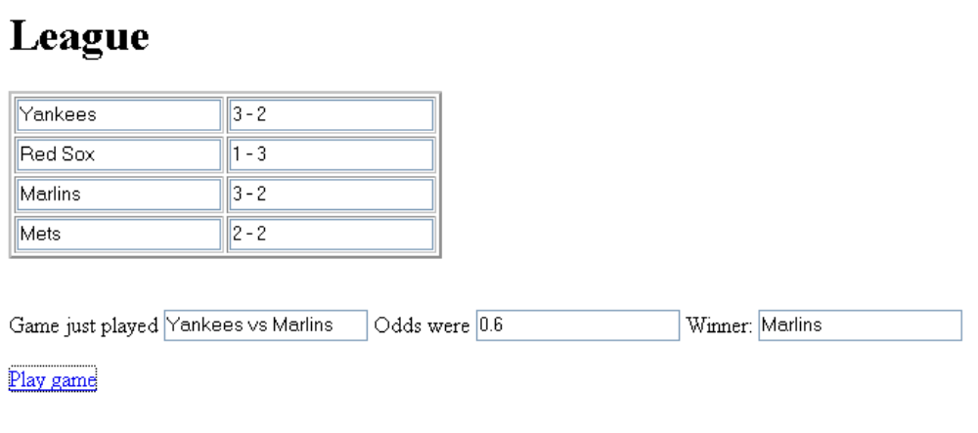
The general idea is that there is a schedule of games. For each game there is a probability that the first team will win. This probability factor is used with a call the built-in pseudo-random number facility to determine what team does win. A running tally is kept of the win-loss record of each team. In the screen shot shown above, the Marlins won even though the probability for that game was in favor of the Yankees.

Critical factors

The critical factors for this application are
- a mechanism for changing information on the screen, that is, in the HTML document. This is performed using <form> <input> elements. In certain cases, these are accessed by name and in others they are accessed using the elements collection of the form and computation to determine which element is to be changed.
- a mechanism for holding data on teams and games. The mechanism used for this is arrays, including arrays of arrays. Arrays are sequenced sets of components in which an individual component is accessed (or set) using an index.

Implementation

A rule in programming is to make haste slowly. The same applies to learning programming techniques. I will now describe 4 applications, with the 4th being the one shown above. It builds on the others. This is how I got to the final application.

The first HTML/JavaScript file demonstrates how to change information shown on the screen and a first use of arrays. The program displays the names of 4 teams. When a player presses the link Advance, the names move up, with the first one becoming the last one.

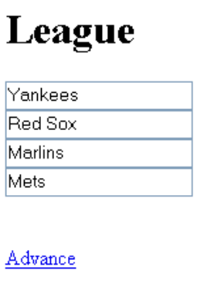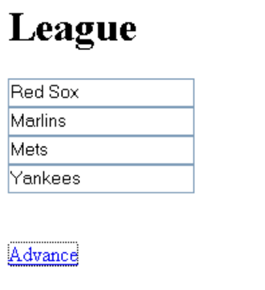

The two figures show the successive screens.

The HTML file has code in the head element for variable and function definitions. One variable is an array variable, named teams, that holds the names. The following line:

var teams = new Array("Yankees","Red Sox","Marlins", "Mets");

sets up a variable, specifically a global variable that can be accessed and changed by any function. The variable is an array with 4 elements, each a character string. The elements of a JavaScript array do not have to be the same datatype, but in most cases they are. This particular array has 4 elements. The indexing starts at 0 and ends at 3. That is, teams[0] has the value "Yankees" and teams[3] has the value "Marlins".

A function named changeorder performs the 'advance' operation. It does two things: changes (permutes) the values of the teams variable and changes what is being displayed. The body element of the HTML document holds a <form> with 4 <input> tags. The value attribute of each of the input tags is what is changed.

<html><head><title>Form element test </title> | standard HTML tags
<script> | script element
var teams = new Array("Yankees","Red Sox","Marlins", "Mets"); | defines teams holding the team names
function changeorder() { | definition of function
holder = teams[0]; | Need a place to save the value of the 0th element
for (i=1;i<teams.length;i++) { | Starting at index 1, loop to last element
teams[i-1]=teams[i]; | Put the ith element in the i-1 slot
} | End of loop
teams[teams.length-1]=holder; | Finish up by putting the element that was in the 0th slot in the last position.
for(i=0;i<teams.length;i++) { | Loop through teams
document.teamlist.elements[i].value=teams[i]; | Put current value of i-th element into the i-th element of the teamlist form of the document
} | End the loop
} | End the changeorder function
</script> | Close script element
</head> | Close head element
<body> | Start body element
<h1>League</h1><p> | Heading
<form name="teamlist"> | Define the form named teamlist
<input type="text" value="Yankees"><br> | Input element, holds an initial value of "Yankees". Line break.
<input type="text" value="Red Sox"><br> | As above
<input type="text" value="Marlins"><br> | As above
<input type="text" value="Mets"><br> | As above
</form> <br> | Close form element
<a href="javascript:changeorder()">Advance </a> | Use <a> tag to invoke function
</body> | Close body
</html> | Close html

Now we move on to the next program in our progression. In this program, all games are played with the same probability (.5).

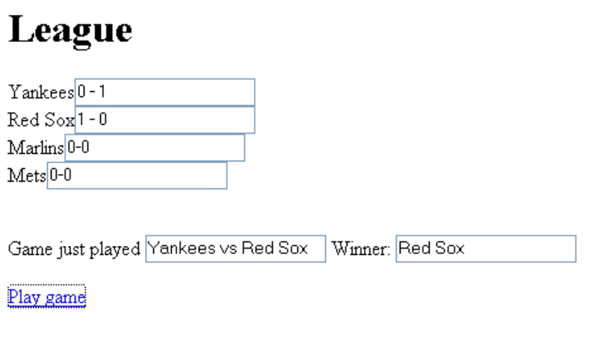
The screen shot shows the results of the very first game: the Red Sox won. Note the won-loss records of all the teams.

This program requires the teams variable as before. It will never change since the other variables refer to it.

var teams = new Array("Yankees","Red Sox","Marlins", "Mets");

The application requires keeping track of the records of each team. This is done using an array of arrays. It is better to say it this way rather than call it a two-dimensional array because the individual array elements can be different. The first element (0-th index) of the records array holds an array referring to the Yankees. This array has two elements: the first will be wins and the second will be losses. The declaration of the records variable in the code holds the initial records: each team has zero wins and zero losses.

var records = [
[0,0],[0,0],[0,0],[0,0]];

The way to refer to the record of the Red Sox would be records[1], the Marlins' would be records[2]. The way to refer to the wins of the Red Sox would be records[1][0] and losses would be records[1][1].

Lastly, there is a schedule of games held in a variable named games, which is another array of arrays. In this case, the elements of the array are (again) a two-element array with the elements being the two teams. In what is specified here, the first game is between the 0-th indexed team, the Yankees, and the 1-st indexed team, the Red Sox. The second game is between the Marlins and the Mets. Because it is necessary to keep track of which game is about to be played, there is a variable named nextgame, initialized to be zero.

var games = [
[0,1],[2,3],[0,2],[1,3],[0,3],[1,2]];

var nextgame=0;

The task of the playnextgame function is to determine the teams playing the game, advance the nextgame variable (a variable used this way is called a pointer or a cursor), determine the results of the game, using the Math.random function, display the teams playing and the results, update the records, and display those records. After the last game (the sixth) is played, nextgame is reset to zero and the program can continue. Note in what follows the use of a function called displayrecord. This function is just one line of code so it can be argued that it does not pay to make it a function. My thinking is that it is a fairly complex line of code and so I wanted to debug it only once!

function playnextgame() { | Function header
game =games[nextgame]; nextgame++; | Set game to be the game to be played and then increment the pointer
if (nextgame==games.length) { nextgame=0;} | Reset the pointer back to zero, if necessary
gameteams = teams[game[0]]+  " vs "+teams[game[1]]; | Create a string that will show the teams
document.gameplayed.gamep.value=gameteams; | Display that string using the named input element
roll = Math.random(); | Get a random number between zero and 1.
if (roll<.5) { | Compare that number to .5 (all teams are equal here)
winner = game[0]; loser = game[1]; } | Set the winner and loser
else {
winner = game[1]; loser = game[0]; } | Set winner and loser the other way
document.gameplayed.winner.value = teams[winner]; | Display the winner using the named input element
records[winner][0]++; | Update the record of the winner
records[loser][1]++; | Update the record of the loser
displayrecord(winner); | Call on function to display the record of the winner
displayrecord(loser); | Do the same for the loser
} | Close function

The function to display the record of an individual team is defined as follows:

function displayrecord(t) {
document.teamlist.elements[t].value = String(records[t][0])+" - "+String(records[t][1]);
}

The String function takes the number and makes it into a character string. Three character strings are concatenated to make the (string) value that is placed in the input element corresponding to the t position in the teamlist form. If you wrote
= records[t][0]-records[t][1]

JavaScript would do a subtraction and convert the result to a string to be displayed.

Now it is on to what is in the body of the HTML document. It is similar to the first example: a <form> with unnamed <input> elements, a second form with named elements, and an <a> element to invoke the function. In this case, regular text is intermixed.

<form name="teamlist">
Yankees<input type="text" value="0-0"><br>
Red Sox<input type="text" value="0-0"><br>
Marlins<input type="text" value="0-0"><br>
Mets<input type="text" value="0-0"><br>
</form> <br>
<form name="gameplayed">
Game just played <input type="text" name="gamep">
Winner: <input type="text" name="winner">
</form>

<a href="javascript:playnextgame()">Play game </a>

Note that the two forms could have been combined since the named elements are at the end. This was seemed cleaner to me. I am assuming that the reader knows how to put these code and HTML pieces together in one document!

The next application uses another array to specify distinct probability factors for each game. The concept is called parallel arrays. Before explaining the code, here is a screen shot:

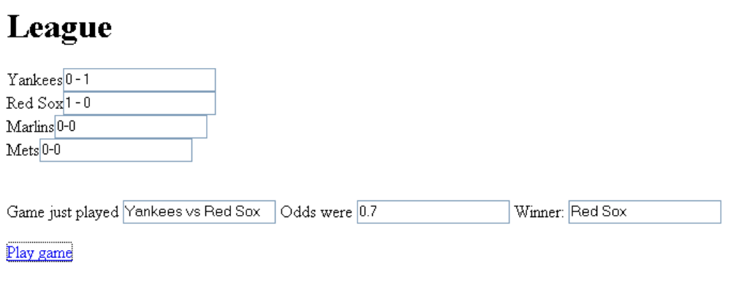

(Do not assume any bias in this rivalry. I take the screen shots as the game is played.)

Here are the variable declarations. There is only one addition, but I show everything to show the new one, odds, next to the array games to which it is 'parallel'.

var teams = new Array("Yankees","Red Sox","Marlins", "Mets");
var games = [[0,1],[2,3],[0,2],[1,3],[0,3],[1,2]];
var odds = [ .7, .5, .6, .4, .6, .3];
var records = [
[0,0],[0,0],[0,0],[0,0]];
var nextgame=0;

The screen shot showed that the data specifies that the first game is between the 0-th and the 1-th teams, the Yankees and the Red Sox. The odds factor is .7 for the first team named, in this case, the Yankees. The last game is between the Red Sox and the Marlins. In this case, the probability used is .3 for the Red Sox, meaning there is less chance that they will win.

Before going on, look back at the playnextgame function of the previous example. What needs to be changed? The start of the answer to this question is: the .5 in the if test. This is to be replaced by a value, the code here sets and uses a local variable called oddsnow, that is extracted from the odds array using the same nextgame variable.

function playnextgame() {
game =games[nextgame];
oddsnow = odds[nextgame];
nextgame++;
if (nextgame==games.length) { nextgame=0;}
gameteams = teams[game[0]]+" vs "+teams[game[1]];
document.gameplayed.gamep.value=gameteams;
document.gameplayed.oddsgame.value = String(oddsnow);
roll = Math.random();
if (roll<oddsnow) {
winner = game[0]; loser = game[1]; }
else {
winner = game[1]; loser = game[0]; }
document.gameplayed.winner.value = teams[winner];
records[winner][0]++;
records[loser][1]++;
displayrecord(winner);
displayrecord(loser);
}

The added or changed lines are indicated in bold and italics. Of course, the <body> section must be changed to accommodate the display of the odds.

<form name="gameplayed">
Game just played <input type="text" name="gamep">
Odds were <input type="text"name="oddsgame">
Winner: <input type="text" name="winner">
</form>

The last application differs from the next to the last primarily in aesthetic grounds: aesthetics you can see and also something related to the robustness of the application. I did not like the fact that the text in the <body> element essentially repeated what was in the <script> element. This meant that I needed to make sure that these two things coordinated. I adapted the coding to make the names of teams be picked up from the teams variable and displayed in the HTML document when the document is loaded. This required some calculations because now there are two <input> tags for each team. I also use a table to display the information. See the Enhancements sections for more ideas.

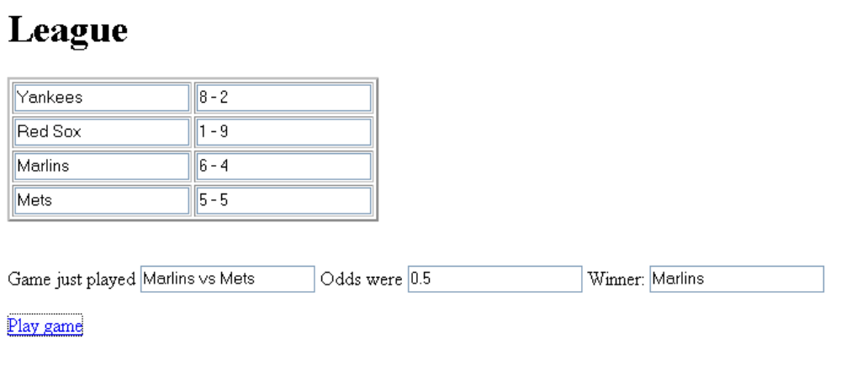
The screen shot was taken after many games, cycling through the schedule.

To explain this version of the program, it is best to start with the modified form:

<form name="teamlist">
<table border="2">
<tr><td><input type="text"></td><td><input type="text" value=" 0-0"></td></tr>
<tr><td><input type="text"></td><td><input type="text" value=" 0-0"></td></tr>
<tr><td><input type="text"></td><td><input type="text" value=" 0-0"></td></tr>
<tr><td><input type="text"></td><td><input type="text" value=" 0-0"></td></tr>
</table>
</form> <br>

Notice that there are no team names, but there is a place for the team name. The <input> tags are mixed in with the table tags.
The setting of the teams name will be done by a function specified by setting the onLoad attribute of the body tag:
<body onLoad="displayteamnames();">

This is interpreted as: when the document is loaded, that is, when that event happens, handle it by invoking displayteamnames(). This function is defined in the <script> element as follows:

function displayteamnames() {
for (i=0;i<teams.length;i++) {
document.teamlist.elements[2*i].value = teams[i];
}
}

In our example, it is the 0-th, 2-th, 4-th, and 6-th elements that are to receive the team names.

Moving on to the displayrecords function (and now you will appreciate my making it a distinct function), the code needs to put the record information in the first, third, fifth, or seventh <input> elements. Note that the parameter to the function, t, that indicates which team, is used as is the calculated tre.

function displayrecord(t) {
tre= t*2 + 1;
document.teamlist.elements[tre].value = String(records[t][0])+" - "+String(records[t][1]);
}

Enhancements
- Add another column with the team logo. You will use <img> tags and use the fact that all images can be accessed using document.images[ ]. This is called the images collection of the document object.
- You can incorporate a notion of home team advantage by making the schedule (the games array) have elements being arrays in both orders:
[0, 1] and [1, 0]. Define the odds as you think best. The schedule can have repeated instances of games with the same or different odds. Some teams play better as the season continues.
- If you want to talk about odds, then store that information and do the calculation to derive a number from 0 to 1 for use in the if test using a result from Math.random(). It may be appropriate to have an array with a list of terms and a corresponding number ("even" would correspond to .5).
- Add facility for the player to change the schedule and/or the odds.
- Baseball does not have ties, but other games do. For this situation, you need to formulate a plan for expressing the chances of the first team winning or a tie. The chances of the second team winning would be the remaining probability. One tactic (shown in the file named teamstie.html) is to use two numbers with the first the probability of the first team winning and the second the probability of the first team winning or there being a tie. The odds array would be an array of arrays of length 2 instead of an array of single numbers. The records array would be an array of arrays of length 3. The if statement would be
if (roll<oddsnow[0]) { } else if (roll<oddsnow[1]) { act on a tie } else { act on second team winning}
- Assume this is like the first part of World Cup Soccer. Do not let the schedule repeat, but instead compute the rankings based on a win is two points, a tie is one and a loss is nothing. Re-order the listings according to the rankings.

