Flash tutorial: Grabber /attractor / idling added to Jigsaw puzzle

A frequent feature of what are termed kiosk applications is some active animation or other graphics to attract or 'grab' people passing by. Once the person steps up to computer station and does something, such as move the mouse, the real show or game begins. When the show or game is complete, the application waits a set amount of time, and then goes back to the initial display. This is sometimes called idling. This tutorial will show how to add these effects to the jigsaw program.

The nature of the grabber display can be independent of the main subject matter but in the case of the jigsaw puzzle, it seemed to be appropriate to mix up and display the pieces over and over again. This also means that we can take advantage of the mixup function already written. When the puzzle is complete, which is detected by the code (see the jigsaw tutorial), after the message 'Good Job' is displayed, the application waits for 5 seconds and then goes back to the initial grabber.

The original Timeline held just one frame. This held the buttons, the dynamic textfield holding instructions and result, and all the puzzle pieces.

The first step was to insert several keyframes and frames before that first frame. This was done in several steps:
- Insert a second keyframe,
- Copy over all the graphical content to the second frame
- Delete from the first frame the buttons. Keep the puzzle pieces and the result textfield
- Keep the frame actions in the first frame. These are the function definitions and it is good practice to keep them in one place.
- Now, insert frames in-between the first and second frames. This is also done in multiple steps: Insert frame and then Convert to Keyframe.
- Label the second frame 'idling' and the last frame (the original one that has been pushed over) 'game'.

The timeline will look something like this.

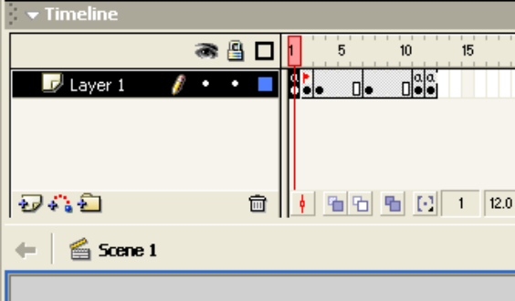
The graphical content of the inserted frames is all the same—the code does the animation. The reason why several frames are used is to occupy time between the displays. If your grabber involves frame/cell animation, these would be keyframes with distinct graphics. In this case, the frames from 3 to 10 can be regular frames and not keyframes. The screen shot shows black arrows indicating keyframes because of some debugging code. Note: there is not harm in making them keyframes. The second frame needs to be a keyframe in order to have a frame label.

The logic for the grabber is to call, periodically, a function to check if the mouse has been moved and if it has, go to the 'game' frame to do the actual game. If the mouse has not been moved, the action is to go to the 'idling' frame. This is done periodically by putting a call to a function, checkmouse, in frame 11 (one before the 'game' frame). The checkmouse function uses some global values holding the original position of the mouse.

In the first frame, this code has been added to hold the global values, define two functions, idle and checkmouse, and invoke idle.

var oldx; | Hold original (old) mouse x
var oldy; | Hold original mouse y
function idle() {
oldx = _root._xmouse; | store the current x coordinate of the mouse
oldy = _root._ymouse; | store the current y coordinate
mixup(); | call mixup to shuffle the puzzle pieces
result="Move mouse to play game"; | Display instructions for anyone walking up to the screen
goToAndPlay("idling"); | Go to the grabber code
}
function checkmouse() {
newx = _root._xmouse; | Find out current x coordinate of mouse
newy = _root._ymouse; | Find out current y coordinate of mouse
delta = Math.abs(oldx-newx) + Math.abs(oldy-newy); | Calculate the sum of the absolute differences: the combined changes
if (delta>300) | Compare this to some set amount. Note: experiment with different numbers.
{ result=""; | If there has been a significant change, blank out the result dynamic text field
_root.goToAndPlay("game"); | … and go to the game
}
else { | If there has not been significant change
mixup(); | Mixup the pieces
goToAndPlay("idling"); | Go (back) to the start of the frames for the grabber, also known as idling.
}
}
idle();

The question you should have now is where is checkmouse() called. The answer is in the frame before 'game'. The Flash environment would show the following:

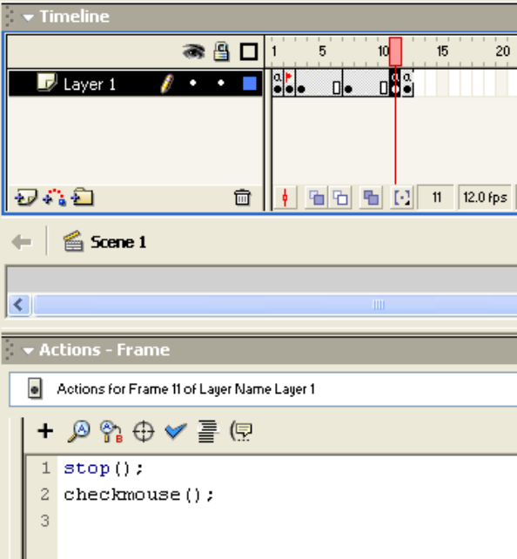

Note the stop(); statement to make sure control does not proceed to the next frame.

This shows how to produce the grabber / idling / attractor feature initially and how to leave it. The next task is to determine how to get back to it. Notice that for the idler, time is handled by setting up a sequence of frames. For providing the player a certain amount of time to look at the 'Good Job' display to decide if he or she wants to play again, I make use of another technique: empty movie clips and clipevent actions.

You will create 2 movie clips, one containing the other. One clip is totally empty and the other just contains code. Go to Insert/New Symbol and create a movie clip called timermonitor. Leave it empy! Now go again to Insert/New Symbol and create a movie clip called timersetup. The following is not strictly necessary, but I create a layer called process and another layer called actions. In the actions layer, put the following code

var timeractive;
var timerend;
var timerfunc;
function starttimer(msec, func) {
timerend= getTimer() + msec;
timeractive = true;
timerfunc = func;
}
stop();

When the function starttimer is called, the function will set the variable timeractive to be true indicating that the timer is turned on. It will calculate and store in the variable timerend when the timing interval is to stop and store in timerfunc the name of a function. This is similar to the action of setInterval in JavaScript. When the timing interval specified has elapsed, the indicated function is called. So now the issue is where is the check made that the time has elapsed?

Into the process layer of this movie clip, drag an instance of the timermonitor clip. It does not need a name. When it is selected, enter the code indicated in the screen shot:

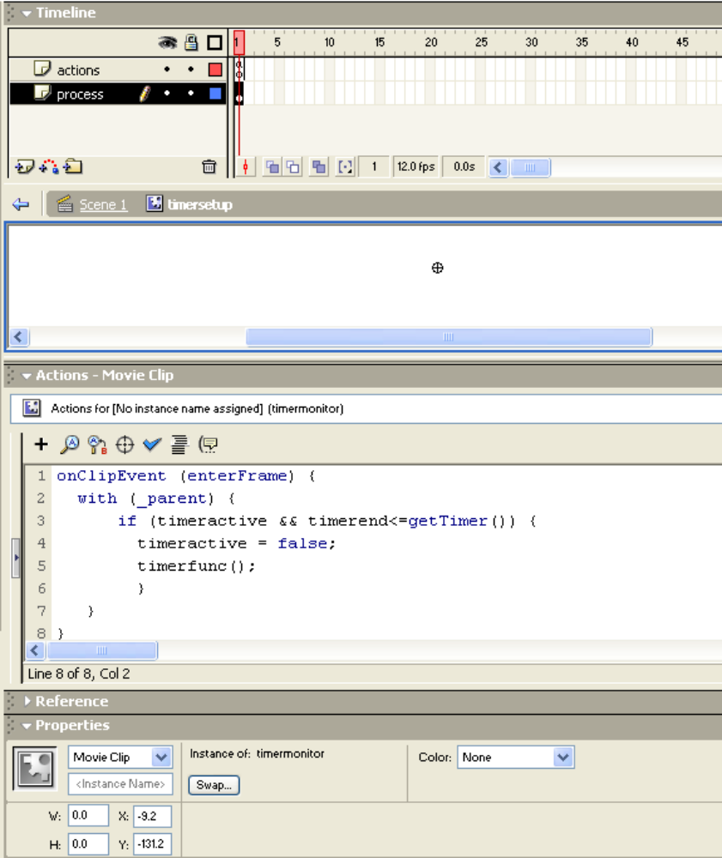

The enterFrame code is invoked for each frame of the timermonitor movie clip. This movie clip instance has no content and no actions, but it does have one frame, so this keeps happening. The with (_parent) construction means that the variables in the clause are variables of the parent movie clip. In this case, it is the timersetup movie clip.

The next step is to bring an instance of the timersetup movie clip symbol into the main timeline. NOTE: I actually did this before adding frames, so it is contained in every frame. Give it a name: timersetupinst.

The next and last step is to put in the code to take a pause, using a call to starttimer. You need to determine this position based on your application. For the jigsaw puzzle, as indicated above, this was in the check function:
if (oksofar) {
result = "Good job!";
timersetupinst.starttimer(5000,goToIdle);
}

This will produce a pause and then a call of a function goToIdle. This function simply is the following:

function goToIdle() {
goToAndPlay(1);
}

Note that the frame code for frame 1 ends in a call to idle(); the frame code of the frame before the last has

stop(); checkmouse();

and the frame code of the last frame, the one labeled 'game' has

stop();

This last prevents control going to the first frame.

This application handles time using frames in two distinct ways: for the grabber/attractor sequence, frames go by and the code makes a check. For checking for elapsed time, the application uses a separate movie clip holding an empty movie clip. A clip event based on the frames of empty clip is used to make the check.

Please give it a try. Remember when you are checking it out, use a very short wait and once it is working, increase the time.

Now, what if you want to put in checks to go back to the grabber sequence in the middle of the game if nothing is happening? Checking for nothing is difficult. Instead, I use the technique of pushing the time limit forward. At this point, some aspects of the style of past coding help and some mean work. The flexibility of the timersetup movie clip is useful here. The code will call it at different points independent of whether or not there is a time interval currently active. To distinguish between pauses of different size, declare (something like) the following:

var limitbetweenmoves = 10*1000; //thinking time
var limitoncompletion = 5*1000; //after 'good job'
var limitstart = 12*1000; //limit to start play
var limittoseecomplete = 3*1000; //to view complete puzzle

These limits probably are too low for the final version. You want short times for debugging. I also put a trace statement into the starttimer function to tell me what the msec parameter value was to verify that the caller was correct.

When the game is underway, each time the player moves a piece, a timer limit will be placed of limitbetweenmoves more time. This will be done in the handler for the mousedown event. You need to take the current code for each piece (in each frame):

onClipEvent (mouseDown) {

if (this.hitTest(_root._xmouse, _root._ymouse, true)) {
this.startdrag(false);
}
}

and change it to

onClipEvent (mouseDown) {
_root.checkmousedown(this);
}

This should have been down originally. The general advice is to make the code in clip events function calls, with parameters as necessary, so then there is only one place to make changes. The _root is necessary as is the parameter 'this'. The latter will be used to apply the coding of the function checkmousedown to each specific puzzle piece.
The function is defined in frame 1 and is the following:

function checkmousedown(which) {
if (which.hitTest(_root._xmouse, _root._ymouse, true)) {
_root.timersetupinst.starttimer(_root.limitbetweenmoves,_root.goToIdle) ;
which.startdrag(false);
}
}

The parameter which holds what the invoking call sent, namely the value of the special variable this, a pointer to the instance for which it was a clip event.

Where the code above used a constant of 5000 indicating the time after completion, change this to

if (oksofar) {
result = "Good job!";
_root.timersetupinst.starttimer(limitoncompletion,goToIdle);
}

In the checkmouse function that is invoked by the next to the last frame, modify to

if (delta>300)
{ result="";
mixup();
_root.timersetupinst.starttimer(_root.limitstart,goToIdle);
_root.goToAndPlay("game"); }
This will mean that if someone comes up and moves the mouse, the application goes to the play frame, and the person who stopped by decides not to play, the control will go back to the grabber sequence.

Lastly, say someone started the game and clicked the button to see the completed picture. You do not want to remain frozen on the screen if the person did not resume play. This means inserting a call to the timer:

function build() {
for (i=1; i<=numpieces; i++) {
np = "piece"+i;
_root[np]._x = _root[np].offsetx;
_root[np]._y = _root[np].offsety+20;
_root[np]._rotation = 0;
}
_root.timersetupinst.starttimer(_root.limittoseecomplete,goToIdle);
}

Again, give it a try. The integration into your own game or activity will require attention to the specific structure of your program.

