Flash lab: Hangman
This tutorial describes an implementation of the child's guessing game Hangman. Hangman is a two-person game, but the two players have distinct roles. In this implementation, the computer is the player with the secret word. The word is chosen using a random process from an internal list (held as an array of strings). The (human) player clicks on buttons representing letters of the alphabet.

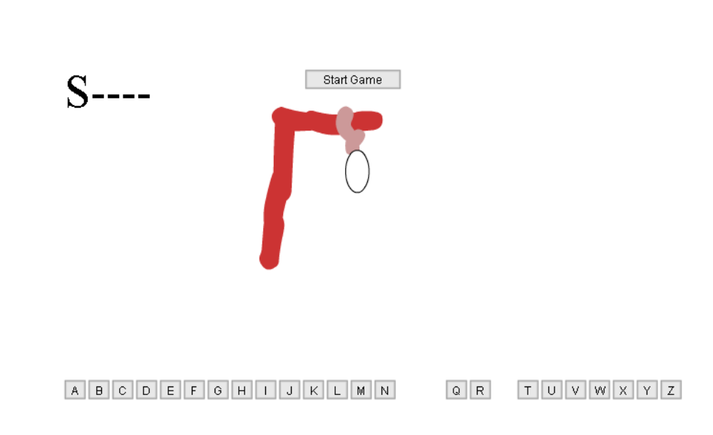

The screen shot shows a game in process. The letters O, P and S have been played, with S found to have been in the word. The hanging has progressed to the point shown. Note that other implementations of indicating letters are possible. For this implementation, I have shown to incorporate the alphabet as buttons.
One aspect to be addressed is the flexibility of the implementation, specifically, varying the graphical display for the progression of the hanging and changing the set of words used by 'the computer'.

Critical features
The implementation requires the following features:
- buttons representing letters of the alphabet. To do this, I moved to the stage one instance of the built-in component PushButton. This was named buttonA. Its click handler was set to pickletter, a function to be defined in the Actions layer, frame 1. I used ActionScript to create the remaining 25 buttons.
- a set of words to be used as secret words. I defined an array called wordbank and the usual pseudo-random expressions to choose from the words.
- a movie clip called hanging representing the progression of steps. The hanging is a sequence of frames that can be as long and detailed as you like. Certain frames are labeled and those labels are used in an array called steps. The frame before each labeled frame contains the ActionScript stop(); This produces the effect of some animation for each step of the hanging.
- a place (dynamic text field named place) where dashes indicate the length of the secret word to be modified if and when the correct letters are picked. This requires the use of the substring method.

Implementation
Any game has many designs. For example, one way of designing hangman is to make use of the keyboard instead of buttons on the screen. To do this, look up the Key object. I chose to use buttons because it mimics the way I play hangman. Similarly, any one design can be implemented in distinct ways to produce the same apparent results to the user. This tutorial describes one set of choices.

Start by creating 2 layers: board and actions. Note: the main movie (also known as _root or Scene I) will have one single frame.
For the alphabet buttons, the first step is to move an instance of the Pushbutton component to the stage. Name the instance buttonA, adjust its width and height to 22 and 20, change the label to A, and enter pickletter as the Click handler. The following screen shot shows what you should see.

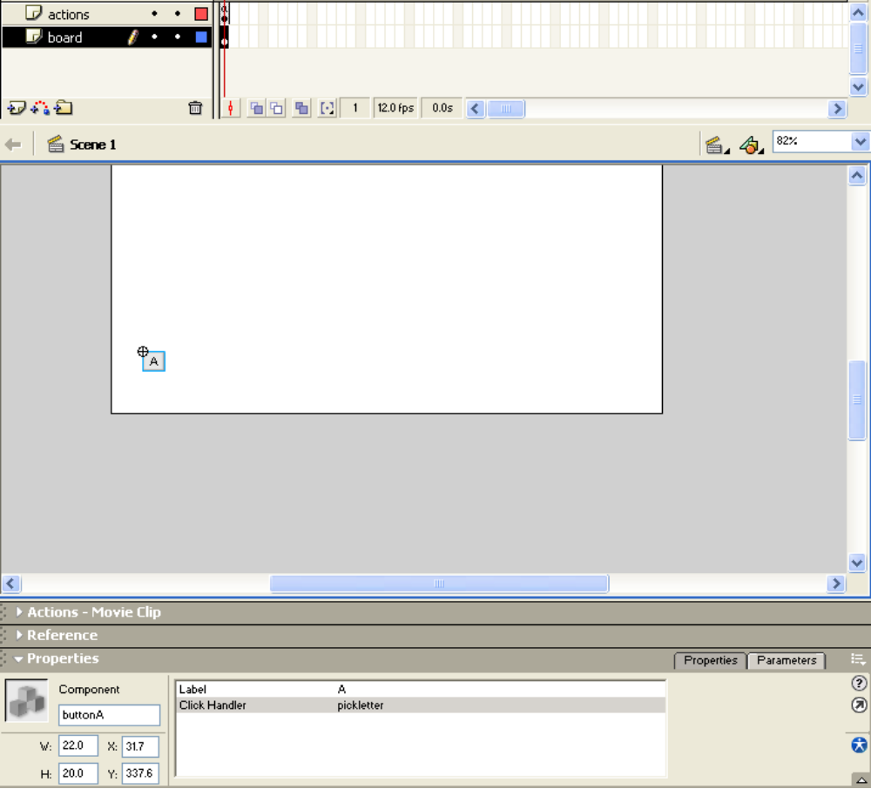

In the Actions layer, frame 1, enter the following code to generate the remaining buttons at runtime.

var alphabet = "ABCDEFGHIJKLMNOPQRSTUVWXYZ";
var nl = 1;
function createbuttons() {
for (i=1;i<26;i++) {
bl = alphabet.substr(i,1);
bn = "button"+bl;
buttonA.duplicateMovieClip(bn,nl++);
_root[bn].setLabel(bl);
_root[bn].setSize(22,20);
_root[bn]._x = buttonA._x + i*25;
}
}
createbuttons();

The duplicateMovieClip method produces a duplicate of the component! The nl variable, which is incremented each time, is used to specify the level. You can have only one movie clip per level. The names of the movie clips follow the pattern of buttonA. Note: in my first attempt, I used just the alphabet letter but ran into problems because the code used a variable named i. The substr method plucks the successive letters from the string alphabet. Your code needs to do something to prevent these instances from all being on top of each other. This is achieved by the code:
_root[bn]._x = buttonA._x + i*25;

You can check your code by testing this movie. You should see all 26 letter buttons appear.
You can make another check by coding partially 'throwaway' code:

function pickletter(component) {
letter = component._name.substr(6,1);
trace("you picked "+letter);
}

The click handler is called with the component, the specific pushbutton instance, passed as an argument. We could use another term for the parameter. That is, the system specifies the parameter value but not its name. However, component is as good a term as any. The substr method extracts from the name of component, the string starting at the 6st character (remember, strings are indexed starting from 0), for 1 character.

(The methods substr and substring are similar, but different: the first parameter of each is the starting index of the sub-string to be extracted. The second parameter of substr is the length of the sub-string. The second parameter of substring is the index one past the index of the last character to be extracted. If this second parameter is omitted, substring extracts from the first character indicated to the end of the string.)

Later, you will replace the line with the trace statement with the code for checking the letter. Try your program. You should be able to click on a letter and see some output in the Output panel. You can add the line:

component._visible = false;

This will make the letter button clicked disappear. This feature helps the player keep track of guesses.

We skip now to the implementation of the features for the secret word. For the word bank, write

var wordbank = new Array ( "MUON", "SILLY", "GOOSE", "HOLIDAY", "QUIXOTIC");
var answer;

The wordbank can be as big as you want. My list here mainly represents my tastes, but does has some worthwhile features: the size of the words gives me clues so I can win if I want to, which means I do not have to play the game to build the game. There also are words with repeated letters. The implementation supports this feature without any extra coding, but to be sure, it is good to test it. The variable answer will hold the selected word.

Create on the stage, board layer, two dynamic text fields, one var named place and the other var named result. Also move to the stage, board layer, an instance of PushButton, label Start Game and Click handler startgame:
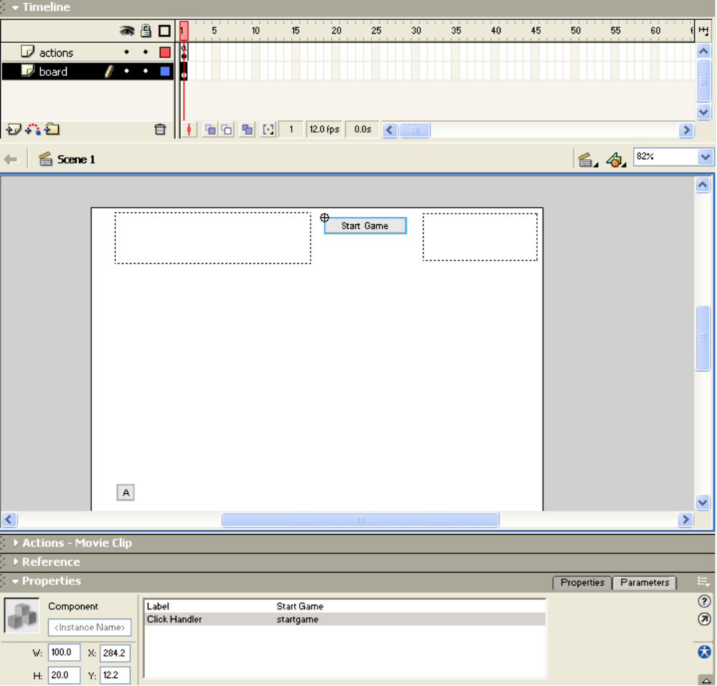

The code for startgame is the following:
function startgame() {
for (i=0;i<alphabet.length;i++) {
_root["button"+alphabet.charAt(i)]._visible = true;
}
_root.nextstep = 0;
var choice = Math.floor(Math.random()*_root.wordbank.length);
_root.answer = _root.wordbank[choice];
_root.place = makedashes(_root.answer.length);
_root.result="";
_root.hanging.goToAndStop("start");
}

The for loop that starts the startgame function was (I admit) added later. It makes sure all the alphabet buttons are visible. Some could have been made invisible by an earlier game. A challenge for creating any game is to program initializations and re-initializations correctly. The variable nextstep will be described later along with the code involving the instance named hanging. The next lines of code assign to the variable choice a random value based on the size (length) of the wordbank array. The answer variable is set to be that element of wordbank.

The place text field starts out holding a string of dashes, one dash for each letter in answer (the secret word). I use a distinct function to generate a string with this many dashes. The code is the following:
function makedashes(dc) {
var s = "";
for (i=0;i<dc;i++) {
s += "-";
}
return s;
}

This code starts off with s holding an empty string and concatenates to it a dash as many times as the value of the passed parameter dc. The string value generated is returned to the calling function. The code certainly could be part of startgame because it is not called by any other function. However, this is a case where it made sense to me to make a new function because it had a well-defined role.

The next topic is the hanging progression. I use the word progression because that is what it is: a progression of steps. Create (insert) a new movie clip symbol named hanging. You can and should use your artistic ability here! What is required is a sequence of frames as detailed as you wish. You will add the ActionScript code stop(); at specific frames. You also will add labels to specific frames. The following screen capture shows what is required:
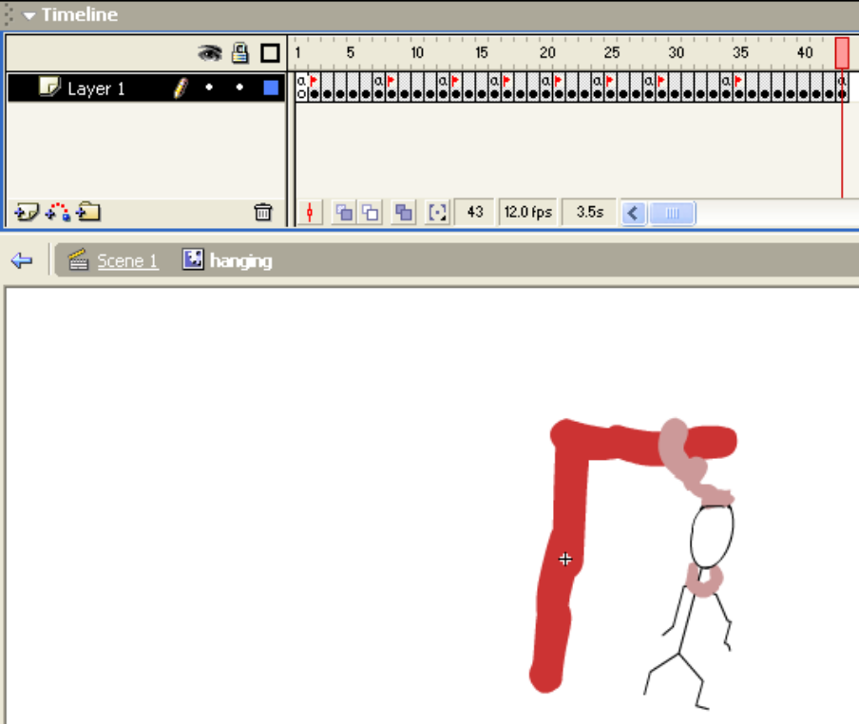

Note: the very first frame also has a label (no flag shown in the screen shot) and this label must be 'start'. After each frame (except the last) that has stop(); as its frame action, the frame has a label. The code (in the main movie) will goToAndPlay to a frame label and the hanging instance movie clip will continue until a stop(); is played. As always, I suggest starting simple: make a movie clip with 7 frames, the first labeled 'start', the second labeled 'gallows' and the 6th labeled 'rope'. Insert stop(); code into the first, 5th and 7th frame. Draw images of a hanging on the stage, keeping in mind that the action will stop at the 1st, 5th and 7th frame. Go back to the main movie (Scene I) and move an instance of hanging to the middle of the stage. Name this instance hanging. This last step is essential (and easy to forget).

The implementation of the progression involves the hanging instance, an array variable called steps and a variable called nextstep. Following indicates the relationship of these entities:

nextstep points to an element in steps which contains the labels of hanging

If you followed the suggestion given above, in the main movie, actions layer, you will have the code:

var steps = new Array ("gallows", "rope");

In my code, after I had tested it with a smaller version of the hanging movie, the code is
var steps = new Array ("gallows", "rope", "head", "leg1", "leg2", "arm1", "arm2", "noose");

The code also has the declaration of the variable nextstep:
var nextstep;

You will recall that the function startgame set the global nextstep to zero, meaning the first element of steps. Note that for steps (and for wordbank), the code uses the length attribute to determine the size of the array so that if and when you add elements, the code still works.

The last topic to address is the implementation of pickletter. This code must do the following:

determine what letter was picked
make the corresponding button invisible
determine if that letter is in the secret word.
For each time the letter appears in the secret word, the letter is substituted for the dash in the text field named place. This is accomplished by re-creating place concatenating 2 or 3 generated strings. There are 3 cases: the first letter, the last letter and a letter in the middle.
If the letter did not appear anywhere in the secret word, the hanging is advanced.
If the hanging is advanced, a check is made if the progression is over. If it is over, indicate this using the result text field.
If the letter did appear, then a check is made if the word has been completed uncovered. If the game is over, indicate this using the result text field.

Notice that the check if the player has won and the check if the player has lost are performed in two distinct places in the coding.

Examine the following code to make sure you understand how it accomplishes the above tasks. Remember you need to remove the trace statement in the first version of pickletter.

function pickletter(component) {
letter = component._name.substr(6,1); component._visible = false;
notfound = true;
for (i=0; i<_root.answer.length; i++) {
if (_root.answer.charAt(i)==letter) {
notfound = false;
if (i==0)
{_root.place = letter+_root.place.substring(i+1);}
else if (i==(_root.place.length-1))
{ _root.place=_root.place.substring(0,i)+letter;}
else {
_root.place = _root.place.substring(0,i)+
letter+_root.place.substring(i+1);
}
}
}
if (notfound)
{
hanging.goToAndPlay(_root.steps[_root.nextstep++]);
if (_root.nextstep==_root.steps.length)
{
_root.result="Game over. Try Again.";
_root.place = _root.answer;
}
}
else if (_root.place==_root.answer) {
_root.result = "Good job. Play again";
}
}

This is the implementation of hangman. To review, the main movie has one frame, two layers, board and actions. The contents of the board layer are

Pushbutton component named buttonA, labeled A, click handler pickletter
hanging instance named hanging
dynamic text field named place
dynamic text field named result
Pushbutton component labeled Start Game, click handler startgame

The actions layer contains the definition of the following functions:
startgame
createbuttons
pickletter
makedashes

The global variables are
alphabet
nl
wordbank
answer
steps
nextstep

After you have something working, enhance the hanging movie clip and add more words to wordbank. Ask a friend to test, that is, play your game.

OOOPS: when publishing the game, I found a significant flaw. The set of letter buttons did not fit on the screen. To fix this, I did the following: I changed the width of the original buttonA to be 20 pixels and also moved it over to nearly the edge (see W: and X: values in the screen shot).
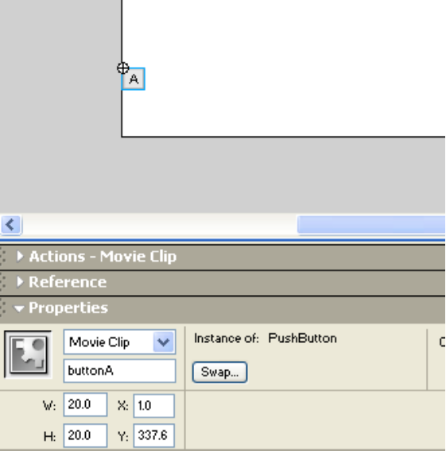

This also meant that the code for generating the 25 letters needed to be changed:
_root[bn].setSize(20,20);
_root[bn]._x = buttonA._x + i*21;

Next, in the Publish settings, I changed the width of the movie to 650 (from 550). The one flaw here is that the W is slightly cut off. Exercise for the reader: make a better adjustment.

