Virtual Pet using XML and XSLT
Jeanine Meyer
Purchase College/SUNY
http://newmedia.purchase.edu/~Jeanine

Abstract
EXtensible Markup Language (XML) and eXtensible Speadsheet Language Transform (XSLT) are tools for creating and maintaining content-rich applications, such as Web documents. The application content is specified using XML with a structure invented by the application developer. An XSLT file transforms any XML file using that structure into another form. In this case, the XSLT formats the content in the XML file to produce an HTML file containing JavaScript code. This paper describes the implementation of a virtual pet using these tools.

Background on virtual pets
A virtual pet is a computer representation of a [simple] model of pet behavior incorporating mechanisms for owner actions. One example would be a virtual dog that could be fed or petted. If the virtual dog is fed too little or too much, it dies. When the virtual dog is petted, the response would be either showing anger or wagging its tail depending on a function involving pseudo-random features and the time since the dog was last fed.

Here are screens representing sample stages in the life of a virtual dog. This is the initial screen. The dog is in the normal state, as shown by the graphic and the label. The other textbox shows the dog's weight. Below the textboxes are labels for 4 possible actions: Feed Dog, Pet Dog, Start Play and Stop Play.
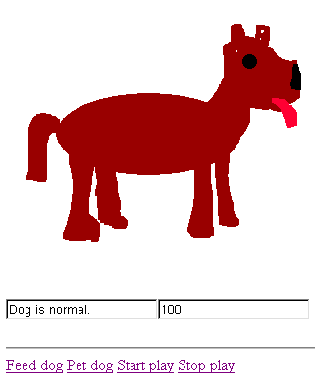
The next screen shot shows a situation in which the dog has not been fed. The weight is now 61 and the graphic is of a thin dog.

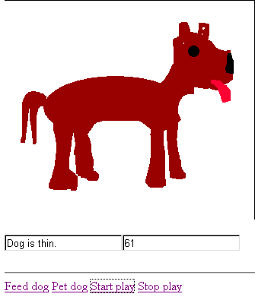

The situation continues with no feeding of the dog, so the dog dies:

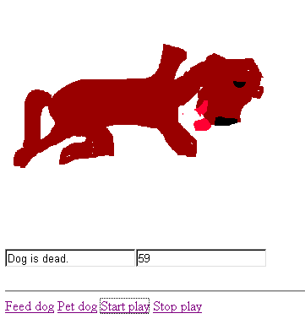

The next screen shot shows a situation in which the owner has fed the dog. Notice the weight is 105.
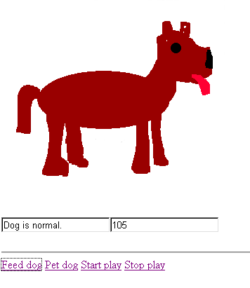
Just as it is possible to starve the virtual pet, it is also possible to overfeed the pet.
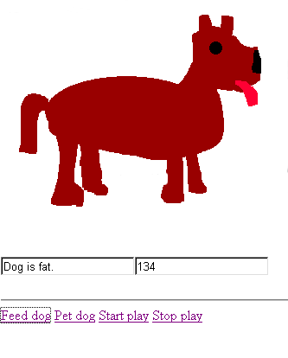
Overfeeding can also lead to the death of the virtual pet:
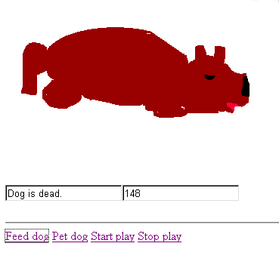
The action of petting the dog can lead to a happy dog wagging its tail or a dog that snarls. The tail wagging dog is implemented using an animated gif file. Here is one frame from wag.gif.
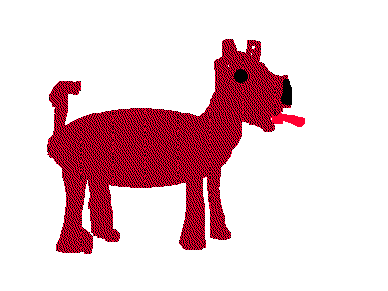
The snarling dog is portrayed using a static graphics file (mean.gif)
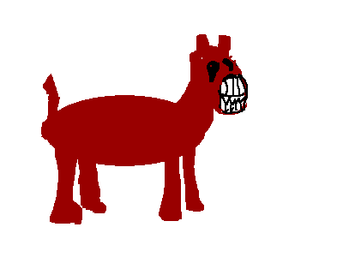

The model could be more developed than it is: there is only one wagging picture and only one snarling picture. (This enhancement is left as an exercise to the reader.)

The original implementation of the virtual dog was done by 'straight' hand coding of HTML and JavaScript. The HTML consists of a single, named image tag, a form with 2 input tags (used to display the status and the weight), and 4 hyperlinks for the 4 actions.
JavaScript has functions that establish timed events and the associated event handling. The call
tid = setInterval("change()", 1000);
establishes that every 1000 milliseconds a call is to be made to the function change(). The variable tid is set to a number that identifies this particular timed event. A call to
window.clearInterval(tid);
turns off the timed event pointed to be the variable tid. The change() function examines the weight of the dog, held in a variable and contains a nested if statement to determine what image file is to be placed in the image tag.
The actions designated by the 4 labels are implemented using HTML a tags. For example, the Pet Dog action is implemented using
<a href="javascript:petdog();">Pet dog</a>
where petdog() designates a function. This function performs a calculation using the Math.random() method of JavaScript. Depending on the results, the wag.gif or the mean.gif is placed in the image tag.

Defining the content
An XML/XSLT version of the virtual dog would mean that the model of the pet behavior could be separated from the details of the implementation and either one could be modified or completely changed. The application really would be 'virtual pet' with other people able to define their own pet. However, to do that, it is necessary to abstract the content.
The framework chosen here is to define a pet behavior in terms of states, state variables, actions, and the base interactions done at each iteration.
Each state has a name, a graphics file, and a set of zero or more switch conditions. These are tests that when done lead to changes in the state. At least one state is designated the starting state. Zero or more states can be designated stopping states.
State variables are exactly what they sound like: variables that maintain information. They can be viewed as a way of parameterizing states. An obvious candidate for a state variable for this application is weight.
Actions are implementations for player moves. In this case, the actions correspond to the Pet Dog and Feed Dog links. The two other links, starting and stopping, are created automatically for all applications.
This application assumes some sort of cycle. However, two features of that cycle are up to the individual specification for each virtual pet. These are the timing interval, specified by a state variable named interval and the code that is executed each interval (in addition to the state switch conditions). This code is designated as the interactions.

The XML file
The design of the XML file follows the requirements indicated in the previous section. Someone else may have done things differently. Notice especially the use of attributes versus child elements. An outline for the XML file for the virtual dog is the following:
- Xml header tag and pointer to stylesheet tag
- The root node is the <animal> tag. Everything is contained in this tag.
- The animal name tag contains the name output to the title of the HTML document
- There are 4 state variables: interval, elapsed, wagtime and weight. An attribute indicates if a variable is to be shown. A possible enhancement is to include labels for the textboxes for shown variables. It did not seem necessary in this example, but certainly would be for one with several 'shown' variables.
- There are 7 states: normal, fat, fatdead, thin, thindead, wag, and mean. Attributes indicate the start and the stopping states. Both fatdead and thindead are stopping states. A switch condition contains a condition tag and a truestate tag containing the state to switch to if the condition is true. The implementation allows for a falsestate tag, but it was not used for this example. To avoid the requirement to escape all code in CDATA sections, the conditions are specified using the greater than symbol rather than the less than symbol. The less than symbol, <, is not allowed in XML documents outside of its role as starting tags. Similarly, the JavaScript ++ operator was used in place of the -- operator.
- There are two designated actions: petting the dog and feeding the dog. These elements contain procedurenames and procedures.
- The interactions are to add the interval to the elapsed variable and to decrement the weight by one.

Here is the full text of vdog.xml:

<?xml version="1.0" ?>
<?xml-stylesheet href="virtual.xsl" type="text/xsl"?>
<animal>
<animalname>Dog</animalname>
<statevar name="interval">1000</statevar>
<statevar name="elapsed">0</statevar>
<statevar name="wagtime">0</statevar>
<statevar name="weight" show="yes">100</statevar>
<state name="normal" start="yes">
<picture>dog.gif</picture>
<label>Dog is normal.</label>
<switchcondition>
<condition>weight>120</condition>
<truestate>fat</truestate>
</switchcondition>
<switchcondition>
<condition>80>weight</condition>
<truestate>thin</truestate>
</switchcondition>
</state>
<state name="fat">
<picture>fatdog.gif</picture>
<label>Dog is fat.</label>
<switchcondition>
<condition>120>weight</condition>
<truestate>normal</truestate>
</switchcondition>
<switchcondition>
<condition>weight>150</condition>
<truestate>fatdead</truestate>
</switchcondition>
</state>
<state name="fatdead" stopstate="yes">
<picture>fatdeaddog.gif</picture>
<label>Dog is dead.</label>
</state>
<state name="thin">
<picture>thindog.gif </picture>
<label>Dog is thin.</label>
<switchcondition>
<condition>weight>80</condition>
<truestate>normal</truestate>
</switchcondition>
<switchcondition>
<condition>60>weight</condition>
<truestate>thindead</truestate>
</switchcondition>
</state>
<state name="thindead" stopstate="yes">
<picture>thindeaddog.gif</picture>
<label>Dog is dead.</label>
</state>
<state name="wagging">
<picture>wag.gif</picture>
<label>Dog is wagging its tail.</label>
<switchcondition>
<condition>(wagtime++)>5</condition>
<truestate>normal</truestate>
</switchcondition>
</state>
<state name="mean">
<picture>mean.gif</picture>
<label>Dog is angry. </label>
<switchcondition>
<condition>(wagtime++)>5</condition>
<truestate>normal</truestate>
</switchcondition>
</state>
<action label="Feed dog">
<procedurename>feeddog</procedurename>
<procedure>weight=weight+10;elapsed=0;
</procedure>
</action>
<action label="Pet dog">
<procedurename>petdog</procedurename>
<procedure> wagtime=0;
if (Math.random()>Math.min(elapsed/interval,19)/20)
{curstate="wagging";}
else {curstate="mean";}</procedure>
</action>
<intervalaction>
elapsed=elapsed+interval;
weight=weight-1;
</intervalaction>
</animal>

Implementation of virtual pet using XSLT
The implementation of the xml content is done using an XSLT file, named virtual.xsl. It must create the HTML document with all the necessary JavaScript coding, including variables and functions in the head section and calls to functions in the a tags.
The tasks of the XSLT file are as follows. This is an example of what is called 'pull' processing. The required elements are selected and manipulated as needed as opposed to using multiple templates and apply-templates to push nodes out to the HTML document. The xslt program examines certain nodes, for example, the state nodes, more than one time.

- xml and xslt standard boilerplate
- One template: for the topmost node: animal
- Set a variable interval to hold the value of the statevariable named interval
- Output the html and head tags. Include in the title the value of the animalname tag
- Output the tags for JavaScript in the head section
- Output the declaration (var statement) of a variable called curstate. It is initialized to be the value of the state with attribute start equal to yes.
- Output declarations for all the statevariables designated in the xml file.
- Output a declaration for a variable called tid, used by setInterval and clearInterval
- Output declarations and initializations for two arrays, statepictures and statelabels. These are to be associative arrays. The index is the state name and the value is the picture image file and the label, respectively. The initialization is done using the for-each construct.
- Output the change function. This starts with the content of the interactions element. The next part of the change function is a switch statement, with each case corresponding to a state. Within each case, each switchcondition produces the if test and the code to switch the state. The label for the current state and the picture for the current state are picked up using the associative arrays and placed in the form label tag and the image tag. Then, for each state variable designated as to be shown, the value is placed in the appropriate form input tag. The last part of the change function concerns the states that are designated as stopping states. For each of these, code is output to test for that state being the current state. The contents of the if true clause is a call to stop the timing event (window.clearInterval(tid)).
- The start and stop functions, which are constants, independent of the xml content, is output.
- For each action designated, functions are defined using the contents of the action elements. This ends the head section.
- The body section starts with the image tag.
- The next item is a form element. Notice that the form, input and, later, the a elements, are output using several xsl tags, including a set for each attribute. The form will contain an input element for the label for the current state plus one for each variable that is to be shown.
- For each action designated, the xsl outputs an a tag with the href attribute written as a call to a JavaScript function.
- Similarly, the xsl outputs an a tag for calls to start() and stop().

The complete xslt file follows:

<?xml version="1.0" ?>
<xsl:stylesheet version="1.0" xmlns:xsl="http://www.w3.org/1999/XSL/Transform" xmlns:fo="http://www.w3.org/1999/XSL/Format">
<xsl:output method="html"/>
<xsl:template match="/animal">
<xsl:variable name="interval">
<xsl:value-of select="/statevariable[@name='interval']"/></xsl:variable>
<html>
<head>
<title> Virtual <xsl:value-of select="animalname" /></title>
<script language="JavaScript" type="text/javascript">
<xsl:comment>
<xsl:text>
var curstate='</xsl:text><xsl:value-of select="state[@start='yes']/@name"/><xsl:text>';
</xsl:text>
<xsl:for-each select="statevar">
<xsl:text>var </xsl:text><xsl:value-of select="@name"/>
<xsl:text>=</xsl:text><xsl:value-of select="."/>
<xsl:text>;
</xsl:text>
</xsl:for-each>
var tid;
<xsl:text>var statepictures=new Array();
var statelabels=new Array();
</xsl:text>
<xsl:for-each select="state">
<xsl:text>statepictures['</xsl:text>
<xsl:value-of select="./@name"/>
<xsl:text>']='</xsl:text><xsl:value-of select="./picture"/><xsl:text>';
statelabels['</xsl:text><xsl:value-of select="./@name"/><xsl:text>']='</xsl:text><xsl:value-of select="./label"/><xsl:text>';
</xsl:text>
</xsl:for-each>
<xsl:for-each select="function">
<xsl:value-of select="."/>
</xsl:for-each>
<xsl:text>
function change()
{
</xsl:text>
<xsl:value-of select="intervalaction" />
<xsl:text>switch (curstate) {</xsl:text>
<xsl:for-each select="state"><xsl:text>
case '</xsl:text><xsl:value-of select="./@name"/><xsl:text>': </xsl:text>
<xsl:for-each select="./switchcondition">
<xsl:text>if (</xsl:text><xsl:value-of select="./condition"/><xsl:text>) {
curstate='</xsl:text><xsl:value-of select="./truestate"/><xsl:text>';}</xsl:text>
<xsl:if test="./falsestate">
<xsl:text>else {
curstate='</xsl:text><xsl:value-of select="./falsestate"/><xsl:text>';}</xsl:text>
</xsl:if>
</xsl:for-each>
<xsl:text>break;</xsl:text>
</xsl:for-each>
<xsl:text>}</xsl:text>
<xsl:text>document.f.label.value=statelabels[curstate];
document.pic1.src=statepictures[curstate];
</xsl:text>
<xsl:for-each select="statevar[@show='yes']">
<xsl:text>document.f.</xsl:text><xsl:value-of select="./@name"/><xsl:text>x.value=</xsl:text>
<xsl:value-of select="./@name"/><xsl:text>;
</xsl:text>
</xsl:for-each>
<xsl:for-each select="state[@stopstate='yes']">
<xsl:text>if (curstate=='</xsl:text><xsl:value-of select="./@name"/><xsl:text>'){
window.clearInterval(tid);}</xsl:text>
</xsl:for-each>
<xsl:text>
}
function start() {
tid=setInterval("change()",interval);
}
function stop() {
window.clearInterval(tid);
}
</xsl:text>
<xsl:for-each select="action">
<xsl:text>function </xsl:text>
<xsl:value-of select="procedurename"/>
<xsl:text>() {
</xsl:text>
<xsl:value-of select="procedure"/>
<xsl:text>}
</xsl:text>
</xsl:for-each>
</xsl:comment>
</script>
<xsl:text>
</xsl:text>
</head>
<body>
<xsl:element name="img">
<xsl:attribute name="src">
<xsl:value-of select="state[@start='yes']/picture" />
</xsl:attribute>
<xsl:attribute name="name">pic1</xsl:attribute>
</xsl:element>
<br/>
<xsl:element name="form">
<xsl:attribute name="name">
<xsl:text>f</xsl:text>
</xsl:attribute>
<xsl:element name="input">
<xsl:attribute name="type">
<xsl:text>text</xsl:text>
</xsl:attribute>
<xsl:attribute name="name">
<xsl:text>label</xsl:text>
</xsl:attribute>
<xsl:attribute name="value">
<xsl:value-of select="state[@start='yes']/label" />
</xsl:attribute>
</xsl:element>
<xsl:for-each select="statevar[@show='yes']">
<xsl:element name="input">
<xsl:attribute name="type">
<xsl:text>text</xsl:text>
</xsl:attribute>
<xsl:attribute name="name">
<xsl:value-of select="./@name"/><xsl:text>x</xsl:text>
</xsl:attribute>
<xsl:attribute name="value">
<xsl:value-of select="." />
</xsl:attribute>
</xsl:element>
</xsl:for-each>
</xsl:element>
<hr/>
<xsl:for-each select="action">
<xsl:element name="a">
<xsl:attribute name="href">
<xsl:text>javascript:</xsl:text><xsl:value-of select="procedurename"/>
<xsl:text>();</xsl:text>
</xsl:attribute>
<xsl:value-of select="@label"/>
</xsl:element>
<xsl:text> </xsl:text>
</xsl:for-each>
<xsl:element name="a">
<xsl:attribute name="href">
<xsl:text>javascript:start();</xsl:text>
</xsl:attribute>
<xsl:text>Start play</xsl:text>
</xsl:element>
<xsl:text> </xsl:text>
<xsl:element name="a">
<xsl:attribute name="href">
<xsl:text>javascript:stop();</xsl:text>
</xsl:attribute>
<xsl:text>Stop play </xsl:text>
</xsl:element>
</body>
</html>
</xsl:template>
</xsl:stylesheet>

Recommendations: to understand the workings of the xml and xslt, go over the code using the outlines given. Make sure you can follow what sections of the code are doing in terms of the bullets in the outlines. Next, get the example working using this exact xml and this exact xslt. If you use saxon (or some other XSLT processor), examine the HTML code. It may be compressed; that is, the white space (the line breaks and spacing) will not be what you would do if writing by hand. However, you should be able to follow it. The next step is to change the files. First change the xml. Put in your own [improved] images. Change the numbers for changes for the weights. Add another state. The enhancement indicated above would test your understanding: add states for a fat, wagging-tail dog, a fat mean dog, a thin, wagging-tail dog, and a thin, mean dog. Change the calculation in petdog. Add another action. (Now the xslt has not been extensively tested, so there may be problems!) Lastly, change the XSLT file to format the page differently. Let me know how it goes.

