Flash lab: Jigsaw puzzle

This tutorial describes how to make a computer-based jigsaw puzzle. Two versions are presented. The second version is built by making modest modifications of the first application.

Version I: screen shot after clicking the mix up button.
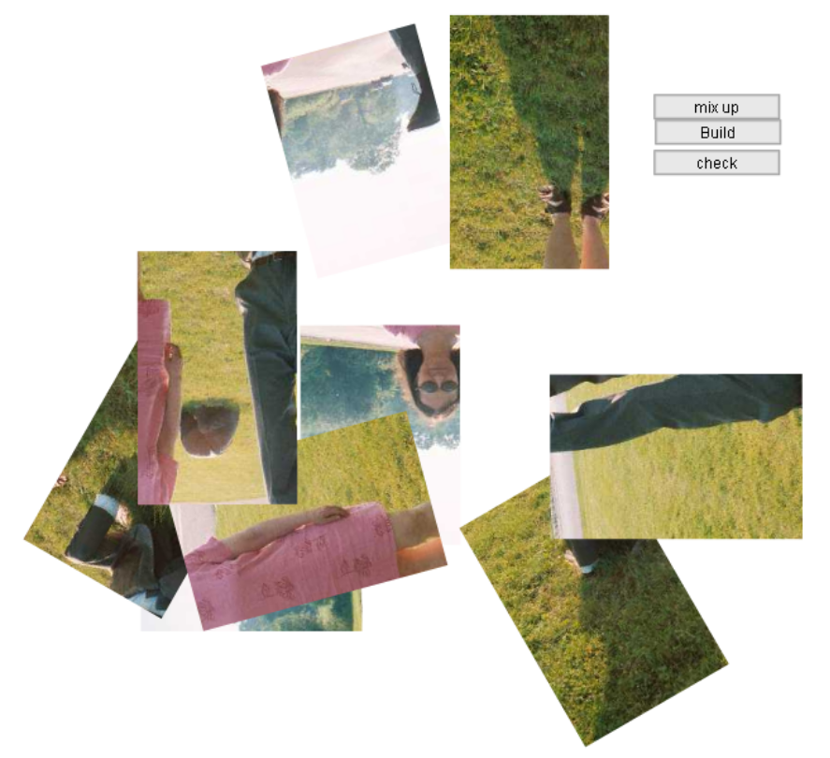
The player clicks buttons to mix up the pieces, show the puzzle put-together probably (via the build button), and check that the puzzle is put together correctly. The player uses the mouse to drag pieces to re-arrange them. Arrow keys (indicated by a text message erased as soon as the mix up button is clicked) are used to rotate pieces.

Version II: after clicking the Play button.

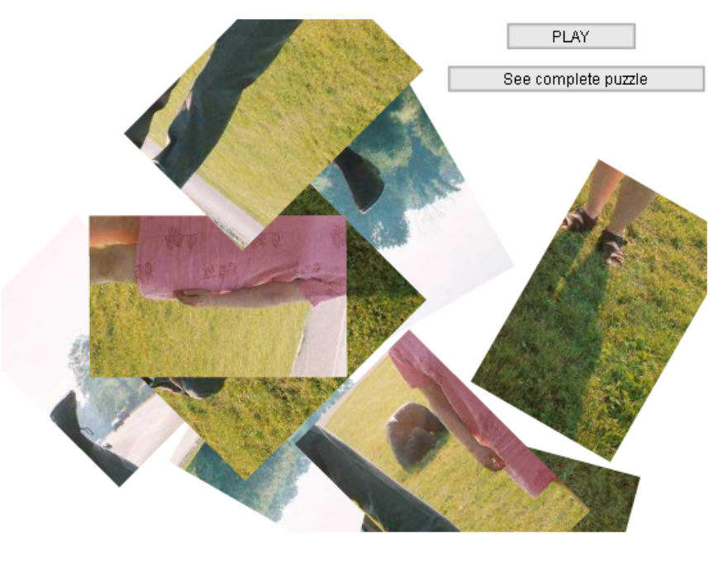
In addition to the cosmetic differences (the button labels are more player oriented), in this version, the condition of the puzzle pieces is checked after each piece is moved. No message appears until the puzzle is complete at which time "Good Job" appears in a text field.

Critical features
The implementation requires the following steps and features:
- acquisition of the image and slicing up of the image into pieces. Each piece will be its own movie clip symbol in the library and will hold information in frame variables to indicate the proper (nominal) location of this piece in terms of the other pieces.
- mixing up of the puzzle pieces in a random fashion, both with respect to x and y position and rotation. This will be done using the usual Math.floor and Math.random methods.
- providing ways for the player to interact with the system. Pushbutton components are used to play (and replay) via the mix up button; show a finished puzzle via the build button; and check the work via the check button. Players move pieces by dragging. Listener objects are created: one for the onMouseDown and onMouseUp events and one for the onKeyDown event.

Implementation of Version I

The jigsaw puzzle consists of a main movie with timeline one frame and one layer and instances of movie clip symbols in the Library for each of the 9 pieces of this particular puzzle. The creation of the piece symbols is done using what I call a base symbol holding the complete image. The creation of the puzzle pieces, namely the slicing up of the original picture, is the most challenging part. This slicing pattern can be more intricate than the rectangular one shown here.

The first step is to Insert/New Symbol to create a movie clip symbol called base. The graphic material is a whole image. I used Paint Shop Pro (Photo Shop would have served as well) and selected and copied the image for the complete drawing. Returning to Flash, click on Edit/Paste to acquire the image as a bitmap. To change the bitmap to graphics that can be modified, use Modify/Break Apart to produce a set of pixels from the intact bitmap. Note: I needed to repeat this step for it to work: Modify/Break Apart, select image, and then Modify/Break Apart. I then used the line tool to produce lines dividing the whole image into pieces.
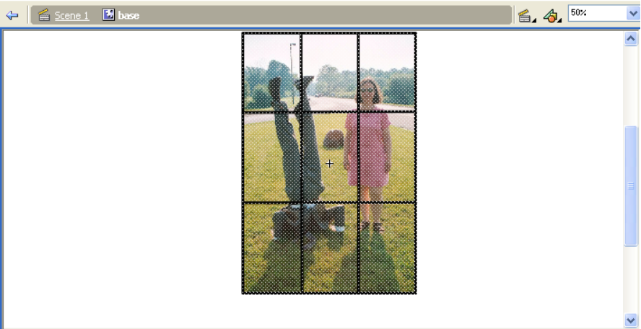

You can use the pencil or pen tool to create a more intricate pattern for dividing up the image into pieces. After marking up the base as indicated, you need to determine the relative location for each piece.

NOTE: an improved way to determine the offset values is given at the end of this tutorial.

One way to do this is to go back to the base symbol and select the area corresponding to each piece and note the x and y values in the Property panel. In the screen shot shown, the upper right piece has been selected and the x and y values are 127.9 and -200.1, respectively. Make note of these values. 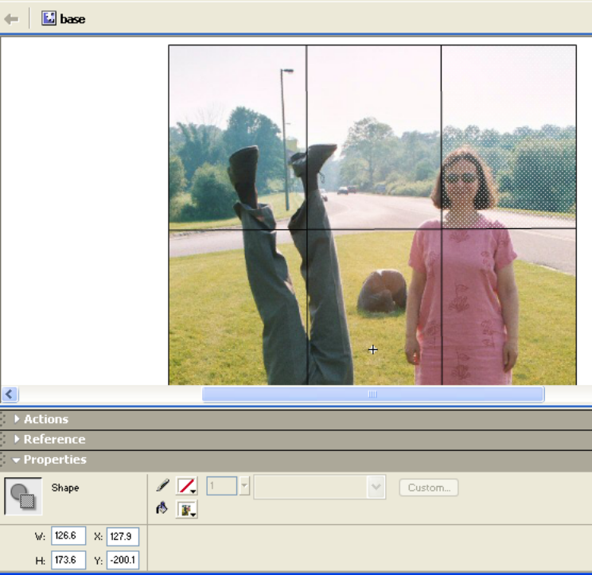
This process is not exact. You may need to adjust some of the values to make the puzzle better fit together.
Now, duplicate the base symbol for each piece. For example, duplicate it and name the new symbol "piece1". In the frame code for this piece, enter
var offsetx = 127.9;
var offsety = -200.1;

Now, returning to the Stage for the piece instance, erase all the material except the piece itself. Do this by selecting and moving the piece away from everything else and then select (using the standard selection tool: the pointer) and delete everything else. Lastly, move the piece to position 0,0 using the Info panel. Moving each piece to 0,0; that is, centering the piece on its registration point, makes rotating the piece more what a player would expect. The results of these operations for piece3 are shown in the screen shot:
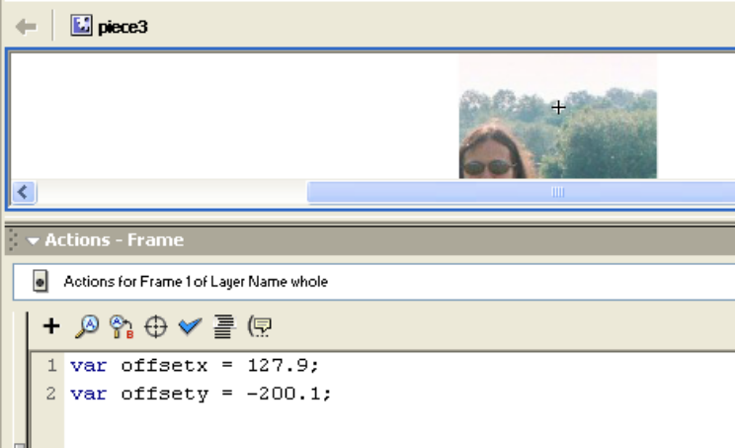
You need to do this for all of the pieces. You then make (move) instances of each piece to the stage, naming the instances piece1, piece2, etc. A way to correct the offsets, if necessary, is indicated later in the description of the check function.

You need to establish the event handling for mouse events and key events. Our approach is to create listener objects. These are abstract objects (no graphical material) that are just for event handling. It is not strictly necessary, but to organize the code better, you can add a new layer, name it listeners, and put the listener related code there.

For mouse event handling, create a listener object that checks which object is under the mouse and takes the appropriate action. The code sets up an object using a var statement, then defines a function for the event. This function has code the loops through each of the pieces to determine which one is under the mouse. Notice how the np variable holds a string that is the name of each piece in turn. Once the code makes this determination, that piece is set up for dragging. Lastly, it is necessary to register the listener object with the Mouse object. This is done using the addListener method.

var mouseListener = new Object();
mouseListener.onMouseDown = function() {
var found = false;
var np;
var i;
for (i=1; i<=numpieces; i++) {
np = "piece"+i;
found=_root[np].hitTest(_root._xmouse,_root._ymouse, true);
if (found) {
_root[np].startDrag(false);
i = numpieces; //force exit of loop
} // ends if found
} // ends i loop
}; // ends definition of function
mouseListener.onMouseUp = function() {
stopDrag();
};
Mouse.addListener(mouseListener);

The true argument in the call to the hitTest method checks the mouse coordinates against the material of the piece, not just the bounding rectangle, so you can use this for jigsaw pieces with irregular shapes.

The stopDrag() function turns off any (and all) dragging operations.

The approach for key event handling is the same: define a listener object, define a function, and then register this listener with the Key object. The function will include similar code to what was done for Mouse events: determine which piece is under the mouse and adjust the rotation of that piece according to which arrow key (right or left) was pressed.

var keyListener = new Object();
keyListener.onKeyDown = function() {
var found = false;
var np;
var i;
for (i=1; i<=numpieces; i++) {
np = "piece"+i;
found=_root[np].hitTest(_root._xmouse,_root._ymouse, true);
if (found) {
if (Key.isDown(Key.RIGHT)) {
_root[np]._rotation += rinc;
}
if (Key.isDown(Key.LEFT)) {
_root[np]._rotation += -rinc;
}
i = numpieces; //force exit of loop
}// ends if found
} // ends i loop
}; // ends definition of function
Key.addListener(keyListener);

If the right key is down, then the rotation of this instance is increased by rinc, to be set (see below) to be 15 degrees. If the left key is down, then the rotation of this instance is decreased by 15 degrees. Of course, you can change rinc to some other value.

Note: the original way I coded this application was to place code 'in' the pieces for onClipEvent(mouseDown), onClipEvent(MouseUp) and onClipEvent(keyDown). The procedural approach is somewhat more efficient since even though it does loop through each of the pieces, on average it would only check half the pieces and not every single one.

Click on the original layer. The stage now has the piece instances. Add two dynamic text fields: one called instructions and the other result. The instructions field has an initial value as shown in the screen shot. This field is made dynamic so it can be erased.
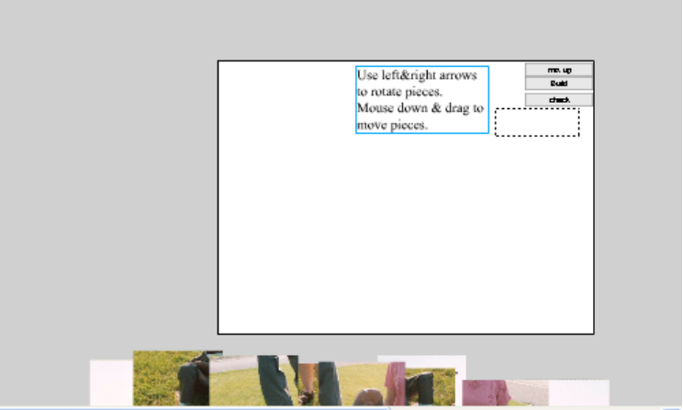

Flash MX:
The three buttons are implemented using the PushButton component. Components are features of Flash MX that simplify the programming process. Making sure the component panel is open, click on the button and drag to position an instance on the stage. You now can set the label and the click handler. The screen shot shows the label and click handler for the check button. The settings for the other buttons are mix up and mixup and Build and build. The next step is to define these three functions by putting code in the [single] frame for the main movie.

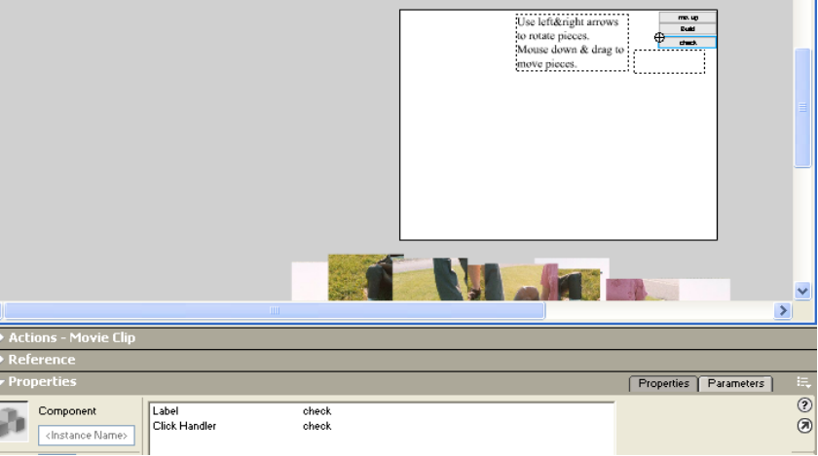

Flash 8:
The components in Flash 8 provide somewhat different functionality than in MX. Specifically, you need to use procedural code to specify what function is to be called when a button event, such as onRelease, happens. This does make the components less useful (in my opinion). So, create buttons any way you want. Make sure the label says what you want it to say. Then give each button an instance name. Let’s say the instance name is mixupbut. In the Actions panel for the first frame, write

mixupbut.onRelease = mixup;

This means the function called mixup will be called when the mixupbut is clicked on (mouse down and then released). You need to keep in mind the following distinct things:
- a button in the library
- a button instance on the Stage with instance name mixupbut
- the label for the button, which may be the phrase “mix up”
- a function called mixup, that has the code that does the work.

The frame code requires three global variables (variables outside any function and accessible by all functions). These three variables are really constants:

var numpieces = 9; //number of pieces
var rinc = 15; //amount of degrees rotated
var rinclimit = 24; // 360/15, for calculation on rotation

Each of the three functions performs operations on each piece. This is done using a for loop and constructing the instance name of the piece by concatenating "piece" and the value of the loop variable i converted to a string. This instance name can then be used as an index to _root[ ] to get at the instance.

The build function positions each piece using the offsetx and offsety values stored in the frame for each piece. This could result in the built puzzle being off-screen. The values 130 and 205 (they could each be slightly less) make sure the puzzle is fully visible. YOU MAY NEED TO CHANGE THESE.

function build() {
for (i=1; i<=numpieces; i++) {
np = "piece"+i;
_root[np]._x = _root[np].offsetx+130;
_root[np]._y = _root[np].offsety+205;
_root[np]._rotation = 0;
}
}

The mixup function makes the instructions and result text fields empty, effectively erasing them. Next, it positions each piece instance randomly on the screen and with a random rotation. The rotations are done in discrete amounts (15 degrees).

function mixup() {
instructions="";
result="";
for (i=1;i<=numpieces; i++) {
np = "piece"+i;
_root[np]._x = Math.floor(Math.random()*500);
_root[np]._y = Math.floor(Math.random()*400);
rot = Math.floor(Math.random()*rinclimit)*rinc;
_root[np]._rotation = rot;
}
}

The 500 and 400 are to make sure the pieces are visible. YOU MAY NEED TO CHANGE THESE.

The check function examines the relationship of each piece to the piece1. The idea here is that the player can locate the finished puzzle anywhere on the screen, so your code must check relative positions, not absolute positions. Any piece, not just piece1, could have been picked for this check. The requirement is that the x distance and the y distance must each be close to the differences between the offsetx variables and the offsety variables. The tolerance of 20 chosen here is fairly arbitrary. You can experiment with other values. The oksofar variable is what is called a flag. It is initialized as true. If it is ever set to false, then the code inserts the bad result ("Keep working.") in the result text field. If it remains true, then the code inserts the successful phrase ("Good job!") in the result text field.

function check() {
var tolerance = 20;
var oksofar = true;
result = "";
for (i=2;i<=numpieces; i++) {
np = "piece"+i;
diffx0 = _root["piece1"].offsetx - _root[np].offsetx;
diffy0 = _root["piece1"].offsety - _root[np].offsety;
diffx = _root["piece1"]._x - _root[np]._x;
diffy = _root["piece1"]._y - _root[np]._y;
if (Math.abs(diffx-diffx0)>tolerance || Math.abs(diffy-diffy0)>tolerance)
{oksofar = false;}
}
if (oksofar) {
result = "Good job!";}
else {
result = "Keep working.";}
}

The code just given is the correct definition of the check function. However, in order to confirm or correct the offsets, modify the for-loop control statement and the start of the for-loop as follows:

for (i=1;i<=numpieces; i++) {
np = "piece"+i;
trace("piece "+i+" x is "+ _root[np]._x);
trace("piece "+i+" y is "+ _root[np]._y);
…

Now, run the example. Click on the build button. If the puzzle is not perfectly put together in your estimation, use dragging to improve it. Then click on the check button. The trace statements will show the positions of each of the pieces (adjusting for any corrections you placed in the build function to make sure the image is all on-screen). Put these values into the offset variables of each piece. Then restore the check code to its proper form (change the for-loop to start at 2 and remove the trace statements).

Implementation of Version II
Version II is built from Version I by changing the labels for two of the buttons, moving or deleting the check button, changing the check function and arranging for the check function to be called whenever a piece is moved.

You change the label for a button by clicking on the button, and changing the component properties. The screen shot shows the new settings for the button had the label "mix up". Note that the click handler remains the function mixup.
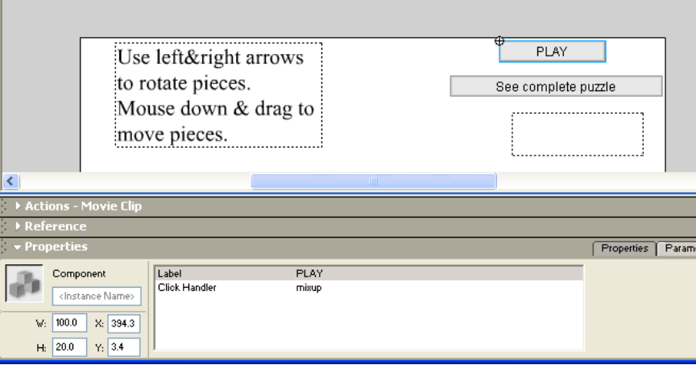

The check function is changed so it only changes the result text field when the puzzle is complete. The player is not told to "Keep working", which is appropriate since in this version, the player did not claim to be finished. The else clause after the if (oksofar) is removed.
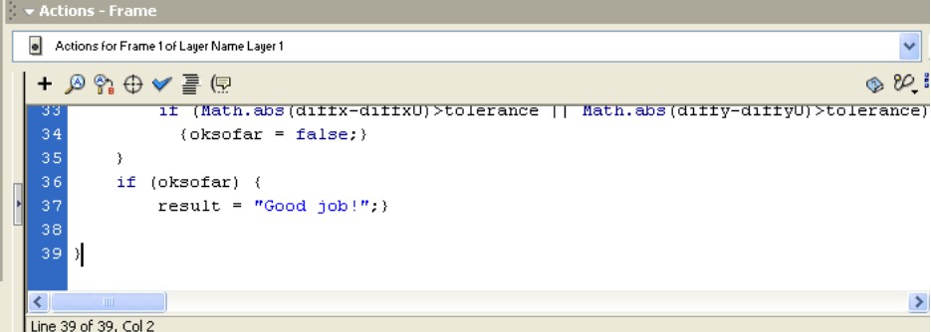

Lastly, you must invoke the check function. Go back to the listener layer and add one statement to the onMouseUp function before (or after) the stopdrag();

_root.check();

Yet another version of the puzzle would be to omit checking and building altogether. This would mean that you would not need to have the offsetx and offsety variables in each piece. My inclination is to have both checking and building. The usual practice in computer games is to give feedback to the player.

Get a simple example working and then try for a more intricate slicing up of the whole image. Here is the (sliced up) base symbol for another puzzle. The lines were done using the pencil tool with the smooth setting and the straight line tool for the borders.
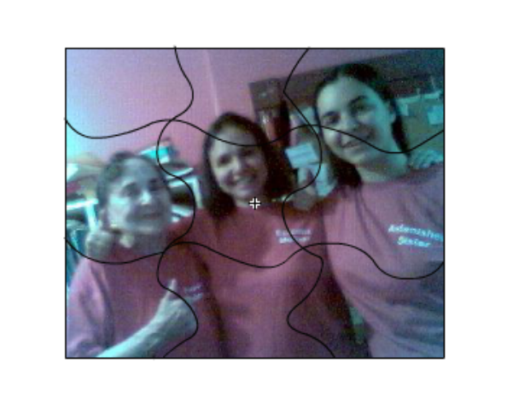
Note: this new puzzle was implemented by changing the piece symbol definitions in the Library and making minor adjustments to the build function. Of course, if and when you build a puzzle with a number of pieces other than 9, you will need to create more piece symbols, move instances of them to the stage, and change the numpieces variable. Enjoy.

Improved way to determine offsets

- After pasting the original complete image into the base symbol (and using modify/break apart 2 times), select and move the entire image to be over and below the registration point. This means you will not have to add in values to ensure that the build function places the puzzle on the visible stage.
- Draw lines cutting up the image into pieces.
- Make sure the Info Panel is visible. Click on the center square in the Info panel so that positions are determined with respect to the center of pieces, not the upper left corner.
- For each piece, select the piece in the base, and copy.
- Create a new symbol, naming it piece1, piece2, etc.
- Paste in place the part selected and copied from the base.
- Copy down the x and y positions as given in the Property panel and the Info panel. Then change these to 0.0 and 0.0. This will move the registration point to a point close to the center of the piece.
- Use the copied values in the var offsetx = and var offsety = statements.
- Move an instance of each piece to the Stage and name it piece1, piece2,….
- It will not be necessary to add numbers in the build function.

