Flash Tutorial: preloader
You have probably seen a Flash application that had an animated display indicating that the application was loading. This is done both to occupy the viewer while a large file is being downloaded and to prevent the viewer, perhaps a game player, from starting the game before all parts are loaded. This tutorial shows how to add a preloader to an application you have already made.

Start a new Flash project. Make two layers: name one actions and the other loader. The animated display for this example will be the word Loading followed by a changing number of periods. In the first frame, loader layer, create a static text field with the string Loading. Insert a new keyframe, and add to the text field a single period. Repeat this a few more times (say, 4 times in all). NOTE: after you understand the ideas of making a pre-loader, you can put in other material. Of course, you want to avoid putting so much graphics into the pre-loader that your viewer needs to wait for it to load!

Go back to the first frame. Click on the actions layer. In the Actions panel, enter the code:

ifFrameLoaded ("end") {
gotoAndPlay ("start");
}

The labels "end" and "start" have not been assigned yet because the corresponding frames do not exist. They will be the first and last frame of your application.

Add a new keyframe to the actions layer on top of the last keyframe of the loader layer. In this keyframe, use the Actions panel to enter the code:

goToAndPlay(1);

This is the preloading animation: Flash will loop over these 5 frames until the ifFrameLoaded test is satisfied. The screen shot shows the timeline, part of the stage and the Actions panel, for the 5th frame.

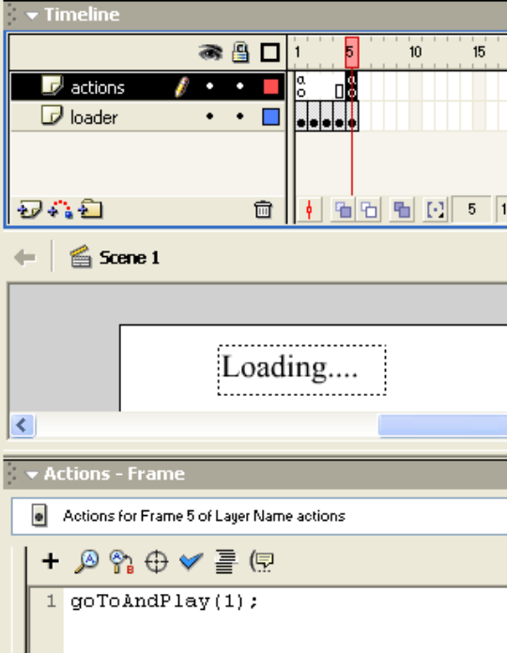

Save this Flash document using a name such as loader. You may want to use it with multiple applications. To make sure you don't over-write this base application, save the document again, this time with a name specific to your application. In the case described here, it will be puzzle3loader.

Add a new layer to loader application: call it board. This, as with the common practice of defining distinct layers for actions and for graphical material, is not strictly necessary, but simply a way to keep things organized.

Now, open up the application to which you want to add a pre-loader. (Of course, if you had planned on creating a pre-loader from the start, you would now start work on your application. This assumes that your application is written, debugged, and you have decided to add a pre-loader because you feel the need to entertain your audience while the application is loading.) Copy and paste the frames and layers from the original application to the loader application starting with frame 6. You will need to copy and paste-in-place the contents on the stage and the code in the Actions panel. When you do this, any symbols in the symbol library will be copied to the library of the new project.

Label frame 6 "start" and label the last frame "end". If there is only one frame (as is not uncommon with games), add one more frame and label it "end". In this case, you will need to add a stop(); to the actions layer, start frame.

IMPORTANT: If any of the coding uses 1 to refer to the first frame of the application, you will need to change the code! Use the label "start" instead.

The screen shot shows the puzzle3loader, with the contents of the start frame, that is, the first frame of the original application. It also shows the code, with the stop(); statement.

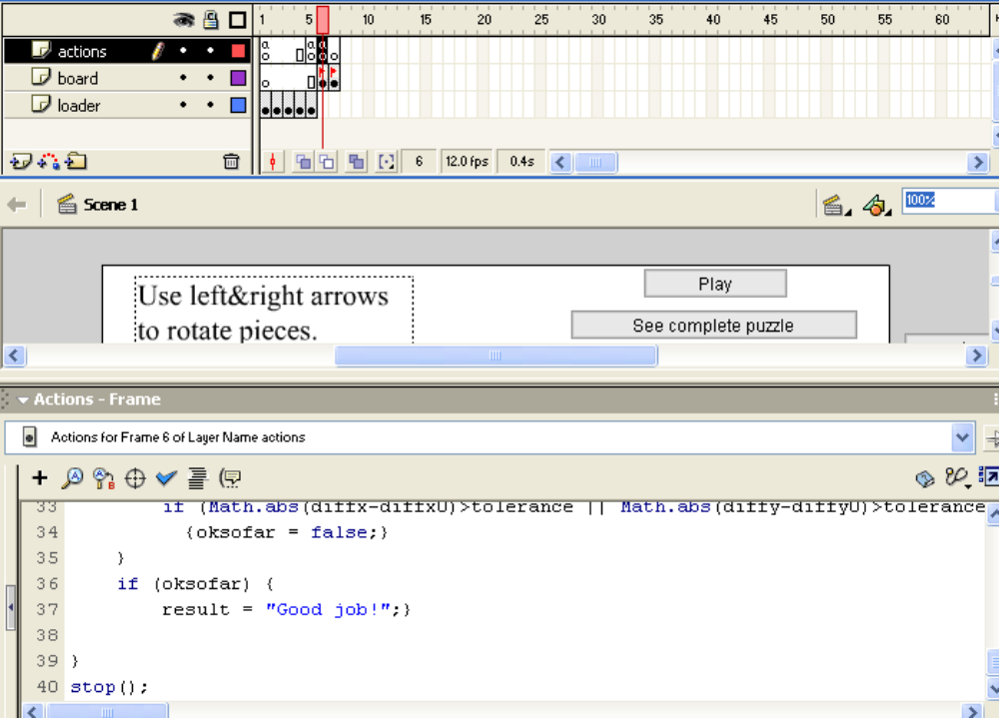

Now, you may wonder why I haven't suggested that you test the application using the drop-down Control/Test command. The problem is that it is not possible to have a meaningful test until you are actually downloading the application over a communications line. You need to Publish the application, upload html and swf files to your web site and then test the application. Depending on the speed of your connection, you will see

Loading

Loading.

Loading..

Loading…

This may repeat. It did not for my DSL connection and relatively small puzzle application. The puzzle application then appears. Do this for your application. You need to check that it works as planned.

