Flash tutorial: articulated (jointed) movement

This tutorial describes a very simple application in which an arm-like graphical object is moved in three ways:
- translated horizontally and vertically
- rotated at the 'shoulder'
- rotated at the 'elbow'

The moves are initiated by the 'player' by clicking on buttons. The amount of movement is controlled by input text fields. The main lesson is to show how the arm is constructed: two instances named upper and lower and how movement changes both instances. Students/readers can take this application and use it as a basis for a more elaborate project.

The screen shot shows the application. Note that each movement (both the translation moves and the bend moves) are relative or incremental from the current position: -45 indicates move -45 degrees from current orientation.
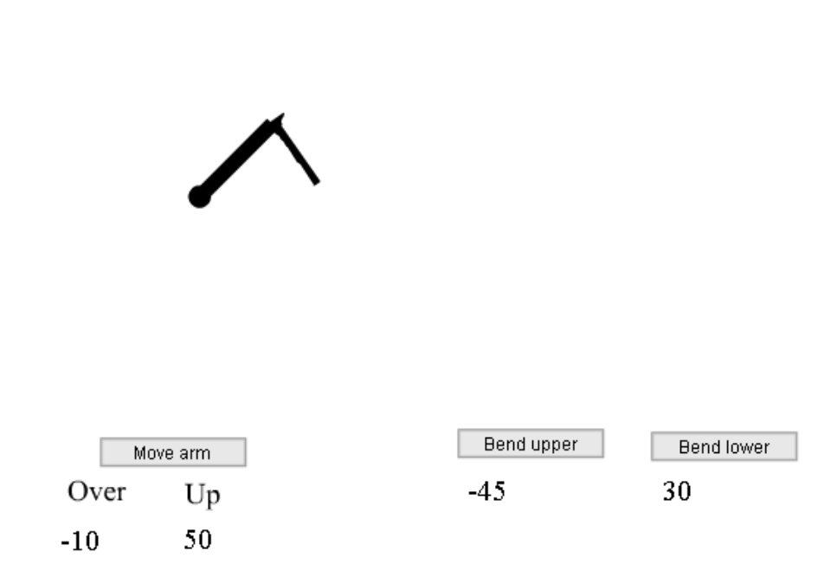

Critical features

- The arm is to be what is called an articulated or jointed structure. This is implemented by making it two instances. The code will make sure that the two instances remain connected.
- The joint action is to consist of rotation at the shoulder and the elbow. When the shoulder rotates, the upper arm must rotate and the lower arm must be carried along. The code does this using trig functions: to compute the _rotation attributes and, also, to compute the position of the tip of the upper limb so the lower limb is positioned correctly.

Implementation

Create movie clip symbols representing the upper arm and the lower arm. Bring each onto the stage and name the instances upper and lower. Make sure the registration point of each one is at the left end. The initial orientation of each is horizontal.

Create 4 input text fields on the stage. Name them xm, ym, angleu, and anglel. These will hold the amounts indicated by the player. It is best to place initial values in the boxes. The values indicated here are 100, 100, 10 and 10. The units are pixels for the first two and degrees for the last two. Create two static text fields: one above xm and one above ym and type in the text Over and Up, respectively. You will note that the code makes the sign change so the a value in ym of 100 is changed to -100 to cause the arm to be moved up the screen.

Bring three PushButton components to the stage. Change the labels appropriately (see screen shot above) and type in for the click handlers, rotateupper, rotatelower, and moveit. These are each the names of functions that will be defined as frame action code in the first (and only) frame. The screen shot shows the setting for the move arm button.
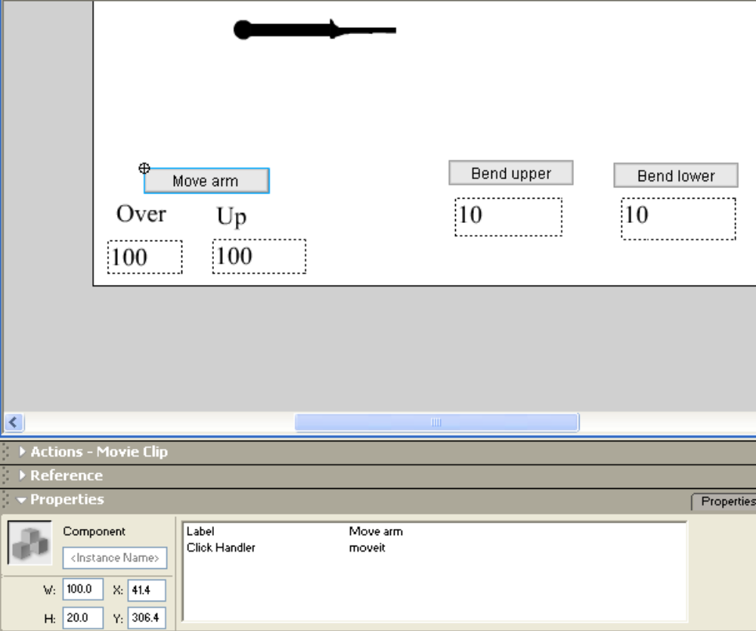

The next step is to define the functions. Select the first (and only) frame and open the Actions panel. Here are some general remarks about these functions and then the code with comments.

All the functions read in the values in the input text fields. The code here uses the parseInt function to convert the value to an integer from text. This may not be necessary: that is, ActionScript may do this conversion, also called a cast, automatically. However, since sometimes it is necessary, perhaps the player typed in a blank, for example, we recommend this step.

The task of rotating the upper joint means to rotate the upper instance and bring the lower along with it. This is implemented by doing the following steps:
- change the _rotation of the upper instance by the incremental amount in the input text field
- determine where this puts the end of the upper instance, which is now the desired position for the registration point for the lower instance
- move the lower instance to this position.

In anticipation of this calculation, type in the code that stores away the length of the upper instance:

var upperlength = _root.upper.width;

Consider the following diagram:

upperlength

angle A

The task is to compute the horizontal and vertical positions for the black circle, based on the length of the line, namely upperlength, and the angle A, where this is the angle from the horizontal. The computation uses the trig functions sine and cosine. More properly put, these are the definitions of sine and cosine.

upperlength

angle A
upperlength*sin(A)
upperlength*cos(A)

One required step is to convert the rotation as given in instance attributes from degrees to radians because the Math methods require radians.

The moveit function is to move (the term translate is used) the whole arm, that is, both parts, by the amounts indicated in the text fields. As indicated previously, the value in the text field named ym, under the label Up, is negated (sign change).

var upperlength = _root.upper._width; | save length of upper
function rotateupper() { | definition of rotateupper
var angle = parseInt(_root.angleu); | extract integer from text field
_root.upper._rotation +=angle; | increment rotation
var nangle = _root.upper._rotation; | extrace current rotation
var angler = nangle*Math.PI/180 | convert to radians
var endx = _root.upper._x + upperlength*Math.cos(angler); | calculate horizontal position of end point
var endy = _root.upper._y +upperlength*Math.sin(angler); | calculate vertical position of end point
_root.lower._x = endx; | change x value of lower
_root.lower._y = endy; | change y value of lower
_root.lower._rotation += angle; | rotate lower incrementally by same amount
}
function rotatelower() { | definition of rotatelower
_root.lower._rotation += parseInt(anglel); | extract integer from text field and use it to modify lower rotation incrementally
}
function moveit () { | definition of moveit
var xm = parseInt(_root.xm); | extrace horizontal value
var ym = -parseInt(_root.ym); | extract vertical value, changing sign
_root.upper._x += xm; | change x value of upper incrementally
_root.lower._x += xm; | change x value of lower incrementally
_root.upper._y += ym; | change y value of upper incrementally
_root.lower._y += ym; | change y value of lower incrementally.
}

Now, what if the problem required the original position of the arm to be vertical?
You would need to apply similar formulas, but based on the following diagram:

upperlength*sin(A)
upperlength*cos(A)
upperlength

In this situation, the horizontal displacement from the origin of the line will be upperlength*sin(A) and the vertical displacement will be by upperlength*cos(A).

