Psychic Flash Movie

This Flash example was suggested by a friend. A quick google search led me to http://www.cyberglass.biz/FlashEx/mindreader.html authored by Andy Naughton. This tutorial describes my implementation.

The game asks the player to think of a two digit number, add the digits, subtract the total from the original number to get a final result. The player then looks up a symbol in a table, thinks of the symbol while gazing at ball on the screen, and pushes a button. The symbol appears in the middle of the ball. The game is based on a mathematical trick and a subtle, but typical use of images. Any two digit number can be expressed as

a * 10 + b

where a is an integer from 1 to 9 and b is an integer from 1 to 9. The result of the operation is

(a*10 + b) – (a +b)

which is

a*9

In the table of numbers and symbols, all multiples of 9 from 9 to 81 indicate the same symbol. The table is recreated with new, random-appearing values each time to make this less noticeable. The table contains entries from 99 on down to zero.

Requirements for the game

For this game, you need to use ActionScript and Flash for the following features.
- Create a set of possible table entries, with a place for the number and place for a symbol. We will make both of these be dynamic text fields. The number of possible symbols is somewhat arbitrary. We choose 13. (See note below concerning fonts.)
- Write code to generate the table of entries, randomly choosing from among the possible table entries
- Make sure the symbol fields for the multiples of 9 (0 to 81) are all the same
- Create buttons with button action to show the symbol emerging and to return to replay the game.
- Create the graphics on the timeline for the symbol to appear 'on' or 'in' a crystal ball like graphic.

Production plan

Create 13 (or so) movie clip symbols, named seed0, seed1, etc. Each will consist of 2 dynamic text fields. The first text field should have the variable name numberplace and the second text field, the variable name symbol. Put a variety of symbols into the symbol text field. Notice that I used the Ariel font. See note at the end of the tutorial. The numberplace text field is set with 99, but this will be changed.

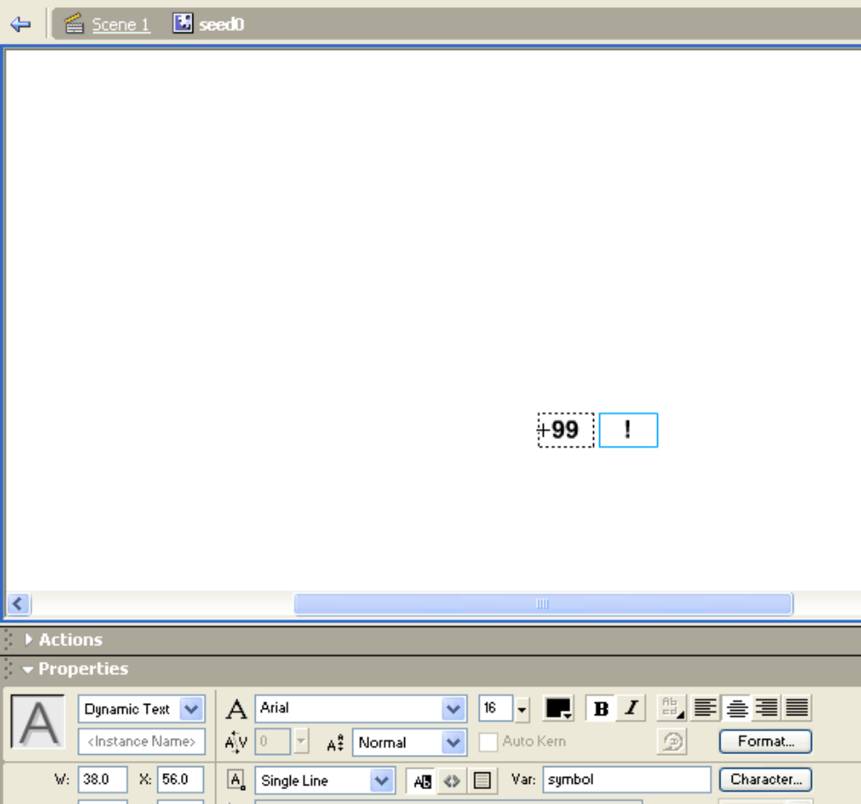

The numberplace contents in the instances of this symbol will be replaced by the appropriate number. The symbol field has a name because the code will need to reference the choice made for the multiples of nine. The variable ns holds the number of possible seeds.

Rename the first (original) layer board, and add two more layers naming them action and labels. After creating the seed symbols in the Library, move instances of them to off stage, in frame 1, board layer. Give each an instance name: seed0, seed1, etc.

The next step is to write the code to generate the table. It will use the Math.random function to make a choice and then the duplicateMovieClip function to produce a new instance of that item. Actually, the choice for the multiples of 9 is made first, stored in the variable choice9. Nested for-loops are used to create the items, using choice9 or a new random calculation. In either case, the seed instance to be duplicated is stored in the variable choice. The numberplace value must be changed from the original 99. The code must position the new instance to make a neat table: 5 columns of 20 rows. The nested for-loops do the columns and the rows within the columns.

Because we want the table to disappear and also want the instances to go away so we can begin again, we 'save' the names of the created instances in an array named tableitems. This array is done used to produce parameters for the removeMovieClip function.

The code sets a dynamic text field named hidden to hold the multiple of 9 symbol value. This text field is underneath a movie clip named clouds. The _alpha property of clouds will be gradually changed to make it transparent.

Keep in mind that the first frame is what players see initially and what they see after choosing to play again. This means that the code must reset certain things. In particular, a new table will be created each time the movie goes to frame 1.

The board layer, besides holding the seed instances, should contain
- one static text field with the instructions. My example includes another static text field containing a reference to an on-line Flash movie used as a model.
- 3 movie clip symbols: a ball shaped clip named crystal, a dynamic text field named hidden, and a blobby shaped movie clip named clouds.
- a button

Here is a screen capture:

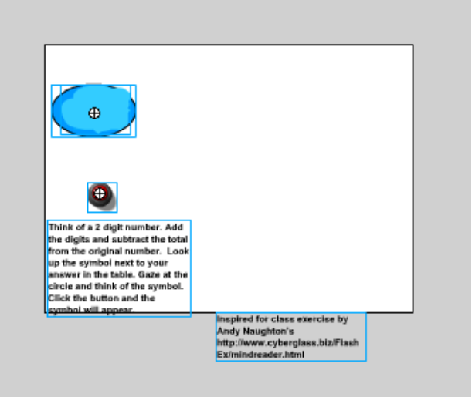

NOTE: I rearranged the board so that the reference to the Andy Naughton's site is visible in the published version. The development field of view is larger than the published field of view and you may need to rearrange things. It appears to be smaller even than the white rectangle.

The button was from the Common Library.

As has been our practice, most of the code goes in the actions layer, frame 1. Here it is:

var ns = 13; | fixed at number of seeds
var tableitems = new Array(); | will hold names of all the created table items
function buildtable() { | Function called to build the table
clouds._alpha=100; | reset clouds to be fully opaque
var r; | used for counting rows
var c; | counting columns
var cury; | current x position
var curx; | current y position
var ncols = 5; | number of columns
var nrows = 20; | number of rows
var origx = 200; | starting position in x
var origy = 8; | starting position in y
cury = origy; | start off current x
curx = origx; | start off current y
var deltax = 66; | the change in x from column to column
var deltay = 20; | the change in y from column to column
var depth = 0; | required for duplicating instances to keep distinct levels
var count = 99; | initial number value for table
choice9 = "seed"+Math.floor(Math.random()*ns); | Make choice for multiples of 9
hidden = _root[choice9].symbol; | Set the hidden text field to hold this symbol.
for (c=0;c<ncols;c++) { | Outermost loop, for the columns
for (r=0;r<nrows;r++){ | Inner loop for the rows
if ((count%9==0) && (count<90) && (count>0)) { | Is this one of the special multiples of 9
choice = choice9;} | … make the choice the preselected choice9
else { | or
choice = "seed"+Math.floor(Math.random()*ns); | make a new random choice
}
iname = "t"+count; | create name for this instance
duplicateMovieClip(choice,iname,depth); | create the new instance (a copy of the appropriate seed). The depth argument is the level, which must be unique
tableitems.push(iname); | add to the table of saved names
_root[iname].numberplace=count; | Insert the right number value
_root[iname]._x = curx; | position at the current x
_root[iname]._y = cury; | position at the current y
count--; depth++; | decrement count and increment depth
cury+= deltay; | move to the next row
} | end loop down the column
cury = origy; | reset to the original y, to start next column
curx += deltax; | set to the x position for the next column
} | end loop over columns
} | end function
function removeitems() { | function to remove table items
var i; | local variable
for (i=0;i<tableitems.length;i++) { | for loop going through the array
removeMovieClip(tableitems[i]);} | remove this instance
} | end function
buildtable(); | Call function to build the table
stop(); | Stop Flash from advancing.

The timeline is set up as follows:
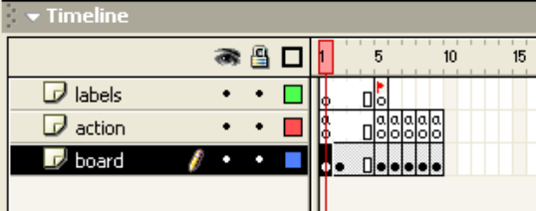

The labeled frame, named 'magic' starts a sequence in which the clouds movie clip fades to transparent. The code in the action layer of this frame removes all the table items. The successive ActionScript in the frames after magic change the clouds._alpha values. The last frame also contains a stop().

The button action in the first frame is to gotoAndPlay("magic");

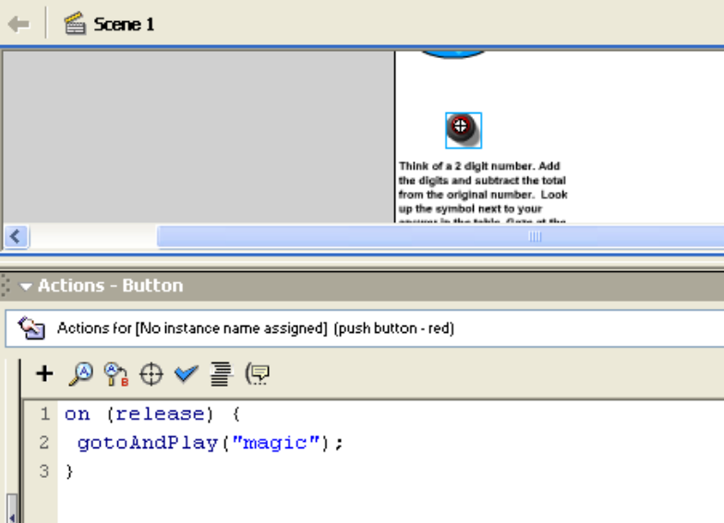

The magic frame, action layer:
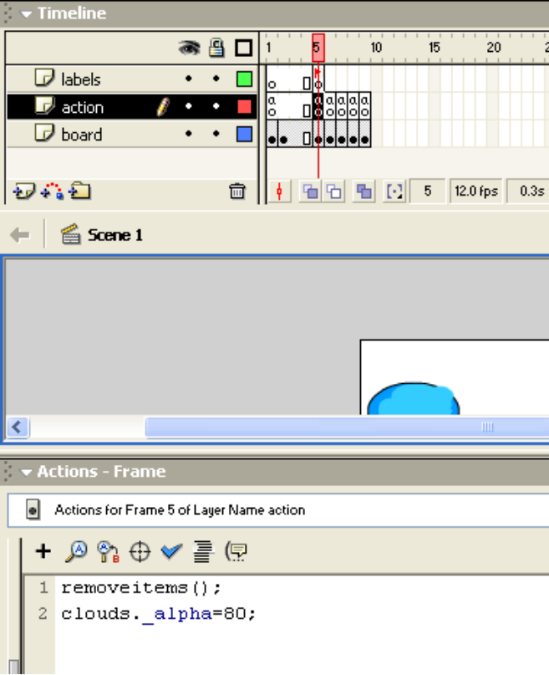

The board layer, frames from magic on is:
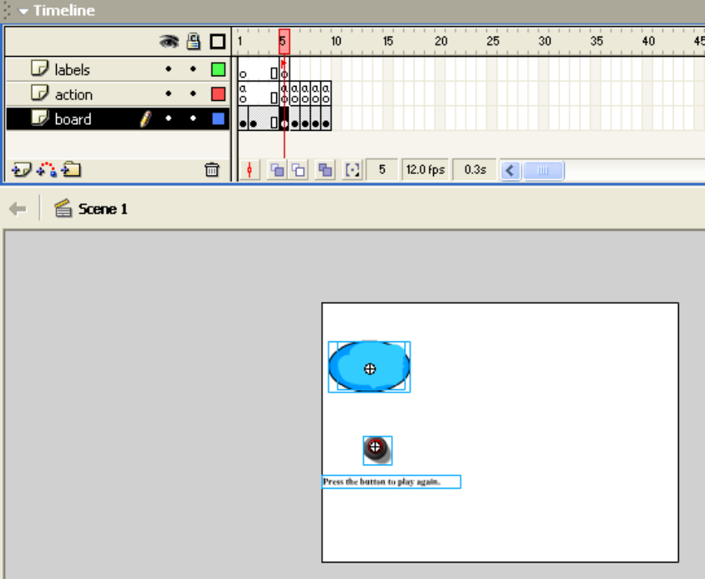

Notice the static text field has a new value. This is the contents of the board for the next several frames. However, during the running of the movie, your player will see the light blue clouds become transparent. The button action is to go back to the first frame.

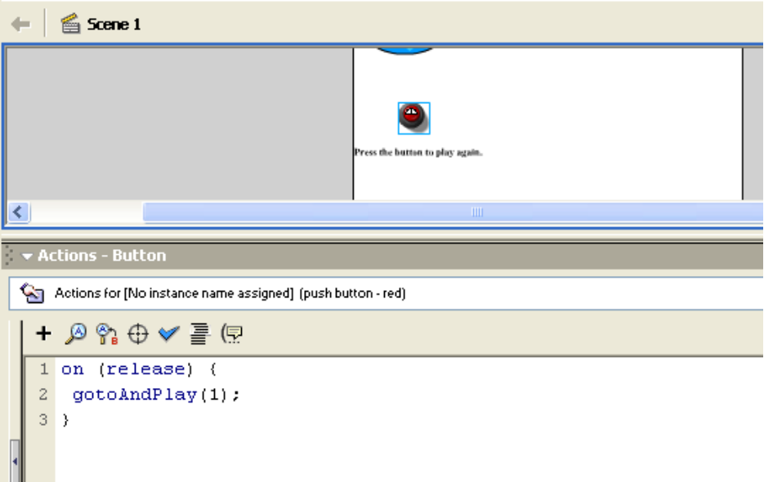

The code for each of frames after the magic frame is to change the _alpha of clouds. The value 100 represents solidly opaque and 0 represents fully transparent. For example, in the frame after magic,

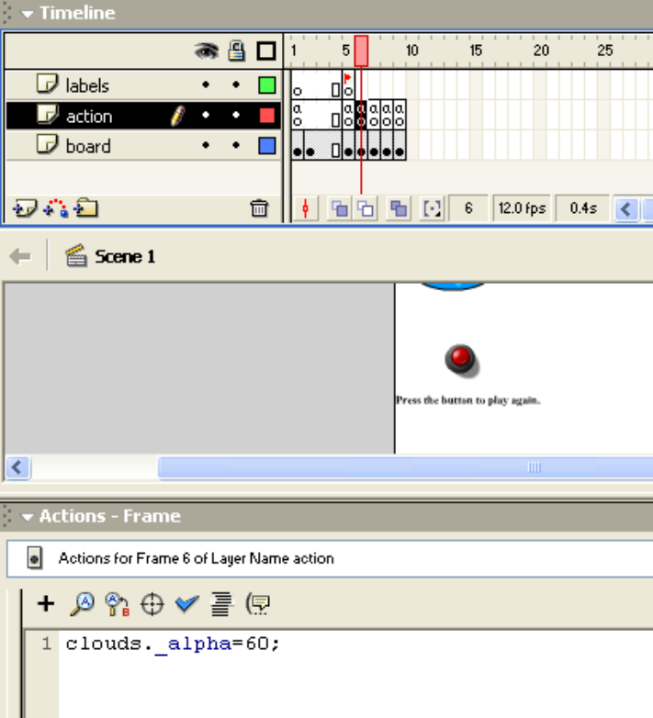

The last frame sets the _alpha to 0, or fully transparent and has a stop().
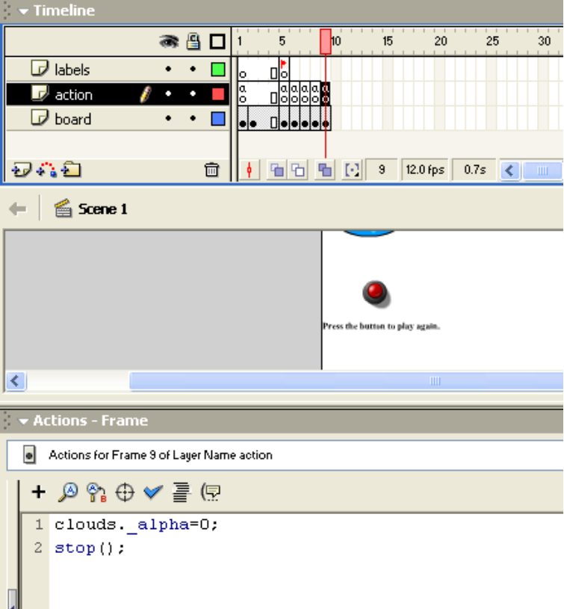

You can certainly make the crystal ball and the clouds more dramatic. One possibility is to use shape and/or motion tweening. Have fun!

Note: my original implementation used the wingding 2 fonts for the symbols. However, most of these symbols did not all appear when running the movie. The suggested tactic for making sure a font is available is to specify that the font be embedded. This did not work and my on-line research seems to indicate a known problem. I then chose to use the Ariel font, which is what you see.

