United States Geography Game: Tutorial

Inspired by Isaac Ohring last summer, I decided to learn (re-learn?) the capitals of the states. I quickly decided that I wanted to be able to list the states and came up with a scheme in which I grouped the states into regions. Next, I turned to the challenge of creating a Flash project incorporating different types of questions. The current version of the game has 7 choices for type of question, as shown in this the opening screen:

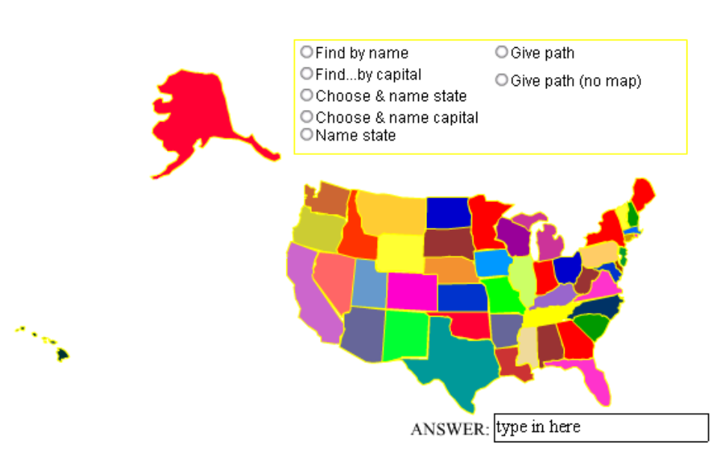

The best way to attempt this, and any other programming project, is to work incrementally. In this case, you can work on the questions one at a time or in even smaller steps. Each question requires code for asking the question and code for checking the answer. Code a little; test what you have done; code more; test the new part.

Returning to the description of the action, if the player selects Find by name, the following screen may appear (the state is chosen randomly):

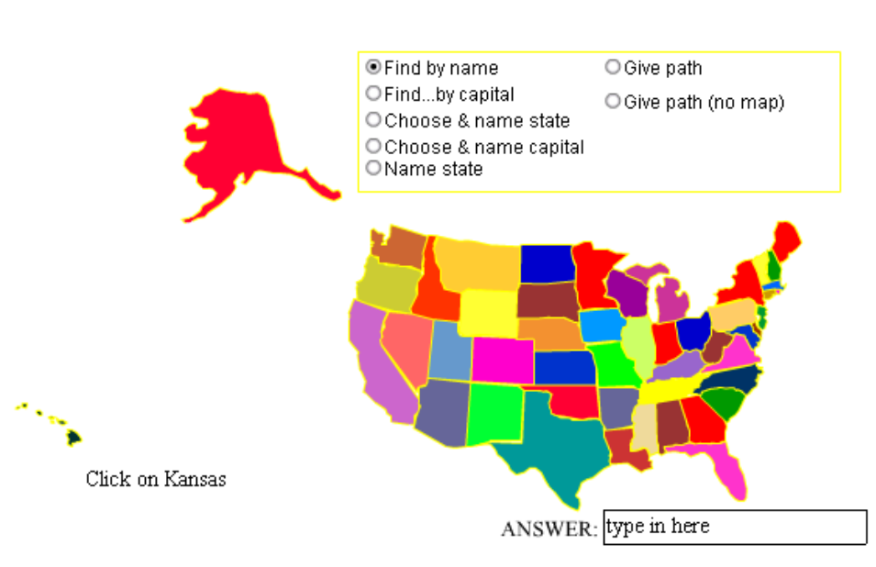

If the player correctly clicks on the Kansas (blue, in the center, above red Oklahoma, which is above teal Texas), the game responds by displaying CORRECT!!; otherwise it displays WRONG. The second type of question asks the player to click on the state with a specified capital. The next two options allow the player to choose their own questions. The third question asks the player to type in the name of a state and then click on the state and the fourth question asks the player to type in the name of a capital and then click on the state. The game will indicate if an answer was not the name of any state or any capital (respectively).

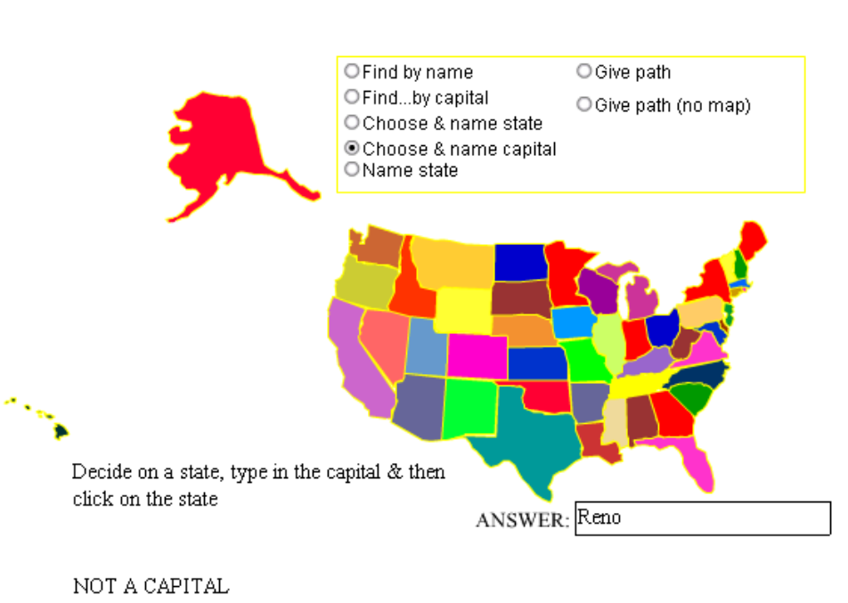

The fifth option makes one state disappear and then asks the player to identify the missing state by typing in the name and pressing the Enter key. The player can type in an 'X' to signal giving up.
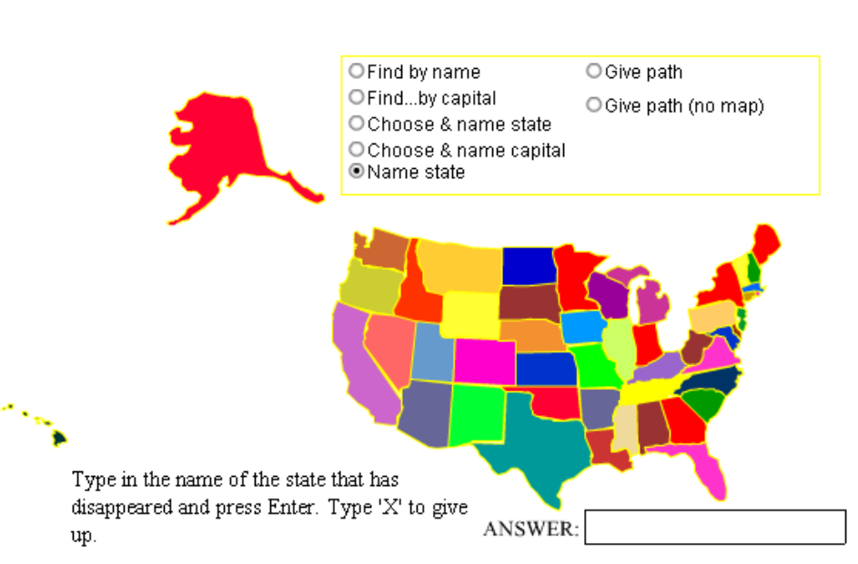

The path questions ask the player to identify the states connecting two states.
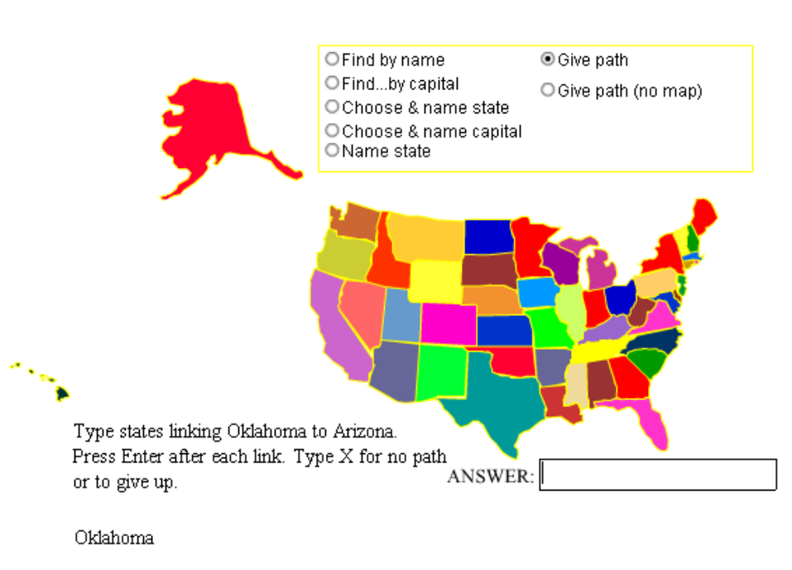

The player types in the linking states one by one. If a state is named that is not a neighbor of the prior state in the chain, the game issues an error message. Here is a screen shot of a successful answer for another asking of the question:
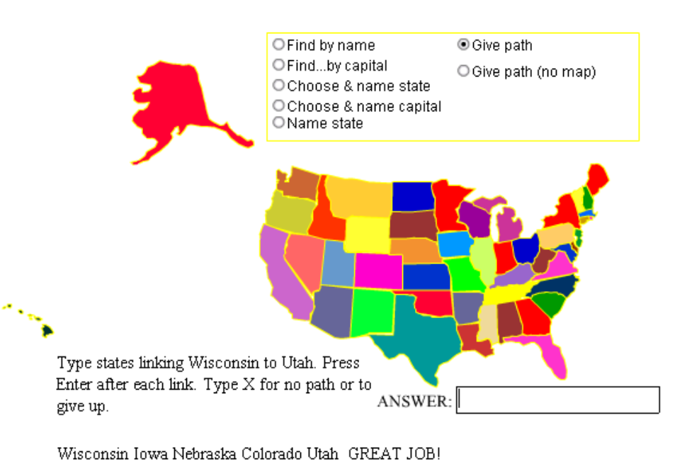

This part of the project required generation of code that indicated the neighbors of each state. As will be explained below, this code was produced by a program—not hand-coded.

Design & Programming Tasks

Challenge: Represent the states as Flash objects.
Strategy: Create movie clip symbols in the shape of each of the states and arrange them appropriately on the Stage.
Solution: The critical challenge here is drawing each state. Flash does have a facility to convert bitmapped graphics, but I worried that the resulting vector graphics would be too detailed and there was still the challenge of positioning each state relative to the other states. My approach was to copy a [bitmapped] graphic of the whole United States into one layer and trace the border of each state in turn into another layer. I would then delete the first layer. The positioning of each state turned out to be simple since all the states shared the same registration point so when I brought in instances of each of the state symbols, I positioned them at the same x and y coordinate.

Challenge: Create a facility for the player to choose the type of questions.
Strategy: Flash MX has components, including radio buttons.
Solution: The five options are specified as radio buttons, with a common group. The radio button component allows you to specify the change handler for each button. This would be the function that asks the question. Each radio button has its own data value. An event handler for MouseUp for an empty movie clip determines which question option has been set and based on it, invokes one of 5 functions for checking the answer.

Challenge: Represent the names of states and the names of capitals.
Strategy: In place of using a numbering scheme, my approach was to use the names of the states as the instance names and use internal arrays in the main movie as well as the individual state symbols.
Solution: The names of the state instances are the regular names, all lower case, with spaces removed. An array holds the [regular] names of the states in the main movie. Each symbol holds as ActionScript a variable with the statename and another variable with the capital. A function, called cleanname, produces the compressed form from the original name. To save executing time during the game, or, rather, to move a job to the start up time, a parallel array named cleannames holds the compressed form.

Challenge: Program the interactions.
Strategy: The player moves are choosing a question type by clicking on a radio button, responding to certain questions by clicking on a state, and entering data into the answer text field.
Solution: The invoking of the code for asking the question and, subsequently, for checking the question is specified in the properties of the radio buttons and the action of one event handler (for MouseUp) that checks the data value stored in the radio button. Responding to the player typing in a text answer is done by an event handler responding to KeyPress.

Challenge: Program the game!
Strategy: Each option has two functions: one to ask the question and one to check the answer. The code makes use of the pseudo-random facility of Flash to produce random values.
Solution: The actual code makes use of the state instances, the internal array variables in the main movie holding the names of the states, variables in each state instance, dynamic text fields, input text fields, and the hitTest method. For the questions in which 'the computer' picks a state, I made use of the Math.random facility.

Creating the state instances

The first step was to insert a new movie clip symbol I called basemap. It had 3 layers. The first layer was named us and contained a copy-and-pasted map of the United States. The second layer was named action and contained:
var statename;
var capital;

The third layer was named state and was empty in basemap. For each of the fifty states in turn, I did the following procedure:
- duplicate basemap, naming the symbol instance the name of the state (in the compressed, all lower-case format). Then edit the new symbol. The screen shot shows this situation with northdakota.
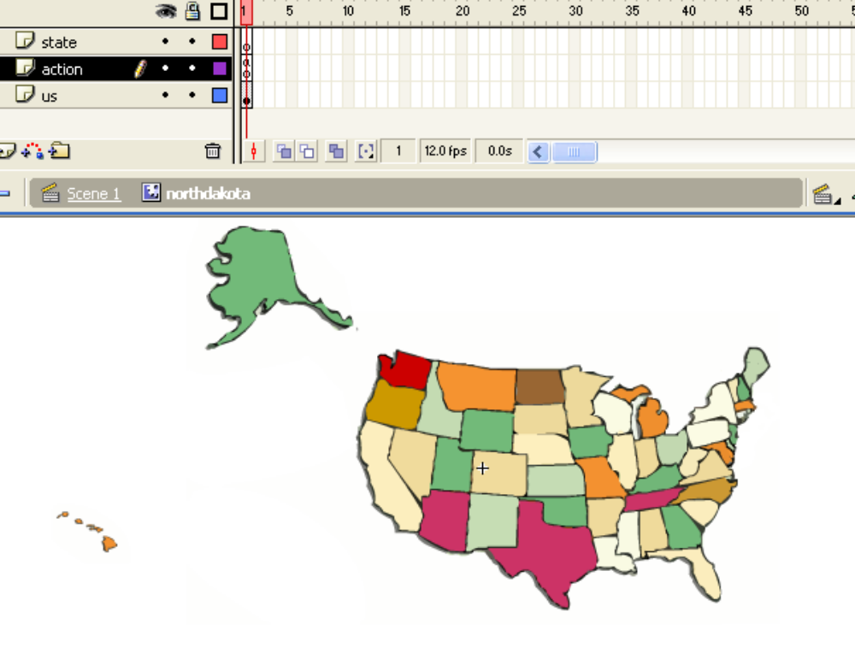
- Click on the action layer, expand the Actions panel, and complete the two lines. In this case it would be:
var statename = "North Dakota";
var capital = "Bismarck";
- Click on the state layer and trace the border of the state. The borders should overlap the neighboring states (to be explained below).
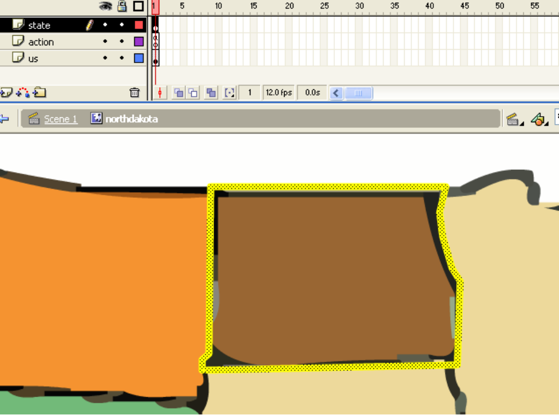
- Now click on the us layer and then right-click and delete the layer! Click on the state layer and fill in the boundaries. I needed to re-do this step several times in order to get neighboring states to have distinctly different colors.
- Go back to the main movie and bring in an instance of each state. (Excuse the fact that the screen shot is southdakota.)
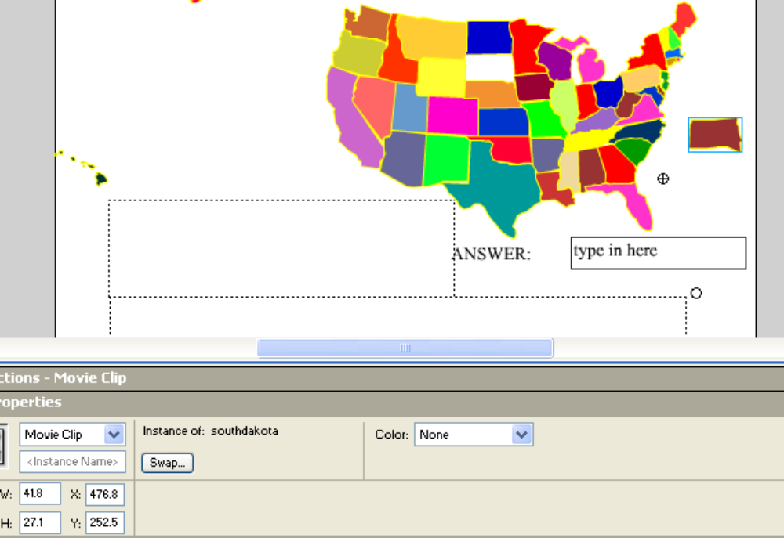
- Give the new instance an instance name the same as the symbol name and also correct the x and y coordinates. I determined that to position the states, ALL states would be at 300.0, 200.0. Note: the important point to recognize is that all the state instances have the same registration point.
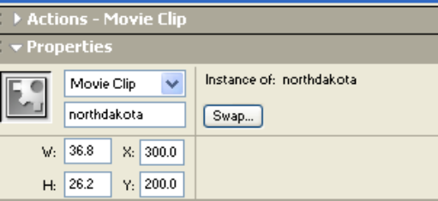

That is the process for the states!

Choosing type of question
The facility for choosing the type of questions is based on the use of the radio button Flash component. You can think of Flash components as being pre-packaged objects for specific types of interactions. You click on Components in the Windows pull down menu and then drag over an instance of the Radio Button to the State. The screen shot shows the Property values of the selected radio button:

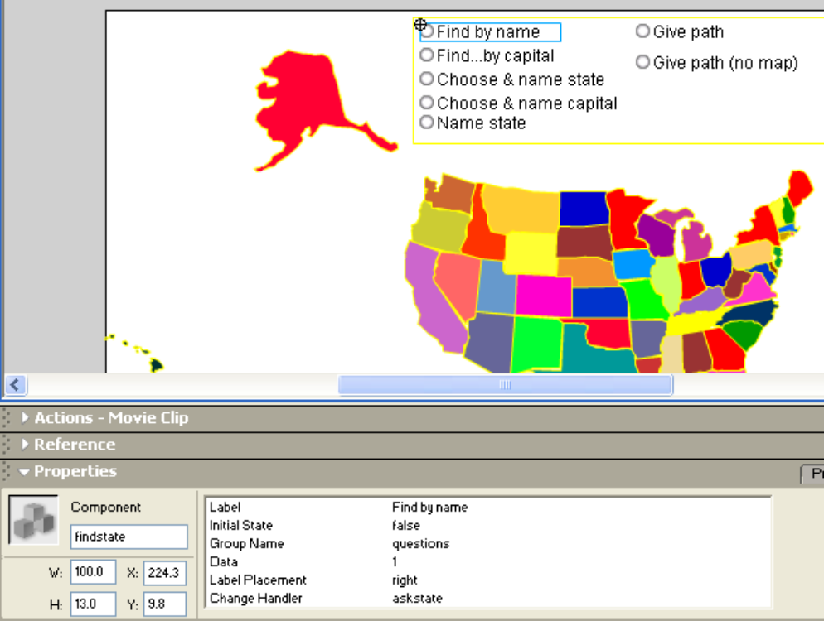

The properties specify the label (what appears on the screen next to the button), the group name shared by all 7 questions, a data value (namely 1) that will be used by the checking functions to determine what function to invoke, and the Change handler (askstate) that is invoked when the radio button is clicked.

Programming interactions
The previous section indicated how the player chooses a category of question. The program must respond to clicks on the map and pressing the enter key. It would be possible to make an event handler for each state. Instead, an empty clip is placed on the screen and its event handlers for MouseUp and for KeyPress invoke functions that, in turn, invoke the appropriate checking function. The screen shot shows the empty clip selected (note the cross in a circle). The Actions panel shows most of the two clip events.

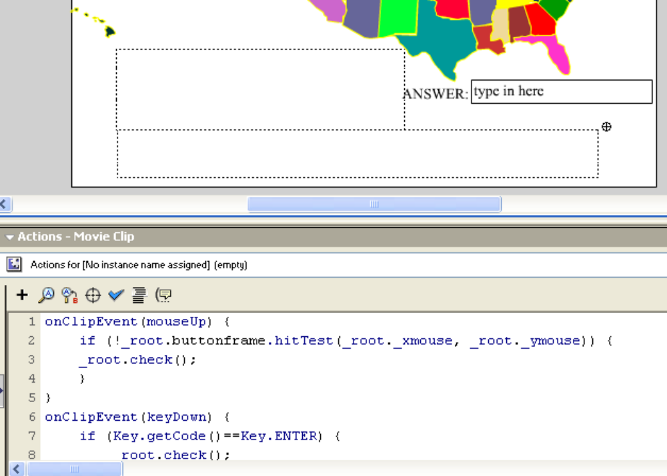

Programming game
The programming of the game, that is, each function for asking a question and each function for checking the answer, makes use of the data stored in the arrays (states for the proper name of states; cleannames for the compressed, lower-case form of state names, and neighbors, an associative array in which each value is a regular array), global variables holding information on the question asked, and data in the state instances.

Code

var states = new Array (
"California",
…
"Ohio"
);

var cleannames = new Array();
for (i=0; i<states.length; i++) {
cleannames[i] = cleanname(states[i]);
}

var numstates = states.length;
var choice;
var stateasked;
stateasked="";
var instname;
var capitala;
capitala ="";

function check() {
var ques = questions.getvalue();

if (ques ==1) {
check1();
}
if (ques == 2) {
check2();
}
if (ques ==3) {
check3();
}
if (ques == 4) {
check4();
}
if (ques == 5) {
check5();
}
if (ques == 6) {
check6();
}
if (ques == 7) {
check7();
}
}

function cleanname(regular) {
var bi;
var clean;
clean = regular;
bi = regular.indexOf(" ");
if (bi>=0) {
clean = regular.slice(0,bi)+regular.slice(bi+1,regular.length);
}
bi = clean.indexOf(" ");
if (bi>=0) {
clean = clean.slice(0,bi)+clean.slice(bi+1,clean.length);
}
return clean.toLowerCase();
}

function askstate() {
choice = Math.floor(Math.random()*numstates);
stateasked = states[choice];
question = "Click on " + stateasked;
results = "";
}

function check1() {
instname = cleanname(stateasked);
if (_root[instname].hitTest(_root._xmouse,_root._ymouse,true)) {
results = "CORRECT!!";
}
else {
results = "WRONG";
}
}

function askcapital() {
choice = Math.floor(Math.random()*numstates);
stateasked = states[choice];
instname = cleanname(stateasked);
var captiala;
capitala = _root[instname].capital;
question = "Click on state with capital " + capitala;
results = "";
}

function check2() {
if (_root[instname].hitTest(_root._xmouse,_root._ymouse,true)) {
results = "CORRECT!!";
}
else {
results = "WRONG";
}
}

function askchoosename() {
question = "Decide on a state, type in the name & then click on the state";
answer = "";
results = "";
}

function check3() {
var theanswer = _root.answer;
var notfound = true;
if (!(theanswer=="type in here" || theanswer == "")) {
for (i=0; i<states.length && notfound; i++) {
notfound = !(states[i]==theanswer);
}
if (notfound) {
results = "Not a state";
}
else {
instname = cleanname(theanswer);

if (_root[instname].hitTest(_root._xmouse,_root._ymouse,true)) {
results = "CORRECT!!";
}
else {
results = "WRONG";
}
}
}
}

function askchoosecapital() {
answer = "";
question = "Decide on a state, type in the capital & then click on the state";
results = "";
}

function check4() {
var i;
var notfound = true;
for (i=0;i<states.length && notfound; i++) {
instname = cleannames[i];
notfound = !(_root[instname].capital == _root.answer);
}
if (notfound) {
results = "NOT A CAPITAL"; }
else if (_root[instname].hitTest(_root._xmouse,_root._ymouse,true)) {
results = "CORRECT!!";
}
else {
results = "Wrong state";
}
}

function askidentify() {
choice = Math.floor(Math.random()*states.length);
instname = cleannames[choice];
_root[instname]._alpha = 0;
question = "Type in the name of the state that has disappeared and then click in that space. Type 'X' to give up.";
}

function check5() {
var theanswer = _root.answer;
if (theanswer == "X") {
_root[instname]._alpha = 100;
results = "The answer is "+ states[choice];
}
else
if (!(theanswer=="type in here" || theanswer == "")) {
if (theanswer == _root[instname].statename) {
_root[instname]._alpha = 100;
results = "CORRECT!!";
}
else {
results = "Wrong";
}
}
}
var starts;
var endstate;
var cursi;
var ssi;
var esi;
function askpath() {
askpathkernel();
}
function askpathnomap() {
var i;
for (i=0; i< states.length; i++) {
_root[cleannames[i]]._visible = false;
}
askpathkernel();
_root[cleannames[ssi]]._visible = true;

}
function askpathkernel() {
ssi = Math.floor(Math.random()*states.length);
starts = states[ssi];
do {
edi = Math.floor(Math.random()*states.length);
endstate = states[edi];
}
while (starts == endstate);
question = "Type states linking "+starts + " to "+endstate +
". Press Enter after each link. Type X for no path or to give up.";
answer = "";
Selection.setFocus("answer");
curs = starts;
results = starts;
}
function check6() {

var notfound = true;
if (answer == "X") {
if ((startss=="Alaska") || (startss=="Hawaii")
|| (endstate =="Alaska") || (endstate == "Hawaii"))
{results=" You are correct--there is no path.";
}
}
else {
for (i = 0; i< neighbors[curs].length && notfound; i++) {
notfound = !(answer ==neighbors[curs][i]);
}
if (notfound) {
answer += " is not a neighbor of "+ curs;
}
else {
results +=" " + answer;
Selection.setFocus("answer");

if (answer == endstate) {
results += " GREAT JOB!";
}
curs = answer;
answer="";
}
}
}
function check7() {
var notfound = true;
if (answer == "X") {
if ((startss=="Alaska")|| (startss=="Hawaii") ||
(endstate =="Alaska") || (endstate == "Hawaii"))
{results=" You are correct--there is no path.";
}
for (i=0;i<states.length;i++) {
_root[cleannames[i]]._visible = true;
}
}
else {
for (i = 0; i< neighbors[curs].length && notfound; i++) {
notfound = !(answer ==neighbors[curs][i]);
}
if (notfound) {
answer += " is not a neighbor of " + curs;
}
else {
results +=" " + answer;
Selection.setFocus("answer");
if (answer == endstate) {
results += " GREAT JOB!";
for (i=0; i<states.length; i++) {
_root[cleannames[i]]._visible = true;
}
}
else {
_root[cleanname(answer)]._visible = true;
curs = answer;
answer="";
}
}
}
}

Code for event handling of empty clip

Clicking the mouse, such as clicking on a state, or typing into the text field and pressing the enter key, both result in calling the check function. This function invokes the appropriate function using the value stored as data in the radio button.

onClipEvent(mouseUp) {
if (!_root.buttonframe.hitTest(_root._xmouse, _root._ymouse)) {
_root.check();
}
}

onClipEvent(keyDown) {
if (Key.getCode()==Key.ENTER) {
_root.check();
}
}

Code for generating neighbors
The task for representing what states are neighbors could be handled in many ways. My decision was to have an associative way called neighbors in which the value of neighbors["New York"] for example, would be the array
["Vermont", "Massachusetts", "Connecticut", "New Jersey", "Pennsylvania"]
The question was how to produce this information. I wanted to avoid hand-coding it. Instead, I would write a program that produced as output the code that filled in the values My scheme was to use the situation that neighboring states would overlap. However, the Flash hitTest function only works on bounding rectangles between movie clip instances. I decided on a two step approach: use the bounding rectangles produced by the getBounds() method first to narrow down the candidate neighbors, and then use the point versus movie clip version of hitTest to determine the actual neighbors by checking each point in the intersection of the bounding rectangles. I did review all of the results and, as a consequence, re-drew certain states (notably: North Dakota and South Dakota) which did not overlap sufficiently to make the list. The outputneighbors code listed below uses the trace function. I copied and pasted the results from the output window.

function intersect(a,b) {
var ab = _root[a].getBounds(_root);
var bb = _root[b].getBounds(_root);
var xgood;
var ygood;
var cxmin;
var cxmax;
var cymin;
var cymax;
var xi;
var yi;
var nohit = true;
xgood = ((ab.xMin<bb.xMin) && (bb.xMin < ab.xMax)) ||
((bb.xMin < ab.xMin) && (bb.xMax > ab.xMax)) ||
((ab.xMin < bb.xMax) && (bb.xMax < ab.xMax));
if (xgood) {
ygood = ((ab.yMin<bb.yMin) && (bb.yMin < ab.yMax)) ||
((bb.yMin < ab.yMin) && (bb.yMax > ab.yMax)) ||
((ab.yMin < bb.yMax) && (bb.yMax < ab.yMax));
if (ygood) {
cxmin = Math.max(ab.xMin, bb.xMin);
cxmax = Math.min(ab.xMax, bb.xMax);
cymin = Math.max(ab.yMin, bb.yMin);
cymax = Math.min(ab.yMax, bb.yMax);

for (xi=cxmin; ((xi <=cxmax) && nohit); xi++) {
for (yi = cymin; ((yi<=cymax) && nohit); yi++){
nohit = !((_root[a].hitTest(xi, yi, true)) &&
(_root[b].hitTest(xi,yi,true)) ) ;
}
}

}
}
return (!nohit);
}

function outputneighbors() {
var i;
var j;
var instname;
var instb;
var na = new Array();
for (i=0; i<states.length-1; i++) {
trace("// ****");
instname = cleannames[i];
for (j=i+1; j<states.length;j++) {
instb = cleannames[j];
if (intersect(instname,instb)) {
trace(" neighbors["+instname+"].push(" + instb+");");
trace(" neighbors["+instb+"].push(" + instname+");");
}
}
trace("//*****");
}
}

Code placed in final project:

var neighbors = new Array();
for (i=0; i<states.length; i++) {
neighbors[states[i]] = new Array();
}

First lines of code generated by outputneighbors:

// ****
neighbors['California'].push('Oregon');
neighbors['Oregon'].push('California');
neighbors['California'].push('Nevada');
neighbors['Nevada'].push('California');
neighbors['California'].push('Arizona');
neighbors['Arizona'].push('California');
//*****
// ****
neighbors['Washington'].push('Oregon');
neighbors['Oregon'].push('Washington');
neighbors['Washington'].push('Idaho');
neighbors['Idaho'].push('Washington');
//*****

