Virtual Pet

Background on virtual pets
A virtual pet is a computer representation of a [simple] model of pet behavior incorporating mechanisms for owner actions. The version described here is a virtual dog that can be fed or petted. If the virtual dog is fed too little or too much, it dies. When the virtual dog is petted, the response is not fixed, but depends on an expression involving the JavaScript Math.random function to decide if the pet is to wag its tail or show its teeth. Other factors in the expression are how long it has been since the dog has been fed.
Here are screens representing sample stages in the life of a virtual dog. This is the initial screen. The dog is in the normal state, as shown by the graphic and the label. The other textbox shows the dog's weight. Below the textboxes are labels for 4 possible actions: Feed Dog, Pet Dog, Start Play and Stop Play.
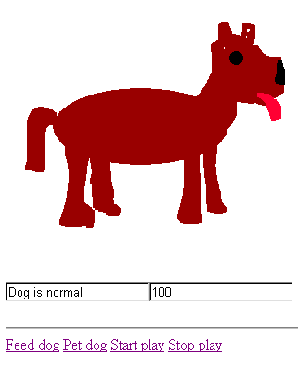
The next screen shot shows a situation in which the dog has not been fed. The weight is now 61 and the graphic is of a thin dog.

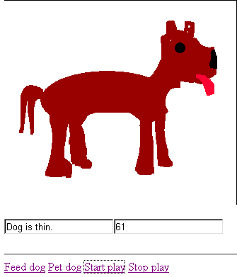

The situation continues with no feeding of the dog, so the dog dies:

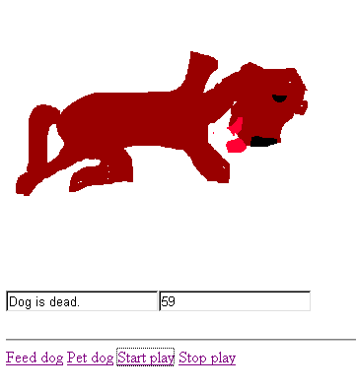

The next screen shot shows a situation in which the owner has fed the dog. Notice the weight is 105.
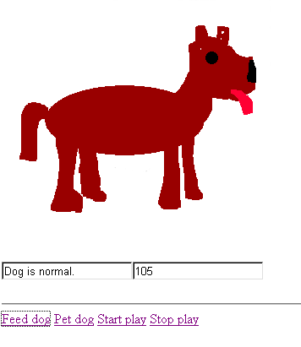
Just as it is possible to starve the virtual pet, it is also possible to over feed the pet.
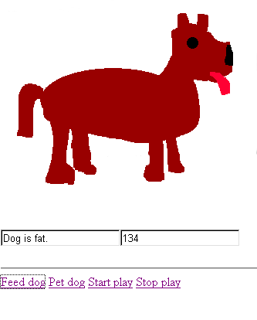
Overfeeding can also lead to the death of the virtual pet:
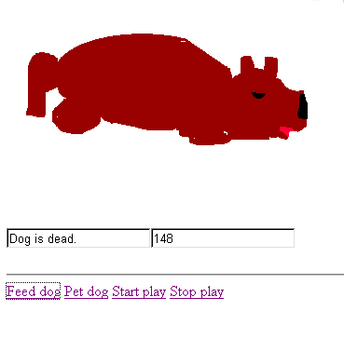
The action of petting the dog can lead to a happy dog wagging its tail or a dog that snarls. The tail wagging dog is implemented using an animated gif file. Here is one frame from wag.gif.
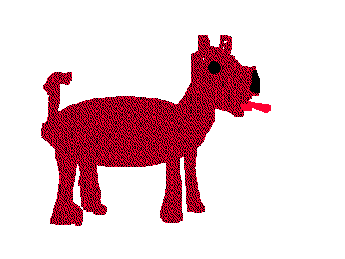
The snarling dog is portrayed using a static graphics file (mean.gif)
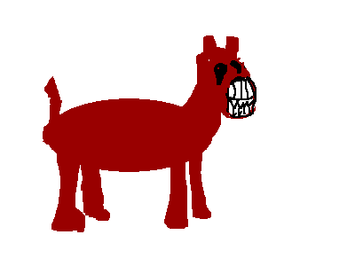

The model could be more developed than it is: there is only one wagging picture and only one snarling picture. That is, there could and should be at least three wagging dog images: a normal wagging dog, a fat wagging dog and a thin wagging dog. (This enhancement is left as an exercise to the reader.)
The virtual pet application can be a model for other 'virtual' worlds, including role-playing games. The application is an example of what is termed a finite state machine in computer science (actually, the number of states, while theoretically finite can be quite numerous since the application also allows for state variables and these can hold a large number of distinct values). To put it abstractly, the application, once started, operates in a loop. The application is in one of several distinct states. At each iteration of the loop, the code examines the state of things (also sometimes called the environment) and may change states depending on conditions. Implementations of finite state machines often use the language switch (select case in Visual Basic) structure to separate the different actions for the different initial states. The coding here used if statements with conditions based on the weight to determine if there should be any change.

Implementation
The original implementation of the virtual dog was done by 'straight' hand coding of HTML and JavaScript. (Go to newmedia.purchase.edu/~Jeanine and follow links to XML/XSLT examples for explanation of a system for producing virtual pets by specifying the content in XML and then transforming this content using an XSLT file.) The HTML consists of a single, named image tag, a form with 2 input tags (used to display the status and the weight), and 4 hyperlinks for the 4 actions.
JavaScript has functions that establish timed events and the associated event handling. The call
tid = setInterval("change()", 1000);
establishes that every 1000 milliseconds a call is to be made to the function change(). The variable tid is set to a number that identifies this particular timed event. A call to
window.clearInterval(tid);
turns off the timed event pointed to be the variable tid. The change() function examines the weight of the dog, held in a variable and contains a nested if statement to determine what image file is to be placed in the image tag.
The actions designated by the 4 labels are implemented using HTML a tags. For example, the Pet Dog action is implemented using
<a href="javascript:petdog();">Pet dog</a>
where petdog() designates a function. This function performs a calculation using the Math.random() method of JavaScript. Depending on the results, the wag.gif or the mean.gif is placed in the image tag.
When designing a computer program, it is useful to outline the coding before plunging in to write it. Here is an outline, more or less, a record of a thought process for the virtual dog.
What variables are needed? More formally, what are the items of information that convey the state of the virtual pet? Answer: weight of the dog and time since the dog was last fed. It will turn out that the mechanics of JavaScript require a variable designating the timing event. This is the variable we have named tid for timer identifier in other applications. The state of the game = state of the dog is also represented by the image shown and by a message put into a form input tag, used as output.
What functions are needed?
startgame()
This function starts the timing event that will examine the state variables and determine if there are any changes to be made.
stopgame();
This function stops the timing event.
feeddog();
This function 'feeds the dog' by increasing the weight of the dog and also recording a new feed time.
petdog();
This function evaluates an expression that does use the time since last fed. Depending on the value, the wagging image is shown or the teeth image is shown.
After consideration of these functions, it was decided to include two more:
change();
This function is the one named in the call to setInterval by startgame. This function determines how long it has been since the dog has been fed and, if appropriate, changes the weight of the dog and outputs a message. The function then examines the weight of the dog and, as appropriate, makes changes. You will notice that this code outputs messages (puts into form input elements) and displays images (sets the src value of the image tag) without checking what the current values are so that values may be set even if they already held those values. This often is the case in programming. It often does not pay to check if you 'need' to make a change. Similarly, the code sets values even they are set again later in the running of the function.
secondselapsed();
This function calculates how long it has been since the dog has been fed. This function will return a value so it can be used in an expression.

Explanation of the code follows:
<html><head><title>Pet</title> | HTML tags
<script language="JavaScript"> | Script tag
<!-- | Put code in comment to prevent message in older browsers
var weight; | Main state variable: weight of dog
var tid; | Identifier for timing event
var feedDate ; | Used to determine feeding time
var feedTime ; | Feeding time
function seconds_elapsed () | Function to perform calculation for how long since dog was fed
{ | Start of function
var date_now = new Date (); | Get current date
var time_now = date_now.getTime (); | Extract from date time in milliseconds since nominal start of Internet.
var time_diff = time_now - feedTime; | Calculate difference
var elapsed = Math.floor ( time_diff / 1000 ); | Convert this to seconds.
return ( elapsed ); | Return this value.
} | End of function
function change() { | Main function for simulation: determines if anything is to change
var secspast; | Variable to be used to hold time since feeding
secspast = seconds_elapsed(); | Invoke the seconds_elapsed function.
if (secspast> 10) { | Check if it is more than 10 seconds since dog was fed
document.forma.condition.value = "dog hungry"; | … if it was, output the message that the dog is hungry. Note: this message may be overwritten.
weight = weight - 1; | Decrement the weight
} | End clause for positive if test
else { | Else clause: say it has not been a long time
document.forma.condition.value = "dog okay"; | Output message that dog is okay. Note: this message may be overwritten.
} | End the else clause
document.forma.dogweight.value = weight; | Output the weight.
if (weight>125) { | Check if weight is over 125
if (weight>150) { | … check if the weight is even more: over 150
document.forma.condition.value ="dog died"; | Output message that the dog died.
document.dogpic.src="fatdeaddog.gif"; | Make image be the fat dead dog.
stopgame(); | Stop the game
} | End the inner clause
else { | Else (fat, but not deadly fat)
document.forma.condition.value ="dog getting too fat"; | Output message.
document.dogpic.src="fatdog.gif"; | Make the image the fat dog.
} | End the inner else clause
} | End the weight >125 clause
if (weight < 80) { | Check if weight under 80
if (weight<60) { | If true, check if the weight is even less
document.forma.condition.value="dog died"; | Output the message that the dog died.
document.dogpic.src="thindead.gif"; | Change the image to the thin dead dog.
stopgame(); | Stop the game.
} | End the inner clause
else { | Else: dog thin, but not deadly thin
document.dogpic.src="thindog.gif"; | Change image to thin dog.
document.forma.condition.value="dog getting too thin"; | Output message.
} | Close inner else
} | Close outer if
} | End function
function feeddog() { | Function to feed the dog
feedDate = new Date(); | Set the feedDate variable
feedTime = feedDate.getTime(); | Set the feed time
weight = weight + 10; | Add to the weight of the dog.
document.forma.condition.value = "dog fed"; | Output message
}
function startgame() { | Function starting the simulation
weight=100; | Initialize weight of dog.
feeddog(); | Call the function to feed the dog. This will set the feedTime variable.
document.dogpic.src="dog.gif"; | Set initial image. This may be needed if the game had been played and the visible image was a dead dog.
tid=setInterval('change()',1000); | Start the timing event by calling setInterval to call the change function every second.
} | End the function
function stopgame() { | Function to stop the game.
window.clearInterval(tid); | Stop the timing event
} | End the function
function petdog() { | Function to pet the dog
var e; | Variables used in calculation: e is for seconds_elapsed
var p; | The p variable is the threshold for wagging or snarling.
var r; | The r holds the random value
e = seconds_elapsed(); | Set e
p = 1-(e/20); | Set p, depending on e.
if (p<.1) { | If p is too low
p = .1; | … make it at least .1. This is so there is always at least 1 chance out of 10 for there to be wagging.
} | End if clause
r = Math.random(); | Set r
if (r<p) { | Compare r to p
document.dogpic.src="wag.gif"; | If less, show wagging
} | End clause
else { | Else
document.dogpic.src="mean.gif"; | Show mean dog.
} | End else clause
} | End function
//--> | End comment enclosing code for older browsers
</script></head> | Ending tags
<body> | Body tag
<a href="javascript:startgame()">Start (re-start)</a> <p> | An <a> tag for javascript code to start the game
<a href="javascript:stopgame()">Stop </a> <p> | An <a> tag for javascript code to stop the game
<a href="javascript:feeddog()">Feed dog </a><p> | An <a> tag for javascript code to feed the dog
<a href="javascript:petdog()">Pet dog </a> <p> | An <a> tag for javascript code to pet the dog
<img src="dog.gif" name="dogpic"><p> | The image tag for holding the changing pictures of the dog
<form name="forma"> | A form tag
Condition <input type=text name="condition" value="initial"><br> | Labeling text plus the input tag named condition that will hold the messages.
Weight <input type=text name="dogweight" value="not set"> | Labeling text plus the input tag that will hold the weight of the dog.
</form></body></html> | Closing html tags

