Project Overview

**Topic:**

Number system converter and binary operations calculator.

**Description:**

This program lets the user to convert numbers from one type of number system to another number system which is discussed in details below. Moreover, it also helps to perform various operations on operands in binary number system. The program provides an interactive interface in the form of well-organized menu systems too. This program has been written in C language and uses various concepts of programming.

**Made By :**

SIDDHARTH SINGH

ABVIIITM GWALIOR

**Features:**

1. **Number system convertor:**

As the name suggests, this is the first part of the program which enables one to convert the entered number from one system to another.

Following Number system are available for conversion:

1. Binary
2. Octal
3. Hexadecimal
4. Decimal

The program can change the number entered from user from one system to another.

1. **Binary Operations:**

This is the second part of the program in which we can perform various operations on the numbers in binary system.

These operations are:

a) Addition

b) Subtraction

c)Bitwise operation

i) AND operation

ii) OR operation

iii) XOR operation

**OUTPUT of the program is as follows:**

1. This is the Entrance output of the program. Here user needs to enter the type of work he wants to perform.

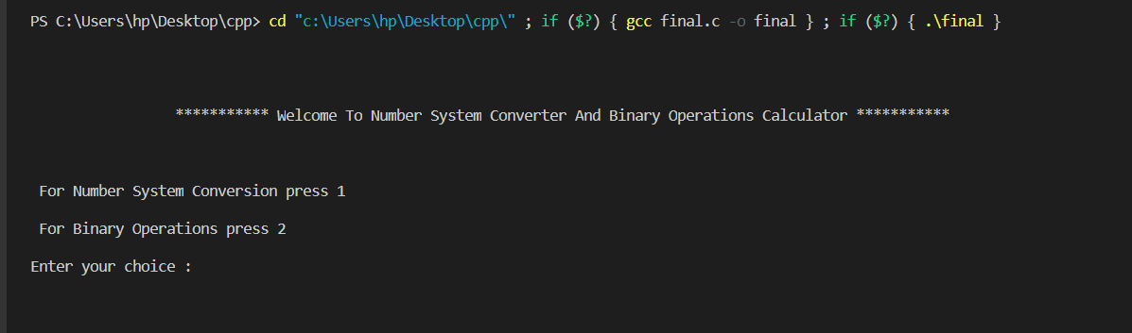

1. Say user wants to do number system conversion. So he enters 1.

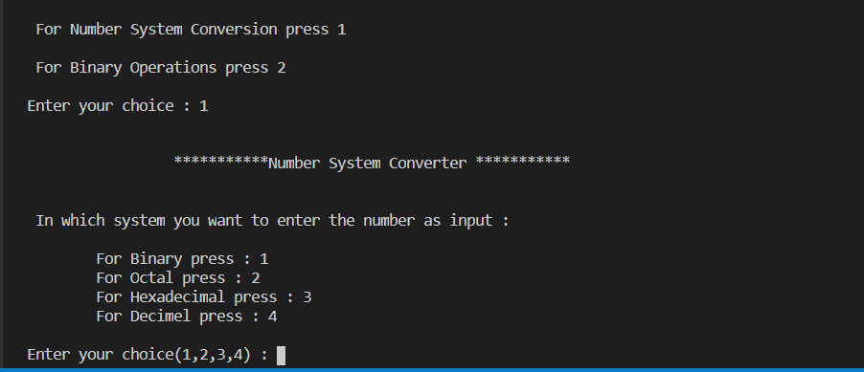

1. Now user needs to tell the input and output number systems of his entries.

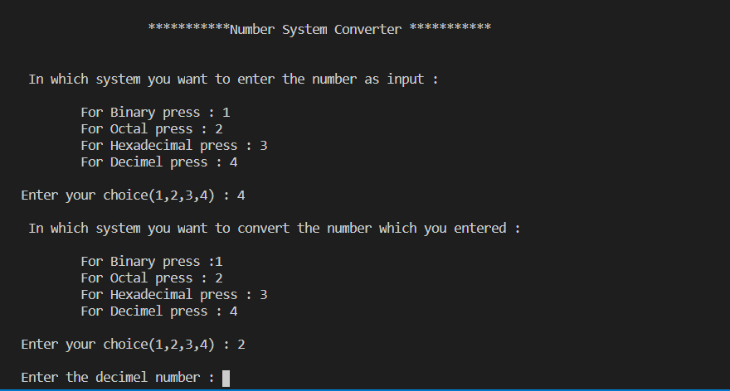

1. Say user selected to convert decimal into octal. After entering the number in decimal and pressing enter key, the program returns the output in octal number system as demanded by the user.

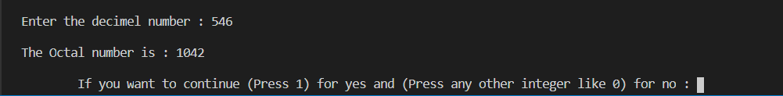

1. Now this is the second part of the program i.e., the Binary operation Calculator.

Here user selects the type of operation he wants to perform. Then two entries are required to be entered and after entering the respective operands, the program performs the operation as demanded and returns the output.

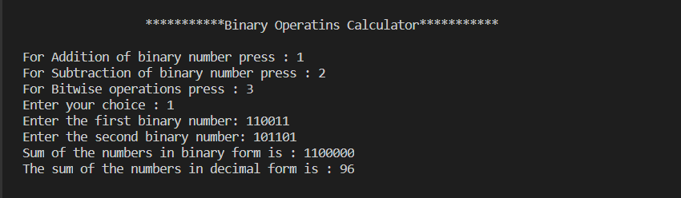

1. This is the last part of the program. If user wants to again use the program, he can do so by entering 1 as input otherwise enter any other integer to finally exit the program.

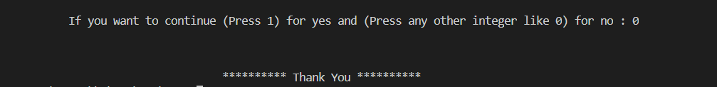

xxxxxxxxxxx