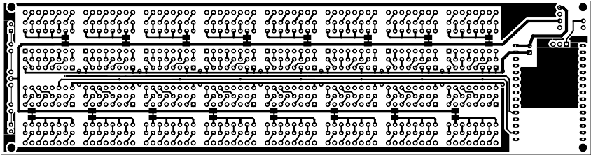
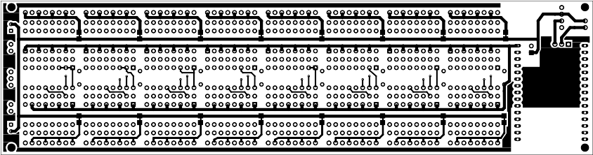
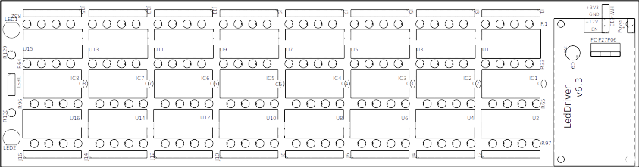

Shopping List
Amount | Part Type | Properties
8 | Ceramic Capacitor | capacitance 100nF; package 200 mil [THT, multilayer]; voltage 16V
1 | Electrolytic Capacitor | capacitance 100µF; package 100 mil [THT, electrolytic]; voltage 10V
1 | DOIT Esp32 DevKit v1 | variant 1; pins 30; part number ESP32S-PIN30
1 | Basic FET P-Channel | type p-channel; package TO220 [THT]
1 | Generic male header -  4 pins | hole size 1.0mm,0.508mm; row single; package THT; form ♂ (male); pins 4; pin spacing 0.1in (2.54mm)
8 | PCF8574 | variant variant 1; type PCF8574; package DIP16 [THT]
16 | Generic male header -  8 pins | hole size 1.0mm,0.508mm; row single; package THT; form ♂ (male); pins 8; pin spacing 0.1in (2.54mm)
2 | Red (633nm) LED | leg yes; current 0.030; color Red (633nm); package 5 mm [THT]
32 | Pad | layer copper0
32 | Pad | layer copper1
1 | Generic male header -  2 pins | hole size 1.0mm,0.508mm; row single; package THT; form ♂ (male); pins 2; pin spacing 0.1in (2.54mm)
66 | 330Ω Resistor | resistance 330Ω; tolerance ±5%; bands 4; power 0.25; package THT; pin spacing 400 mil
64 | 100Ω Resistor | resistance 100Ω; tolerance ±5%; bands 4; power 0.25; package THT; pin spacing 400 mil
1 | Generic male header -  3 pins | hole size 1.0mm,0.508mm; row single; package THT; form ♂ (male); pins 3; pin spacing 0.1in (2.54mm)
16 | Sharp PC847X | part PC847X; package THT

