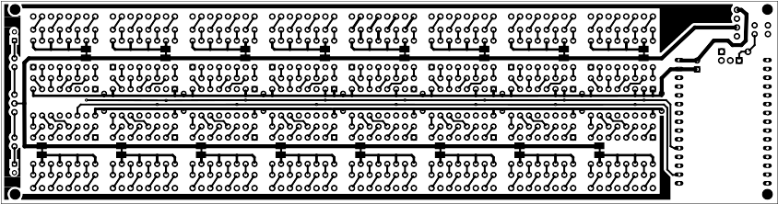
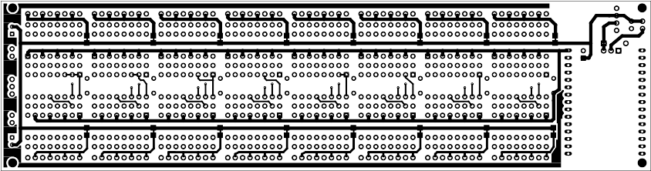
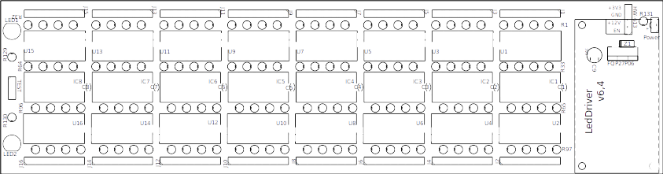
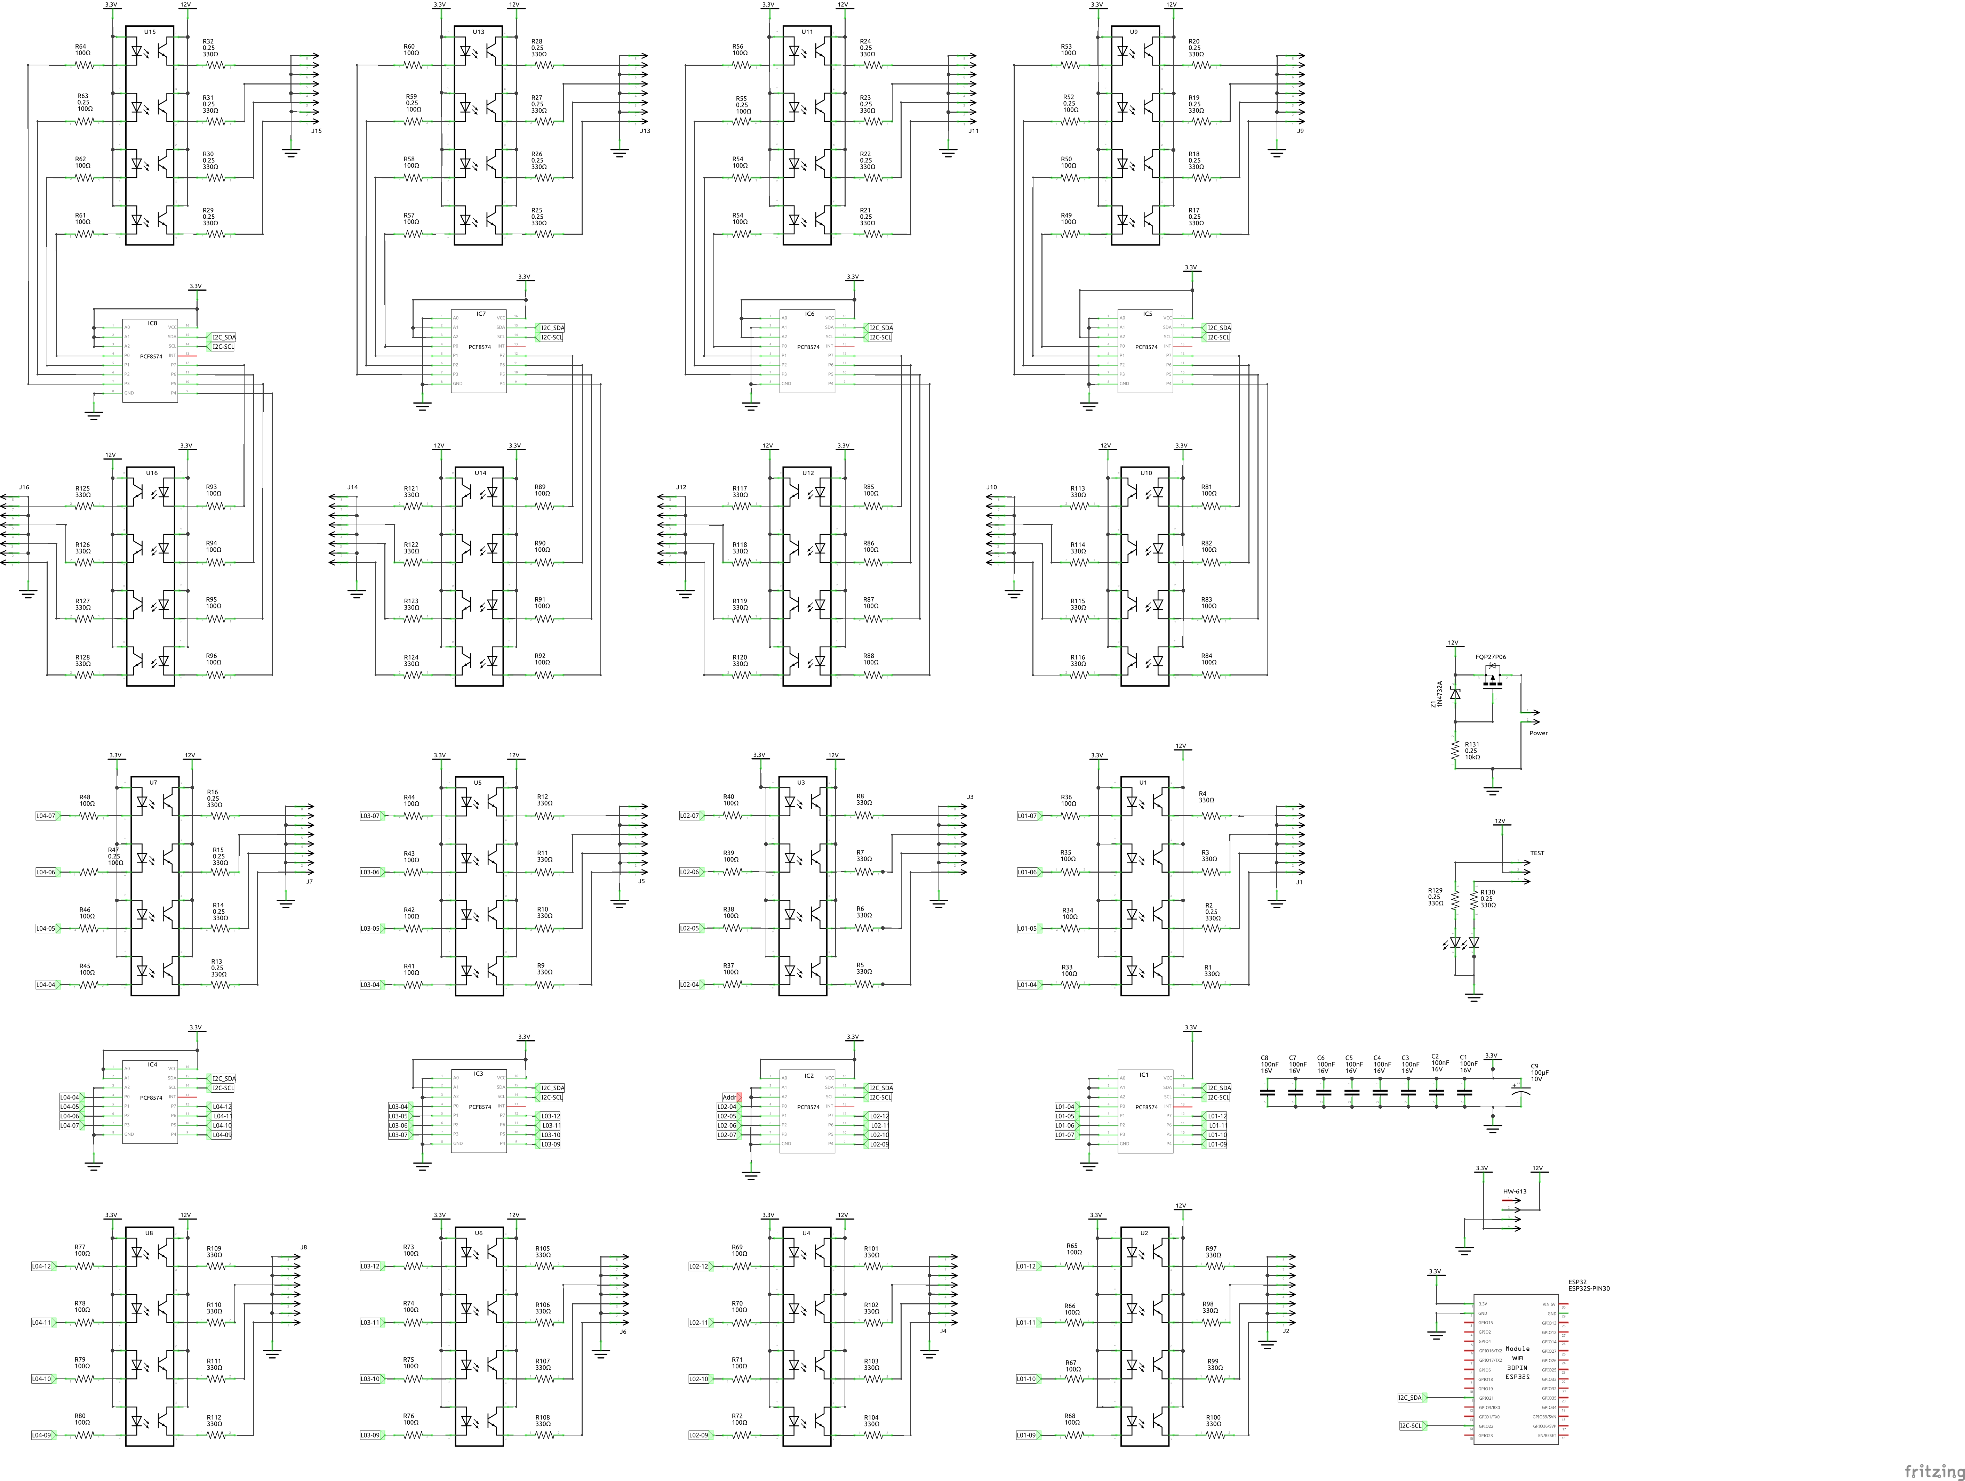

Shopping List
Amount | Part Type | Properties
8 | Ceramic Capacitor | package 200 mil [THT, multilayer]; voltage 16V; capacitance 100nF
1 | Electrolytic Capacitor | package 100 mil [THT, electrolytic]; voltage 10V; capacitance 100µF
1 | Esp32 DevKit v1 | pins 30; variant 1; part number ESP32S-PIN30
1 | FQP27P06 | package TO220 [THT]; type p-channel
1 | Generic male header  - 4 pins | hole size 1.0mm,0.508mm; pin spacing 0.1in (2.54mm); row single; package THT; pins 4; form ♂ (male)
8 | PCF8574 | package DIP16 [THT]; type PCF8574; variant variant 1
16 | Generic male header  - 8 pins | hole size 1.0mm,0.508mm; pin spacing 0.1in (2.54mm); row single; package THT; pins 8; form ♂ (male)
2 | Red (633nm) LED | current 0.030; package 5 mm [THT]; color Red (633nm); leg yes
1 | Generic male header  - 2 pins | hole size 1.0mm,0.508mm; pin spacing 0.1in (2.54mm); row single; package THT; pins 2; form ♂ (male)
66 | 330Ω Resistor | pin spacing 400 mil; power 0.25; package THT; bands 4; resistance 330Ω; tolerance ±5%
64 | 100Ω Resistor | pin spacing 400 mil; power 0.25; package THT; bands 4; resistance 100Ω; tolerance ±5%
1 | 10kΩ Resistor | pin spacing 400 mil; power 0.25; package THT; bands 4; resistance 10kΩ; tolerance ±5%
1 | Generic male header  - 3 pins | hole size 1.0mm,0.508mm; pin spacing 0.1in (2.54mm); row single; package THT; pins 3; form ♂ (male)
16 | Sharp PC847X | part PC847X; package THT
1 | Zener Diode | power dissipation 0.5W; package 300 mil [THT]; type Zener; breakdown voltage 9.1V; part number 1N4732A

