JIRA

-Aplikacion qe provides us with a workflow management system qe mund te perdoret per shume gjera, si running projects, tracking assets etj.

ISSUES:

* Issues jane work packets ne JIRA. Nqs psh po i ben run nje project ne nje zyre, issue eshte tasks qe ti duhet te mbarosh/besh per te plotesuar projektin.
* Cdo lloj issue mund te jete nje task, si task administrimi, filing task, create document task.
* Nqs po perdor JIRA per asset tracking, nje issue mund te represent nje asset dhe issue type mund te jene types of assets.

Per te grupuar issues, track assets etj, perdor projects

PROJECTS:

* Projektet jane nje menyre per te grupuar issues dhe per te aplikuar nje set of defaults, ku kete default-e sigurojne qe issues kane informacionin qe u duhet per te qene progressed dhe tracked gjate workflow.
* Cdo project ka nje administrator i cili eshte zakonisht project lead dhe jane resposibile per administrimin e projektit.

WORKFLOWS:

* Workflow dikton si nje issue mund te behet progressed ne nje project.
* Shpesh modelohen ne procese ekzistuese dhe ndertohen nga statuses (or steps) dhe tranzicione/transitions (ovments between statuses).
* Kur krijon nje issue, automatikisht do te behet assifn nje workflow dhe status ne ate workflow.

APLICATIONS:

* Ka disa JIRA applications. Cdo aplikacion ka distinct features qe e bejne te pershtatshme per ti sherbyer market per te cilen eshte dizenjuar.
* JIRA Software eshte e dizenjuar per agile software developers dhe features perfshijen agile boards.

WHATS POSSIBLE WITH JIRA CORE

* Task Management: Task Management template sets you up me nje simple workflow, issue types te lehta per tu kuptuar, dhe setin duhur te fushave (right set of fields) qe te ndihmojne ty te cosh punen tende nga To Do ne Done ne menyren me te shpejte
* Project Management: Ky template ka nje workflow pak me complex dhe esht shum eficente per projekte qe kerkojne me shume pune. (Nqs perdor In Progress status mund te punosh tasks per nje kohe me te gjate)
* Process Management: Workflow me komplekse
* HR
* Marketing
* Operations
* Finance
* Legal
* A role is a project-specific set of groups and/or individual users.
* The 'Browse Projects' permission controls whether a user can browse a project, i.e. whether they can view the project.

-Issues are specific things needed to do in a project

- the lifecycle of an issue is managed by a workflow. A workflow consists of the issue statuses (e.g. To Do) and the transitions between each status (e.g. Start progress).

Administrimi I nje projekti:

Nje Jira core project eshte nje koleksion issues dhe issues jane paketa bazike te punes qe duhet te behet.

Nje projekt te lejon te aplikosh nje projekt per cdo issue nga nje associeted workflow.

PROJECT DETAILS: Nje projekt duhet te kete keto te dhena per te indetifikuar projektin dhe issuet perkatese.

- nje emer

- nje project key

- nje project lead

PROJECT ACCESS:

- Aksesi controllohet nepermjet project role membership.

- Mund ti besh assign individual users or groups ro the projects

VERSIONS:

-Eshte nje menytr per te grupuar issues ne nje projekt

-Kane start dhe end date

-Mund te perdoren per te grupuar efektivisht group issues.

COMPONENTS:

- Nje tjeter menyre e te grupuarit issues ne nje projekt

- Nuk kane date te bere assigned

- mund te kene nje component lead qe mund te jete nje ekspert I subjetit, ose team leader per ate area te projektit.

WORKFLOWS:

- Cdo projekt ka te pakten nje workflow qe mund te aplikohet ne issues perkatese

- Kontrollon sesi progreson nje issue, qe nga krijimi I issue deri ne clossing issue

ISSUES:

-Jane paketa pune qe duhen bere dhe cdo issue mban informacion ne fusha.

- Mund ti besh costumise duke ndryshuar fushat.

Mund te perdoreshproject roles per ti bere associate users dhe grupeve me nje projekt te caktuar. Nqs do te dergosh nje notification tek nje specific set of users te lidhur me projektin tend, per tua derguar te gjitheve njekohesisht mund te perdoresh project role (I vendos te gjithe ne nje project role)

**->ORGANIZING WORK WITH VERSIONS**

-Versions are point-in-time for a project.

-Ndihmojne ne organizimin e punes duke dhene milestones to aim for.

-Mund ti besh assign issues ne projektin tend, nje versioni specifik

-Duhet te kesh **Administer Projects** *project permission* qe:

1)Add- craete a new version against which issues can be aligned

2)Release- mark a version as released

3)Archive: hide an old version from the Releases repost, and the user interface

4)Delete- remove a version. You must choose an action for any issues with that version.

5)Merge — combine multiple versions into one.

6) Reschedule: rearrange the order of versions

Kur krijon nje projekt fields si ‘Affects version’ dhe ‘Fix Version’ behen available per issues.

VERSIONS

- Mund te vendosen Versione ne

**Project>Versions>Add Versions**

Vendoset emri, description, start date dhe release date

Nje versioni mund ti besh:

- Release; **Project>Versions>Release**

- Archive: Nuk mund ti behen ndryshime ketij versioni vetem nese eshte un-archived, gjithashtu nuk mundet ti besh remove any existing archived versions from an issue affected

**Project>Versions>Archive**

Mund ti besh reveret me option Unarchive

- Delete: Mund ti besh associate issues me nje tjeter version ose thjesht ta fshish

**Project>Versions>Delete**

-Merge: Duke bere merge multiple options mund te levizesh issues nga nje ose me shume versione ne nje tjeter.

Duhet te zgjedhesh cilat versione do qe ti besh move issues dhe versionet e zgjedhura ne kete list do te behen remove

**Project>Versions>Merge link> Merge Versions> Merging from versions list select> MERGE BUTTON**

- Reschedule a version: Changes its place in the order of versions. Mund ti besh drag down per pozicionin e ri ne version order

**->ORGANIZING WORK WITH COMPONETS**

Komponentet jane sub-section te nje projekti.

Perdoren per te grupuar issues ne nje projekt ne grupe me te vogla dhe te menaxhueshme.

Duhet te kesh Administers Project permission per veprimet me poshte:

- Add: Create a new componets against which issues can be aligned

- Edit: Change a components detail

- Delete: remove a component

Si te Version→ Kur kruijon nje component per projektin, ‘Component’ field becomes available per issuet.

Managing a project’s components: **Settings>Projects>Components**

Adding a new component:

**Settings>Projects> Components> Add Components**

Duhet te vendosesh *Name, Description, Component Lead, Defalut Assignee*

SELECTING A DEFAULT ASSIGNEE

Nqs vendos nje default assignee per nje component, kjo do I beje override project’s deafult assignee for issues in that component.

-Nqs nje issue ka multiple components, assignee di behet set tek I pari ne rend afalbetik tek default assignee.

|  |  |  |
| --- | --- | --- |
| Default asignee option | Description | Notes |
| Project Default | Issues qe I bejne match ketij components do te si assigne, default assignee qe eshte ne parent project. |  |
| Project Lead | Assigne do jete project leader |  |
| Component Lead | Assignee do te jete project leader |  |
| Unassigned | Assigne of the issue nuk do behet set ne krijimin e kesaj issue | Ky opsion esht available vetem nese ‘Allow unassigend issues’ eshte enabled |

EDITING COMPONENTS DETAILS

**Settings>Projects>Components>Actions**(select the component you want to edit)

Mund te editosh *Name, Description, Lead, Default Assignee*

DELETING A COMPONENT

**Settings>Projects>Components> Actions>Delete**

**WORKFLOWS**

Path-i qe ndjekin issuet qe nga krijimi, punimi, perfundimi, quhet WORKFLOW.

Workfloe kompozohet nga: statuses (the state your work can be in) dhe transitions (how your work moves between statues)

-JIRA perdor *worklow schemes* per te percaktuar marrdhenien mes issue types and workflow.

-*Workflow schemes* jane te lidhura me nje projekt dhe bejne te mundur te perdoret nje workflow I ndryshem per kombinacione te ndryshme te projekteve dhe issue types.

PROJECT ADMINISTRATORS

- Mund ta editosh workflow qe I perket projektit tend nese:

* the workflow isnt shared wuth any other projects (pra eshte available vetem ne projektin tend)
* the workflow isnt the default JIRA workflow(no one can edit this)

Kur sheh workflow mund te shohesh informacione si: a eshte shared me nje projekt tjeter, sa issue types shares nje workflow dhe afektohen nga ndryshimet qe ti ben.

Ndryshimet: Add a status (duhet te jete ekzituse ne JIRA, smund ta krijosh, fshish etj

Create, Add, edit or delete transitions (sja editon dot properties)

**Project>Project Settings>Issue Types** (shfaqet workflow per kete issue)

Per ta edituar zgjidh me pas, **Edit workflow,** duhet ti besh publish per ta bere aktive **Publish**

JIRA ADMINISTRATORS

-Mund te besh keto veprime si nje Jira administrator.

* Edition workflow ekzituese
* Krijon new workflows
* Konfiguron existing workflows
* Add nje workflow scheme
* Konfiguron nje workflow scheme
* Menaxhon workflow schemes
* Importon workflow dhe Eksporton workflows
* Aktivizon worflows dhe Deaktivizon workflows
* Adding costume events
* Konfiguron initial status
* Konfiguron workflow triggers
* Perdor validator and costum fields
* XML per te krijuar workflow
* Workflow properties

**WORKING IN A PROJECT**

-Nje projekt eshte nje collection of issues.

-Prpjekti mund te perdoret per te koordinuar zhvillimin e nje produkti, track a project, manage a help desk etj.

MENAGING A USER PROFILE: Per te punuar ne nje projekt duhet te jesh logged in

Mund te editosh details, avatar

Homepage: Dashboard, Issue Navigator, Boards

Email

ALLOWING OAuth ACCESS

-OAuth access tokens allows you to:

* Use JIRSA gadged on an external, Oauth-complaint web application or website
* Grant the gadgets access to the same JIRA data that you can access.

ISSUING OAuth ACCES TOKENS

Per te lejuar nje gadget per te aksesuar same JIRA data qe mundesh, I ben issue nje unique OAuth access token.

* *When you use a JIRA gadget on a consumer (such as Bamboo) and this gadget requires access to your JIRA data, you will be prompted to log in to JIRA if you have not already done so.*
* *After you log in to JIRA, you will be prompted with a* ***Request for Access****message*
* *To issue the OAuth token and grant the gadget access to your JIRA data, click* ***Allow****. The gadget can access your JIRA data until you revoke the token.*
* To view tokens you have issued, go to your **Profile >** **> View OAuth Access Tokens**:

REVOKING OAuth ACCESS TOKENS

-Mund ti besh revoke nje OAuth token per te mohuar nje JIRA gadget access.

**Profile>...>View OAuth Access Token**  hapet **Authorized Applications**

tek apllication qe do ti besh revoke shtype **Revoke Access**

REQUESTING ADD-ONS

-Perdoren per te enhance and extend JIRA applications.

USING KEYBOARD SHORTCUTS

Dritarja dialoguese e shortcuts ndahet ne

* **Global shortcuts-**shortcuts qe mund te perdoren kur je ne any part of JIRA
* **Navigating issues-** shortcuts for navigating through issues
* **Issue actions-** shortcuts for working with issues.
* **App specific-** Any aplication specific shortcut

**FIELDS:WORKING WITH AN ISSUE**

**fields -**are the data points used to capture information about issues. Each field represents a specific piece of data, such as a title, description, priority, assignee, or custom information relevant to a project.

**Field configuration schemes:** determinojne cilat fusha jane availablre per perdorim ne nje projekt dhe sesi they behave.

**Specifying field behavior:**

-Nje konfigurim I field definon the behavior te te gjithe fields aqvailable in JIRA installation.

-Per cdo field, nje field configuration specifikon:

* the description that appears under the field whenan issue is edited.
* Wether the field is hidden or visible
* wether the field is required or optional
* which renderer to use

- Nje new field configuration should be added for each project and issue type combination which requires specific fields to be present and/or fields that eexpress unique behavior.

-Multiple field configurations are organized into field configuration schemes=>keto lidhin issue types me field configuration. Kjo skememe pas mund te lidhet me me shume projekte.

-Kur I ben copy nje field configuration, qe permban emer dhe description, do te kopjohen keto te dyja. Mund te editosh nje field, por nuk mund te editosh default field.

-Kur I ben  **configure**  nje field mund ti besh fields required, hide/show, specify their description etj. Mundte ndryshosh dhe screens.

"**Screens"** are user interface elements that define what fields are displayed when creating, editing, or viewing issues. They play a crucial role in how users interact with issues and can be configured based on different issue types or workflows.

**A field renderer** determines how a field is displayed on the user interface, particularly in issue views and during editing

-Qe te kete ndikim ky configurim I field duhet ti beshassociate with one or more issue types.

-Nqs nje field eshte hidden ne nje field configuration, nuk do te marre nje value kur te krijohet nje issue.Fields **summary** and **Issue Typer** nuk mund te behen hide.

**Specifying field behavior: Associating field Behavior with issue types.**

-Nje **field configuration scheme** associates field configurations to issue types in a project. Pra mund te lidhet me nje ose me shume projekte. Per shembull mund te kesh seperate field configurations for the *Bug a*nd *Improvment* issue types (whose associations are defined in a field configuration scheme). Nje shembull

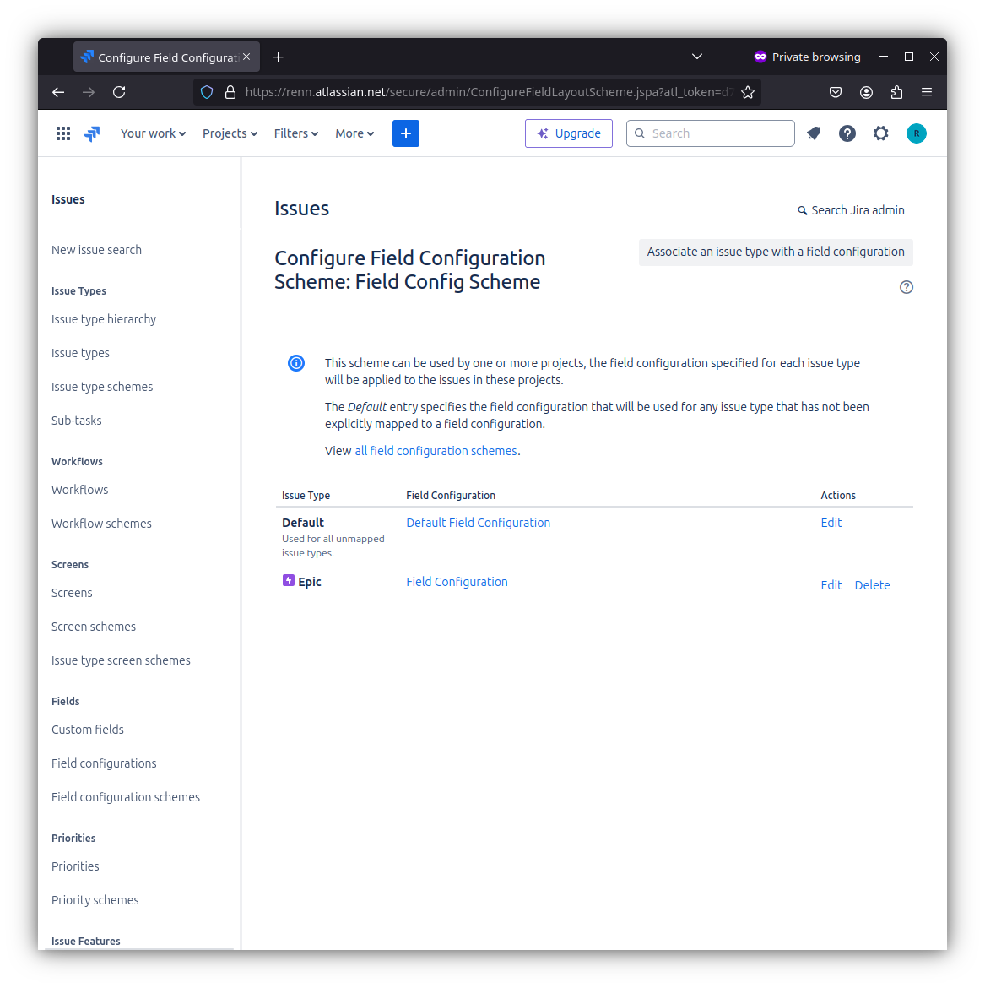

***Nje issue type mund te kete vetem nje association within a given configuration scheme.***

Nese nuk ka nje asscoiatin ne skeme, field configuration e lidhur me Default entry ne skemw do te perdoret per kete issue type.

**Associatr a field configuration scheme with a project:**

- Pra lidhim field configuration, with issue types in a *field configuration scheme* dhe me pas associate this field configuration scheme with a project. Kjo do te thote se kjo skeme konfigurimi do te aplikohet ne projekt.

-Keshtu issues ne kete projekt do te perdorin *field configurations* ‘mapped’ to their issue type, dhe issue types available per kete projekt definohen nga *issue type scheme* associated with the project.

**CONFIGUTING RENDERERS;**

- Renderers determinon si nje field eshte diplayed ne user interface, partivualry in issue views and during editing. Fields te ndryshme mund te behen renderered ne menyra te ndryshme, duke u varaur nga tipi dhe konteksti qe perdoren.

-Psh wiki-style renderer perdoret per “Description” ose ‘Comment”, ky renderer alows for rich text formatting using wiki-style syntax.

-Renderers konfigurohen si ‘per field basis’.

**Renderable fields:**

**-**Cdo text-based field mund te jete nje renderable fields, gjithashtu si multi-select fields.

*Renderable fields:*

* Description
* commeny
* enviroment
* components
* affects versions, fix version etj

*Renderer types:*

*-* for text fieds: wiki style renderer, default text renderer

- for multi-select fields: autocomplete renderer, select list renderer

**Bulk move operations:**  Mund ti besh move issues to an enviroment(project/issue type) where the renderer types for the fields are the same or where they will be different. Kur jane different paraqitet nje warning.

***You will only be allowed to bulk edit a renderable field if all the issues selected for edit use the same renderer type.***

Shkurt mhb ka te bej me stilin, shkrimin e issues

**DEFINING A SCREEN:**

**Screen** group all available fields dhe i organizon ato per prezantim tek user.

Nepermjet screen mund te kontrollosh cfare fields do te behen dispplayed gjate issue operationsose workflow.

Ka disa Screens

* Default Screen: user for the default issue operations for creating, editing or viewing an issue
* Resolve Issue Screen- used for the transition view for the deafult Close Isse and Resolve Issue transitions. TE LEJON TE BESH SET RESOLUTION, CHANGE FIX VERSIONS AND ASSIGN AN ISSUE.
* WorkfloW screen: used for the transition view for the deafult Reopen Issue transitions,originating from the **Resolved** and **Closed** steps and **Close Issue** transition. PERDORET PER WORKFLOW, TE LEJON TE ASSIGN ISSUES

**Configuring screens:**

- Data fields on View Issue Screen- Filed type Date do behen displayed indeafult View Issue screen

- System fields on View Issue screen

-Timetracking- u can add the ability to log work and/or specify/modify times estimates to a screen by adding special **Log Work** and/or **Time Tracking** fields respectively.

- **Renaming standard JIRA fields** — You cannot rename the standard JIRA fields (e.g. Priority, Summary, etc) via the JIRA administration console.

**Associaciating a screeb with an issue operations**

**-**Te lejon te zgjedhesh cila screen do ti treegohet nje jira user kur performojne nje partivcular issue operation. Jane 3 issue operation for which you canb choose a screen:

* Create Issue- the screen that is shown when an issue is being created
* Edit issue- the screen that is shown when an issue is edited
* View issue- the screen that is shown when a user views an issue

PSE? → Associating screens with issue operations in Jira is not merely a technical setup; it is a strategic approach to enhancing project management effectiveness. By thoughtfully considering the fields displayed during each operation, you empower users to enter and manage information more efficiently, leading to better collaboration, improved data integrity, and a more streamlined workflow. This level of customization ultimately supports the broader goals of any project or team, ensuring that all necessary details are captured accurately and efficiently.

-Per te aktivizuar nje screen scheme, duhet ti besh associate me nje ose me shume projekte dhe issue types, using issue type screen schemes.

1. Configure an issue type screen scheme to use the screen scheme.

2.Associate the issue type screen scheme with a project.

Recipents:

Current asignee- the user whom issue is currently assigned

Reporter- the user who originally created the issue

Current user- the user eho performed the action that has triggered this event

project role- the members of a particualr project role for this project.

**Issue collector:**  allows you to easliy embed a JIRA feedback form into your own website. Ky aksesohet nga nje triggered tab, click. Kur perdoret nga njerzit, qe vizitojne kete website dhe klikojne kete trigger, submit the resulting In JIRA Feedback form, nje issue krijohet ne jira.