I fixed the problem with 3 different methods for the single server scenario. You can run the relevant solutions one by one in the Main method in Program.cs.

**Lock Solution**

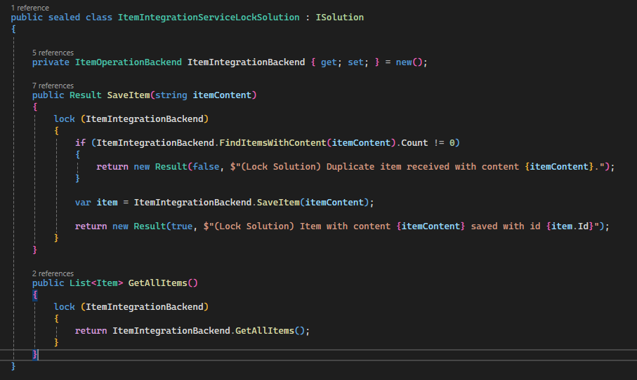

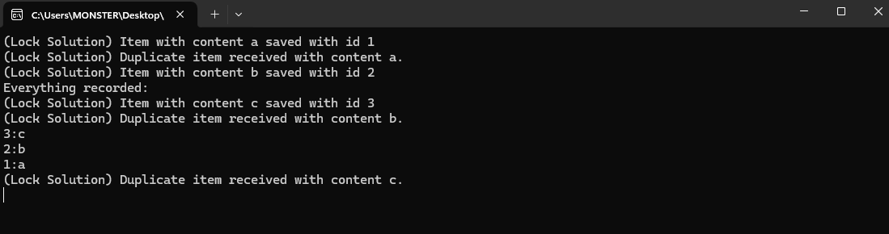

**ConcurrentDictionary Solution**

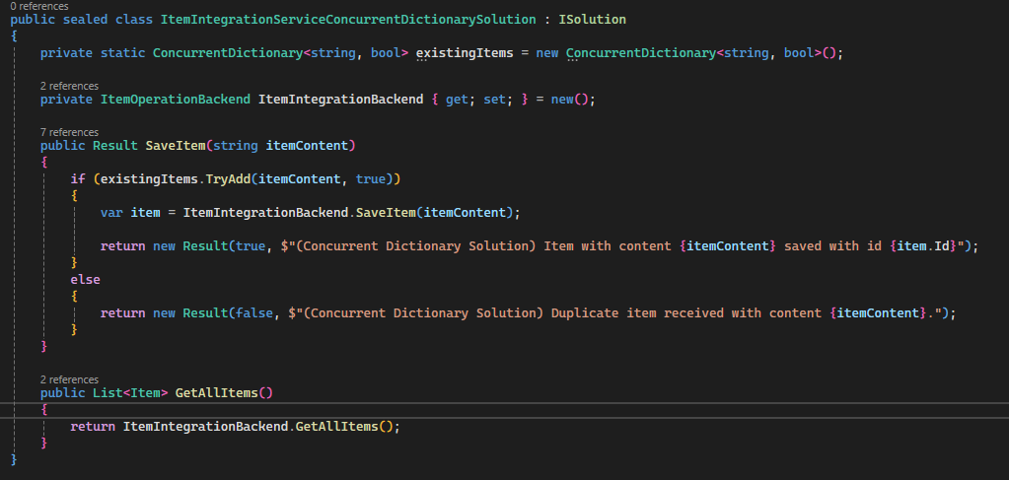

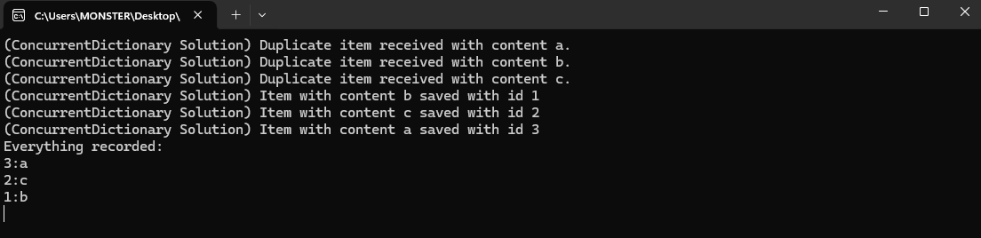

**SemaphoreSlim Solution**

