7.Project Documentation
Project Title
Streamlining IT Procurement: Automating Standard Laptop Order with Flow Designer
Activity-1
- Open service now.
- Click on All >> search for Flow Designer
- Click on Flow Designer under Process Automation.
- After opening Flow Designer Click on new and select Flow.
- Under Flow properties Give Flow Name as “ Standard laptop task”.
- Application should be Global.
- Select Run user as “ System user ” from that choice.
- Click on Submit.
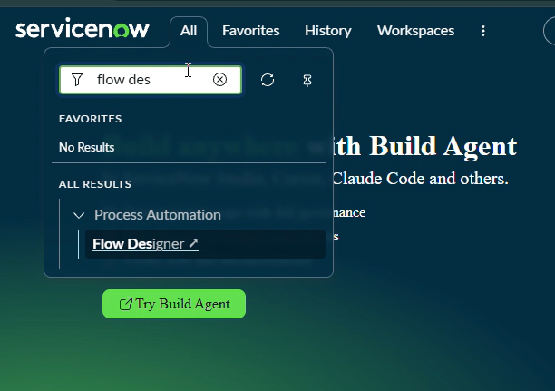
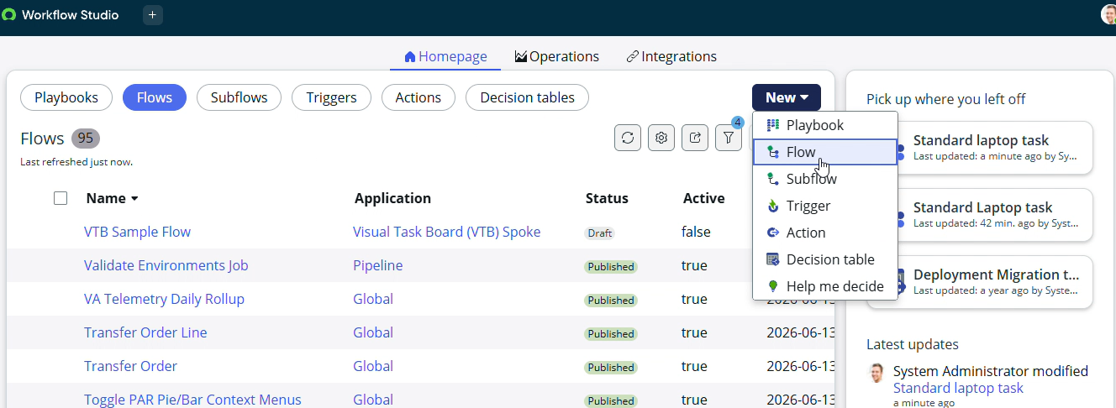
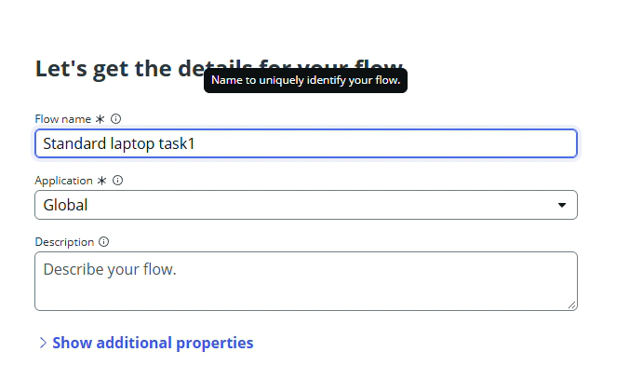
- Click on Add a trigger
- Select the trigger in that Search for “ Service Catalog ” and select that.
- After that click on Done.
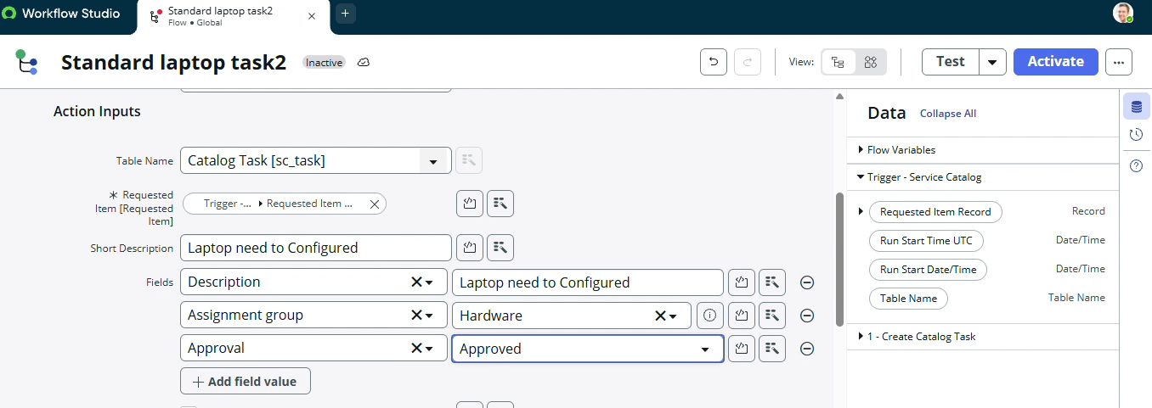
- Now under Actions.
- Click on Add an action.
- Select action in that search for “ Create Catalog Task ” and select that.
- Mention these in that action
- Action as Create Catalog Task
- Drag and drop the Requested Item Record in the Request item.
- Table will be auto populated as a Catalog Task.
- Mention the short description as “ Laptop need to Configured ”.
- Click on add field value
- Select description field and value as “ Laptop need to Configured ”.
- Select Assignment group field and value as “ Hardware ”.
- Select Approval field and value as “ Approved ”.
- Leave the remaining as default and click on Done.
- Click on save the Flow.
- And Click on Activate again click on Activate.

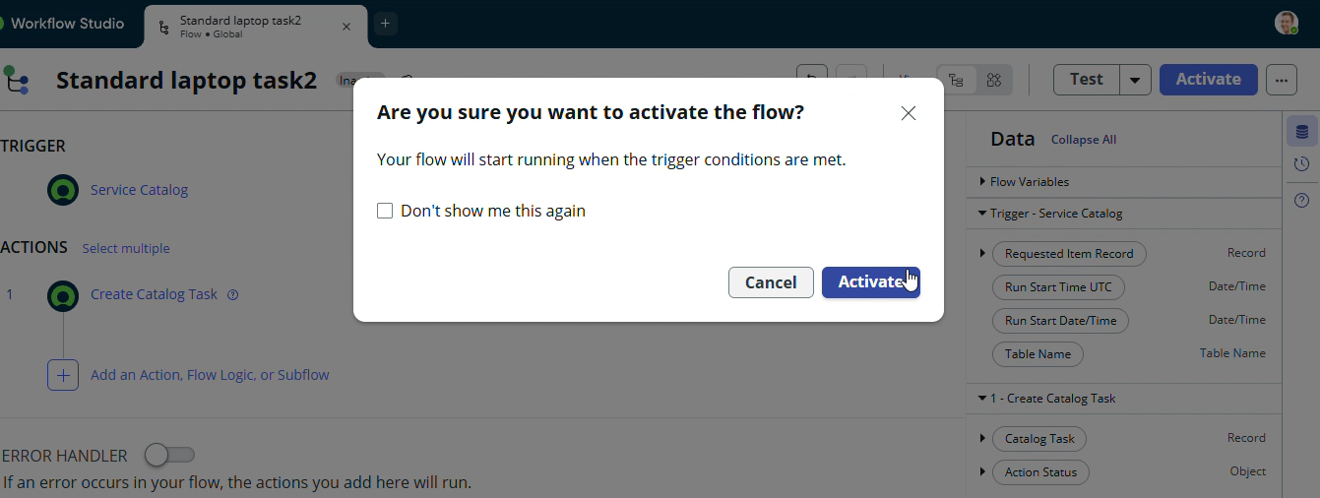

Activity-2

- Open ServiceNow.
- Click on all search for Maintain Items.
- Select Maintain Items.
- Under the name field search for Standard Laptop Select that record.
- Under that record select Process engine
- Remove the remaining automations and add Flow.
- Add the flow that was created with the name “ Standard Laptop Task”.
- Click on the menu to save the record.
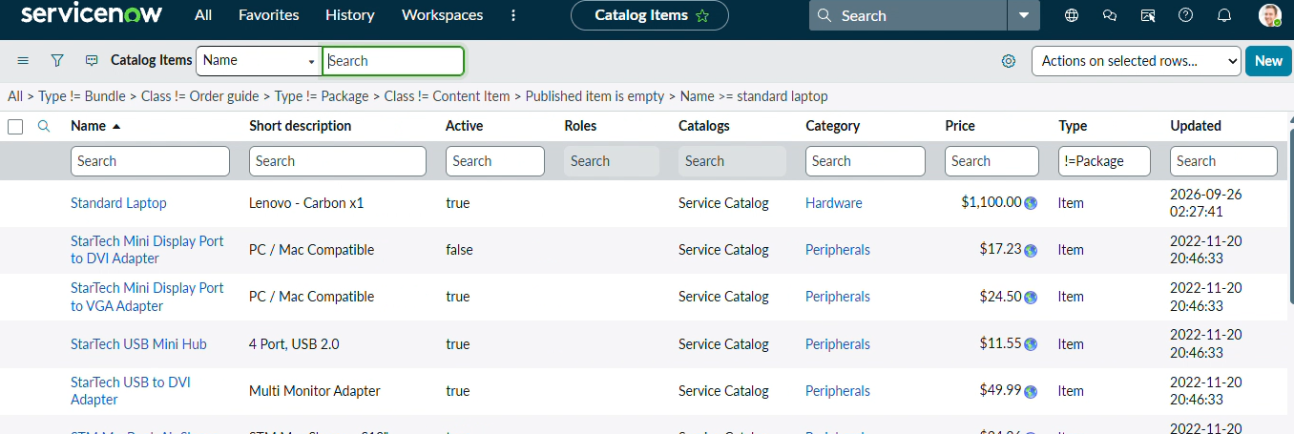
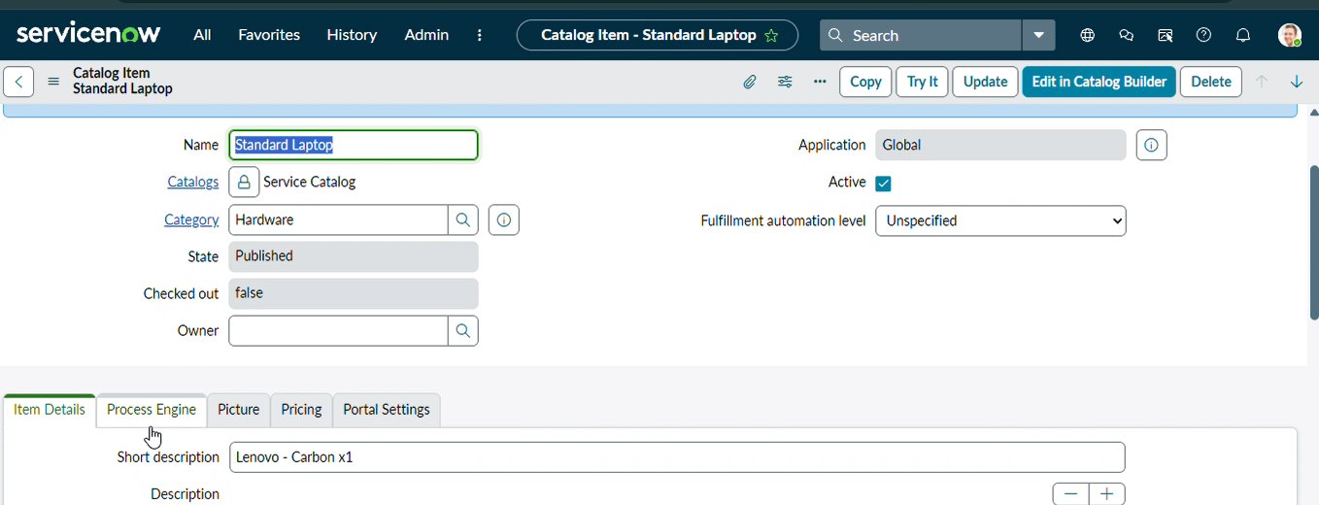

Activity-3
- Click on All >> Search for “ Service Catalog ”.
- Click on Service Catalog >> click on Hardware.
- Scroll a bit to find the “ Standard Laptop ” click on that.
- After that click on “ Order Now ” to place the request.
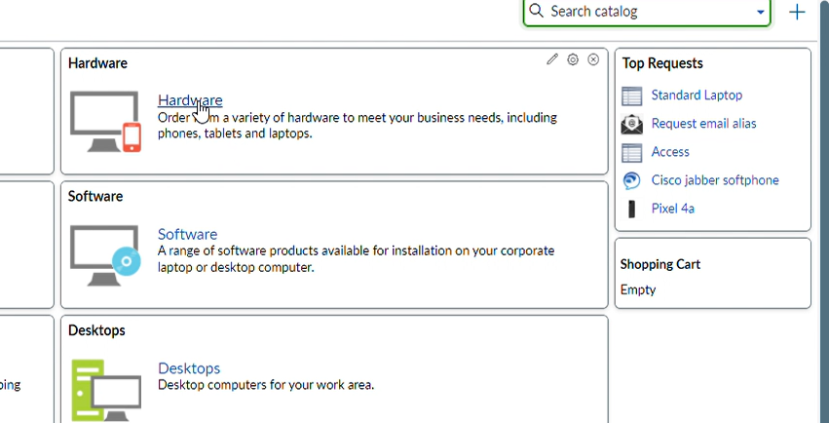
- Now we will see the Order status
- In that click on the Request Number
- It will open the Requested number record.
- Scroll down Click on the Approvers Section.
- It will open the Requested number record.
- Scroll down Click on the Approvers Section.

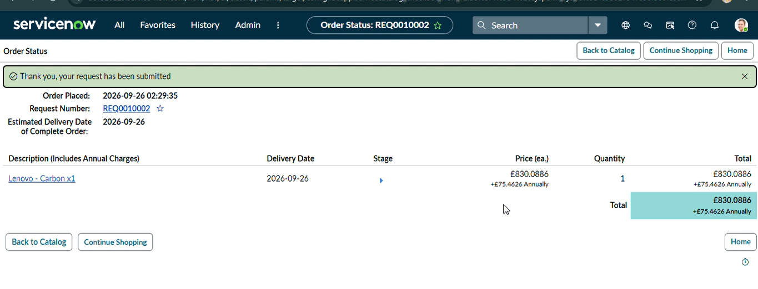
- It will open the Requested number record.
- Scroll down Click on the Approvers Section.
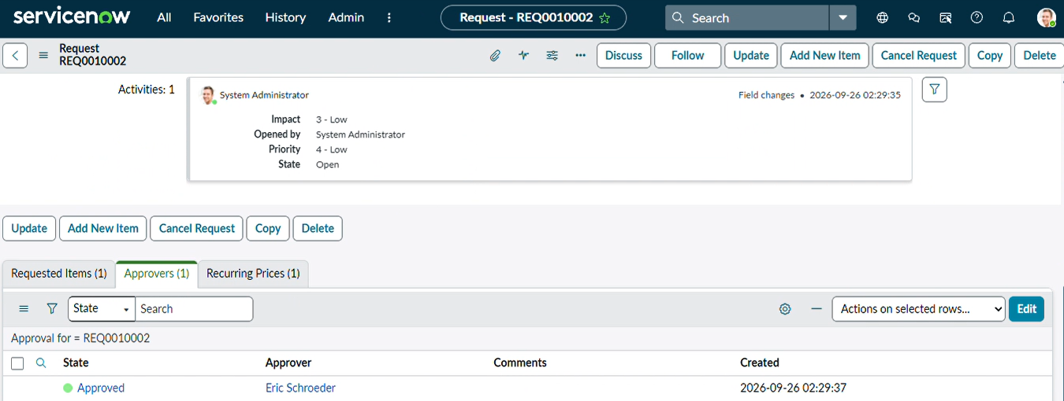
- Then click on the Requested item Section
- Open that Requested Item record
- Scroll down to the “ Catalog tasks ” Section
- Open the record to see the updated status of the record with Short description and Assigned group.
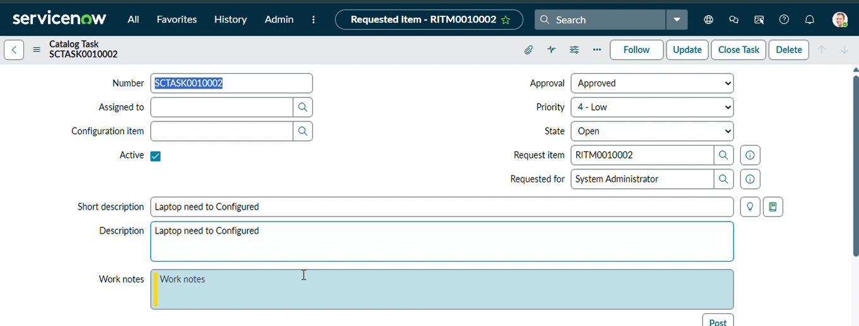

Conclusion:
The Standard Laptop Procurement Automation project successfully demonstrates how ServiceNow Flow Designer can be used to streamline and automate a common IT procurement process. The solution was designed to reduce manual intervention involved in processing standard laptop requests and ensure that approved requests are promptly forwarded to the appropriate hardware team.
The project integrates the Service Catalog, Requested Items, Approval process, Flow Designer, and Catalog Tasks into a single automated workflow. When a user submits a Standard Laptop request through the Service Catalog, the request goes through the required approval process. Once the request is approved, the configured flow creates a Catalog Task for the associated Requested Item with the required configuration details and assigns it to the Hardware assignment group.
This automation eliminates the need for the procurement team to manually create and assign configuration tasks. It also ensures that tasks are created consistently with the correct description and assignment, reducing the possibility of human errors or missed requests.

