W E E K L Y R E P O R T
Weekly Outgoing Shipment Summary
Outgoing Logistics Performance — Volume, Shipment Types & Payment Methods
Reporting period: Monday – Sunday · 5 working days · Tuesday & Sunday off
Prepared by: Tigist Ahmed
1. Weekly Highlights
323  Total Shipments  Across 5 working days | 764 kg  Total Outgoing Weight  Avg 2.37 kg per shipment | 64.6  Avg Shipments / Day  On working days
201.45 kg  Heaviest Day — Friday  74 shipments (peak volume) | 62.8%  COD Share of Payments  203 of 323 shipments | 98.1%  Settled (COD + Cash)  Only 5 credit · 1 pending
2. Weekly Outgoing Shipment Data
Day | Shipments | Weight (kg) | Valuable | Document | Parcel | COD | Cash | Credit | Pending | Remark
Monday | 47 | 118.72 | 5 | 7 | 35 | 30 | 16 | 1 | 0
Tuesday | 0 | – | 0 | 0 | 0 | 0 | 0 | 0 | 0 | Off day
Wednesday | 73 | 171.4 | 11 | 11 | 52 | 49 | 23 | 1 | 0
Thursday | 69 | 174.53 | 3 | 18 | 58 | 39 | 26 | 3 | 1
Friday | 74 | 201.45 | 6 | 20 | 48 | 45 | 29 | 0 | 0
Saturday | 60 | 97.9 | 1 | 15 | 44 | 40 | 20 | 0 | 0
Sunday | 0 | – | 0 | 0 | 0 | 0 | 0 | 0 | 0 | Off day
TOTAL | 323 | 764 | 26 | 71 | 237 | 203 | 114 | 5 | 1
Tuesday & Sunday are off days — no outgoing shipments were made.
Note on source data: item-type counts (26 + 71 + 237 = 334) run 11 above the recorded 323 shipments — a records reconciliation is recommended.
3. Daily Performance — Volume & Weight
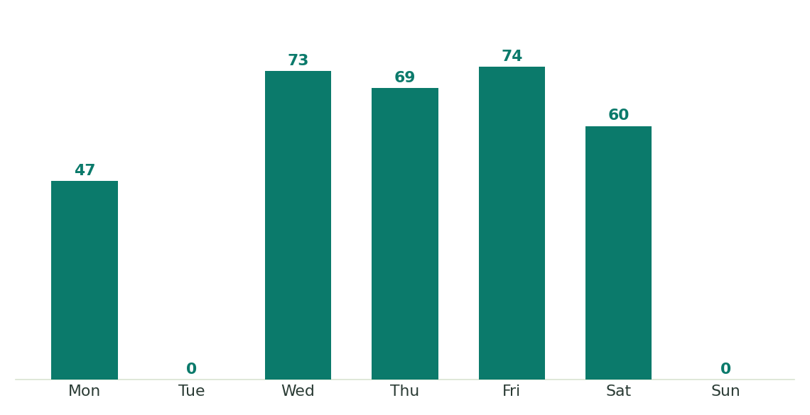
Figure 1 — Shipments per day (working days in teal; off days in grey)
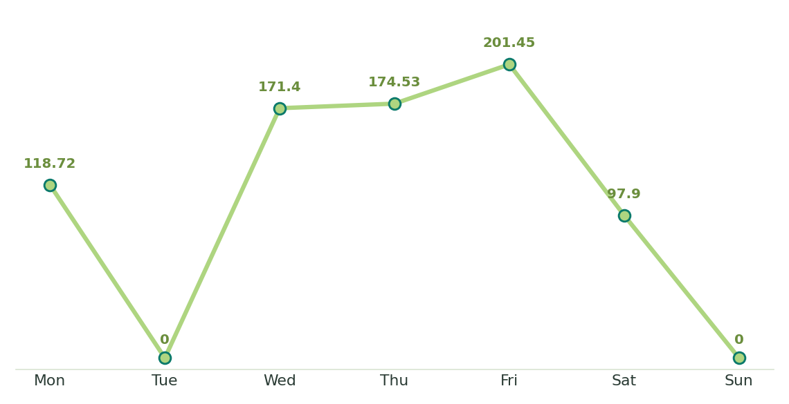
Figure 2 — Outgoing weight per day (kg)
Friday drove the weekly peak in both count (74 shipments) and weight (201.45 kg); activity pauses on Tuesday & Sunday (off days).
4. Shipment Type Breakdown
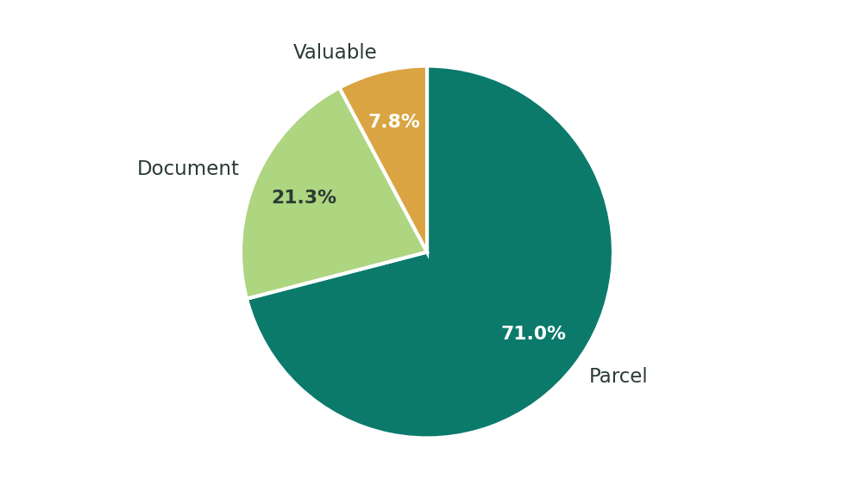
Figure 3 — Share of 334 classified items (weekly total)
- Parcels dominate: 237 items — about 71% of the outbound mix. Parcel handling capacity is the operation's core requirement.
- Documents are secondary: 71 items (≈21%) — a steady, routine flow with low handling risk.
- Valuables are few but critical: 26 items (≈8%) — low volume, high risk; they demand strict chain-of-custody and secure packaging.
- Monday is valuable-heavy: 5 of the week's 26 valuables moved on Monday, the highest single-day count.
5. Payment Method Breakdown
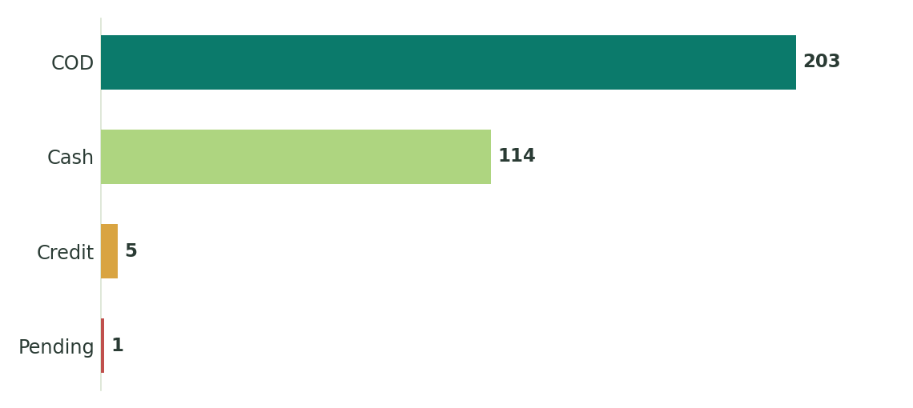
Figure 4 — Shipments per payment method (of 323 total)
- COD leads: 203 shipments (62.8%) paid cash on delivery — the primary collection channel and a healthy cash-flow driver.
- Cash adds 35.3%: 114 shipments prepaid or paid at counter. COD + cash covers 98.1% of the week's shipments.
- Credit is negligible: only 5 shipments (1.5%) — receivables exposure is minimal under current limits.
- One payment pending: a single shipment (Thursday) awaits settlement — follow up to close the week at 100%.
6. Key Findings
- Friday was the peak day: 74 shipments (23% of weekly volume) and 201.45 kg (26% of weekly weight). Saturday was the lightest working day (60 shipments, 97.9 kg).
- Mid-week stayed strong: Wednesday and Thursday together moved 142 shipments — about 44% of the week — showing a stable core rhythm.
- The mix is parcel-heavy: 237 parcels (≈71%), 71 documents (≈21%) and 26 valuables (≈8%) — sorting and packaging should be parcel-first.
- Collections were secure: COD (203) plus cash (114) settled 98.1% of shipments; only 5 on credit and 1 pending.
- Cargo is light: average weight of just 2.37 kg per shipment — well suited to consolidated batching and light vehicles.
- Operations pause on off days: Tuesday and Sunday recorded no outgoing shipments, concentrating the week into 5 working days.
7. Conclusion & Recommendations
The week's outgoing operation delivered 323 shipments (764 kg) across 5 working days, with 98.1% settled through COD or cash — a stable, parcel-driven and financially secure performance.

What Went Well
- Strong collections: 98.1% of shipments settled on delivery — minimal receivables risk.
- Consistent output: 60–74 shipments every working day; no idle capacity days.
- Manageable cargo: light average load (2.37 kg) keeps handling simple and costs low.
Recommended Actions
- Staff for the Friday peak — add picking, packing and delivery capacity; keep Saturday light.
- Tighten COD & cash controls — daily reconciliation, secure floats, and promote digital payment to cut cash-handling risk.
- Protect the parcel flow — keep sorting space and packaging materials stocked for ~71% of volume.
- Secure valuables — enforce chain-of-custody checks for the 26 high-risk items.
- Close the gaps — chase the 1 pending payment and reconcile the 11-unit gap between type counts (334) and shipment records (323).

Source: Weekly Outgoing Summary sheet (as captured from the original record)

