**Name: Selas Moro Roll No.: 39 Pid: 182074 BECMPNB**

**EXPERIMENT 5**

**Aim:** To learn the properties and operations on a Fuzzy set.

**Theory:**

A fuzzy set, then, is a set containing elements that have varying degrees of

membership in the set. If X is a collection of objects denoted by x, then fuzzy set Ã

in X is a set of ordered pairs.



where X is the Universe of Discourse

 is the membership of element x in set Ã and 0 ≤ μ ≤ 1

**Fuzzy Sets Notation**

When the universe is discrete and finite

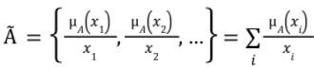

When the universe is continuous and infinite



**Example**

Create a fuzzy set for integers close to 6 where X = the set of integers

Solution: Ã = {(3, 0. 1), (4, 0. 4), (5, 0. 8), (6, 1), (7, 0. 8), (8, 0. 3), (9, 0. 1)}

**Fuzzy Set Operations**

Consider two fuzzy sets A and B on the universe X. For a given element x of the universe, the set theoretic operations union, intersection and complement are defined as follows:

**Union:** The membership function  of union of two fuzzy sets A and B is defined as:



**Intersection:** The membership function  of intersection of two fuzzy sets A and B is defined as:



**Complement:** The membership function of complement of a normalized fuzzy set A, is defined as:



**De Morgan’s laws:** De Morgan’s laws stated for fuzzy sets, as denoted by these expressions.

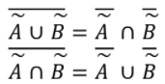

**Properties of Fuzzy Set**

1. **Support of Fuzzy Set**

The support of the fuzzy set A is S(A), which is a crisp set of all x ∈ X such that

μÃ(x) > 0. The element x in X at which μÃ(x) = 0.5 is called crossover point.

1. **Core of Fuzzy Set**

The core of the fuzzy set A is C(A), which is a crisp set of all x ∈ X such that μÃ(x)=1.

1. **α-level set and Strong α-level set**

α-level set is a crisp set of elements that belong to fuzzy set A atleast to degree α

Ã α = {x ∈ X |μÃ(x) ≥ α}

Strong α-level set is defined as

Ã’ α = {x ∈ X |μÃ(x) > α}

1. **Cardinality**

The cardinality of fuzzy set A is defined as

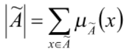

Relative cardinality is

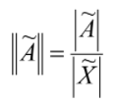

1. **Height**

The height of the fuzzy set A is the largest membership grade of an element in A

Height (A) = max (μÃ(x))

1. **Normality**

A fuzzy set X is called normal, if there exist atleast one element x ε X such that μÃ(x)=1. A fuzzy set that is not normal is called subnormal.

**Experiment:**

**Implementation:**

The following Programming Exercises is perfomed in python in the given link:

<https://colab.research.google.com/drive/14dOtyVXJlFX2S0yelDknCPcCX8mftKV_?usp=sharing>

**Output:**

1. **Take two sets as input from user the elements and membership values. If membership value is not in [0,1] generate error message.**

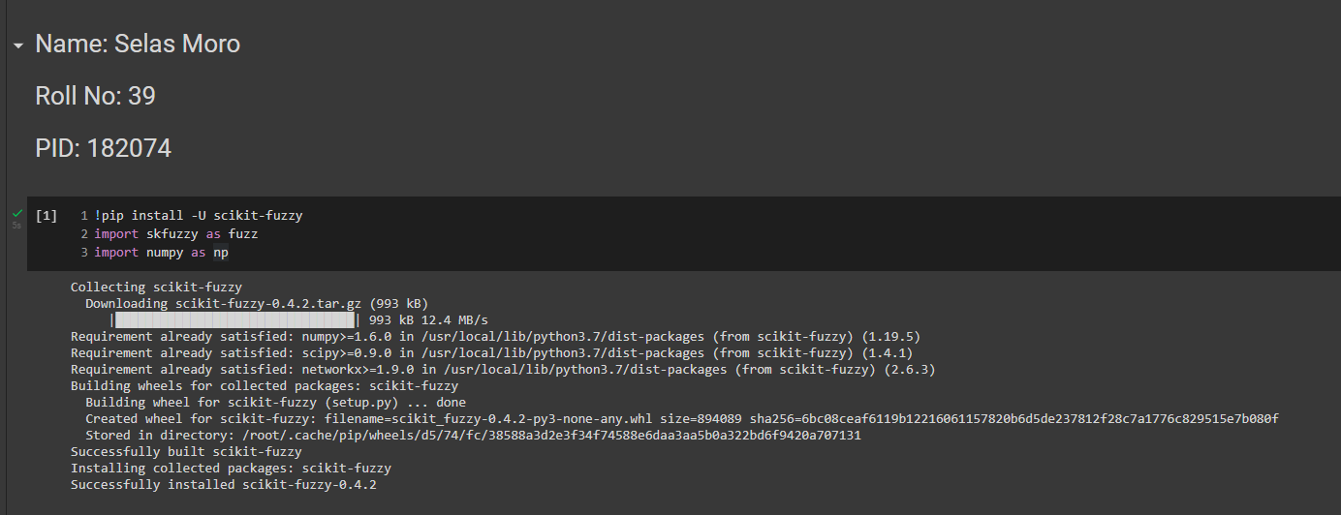

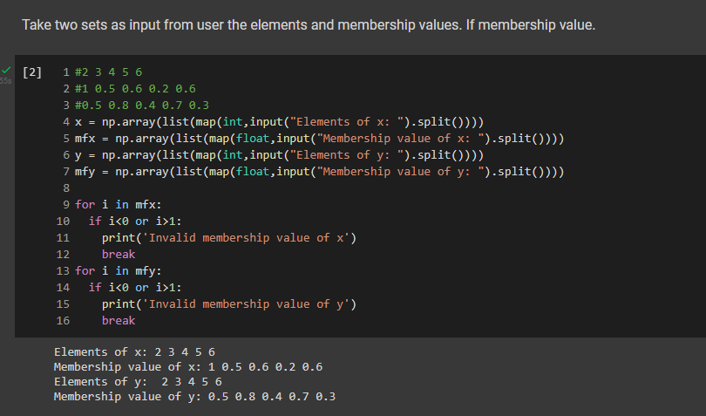

1. **Perform Union, Intersection, Complement of both sets, Difference of both sets.**

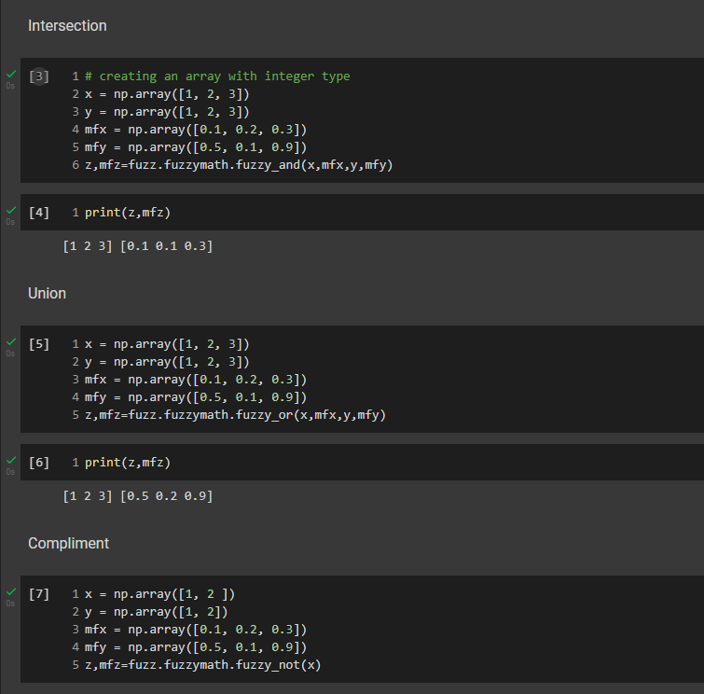

1. **Find and display Support, Core, Height, Cardinality, Relative Cardinality, Alpha Cuts and Strong Alpha Cuts for both Sets:**

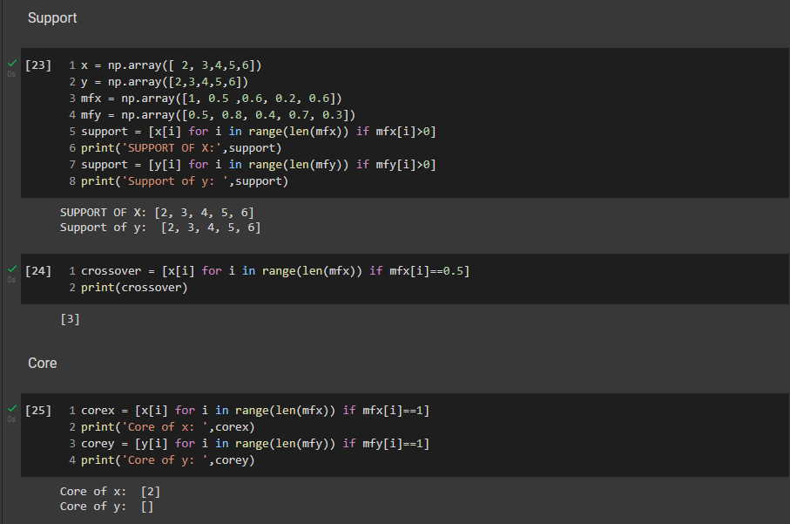

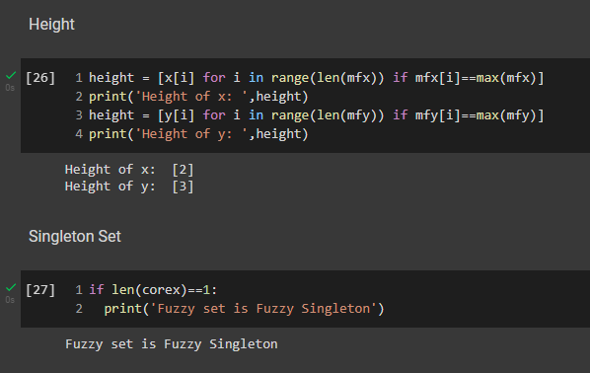

**Relative Cardinality and Cardinality:**

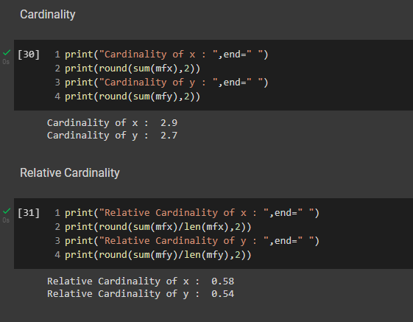

**Alpha Cut and Strong Alpha cut:**

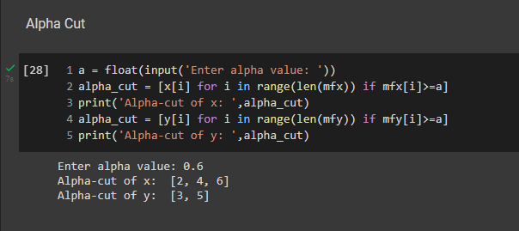

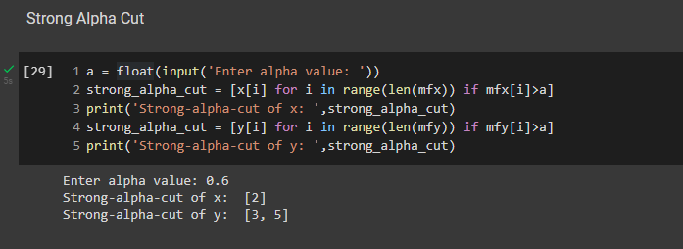

**Post Experiment:**

1. **Prove Demorgan’s law.**

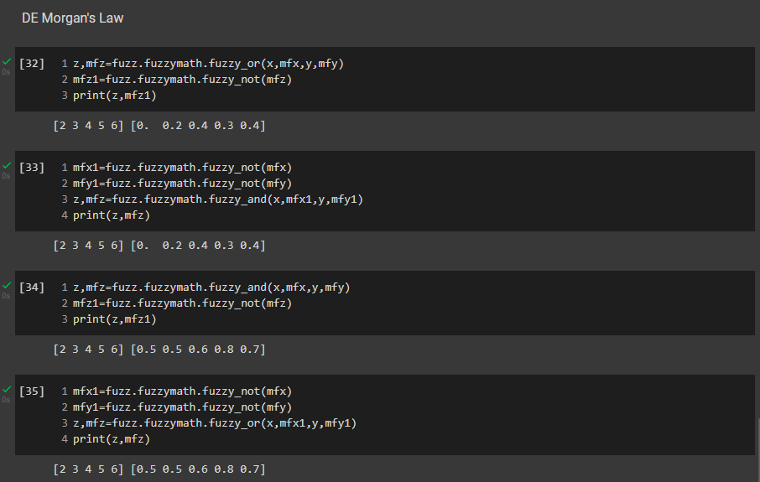

1. **Find and display whether the given sets are normal or subnormal.**

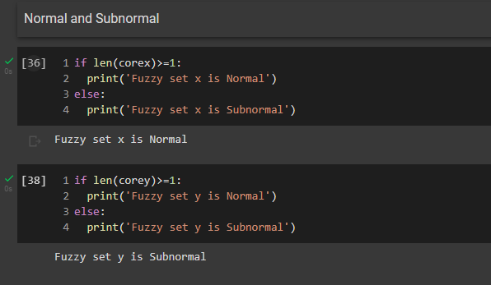

**Conclusion:**

In this following Experiment, we have being able to learn the concepts of fuzzy sets and implement them in the above link .